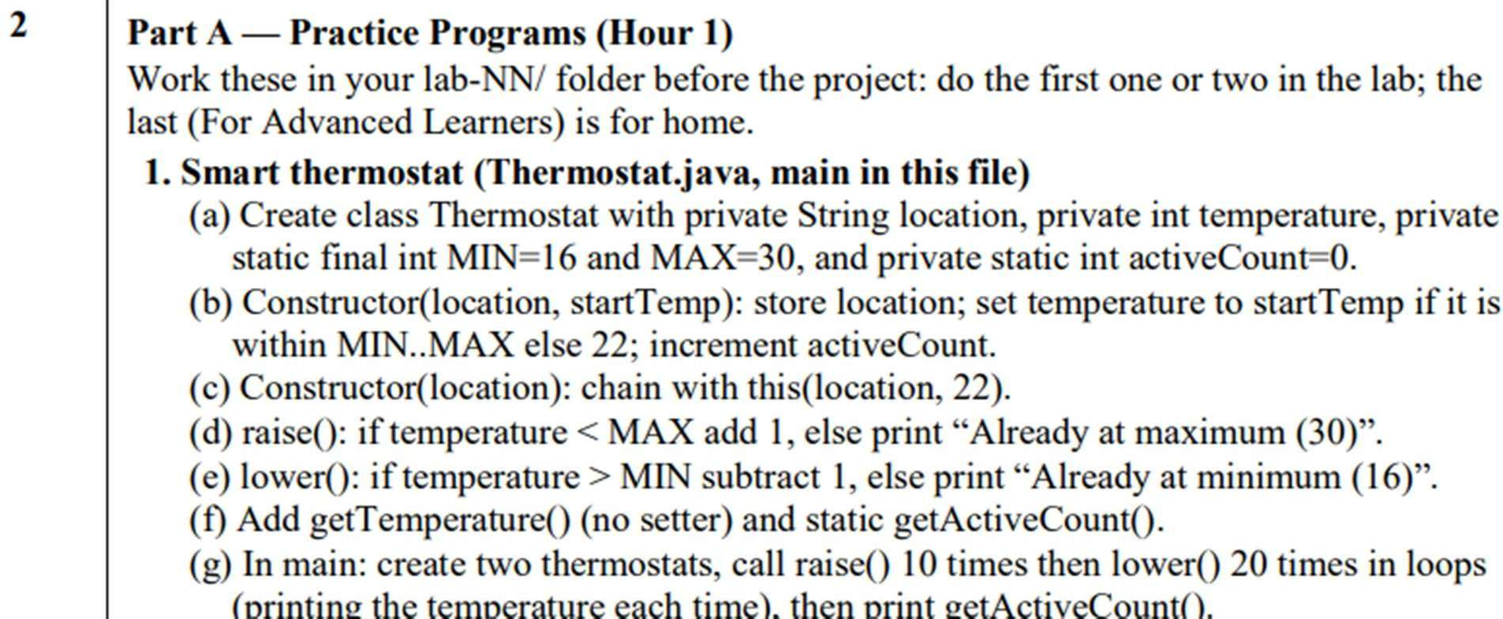

CODE:
public class Thermostat {

private String location;
private int temperature;

private static final int MIN = 16;
private static final int MAX = 30;

private static int activeCount = 0;

public Thermostat(String location, int startTemp) {
this.location = location;

if (startTemp >= MIN && startTemp <= MAX)
temperature = startTemp;
else
temperature = 22;

activeCount++;
}

public Thermostat(String location) {
this(location, 22);
}

public void raise() {
if (temperature < MAX)
temperature++;
else
System.out.println("Already at maximum (30)");
}

public void lower() {
if (temperature > MIN)
temperature--;
else
System.out.println("Already at minimum (16)");
}

public int getTemperature() {
return temperature;
}

public static int getActiveCount() {
return activeCount;
}

public static void main(String[] args) {

Thermostat t1 = new Thermostat("Room 1", 22);
Thermostat t2 = new Thermostat("Room 2", 25);

System.out.println("Thermostat 1:");

for (int i = 0; i < 10; i++) {
t1.raise();
System.out.println("Temperature: " + t1.getTemperature());
}

System.out.println("\nThermostat 1:");

for (int i = 0; i < 20; i++) {
t1.lower();
System.out.println("Temperature: " + t1.getTemperature());
}

System.out.println("\nThermostat 2:");

for (int i = 0; i < 10; i++) {
t2.raise();
System.out.println("Temperature: " + t2.getTemperature());
}

System.out.println("\nThermostat 2:");

for (int i = 0; i < 20; i++) {
t2.lower();
System.out.println("Temperature: " + t2.getTemperature());
}

System.out.println("\nActive Thermostats: " + Thermostat.getActiveCount());
}
}

OUTPUT:

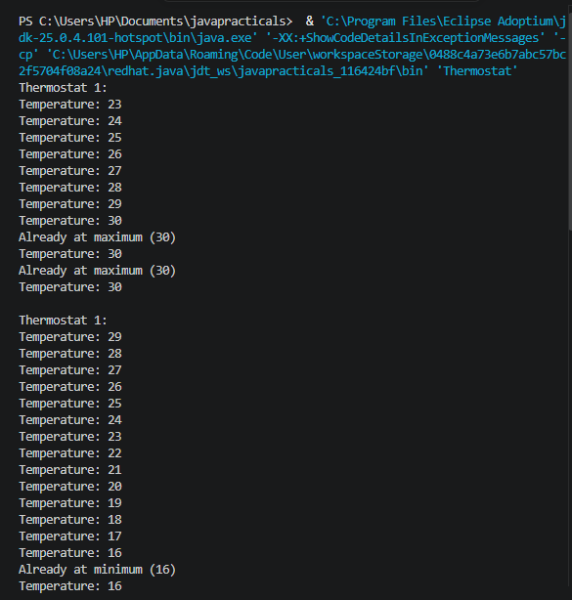

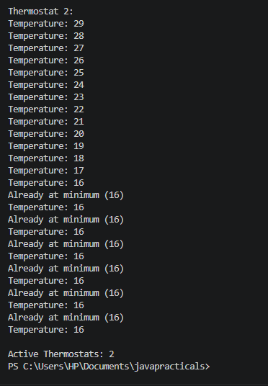

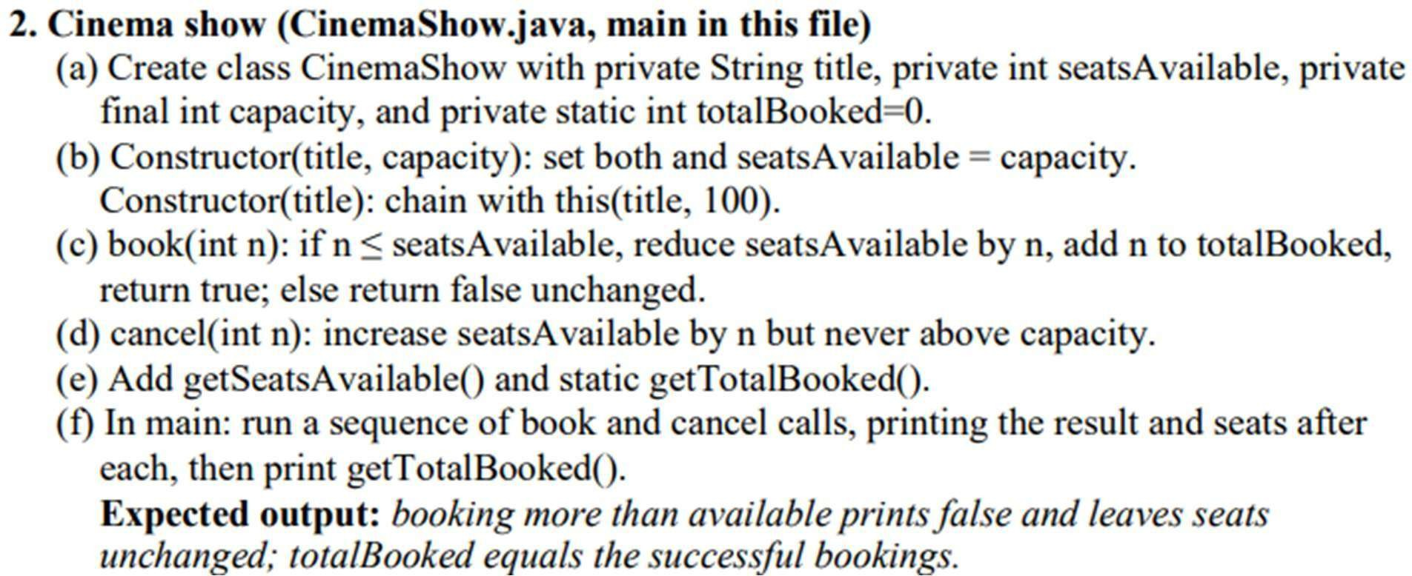

CODE:
public class CinemaShow {

private String title;
private int seatsAvailable;
private final int capacity;
private static int totalBooked = 0;

public CinemaShow(String title, int capacity) {
this.title = title;
this.capacity = capacity;
this.seatsAvailable = capacity;
}

public CinemaShow(String title) {
this(title, 100);
}

public boolean book(int n) {
if (n <= seatsAvailable) {
seatsAvailable -= n;
totalBooked += n;
return true;
}

return false;
}

public void cancel(int n) {
seatsAvailable += n;

if (seatsAvailable > capacity)
seatsAvailable = capacity;
}

public int getSeatsAvailable() {
return seatsAvailable;
}

public static int getTotalBooked() {
return totalBooked;
}

public static void main(String[] args) {

CinemaShow show = new CinemaShow("Avengers", 50);

System.out.println("Initial seats: " + show.getSeatsAvailable());

System.out.println("Booking 20 seats: " + show.book(20));
System.out.println("Seats available: " + show.getSeatsAvailable());

System.out.println("Booking 40 seats: " + show.book(40));
System.out.println("Seats available: " + show.getSeatsAvailable());

System.out.println("Booking 10 seats: " + show.book(10));
System.out.println("Seats available: " + show.getSeatsAvailable());

show.cancel(5);
System.out.println("After cancelling 5 seats:");
System.out.println("Seats available: " + show.getSeatsAvailable());

show.cancel(100);
System.out.println("After cancelling 100 seats:");
System.out.println("Seats available: " + show.getSeatsAvailable());

System.out.println("Total booked: " + CinemaShow.getTotalBooked());
}
}

OUTPUT:

