MSDS 6372 Applied Statistics

Project - 1

Nicholas Cellini, James Clay and Selwyn Samuel

Table of Contents

Introduction 2

Data Description 2

Exploratory Analysis 2

Objective 1 2

Problem Statement 2

Model Selection 2

Selection Type 2

Assumptions 2

Model Comparison 2

Parameter Interpretation 2

Conclusion 2

Objective 2 2

Problem Statement 2

Solution Approach 2

Main Analysis 3

Conclusion 3

Resources 3

Appendix 3

SAS Code 3

Objective 1 3

Objective 2 3

# Introduction

# Data Description

|  |  |  |
| --- | --- | --- |
| Attribute Name | Attribute Type | Description |
| mpg |  |  |
| cylinders |  |  |
| displacement |  |  |
| horsepower |  |  |
| weight |  |  |
| acceleration |  |  |
| model_year |  |  |
| origin |  |  |
| car_name |  |  |
| torgue_lbft |  |  |
| top_speed_mph |  |  |
| 0_60_time_sec_predicted |  |  |
| quarter_mile_time |  |  |
| car_full_name |  |  |

# Exploratory Analysis

## Data Analysis

* Removed observations with horsepower values as NA (In Excel – as SAS was reading them as character datatype)

## Scatter Plot

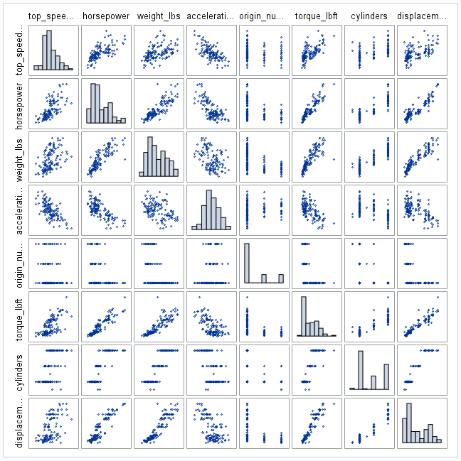

# Objective 1

## Problem Statement

## Model Selection

### Selection Type

### Assumptions

### Model Comparison

## Parameter Interpretation

## Conclusion

# Objective 2

## Problem Statement

## Solution Approach

## Main Analysis

## Conclusion

# Resources

<https://archive.ics.uci.edu/ml/datasets/Auto+MPG>

# Appendix

## SAS Code

### Objective 1

### Objective 2