|  |  |  |  |  |  |  |  |  |  |  |  |  |  |  |  |  |  |  |  |  |  |  |  |  |  |  |
| --- | --- | --- | --- | --- | --- | --- | --- | --- | --- | --- | --- | --- | --- | --- | --- | --- | --- | --- | --- | --- | --- | --- | --- | --- | --- | --- |
| fetch | Armux0 | Armux1 | pcld | Pc++ | memld | regld | zfload | Mux0 | Mux1 | Mux2 | Sp-- | Sp++ | ırld | retmux | intload | flagload | sti | cli | intack |  |  |  |  |  |  |  |
| 1 | 0 | 0 | 0 | 1 | 0 | 0 | 0 | 0 | 0 | 0 | 0 | 0 | 1 | 0 | 0 | 0 | 0 | 0 | 0 | 0 | 0 | 0 | 0 | 0 | fetch | 0 |
| 0 | 0 | 0 | 0 | 1 | 0 | 1 | 0 | 0 | 0 | 0 | 0 | 0 | 0 | 0 | 0 | 0 | 0 | 0 | 0 | 0 | 0 | 0 | 0 | 0 | Ldi | 1 |
| 0 | 1 | 0 | 0 | 0 | 0 | 1 | 0 | 0 | 0 | 0 | 0 | 0 | 0 | 0 | 0 | 0 | 0 | 0 | 0 | 0 | 0 | 0 | 0 | 0 | Ld | 2 |
| 0 | 1 | 0 | 0 | 0 | 1 | 0 | 0 | 1 | 0 | 0 | 0 | 0 | 0 | 0 | 0 | 0 | 0 | 0 | 0 | 0 | 0 | 0 | 0 | 0 | St | 3 |
| 0 | 0 | 0 | 0 | 0 | 0 | 0 | 0 | 0 | 0 | 0 | 0 | 0 | 0 | 0 | 0 | 0 | 0 | 0 | 0 | 0 | 0 | 0 | 0 | 0 | Jz | 4 |
| 0 | 0 | 0 | 1 | 0 | 0 | 0 | 0 | 0 | 0 | 0 | 0 | 0 | 0 | 0 | 0 | 0 | 0 | 0 | 0 | 0 | 0 | 0 | 0 | 0 | Jmp | 5 |
|  |  |  |  |  |  |  |  |  |  |  |  |  |  |  |  |  |  |  |  |  |  |  |  |  |  | 6 |
| 0 | 0 | 0 | 0 | 0 | 0 | 1 | 1 | 1 | 1 | 0 | 0 | 0 | 0 | 0 | 0 | 0 | 0 | 0 | 0 | 0 | 0 | 0 | 0 | 0 | Alu | 7 |
| 0 | 0 | 1 | 0 | 0 | 1 | 0 | 0 | 1 | 0 | 0 | 1 | 0 | 0 | 0 | 0 | 0 | 0 | 0 | 0 | 0 | 0 | 0 | 0 | 0 | Push | 8 |
| 0 | 0 | 0 | 0 | 0 | 0 | 0 | 0 | 0 | 0 | 0 | 0 | 1 | 0 | 0 | 0 | 0 | 0 | 0 | 0 | 0 | 1 | 1 | 1 | 1 | Pop1 | 9 |
| 0 | 0 | 1 | 1 | 0 | 1 | 0 | 0 | 0 | 0 | 1 | 1 | 0 | 0 | 0 | 0 | 0 | 0 | 0 | 0 | 0 | 0 | 0 | 0 | 0 | Call | A |
| 0 | 0 | 0 | 0 | 0 | 0 | 0 | 0 | 0 | 0 | 0 | 0 | 1 | 0 | 0 | 0 | 0 | 0 | 0 | 0 | 1 | 0 | 0 | 0 | 0 | Ret1 | B |
| 0 | 0 | 0 | 0 | 0 | 0 | 0 | 0 | 0 | 0 | 0 | 0 | 0 | 0 | 0 | 0 | 0 | 1 | 0 | 0 | 0 | 0 | 0 | 0 | 0 | Sti | C |
| 0 | 0 | 0 | 0 | 0 | 0 | 0 | 0 | 0 | 0 | 0 | 0 | 0 | 0 | 0 | 0 | 0 | 0 | 1 | 0 | 0 | 0 | 0 | 0 | 0 | Cli | D |
| 0 | 0 | 0 | 0 | 0 | 0 | 0 | 0 | 0 | 0 | 0 | 0 | 1 | 0 | 0 | 0 | 0 | 0 | 0 | 0 | 1 | 0 | 0 | 0 | 1 | İret1 | E |
| 0 | 0 | 1 | 0 | 0 | 0 | 1 | 0 | 0 | 0 | 0 | 0 | 0 | 0 | 0 | 0 | 0 | 0 | 0 | 0 | 0 | 0 | 0 | 0 | 0 | Pop2 | F |
| 0 | 0 | 1 | 1 | 0 | 0 | 0 | 0 | 0 | 0 | 0 | 0 | 0 | 0 | 1 | 0 | 0 | 0 | 0 | 0 | 0 | 0 | 0 | 0 | 0 | Ret2 | 10 |
| 0 | 0 | 1 | 1 | 0 | 0 | 0 | 0 | 0 | 0 | 0 | 0 | 1 | 0 | 1 | 0 | 0 | 0 | 0 | 0 | 1 | 0 | 0 | 1 | 0 | İret2 | 11 |
| 0 | 0 | 1 | 0 | 0 | 0 | 0 | 0 | 0 | 0 | 0 | 0 | 0 | 0 | 0 | 0 | 1 | 0 | 0 | 0 | 0 | 0 | 0 | 0 | 0 | İret3 | 12 |
| 0 | 0 | 1 | 0 | 0 | 1 | 0 | 0 | 0 | 1 | 0 | 1 | 1 | 0 | 0 | 0 | 0 | 0 | 0 | 0 | 1 | 0 | 1 | 0 | 0 | İnt1 | 13 |
| 0 | 0 | 1 | 0 | 0 | 1 | 0 | 0 | 0 | 0 | 1 | 1 | 0 | 0 | 0 | 1 | 0 | 0 | 0 | 1 | 1 | 0 | 1 | 0 | 1 | İnt2 | 14 |
| 0 | 1 | 1 | 1 | 0 | 0 | 0 | 0 | 0 | 0 | 0 | 0 | 0 | 0 | 1 | 0 | 0 | 0 | 1 | 0 | 0 | 0 | 0 | 0 | 0 | İnt3 | 15 |

All circuits that are used in previous projects are also used in this project. But

some of them are changed a little bit.

Control Unit, Register Bank and main are changed.

**Control Unit:**

New instructions and signals are added this project.

New instructions are sti, cli, iret and interrupt codes.

New signals are intload,flagload,sti,cli,intack.

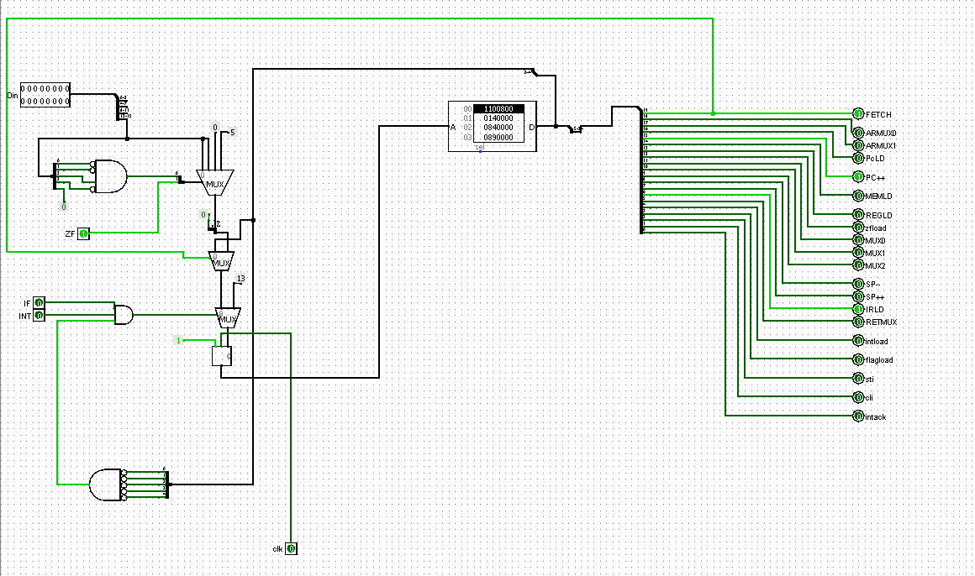

**Reg-Bank**

7. register is stack register. 6.register is changed. It includes flags, sti and cli.

And these signals are matched with control unit signals.

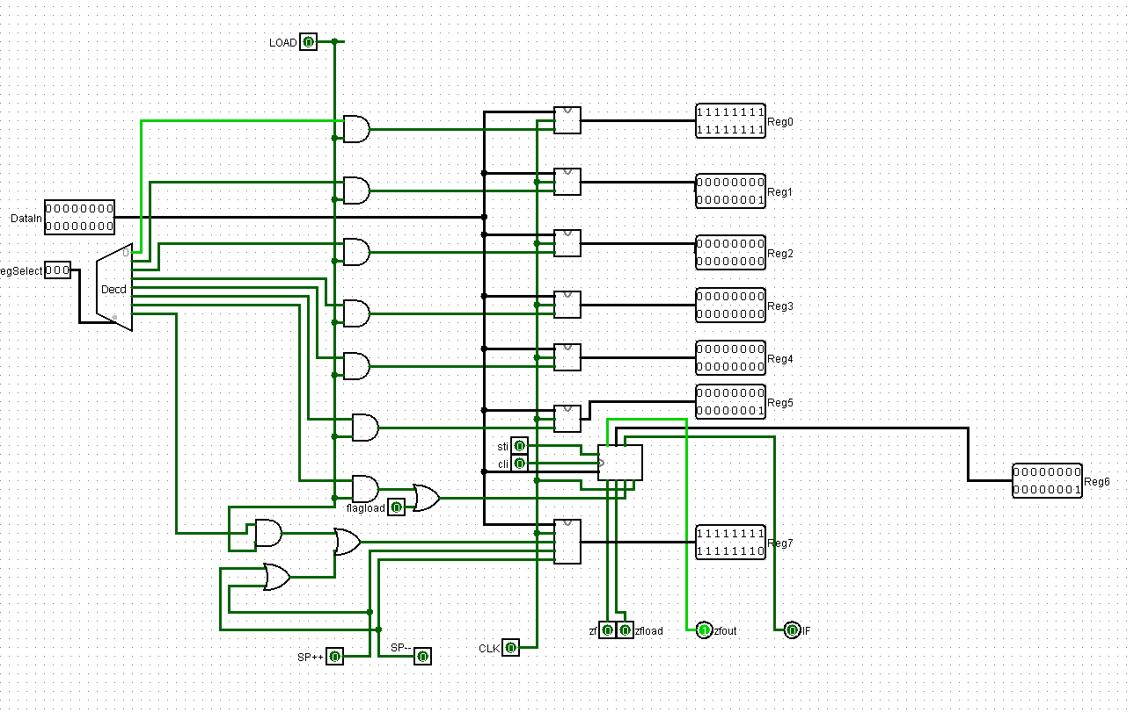

**Main**

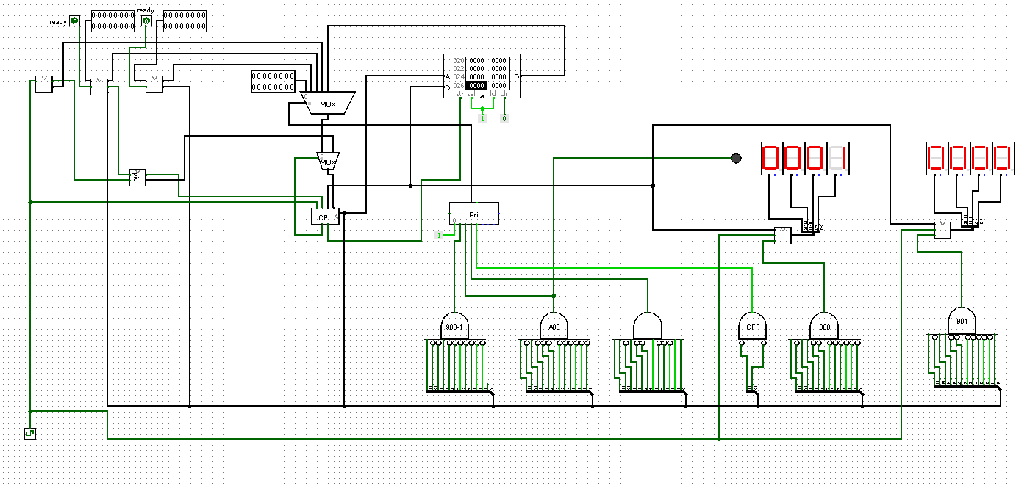

We add two keypad, one of them is with polling and other is with interrupt.

**Polling input**

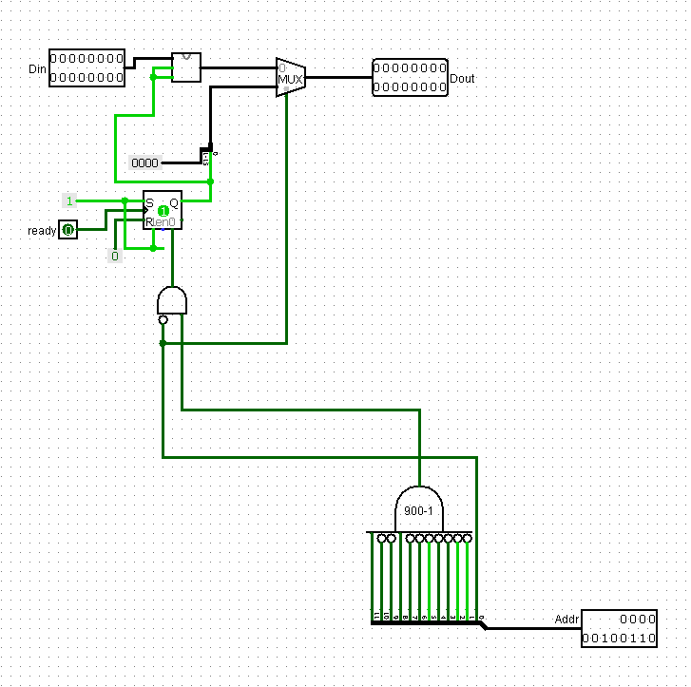

**Interrupt input**

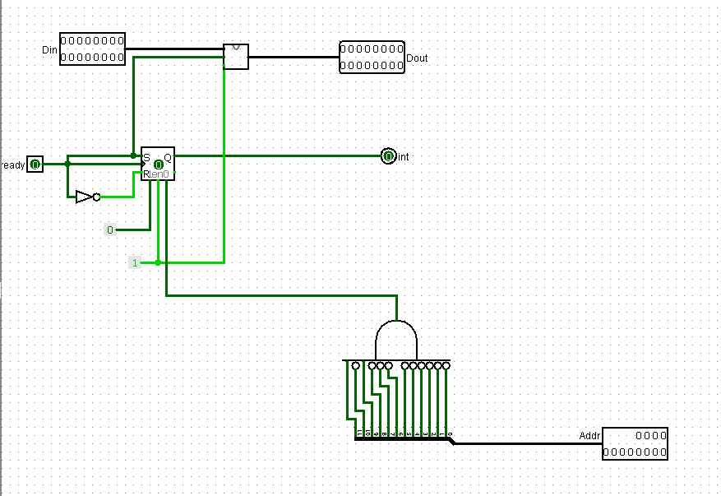

Also we add clock counter that is send interrupt every 1024 clock.

