

CSE 4074 Programmıng assıgnment

Socket Programming – Travel Agency



*Group Members*

*Sema Çevik – 150112077*

*Sibel Aymış - 150112075*

In this Project, we did travel agency. It include a customer, a travel agency, two hotels and two airlines.

We created a client class for customer. Client socket is created to connect server. It connects to server with 1433rd port number. It takes input from user and sends to travel agency.

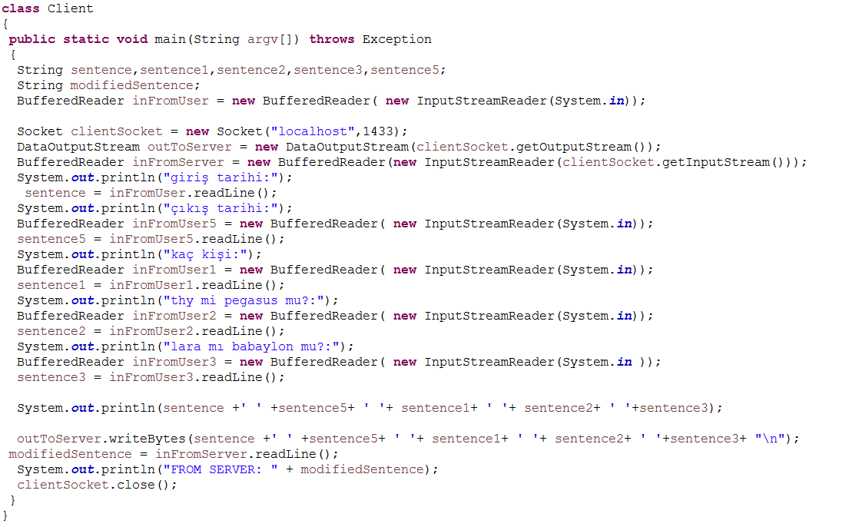

We created a server class for travel agency. Server socket is created to connect client. It connects to client with 1433rd port number.

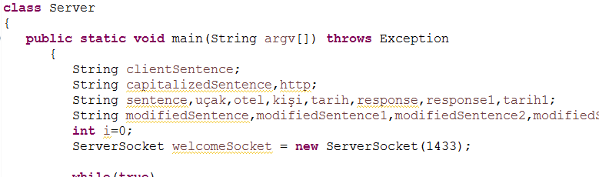

Also it includes four client sockets to connect hotels and airlines. If user selects Lara hotel, it connects to Lara hotel server with 1434th port number and sends entry date, release date and number of people. If 200 response message is sent from Lara hotel server, it connects selected airlines server.

If Thy airline is selected, it connects to Thy airline server with 1436th port number and sends entry date, release date and number of people.

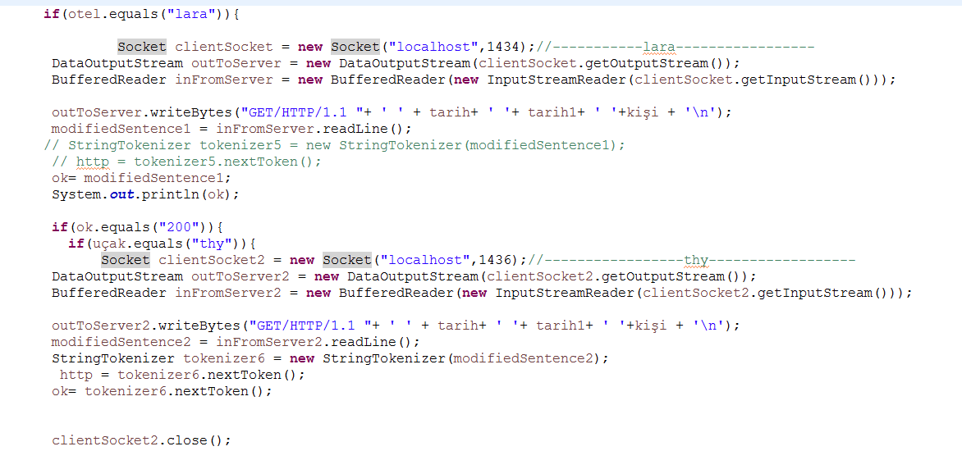

If Pegasus airline is selected, it connects to Pegasus airline server with 1437th port number and sends entry date, release date and number of people.

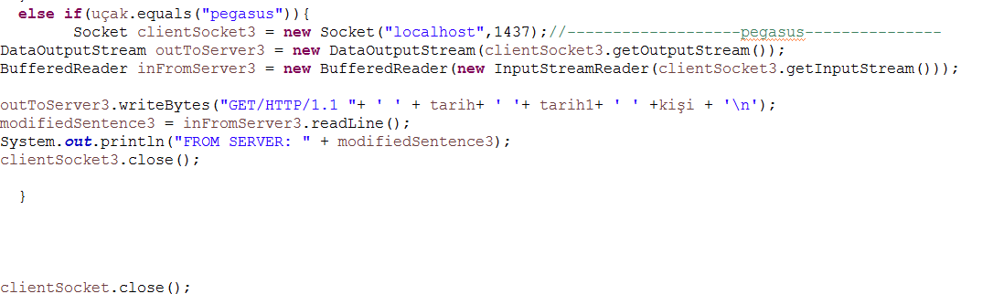

If user selects Babaylon hotel, it connects to Babaylon hotel server with 1435th port number and sends entry date, release date and number of people. If 200 response message is sent from Babaylon hotel server, it connects selected airlines server.

If Thy airline is selected, it connects to Thy airline server with 1436th port number and sends entry date, release date and number of people.

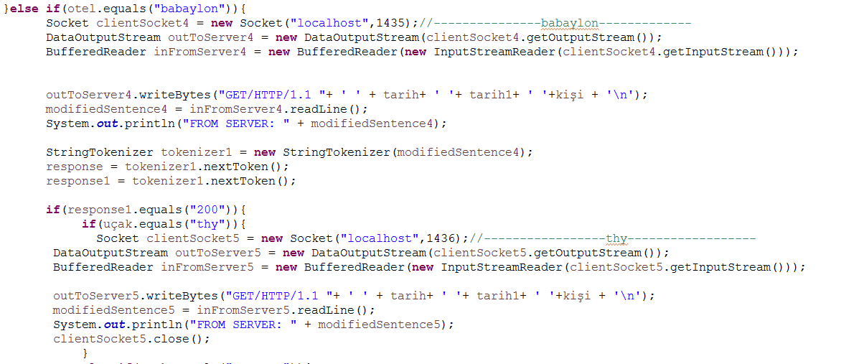

If Pegasus airline is selected, it connects to Pegasus airline server with 1437th port number and sends entry date, release date and number of people.

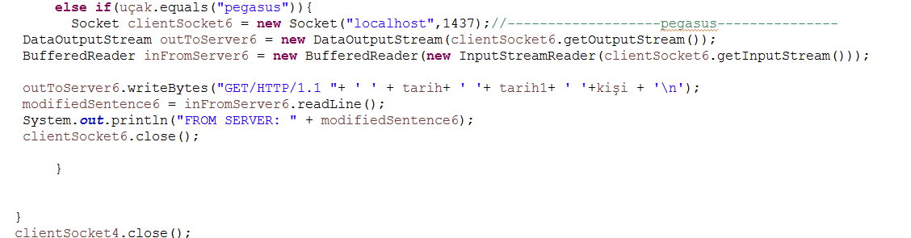

In Lara hotel server, it connects the database of Lara hotel.

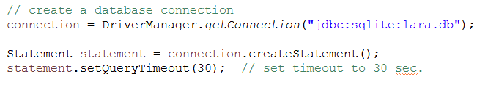

It writes each dates from entry date to release date and number of empty rooms in database. If same dates are entered, it updates the number of empty rooms.

They are same for Babaylon hotels, Thy and Pegasus airlines servers.