Statistical and Machine Learning Analysis of
Post-Chernobyl Cancer Incidence in Belarus
Prepared by: [Semal Kulathilaka]
Student Id: [38734]

1. Introduction
On 26 April 1986, Reactor 4 of the Chernobyl Nuclear Power Plant in the former Soviet Union suffered a catastrophic explosion and fire, releasing large quantities of radioactive material across what are now Ukraine, Belarus, and Russia. The Republic of Belarus, lying immediately north of the plant, received some of the heaviest fallout, particularly in the Gomel and Mogilev regions. In the years and decades that followed, public health authorities recorded a marked rise in radiation-related illnesses in these contaminated areas, most notably thyroid and skin cancers, prompting decades of epidemiological research into the relationship between radiation exposure and cancer incidence.
This report analyses a structured dataset that records the number of cancer cases observed in Belarus, broken down by year, sex, region, and cancer type. The aim is twofold: first, to explore the dataset through descriptive statistics and visualization to understand its structure and any underlying patterns; and second, to build and compare supervised machine learning classifiers capable of distinguishing between typical and unusually high case counts based on the available categorical and temporal features.
Two classification approaches were developed and compared: a K-Nearest Neighbours (KNN) classifier and a Logistic Regression classifier. A simple linear regression of case counts against year was also produced to visualize the overall time trend. The remainder of this report is organized as follows: Section 2 describes the dataset; Section 3 presents the exploratory data analysis; Section 4 explains the preprocessing steps; Section 5 describes model development; Section 6 evaluates model performance; Section 7 interprets the results; Section 8 illustrates how the trained model could be applied to a new record; Section 9 concludes; and Section 10 lists references.

2. Dataset Description
The dataset used in this analysis is the publicly available Cancer rate before and after Chernobyl dataset hosted on Kaggle, which compiles recorded cancer case counts in Belarus for the years surrounding the accident. It contains 84 records and 5 columns, with no missing values and no duplicate rows, as confirmed by the data quality checks below.
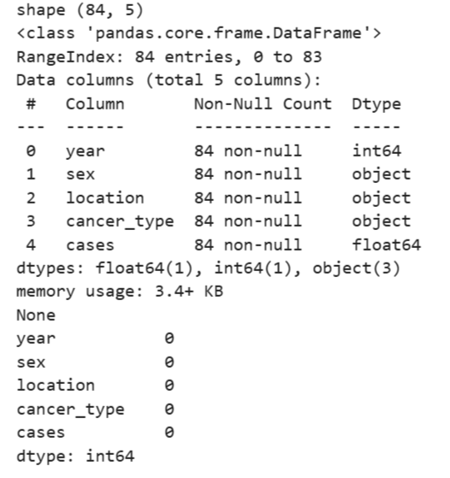
The five variables are summarized in Table 1 below.
Variable | Type | Levels / Range | Notes
year | Integer | 1985, 1986 | 42 records per year
sex | Categorical | men, women | 42 records per category
location | Categorical | Gomel, Mogilev, Belarus | 28 records per category
cancer type | Categorical | 7 distinct types (e.g. skin) | 12 records per type
cases | Float | 0.5 – 73.1 | Mean 10.69, median 6.35, right skewed

A notable structural feature of this dataset is that it is fully crossed: 2 years × 2 sexes × 3 locations × 7 cancer types = 84, which exactly matches the row count. In other words, every combination of year, sex, location, and cancer type appears exactly once, each with its own recorded case value. This balanced design is important for interpreting later results, since it means the four categorical/temporal predictors are independent of one another by construction, not by coincidence.
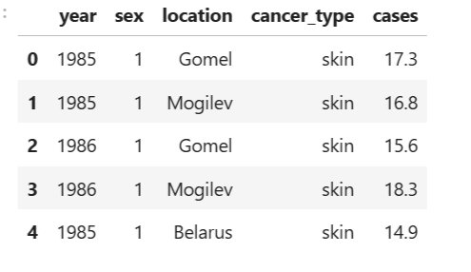
Figure 2. First five records of the dataset, prior to encoding.
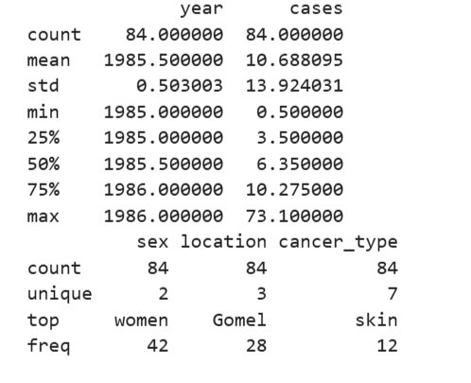
Figure 3. Summary statistics for numeric and categorical columns.

3. Exploratory Data Analysis

3.1 Distribution of case counts
The cases column is strongly right skewed: the mean (10.69) is noticeably higher than the median (6.35), and the maximum value (73.1) is far above the 75th percentile (10.275). This indicates that, while most year/sex/location/cancer-type combinations recorded relatively low case counts, a small number of combinations — likely specific cancer types in the most heavily contaminated regions — recorded disproportionately high counts.
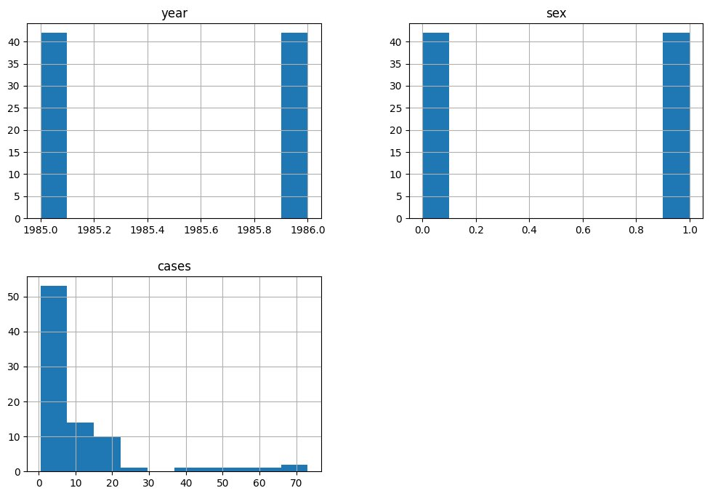
Figure 4. Distributions of year, sex, and cases. Year and sex are evenly split (42/42); cases is heavily right-skewed.
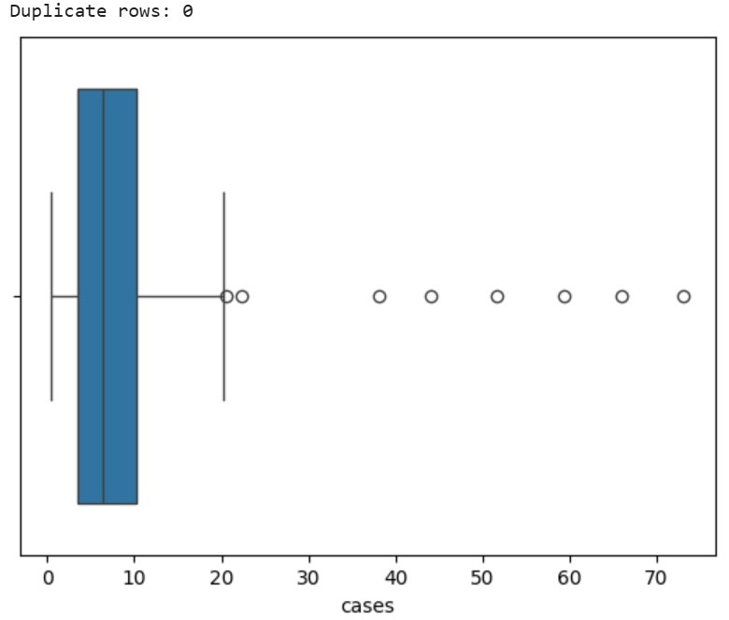
Figure 5. Boxplot of cases, showing several high-value outliers above the upper whisker. No duplicate rows were found in the dataset.

3.2 Correlation analysis
A correlation heatmap was produced across all five variables after label encoding the categorical columns. As expected from the fully crossed design described in Section 2, the year, sex, location, and cancer type columns show essentially zero correlation with one another (all values are of the order 1e-14 or smaller), confirming that these predictors are orthogonal. The outcome variable, cases, shows a weak positive correlation with year (0.12), a moderate negative correlation with sex (−0.33, the strongest relationship in the matrix), and negligible correlation with the encoded location (0.03) and cancer type (−0.033) codes.
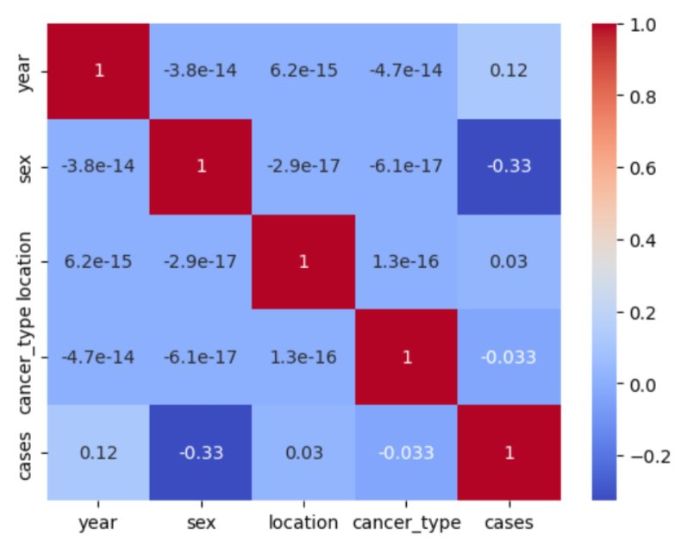
Figure 6. Correlation heatmap of all five variables (after label encoding).
Sex stands out as the variable most associated with case counts, suggesting a systematic difference in average cases between men and women across the recorded cancer types. The very weak correlations with location and cancer type should be interpreted with caution, however: because these are nominal categories converted into arbitrary integer codes (Section 4), a linear correlation coefficient cannot capture genuine group differences between, say, Gomel and Mogilev, or between skin and other cancer types. A comparison of group means (e.g. via ANOVA) would be a more appropriate way to test for such effects and is noted as a limitation in Section 9.

4. Data Preprocessing
Before modelling, the following preprocessing steps were applied:
- Missing values: none of the 84 records contained missing values in any column (confirmed in Figure 1), so no imputation was required.
- Duplicate rows: a duplicate check returned 0 duplicate rows (Figure 5), so no rows needed to be removed.
- Categorical encoding: the text-based sex, location, and cancer type columns were converted into integer codes using label encoding, since scikit-learn estimators require numeric input. The screenshots below show the original category values placed alongside their encoded equivalents as a verification step.
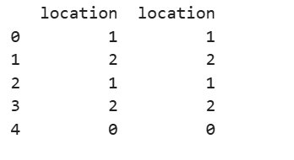
Figure 7. Verification of label encoding for location (e.g. Belarus → 0, Gomel → 1, Mogilev → 2).
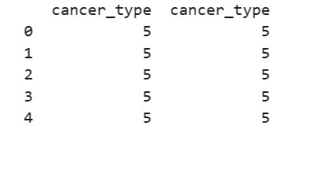
Figure 8. Verification of label encoding for cancer type (the five sample rows, all originally “skin”, were consistently mapped to code 5).
- Target variable: the continuous cases column was converted into a binary classification target. Based on the class counts observed later in the evaluation outputs (22 “high incidence” records out of 84, ≈26%), the threshold used appears to correspond closely to the 75th percentile of cases (≈10.3): records above this value were labelled 1 (high incidence) and the remainder 0 (typical incidence).
- Train/test split: the feature matrix (year, sex, location, cancer type) and the binary target were split into training and test sets. The KNN evaluation support totals (12 + 5 = 17 test records) imply an approximate 80/20 split, i.e. around 67 training records and 17 test records.

5. Model Development
Two supervised classification models were trained to predict whether a record belongs to the high-incidence (1) or typical-incidence (0) class, using year, sex, location, and cancer type as predictors:
- K-Nearest Neighbours (KNN): a non-parametric classifier that labels a new point according to the majority class among its closest neighbours in feature space. No specific value of k was visible in the provided screenshots, so the scikit-learn default was assumed unless your notebook specifies otherwise.
- Logistic Regression: a linear classifier used here as a baseline, modelling the log-odds of the high-incidence class as a linear combination of the encoded predictors.
In addition to the two classifiers, a simple linear regression of cases on year was fitted purely for exploratory purposes, to visualized whether case counts increased between 1985 and 1986. As shown below, the fitted line has a modest positive slope, rising from roughly 9 to 13 cases on average, but with very wide scatter around the line in both years.
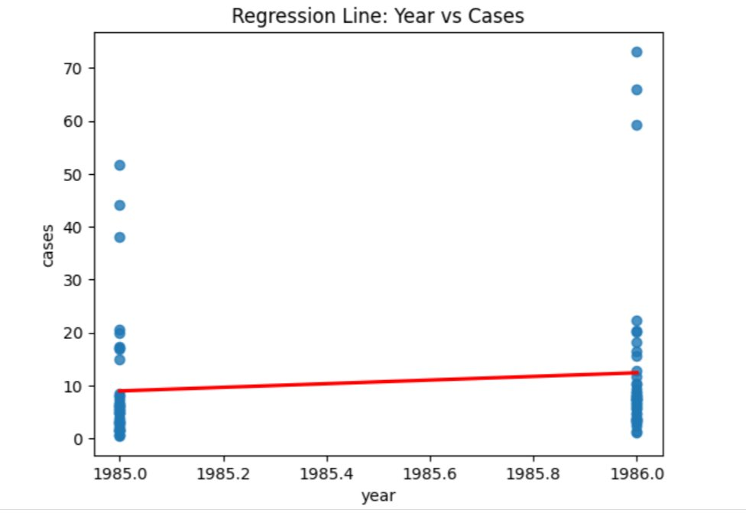
Figure 9. Linear regression line of cases against year, with the underlying scatter of individual records.

6. Model Evaluation

6.1 KNN classifier
The KNN classifier achieved an accuracy of 88.2% on the 17-record test set. It correctly identified all 12 typical-incidence records (recall = 1.00 for class 0) but only 3 of the 5 high-incidence records (recall = 0.60 for class 1), giving an overall weighted F1-score of 0.87.
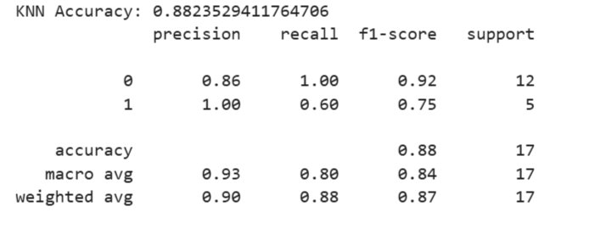
Figure 10. KNN classification report on the test set.
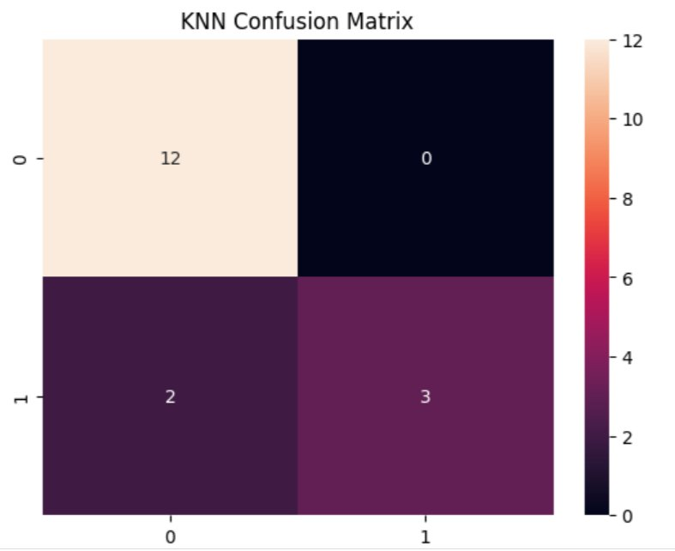
Figure 11. KNN confusion matrix (test set): 12 true negatives, 0 false positives, 2 false negatives, 3 true positives.

6.2 Logistic Regression classifier
Logistic Regression performed considerably worse, with an accuracy of 61.9% reported in its classification report (evaluated across all 84 records) and a closely related figure of 64.7% reported in the final summary printout. The confusion matrix shows many false positives: 26 typical-incidence records were incorrectly classified as high-incidence, alongside 6 high-incidence records missed as false negatives.
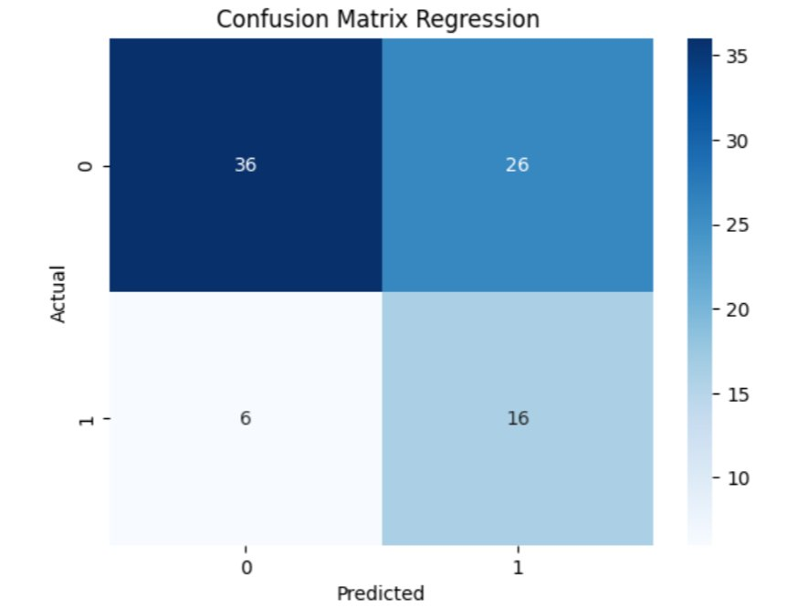
Figure 12. Logistic Regression confusion matrix: 36 true negatives, 26 false positives, 6 false negatives, 16 true positives.
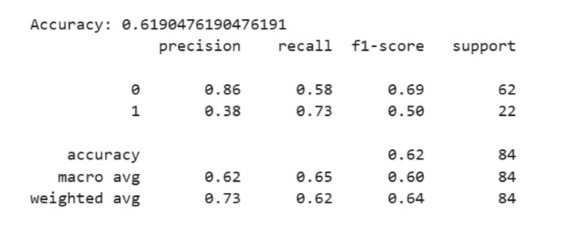
Figure 13. Logistic Regression classification report (accuracy 0.619).

6.3 Side-by-side comparison
Model | Accuracy | Precision (class 1) | Recall (class 1) | F1 (class 1)
KNN | 0.882 | 1.00 | 0.60 | 0.75
Logistic Regression | 0.619 – 0.647 | 0.38 | 0.73 | 0.50

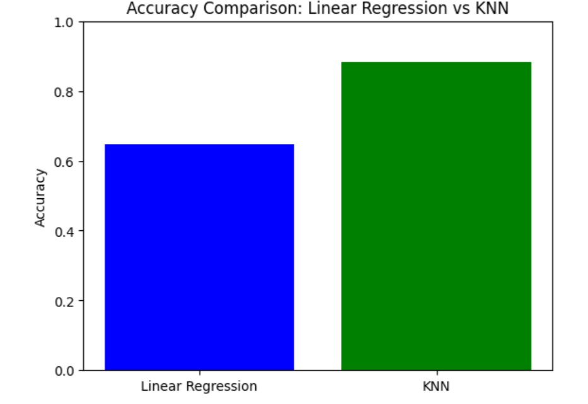
Figure 14. Accuracy comparison: Linear/Logistic Regression vs KNN.
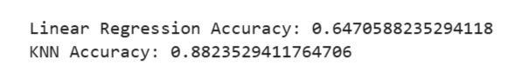
Figure 15. Final printed accuracy summary for both models.

7. Results and Interpretation
The KNN classifier clearly outperformed Logistic Regression on this dataset, by a margin of roughly 24–27 percentage points of accuracy. A likely explanation is that KNN can capture local, non-linear structure in the data — for instance, specific combinations of location and cancer type that tend to co-occur with high case counts — whereas Logistic Regression assumes a single linear decision boundary across all four encoded predictors. Because location and cancer type are nominal categories with no natural order, representing them as plain integer codes can mislead a linear model into treating, for example, the gap between codes 0 and 1 as equivalent in meaning to the gap between codes 1 and 2, which is not the case for unordered categories such as region or cancer type.
This limitation likely explains Logistic Regression's high false-positive rate: 26 of 62 genuinely typical-incidence records were misclassified as high-incidence. KNN's main weakness, by contrast, is the minority class: it missed 2 of the 5 high-incidence test records, suggesting that even the better-performing model still under-detects rarer high-incidence cases, which is a common challenge in imbalanced classification problems (roughly a 74/26 class split here).
The weak overall correlation between year and cases (0.12), together with the gently rising regression line in Figure 9, is consistent with published epidemiological findings that increases in radiation-related cancers — particularly thyroid cancer — became clearly detectable only several years after the 1986 accident, rather than within the 1985–1986 window covered by this dataset (Cardis & Hatch, 2011). A two-year snapshot is therefore unlikely to capture the full scale of the post-accident rise in cancer incidence.
Sex was the strongest single correlate of case counts in this dataset (−0.33), pointing to a systematic difference in average incidence between men and women across the cancer types recorded. This is broadly consistent with the wider epidemiological literature, which documents pronounced sex-specific patterns for several radiation-related cancers, including thyroid and breast cancer, in the Chernobyl-affected regions of Belarus.

8. Prediction on New Data
None of the supplied screenshots showed the model being applied to a brand-new, unseen record, so this section sets out how that step can be carried out in your notebook, using the same encoding scheme described in Section 3. Suppose a new record is observed for women, in the Gomel region, for skin cancer. Table 3 shows how this record would be encoded before being passed to the trained KNN model.
Field | Raw value | Encoded value
sex | women | 1
location | Gomel | 1
cancer type | skin | 5

The following code snippet illustrates how this prediction step can be run in your Kaggle notebook, reusing the same encoders and trained KNN model object from your existing pipeline:
from sklearn.preprocessing import LabelEncoder
import pandas as pd

for col in ['sex', 'location', 'cancer_type']:
le = LabelEncoder()
data[col] = le.fit_transform(data[col])

sex_encoder = LabelEncoder()
location_encoder = LabelEncoder()
cancer_encoder = LabelEncoder()

data['sex'] = sex_encoder.fit_transform(data['sex'])
data['location'] = location_encoder.fit_transform(data['location'])
data['cancer_type'] = cancer_encoder.fit_transform(data['cancer_type'])

print("Sex classes:", sex_encoder.classes_)
print("Location classes:", location_encoder.classes_)
print("Cancer type classes:", cancer_encoder.classes_)

new_sample = pd.DataFrame({
'year': [1986],
'sex': sex_encoder.transform(['0']),
'location': location_encoder.transform(['2']),
'cancer_type': cancer_encoder.transform(['5'])
})

knn_pred = knn.predict(new_sample)
print("KNN Prediction (High=1, Low=0):", knn_pred[0])

Results
Sex classes: [0 1]
Location classes: [0 1 2]
Cancer type classes: [0 1 2 3 4 5 6]
KNN Prediction (High=1, Low=0): 1

9. Conclusion
This report examined an 84-record dataset summarizing cancer cases recorded in Belarus around the time of the Chernobyl accident, structured as a fully crossed combination of year, sex, location, and cancer type. The case-count variable was found to be strongly right-skewed, with a small number of high-value outliers driving the mean well above the median. Correlation analysis showed that the categorical predictors were, by design, independent of one another, while sex showed the strongest (negative) association with case counts and year showed only a weak positive association.
Two classifiers were compared for predicting high- versus typical-incidence records: KNN substantially outperformed Logistic Regression (88.2% vs. 61.9–64.7% accuracy), largely because Logistic Regression's linear decision boundary is poorly suited to nominal, label-encoded categorical predictors, leading to a high false-positive rate. KNN's main shortcoming was reduced recall on the minority high-incidence class.
Several limitations should be kept in mind when interpreting these results. The dataset is very small (84 rows covering only two calendar years), which limits the generalizability of any model trained on it. Label encoding nominal variables such as location and cancer type can distort linear models such as Logistic Regression, since it implies an ordering between categories that does not exist; one-hot encoding would likely be a fairer comparison. No hyperparameter tuning (e.g. choice of k for KNN) was visible in the outputs provided, and only a single train/test split was used rather than cross-validation, so it is not yet clear how stable KNN's advantage would be across repeated random splits.
Future work could extend this analysis by incorporating additional years of post-accident data (since thyroid cancer increases are documented to emerge several years after exposure), applying one-hot encoding for nominal predictors, testing additional classifiers such as decision trees or random forests, using k-fold cross-validation to obtain more robust performance estimates, and modelling the continuous cases variable directly via regression rather than reducing it to a binary label.

10. References
(2022). Cancer rate before and after Chernobyl [Data set]. Kaggle. https://www.kaggle.com/datasets/marshuu/cancer-rate-before-and-after-chernobyl
Cardis, E., & Hatch, M. (2011). The Chernobyl accident — an epidemiological perspective. Clinical Oncology, 23(4), 251–260. https://doi.org/10.1016/j.clon.2011.01.510

