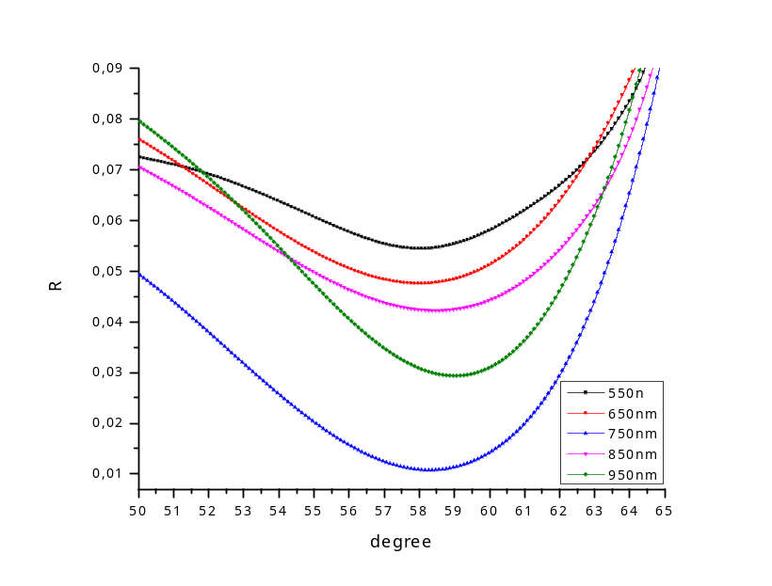

λ, nm | 550 | 650 | 750 | 850 | 950
degree | 58.1 | 58 | 58.3 | 58.6 | 59.2
n

