Máximo sequence: Mo/Zn (190 nm)/Cu (150 nm)7 Sn (210 nm).

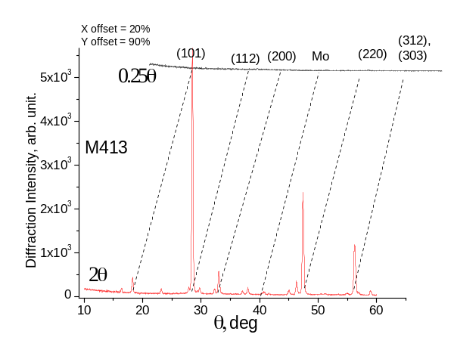 | 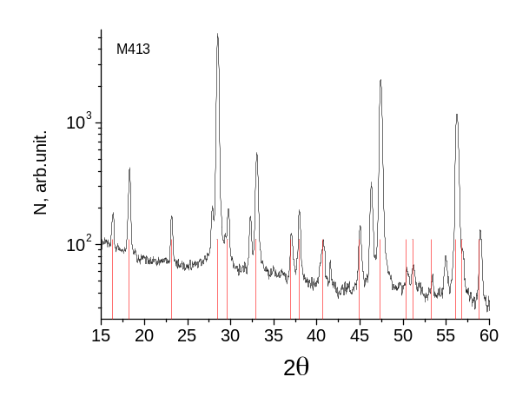
 | P. Bonazzi tabulated spectrum of Cu2ZnSnS4
550 C, 30 min, 50 mbar Ar, 50 mg S, 20C/min

 |  |  |  |  |  | Required ratio
 |  |  |  |  | 2 | 2 | 1 | 1
N | Cu,c(%atm) | Zn,c(%atm) | Sn,c(%atm) | S,c(%atm) | Cu/Zn | Cu/Sn | Zn/Sn | Cu/(Zn+Sn)
1 | 24.12 | 13.69 | 11.43 | 50.75 | 1.76 | 2.11 | 1.20 | 0.96
2 | 26.62 | 12.08 | 10.84 | 50.47 | 2.20 | 2.46 | 1.11 | 1.16
3 | 25.48 | 12.62 | 11.31 | 50.59 | 2.02 | 2.25 | 1.12 | 1.06
Average | 25.40 | 12.80 | 11.19 | 50.60 | 1.98 | 2.27 | 1.14 | 1.06

XRD References:

Paola Bonazzi, Luca Bindi, Gian Piero Bernardini and Silvio Menchetti. A model for the mechanism of incorporation of Cu, Fe and Zn in the stannite – kësterite series, Cu2FeSnS4 – Cu2ZnSnS4. The Canadian Mineralogist. vol. 41, pp. 639-647 (2003).

Swanson, Fuyat. ZnS (cubic) Natl. Bur. Stand. (U.S.), Circ. 539 II 51 (1953).

Evans, H. T. Jr., and McKnight, E. T. New wurtzite poly-types from Joplin, Missouri: Am. Mineralogist, v. 44, p. 1210-1218. (1959).

CIF Information Card from Crystallography Open Database followed link http://www.crystallography.net/result.php?journal=American+Mineralogist

Kesterite (Cu2ZnSnS4) belong to tetragonal system and space group is 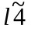.

The lattice parameters of CZTS films determined from the observed d(112) and d(220) spacings are a = and c = nm.

