Electro-optical spectroscopy of tetragonal kesterite Cu₂ZnSnS₄ thin films

M. Semenenko^{1*}, I.S. Babichuk^{1,2}, R. Caballero³, M. Leon³, M. Stetsenko¹, I. Stepukh^{1,4},
K.O. Semenenko⁵, A. Sarikov¹
¹ V.Ye. Lashkaryov Institute of Semiconductor Physics of the NAS of Ukraine, 03680, Kyiv, Ukraine
² Faculty of Intelligent Manufacturing, Wuyi University, 529020, Jiangmen, P.R. China
³ Universidad Autónoma de Madrid, Departamento de Física Aplicada, 28049, Madrid, Spain
⁴Taras Shevchenko National University of Kyiv, Faculty of Radio Physics, Electronics and Computer Systems 03127, Kyiv, Hlushkova Avenue, 4g

⁵Kyiv National University of Construction and Architecture Faculty of Automation and Information Technology, 03037, Kyiv, Povitroflotsky Avenue, 31

*E-mail: semandko@gmail.com
ABSTRACT
This paper reports the room-temperature electroreflectance modulated spectra of quaternary solid solution of sulfurized multilayered metals precursors in kesterite (Cu₂ZnSnS₄) tetragonal composition as measured by electrolyte technique. The analysis of electroreflectance spectra converted by dispersion integrals is shown to be in quantitative agreement with the third derivative of the linear dielectric function measured by high-resolution specular reflectance modulation techniques. It was shown that the direct verification of optical functions can be realized by reflectivity or absorbance techniques. It was demonstrated the possibility to estimate concentration of electrons in the conduction band, plasma frequency of electrons, energies of direct optical transitions corresponding to the critical points of the Brillouin zone as well as values of effective masses of electrons. It was done under assumption that direct or numerical modulated spectra could be reconstructed by Lorentzian functions based on Drude model of electrical conductivity.
Keywords: kesterite, CZTS, electroreflectance, modulation technique, Raman
1. Introduction
Last decade next generation thin film photovoltaics were successfully developed [1]. Actually that, they can be design on flexible cost effective wafers as well as in production various technique are involved. In order to succeed at the market in the long term, they may need to achieve conversion efficiencies of beyond empirical turn-on level of 15%, and contain non-toxic, solely abundant and human benign materials. Reviews [2, 3] give information that Cu₂ZnSnS₄ (CZTS) namely kesterite based solar cell technology is currently maybe the most promising approach in order to meet these requirements in the near future. This possible due to its direct energy band that can be manipulated by replacement of components such as S-Se-Te, Zn-Ge to get value within the range from 1.1 eV to 1.5 eV and increase/decrease carrier nobilities. The other important factors for potential usage of CZTS in solar energy are widespread in the crust of the constituent elements and their sustainability in manufacturing processes. For the short term studies of CZTS solar cells their efficiency has reached a level of about 12.6% by hydrazine processes [4]. Despite the best demonstrated the usage of the extremely toxic solution limits its investments in production of solar cell. Moreover, a solar cell fabricated with the kesterite thin film absorbers without stoichiometry exhibits power conversion efficiency that practically does not depend on the choice of technology. Thus, band structure should be investigated more thoroughly by use of convenient techniques.
Оптичні методи дослідження, як неруйнівні методи для даної мети виглядають найбільш привабливими. Зазвичай досліджуються спектри оптичного відбиття в діапазоні довжин хвиль, який викликає підвищений інтерес для подальшого перетворення спектрів по методиці аналізу Крамерса-Кроніга для отримання оптичних констант. Модуляційні методи дослідження оптичних властивостей матеріалів дають змогу в повній мірі визначати особливості зонної структури. Оптичні константи та їхні функціональні залежності також можна отримати інтерфометрією, методом призм, багатокутовою рефлексометрією, методикою псевдо кута Брюстера, а також еліпсометрією. Основи підходу оптичних вимірювань тонких плівок та кристалів представлені в роботі [vina1984: L. Vina, S. Logothetidis, and M. Cardona. Temperature dependence of the dielectric function of germanium. Physical Review B, V30. 4, p.1979. 1984. Doi: https://doi.org/10.1103/PhysRevB.30.1979]
Для інтерпретації оптичної структури досліджуваного матеріалу наразі відомі теоретичні розрахунки зонної структури та запропоновані декілька моделей опису функціональної залежності діелектричної функції. Із найбільш використовуваних підходів слід відмітити наступні: i) interband standard critical point model (SCP model); ii) the harmonic oscillator approximation (HOA model); iii) the model dielectric function (MDF); iv) the Forouhi-Bloomer (FB) model.
SCP model.
Підхід в данній моделі базується на описі діелектричної функції в околі сингулярності максимуму густини станів. Density of state near a normal critical point M0, M1, M2 was theoretically described firstly in [brust1964: D. Brust. Electronic spectra of crystalline germanium and silicon. Physical Review. V134, 5A, A1337, 1964. Doi: https://doi.org/10.1103/PhysRev.134.A1337]. В роботі [D.E. Aspnes, P. Handler, D. F. Blossey. Interband Dielectric Properties of solid in electric field. Physical Review. V166, 3, p. 921. 1968. Doi: https://doi.org/10.1103/PhysRev.166.921] також розглядається SCP модель функціональної залежності діелектричної функції та дискутується анізотропія оптичних властивостей в околі критичних точок. Моделювання спектрів діелектричної функції в рамках SCP моделі проводилося в роботах [P. Lautenschlager, M. Garriga, L. Vina, M. Cardona. Temperature dependence of the dielectric function and interband critical point in silicon. Physical Review B. V36, 9, p. 4821, 1987. Doi: https://doi.org/10.1103/PhysRevB.36.4821, A. Savitzky, M. Golay. Smoothing and differentiation of data by simplified least squares procedures. Analytical Chemisry. V36, 8. p. 1627, 1964. Doi: https://doi.org/10.1021/ac60214a047]. Модель критичноі точки до теперішнього часу широко використовується при моделюванні діелектричної функції, якщо планується проводитися аналіз зонної структури матеріалу. A line-shape analysis with standard SCP model approach was employed mainly to study the interband transition. Plots of pseudo-dielectric functions and their corresponding second derivative lines generally are demonstrated in Refs. [A. Mendoza-Galván, M. Rybka, K. Järrendahl, H. Arwin, M. Magnuson, L. Hultman, M. W. Barsoum. Spectroscopic ellipsometry study on the dielectric function of bulk Ti2AlN, Ti2AlC, Nb2AlC, (Ti0.5,Nb0.5)2AlC, and Ti3GeC2 MAX-phases JOURNAL OF APPLIED PHYSICS 109, 013530 (2011). Doi: http://dx.doi.org/10.1063/1.3525648, Shunji Ozaki, Toru Namba. Optical properties and electronic band structure of Cu2ZnSnSe4 kesterite semiconductor. Phys. Status Solidi C 9, No. 12, 2403–2406 (2012). DOI: https://doi.org/10.1002/pssc.201200203, G. Gurieva, S. Levcenko, S. Schorr, M. León, R. Serna, A. Nateprov, E. Arushanov. Characterization of Cu2SnSe3 by spectroscopic ellipsometry. Thin Solid Films 535 (2013) 384–386. doi: https://doi.org/10.1016/j.tsf.2012.11.104, Younghun Hwang and Youngho Um. Dielectric Function of the Ferromagnetic Semiconductor CdMnCrTe Studied by Using Spectroscopic Ellipsometry. Journal of the Korean Physical Society, Vol. 65, No. 10, November 2014, pp. 1687-1690. doi: https://doi.org/10.3938/jkps.65.1687, Zhihua Duan, Kai Jiang, Zhigao Hu, Junxia Wang, Genshui Wang, Xianlin Dong, Feifei Wang. Dielectric functions and phase transitions of MgO modified Pb0.99(Zr0.95Ti0.05)0.98Nb0.02O3 ceramics revealed by spectroscopic ellipsometry. Materials Letters V. 244, 2019, pp. 18-21. doi: https://doi.org/10.1016/j.matlet.2019.02.037]. The line shapes of derivative of dielectric function with respect to frequency of electrons and band broadening factor (positive Lorentzian broadening) for the four types of three-dimensional critical points well described in [E. Matatagui, A.G. Thompson, and Manuel Cardona. Thermoreflectance in semiconductors. Physical Review V. 176, 3. P. 176. 1968. https://doi.org/10.1103/PhysRev.176.950].
HOA model.
В основі the HOA model лежить опис поведінки вільних електронів яку можна представити класичною формулою Drude. В рамках даної моделі кожна спектральна лінія представляється як резонанс гармонічного осцилятора розширений затуханням випромінювання. In the region where the oscillator strengths for the optical transitions are mostly exhausted, the dielectric function depends on the plasma frequency of the valence electron, average collision time and their density. В наближенні припускається, що валентні електрони ведуть себе як не звязані частинки. Дану модель використовують в області вище плазмової частоти. Плазмова область ідентифікується на оптичних спектрах, як макимум кривої the characteristic energy function [-Im(1/ε)] calculated from the Kramers-Kronig analysis of the reflection [H.R. Philipp, H. Ehrenreich. Optical properties of semiconductors. Physical Review. V129, 4, P.1550. 1963. Doi: https://doi.org/10.1103/PhysRev.129.1550, I. V. Bodnar;I. A. Victorov;A. G. Karosa;E. K. Arushanov S. Levcenko Polarized infrared reflectivity of Cu2CdSnS4 single crystals Appl. Phys. Lett. 117, 182102 (2020) doi: https://doiorg/10.1063/5.0024482]. Взявши за основу HOA модель автори часто проводять аналіз електричних властивостей структур, а саме визначення питомого електричного опору [A. Mendoza-Galvan, M. Rybka, K. Jarrendahl, H. Arwin, M. Magnuson, L. Hultman, M.W. Barsoum. Spectroscopic ellipsometry study on the dielectric function of bulk Ti2AlN, Ti2AlC, Nb2AlC, (Ti0.5,Nb0.5)2AlC, and Ti3GeC2 MAX-phases. Journal of applied physics, 109. 013530. 2011. Doi: https://doi.org/10.1063/1.3525648].
В даній роботі було прийняте рішення не використовувати FB модель так як підхід передбачає початкові вимірювання спектрів пропускання, що інколи буває не можливо для багатошарових структур, або плівок нанесених на не прозорих підкладках.

MDF model.
У роботах [S. Adachi. Model dielectric constants of GaP, GaAs, Gasb, InP, InAs, and Insb. Physical Review B. V 35, 14 1987. Doi: https://doi.org/10.1103/PhysRevB.35.7454, S. Adachi, H. Mori, and S. Ozaki Model dielectric function for amorphous semiconductors PHYSICAL REVIEW B 66, 153201 2002. Doi: 10.1103/PhysRevB.66.153201] S. Adachi запропонував модель, названу як модель діелектричної функції MDF для розрахунку оптичних констант кристалічних напівпровідників. Так само як SCP модель підхід передбачає опис оптичної взаємодії напівпровідників з фотонами падаючого світла з використанням різних механізмів дисперсії. Дана модель знайшла своє використання для опису inter-valence band transition, indirect-gap transition, а також для детального аналізу оптичних переходів Cu2ZnSnSe4(S4) bulk crystals [M. León, S. Levcenko, R. Serna, I. V. Bodnar, A. Nateprov, M. Guc, G. Gurieva, N. Lopez, J. M. Merino, R. Caballero, S. Schorr, A. Perez-Rodriguez, and E. Arushanov. Spectroscopic ellipsometry study of Cu2ZnSnSe4 bulk crystals. Applied Physics Letters 105, 061909 (2014); doi: 10.1063/1.4892548, S. Levcenko, E. Hajdeu-Chicarosh, E. Garcia-Llamas, R. Caballero, R. Serna, I. V. Bodnar, I. A. Victorov, M. Guc, J. M. Merino, A. Pérez-Rodriguez, E. Arushanov, and M. León. Spectroscopic ellipsometry study of Cu2ZnSnS4 bulk poly-crystals. Appl. Phys. Lett. 112, 161901 (2018); doi: 10.1063/1.5024683]. В недавній роботі автори порівнювали переваги підходів до обчислень різних моделей, а саме SCP and MDF [J. I. Larruquert, L. V. Rodriguez DE Mmarcos. Why is the Adachi procedure successful to avoid divergences in optical models? Optics Express. V28, 19. pp. 28548-28562. 2020. Doi: https://doi.org/10.1364/OE.402079]. Також порівняння та обчислення діелектричної функції з використанням одночасно різних моделей часто використовується [Mariano Campoy-Quiles, Jenny Nelson, and Donal D. C. Bradley. Dimensionality of electronic excitations in organic semiconductors: A dielectric function approach. PHYSICAL REVIEW B 76, 235206 (2007). doi: https://doi.org/10.1103/PhysRevB.76.235206, S. Adachi, T. Kimura, N. Suzuki. Optical properties of CdTe: Experiment and modeling. Journal of applied physics. 74, 3435. 1993: doi: http://dx.doi.org/10.1063/1.354543].

In this work an electro-reflection modulation (ERM) and SCP, HOA modelling of dielectric function of tetragonal kesterite thin films light absorbers are discussed. The samples for investigation were prepared by using a two-step process, the sulfurization of metallic precursors after direct current (DC)-magnetron sputtering. The ﬁlms were characterized in detail by using scanning electron microscopy (SEM), Energy Dispersive X-ray spectroscopy (EDX), X-ray diffraction (XRD), Raman spectroscopy, Bruster technique.

2. Experimental details
Pure metal multi-layered structures were grown by DC-magnetron sputtering of four targets by use of Continuous Operation Line Deposition System. There are possible to deposit structures layer by layer in various stacks ordering when the exposure ratios between each target are change widely at the maximum size of substrate for processes was 40×40 cm². Targets for magnetron were made from pure metals with following levels of chemical impurities: Mo (99.76 %), Zn (99.96 %), Sn (99.999 %), Cu (99.99 %), that were controlled by Low de-charged Element GD mass-spectrometer. The thicknesses of layers were measured by optical micro-interferometer and profilometer with accuracy of 5 nm. Stack ordering was variated widely and the best results were occurred with respected to the series: Mo/Zn (190 nm)/Cu (150 nm)/Sn(340 nm). Sulfurization were performed during 30 min in argon ambient at various pressure and temperature 550°С using pure sulphur powder. Different pressure and heating rate ranging in 5-20 °C/min were used for the thermal treatments and the samples were cooled down naturally after the treatment. The thickness of the kesterite thin films was fixed to 1-1.5 μm.
The composition and maps for bulk compounds and thin films were measured by Energy Dispersive X-ray spectroscopy (Oxford and Zeiss instruments INCA x-sight) that built inside a Hitachi S-3000N and Zeiss Sigma 500 scanning electron microscope. EDX measurements were carried out at 20 kV operating voltage. The Cu K, Zn K, Sn L and S K lines were used for quantification. SEM was used to study the morphology of the surface of CZTS/Mo/glass structure as well as cross sections were studied by use a Zeiss Sigma 500 SEM at 15 kV operating voltage.
The phases forming during processes were studied using Grazing Incidence X-ray diffraction (GIXRD) spectroscope. GIXRD data were collected with a PANalytical X'Pert Pro multi-purpose diffractometer using Cu Kα radiation (λ = 1.54056 Å) and a multilayer mirror. Detector scans with incident angles of 0.25°, 2° and 4° were performed, and in addition, XRD measurements using the Bragg Brentano configuration were carried out.
A HORIBA Jobin Yvon T64000 spectrometer was employed for Raman spectroscopy in the backscattering configuration with 514.5 nm excitations wavelength by Ar⁺ laser. The laser radiation was focused on sample with a 50x objective of a confocal Olympus microscope to a spot of ~1 µm in diameter. The power density of laser irradiation did not exceed ~10⁶ W/cm² to avoid changes in the film structure during the measurements, as was confirmed earlier [5-7]. Due to the presence of non-uniformities onto the surface, that visible in microscope, Raman spectra were measured in different areas of each sample to obtain average. The mismatches in peak positions and half-width were less than 5%, therefore all spectra were integrated.
Normal incidence reflection spectra were obtained using a Cary 5000 UV-Vis-NIR double beam spectrophotometer.

Brewster technique was applied by using modulation-polarization spectroscopy. A halogen quartz tube was used as a source of incidence beam. Single beam double dispersion prism type monochromator MDR-4 selected the spectral component in the wavelength of interest. Franck Ritter polarizer was used for the polarization of the incidence beams. The polarization modulation was obtained by means of a photo-elastic polarization modulator and a quarter-wave phase plate. Finally, a Si photo-detector was used to acquire the light intensities which were then processed by a lock-in amplifier operated by modulation frequency (f = 60 kHz). The samples were analysed by varying the incident angle and wavelength, while maintaining all the other parameters constant, such as intensity and frequency [8].
The convenient electrolyte method was applied to the measurements of ERM spectra following [9]. A cell was equipped with quartz window and all results were collected at room temperature. The top side of the sample was connected to a positive electrode by silver wire and GaIn eutectic alloy to obtain ohmic contacts. The samples were fixed onto the holder and isolated with wax. A negative biased Pt electrode was placed facing the top surface of the sample dipped in the 0.1M KCl water solution. A modulation signal was applied by means of 1500 Hz, as well as ac signal was ranged from 1 to 1.5 V. The reflected light beams from the samples were focused on a photo-amplifier combined with a lock-in-amplifier and the detected signal was recorded as a function of frequency. The DC output, corresponded to R from the photomultiplier was carried out to automatic operated power supply acting on a logarithmic voltage divider which varies the high voltage applied to the photomultiplier. Under condition which fixes DC output during the measurement the ac output from the lock-in-amplifier is proportional to the ratio ΔR/R. Thus, the third derivative of real part of dielectric function was measured directly and adjusted to its equivalent by numerical differentiating of complex dielectric function. The analysis of ERM spectrum converted by Kramers-Kronig dispersing integrals gives the possibility to estimate concentration of electrons in the conduction band, plasma frequency of electrons, energies of direct optical transitions corresponding to the critical points of the Brillouin zone as well as values of effective masses of electrons. The obtained results contribute to the understanding the band structure of the kesterite materials and might be useful for further development of optoelectronic applications based on them due to its high resolution in contrast with spectral ellipsometry technique.

3. Results and discussion
3.1. Morphology, elemental and structural analysis of CZTS films
Fig. 1 shows morphological, elemental and structural analysis of a representative film. Figure 1a shows the SEM photo morphology of the CZTS film. It is seen that the surface has a uniform distribution on the surface of the micro granules with a size of from 0.5 to 2 μm. The insert (Fig. 1a) shows the morphology of the agglomeration of such granules with a size of several hundred nanometers. EDX mapping in the area of near this cluster shows a uniform distribution of elements (Fig. 1b-e), which allows us to argue about the formation of an ordered film.
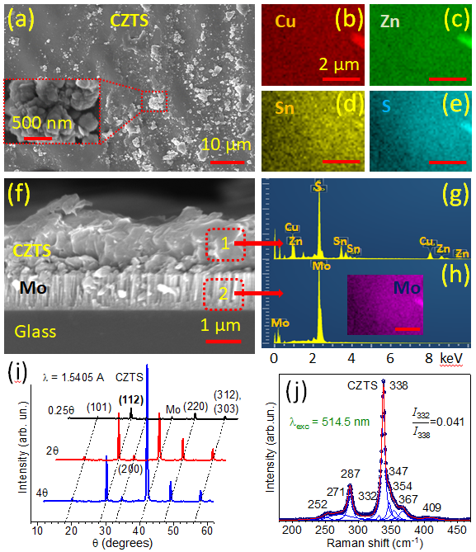
Fig. 1. Surface morphology (a), elements mapping (b-e) cross-section (f), the elements spectra detected at two layers (g, h), XRD (i) and Raman spectroscopy of the representative CZTS film.

Fig. 1f shows a cross-section of the film. A 1.5 μm CZTS film is clearly visible, which is formed after the sulfurization on a Mo-coated layer with a thickness of 1 μm on a glass substrate. Elemental analysis was performed from the respective cross-sectional areas, which allowed to clearly mark off each layer of CZTS/Mo/Glass with the corresponding EDX spectra (Fig. 1g,h). It can be seen from the spectrum that area (1) of CZTS includes all elements (Fig. 1g), and section (2) with the Mo layer, respectively, includes only Mo (Fig. 1h). Also, the insert Fig. 1h shows the distribution of Mo from the same area as for other elements of the CZTS film, which are shown in Fig. 1b-e. Elemental analysis of this representative film from these areas is shown in Table 1. At comparing the obtained data of elemental analysis in Table 1 with the stoichiometric composition of Cu: Zn: Sn: S = 2:1:1:4 = 25: 12.5: 12.5: 50 it is seen that the film is poor of Cu and Sn and at the same time rich in Zn and S [10]. This composition generally has a positive effect on the structure of the film, as the lack of Cu atoms can be compensated by Zn atoms, as they have commensurate atomic radii and placed are close to each other in the crystal lattice of kesterite [11, 12]. Moreover, the substitution of the Cu atom for the Zn atom is more likely due to the fact that the atomic radius of Zn⁺ is 0.72 Å, and Cu⁺ - 0.94 Å [11, 12]. However, this leads to the appearance of anti-site defects of Zn_{Cu} and also V_{Cu} [14, 15]. Tin has a similar mechanism for healing point defects, but it is less likely. As for the enriched sulfur content, it has a positive effect on the formation of the CZTS film.
The structural characterization was carried out at room temperature by XRD and μ-Raman spectroscopy (Fig. 1i,j). Fig. 1i shows XRD for CZTS film with various angles of 0.25°, 2° and 4°. This allowed you to choose the optimal angle to get the best signal from the film rather than the substrate.
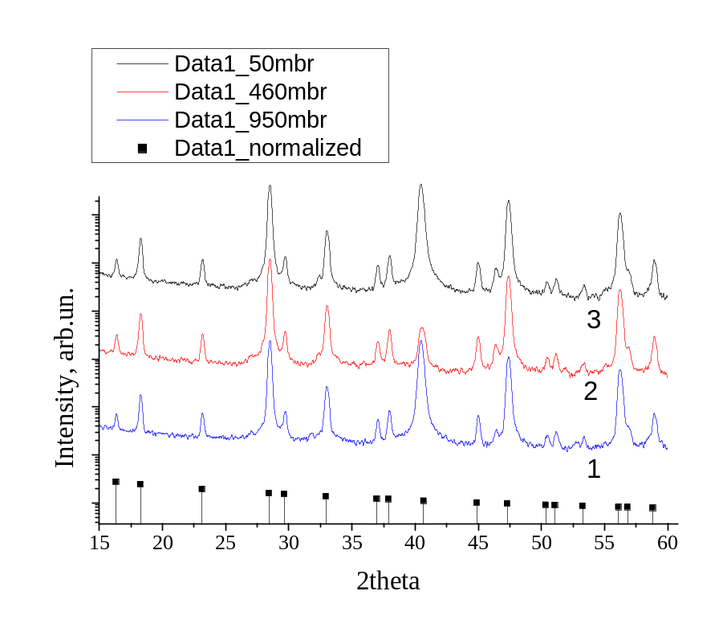

The intense peak positioned at 28° (112 plane) indicates the orientation of kesterite structure [16]. Other diffraction peaks, labeled in Fig. 1i, also correspond to CZTS kesterite structure that belongs to a tetragonal system according to JCPDS 26-0575 database. The intense peak at 41° can be attributed to the Mo layer [16]. A Full Width at Half Maximum (FWHM) of the main peak at 28° in representative CZTS film can be assessed and considered as an index of crystal quality. FWHM is 0.30° for this film. The crystallite size D in film can be calculated using the Scherrer’s equation [15]:
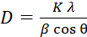, | (1)
where K = 0.9 is the shape factor, λ = 1.54056 Å is the wavelength of X-rays exploited, β is the FWHM in radians, and θ is the Bragg angle of diffraction. Therefore, the size of the crystallite with an orientation of 112 plane in the film is 33 ±3 nm. This good agreement with the literature data for high-quality films [16]. The same calculations can be performed for all other planes.
Fig. 1j shows the Raman spectrum measured from the Cu₂ZnSnS₄ sample, together with the fitting of the peaks with Lorentzian curves. The spectrum shows two dominant peaks at 287 cm⁻¹ and 338 cm⁻¹, which correspond to the vibrations of S atom surrounded by motionless neighbouring atoms that are identified as A symmetry modes of the kesterite structure (space group 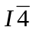). In addition, the spectrum also shows weaker contributions at 252, 271, 332, 347, 354 and 367 cm⁻¹, which are attributed to E and B symmetry modes [18-20]. The peak at 409 cm⁻¹ in the spectrum (Fig. 1j) corresponds to MoS₂ which is obviously formed at the Mo/CZTS interface [21]. From the fitting of experimental Raman spectrum by a set of Lorentzian components we can conclude that at the low-frequency side of the most intense band (338 cm⁻¹) a weaker component at about 332 cm⁻¹ is observed (Fig.1j). Most probably this Raman band is related with disorder of Zn and Cu atoms in CZTS lattice, as was proposed in [22]. This disorder is often caused by so-called anti-sites defects, such as Zn atoms on the place of Cu (Cu_{Zn}) and visa versa (Zn_{Cu}). The effect of this phase on the Raman spectra of kesterite is detailed in [23].
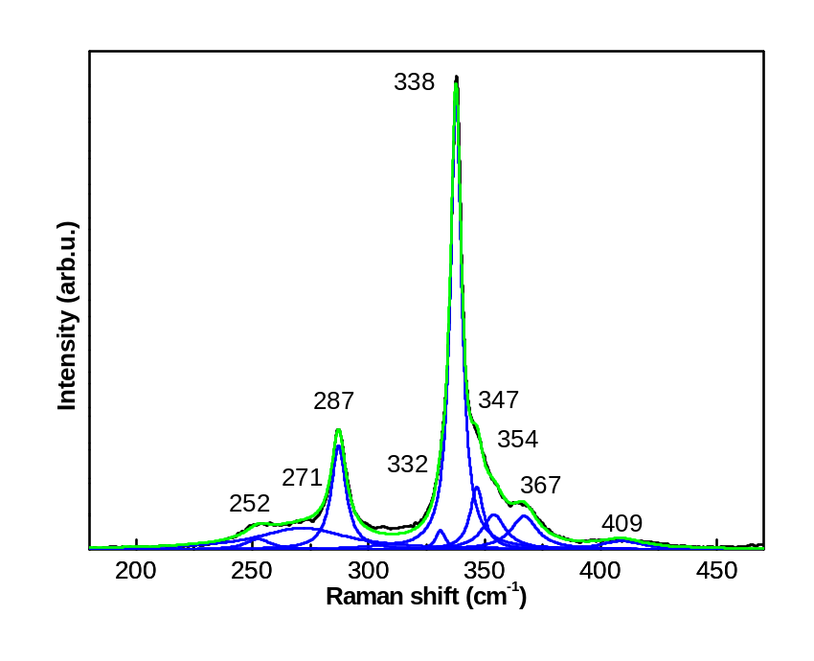

The degree of disorder of the kesterite structure can be estimated from the Raman spectra based on the intensity ratio of the peak at 332 cm⁻¹ to that of the peak 338 cm⁻¹, I₃₃₂/I₃₃₈. It turned out that of all the investigated samples, the smallest I₃₃₂/I₃₃₈ value was measured for sample A38 (0,041). This also has good agreement with the literature data for high-quality films [23].
Thus, qualitative films were obtained, which is confirmed by high-quality measurements and consistent with the literature data.

3.2. Electroreflectance spectra

In order to determine the energy values of interband transitions from spectrum in weak applied electric field assumption and normal incidence of light, a standard fitting procedure was used solving the following third-derivative equation [Aspness, ] within only one critical point:
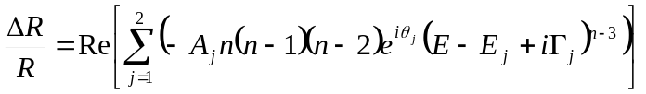, | (2)
where R is the reflection coefficient; ΔR is changes in the reflection; A_{j} is the amplitude of the transition; θ_{j} is the phase factor; E is the energy of photon; Е_{j} and Γ_{j} are the energy and the broadening parameter of j-th transition, respectively. The power index n refers to the type of density of states within the critical point (ellipsoid type M₀) in the Brillouin zone, where the optical transitions take place and we assume this parameter to n = 1/2 (3D critical point case). It should be noted which type of power index is preferably (3D, or exciton) because in case of excitonic transition the phase factor ≠ 0 and is corresponded with the case of Fano scattering.
The normal-incidence ERM spectra of kesterite shown in Fig. 1, 2. The peaks in the spectra are atributed to direct interband transitions followed band structure presented in Fig. 1, 2 at point in k space at which the combined density of states for optical transitions has a singularity.

3.3. Transformation procedures of ERM spectra into corresponding optical parameters

Thus, changes in corresponding functions (3), produced by modulation of the translation symmetry of crystal nearby surface electric field region, can be calculated from the ERM spectrum in a manner similar to that as used in analysing conventional reflection spectra:
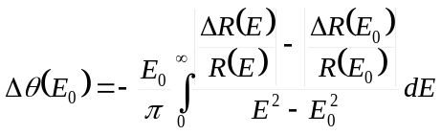. | (3)
It should be noted, that in case of automatic operated power supply the ratio ΔR/R is presented in logarithmic form. Because, during the measurements, the dc output corresponded to R is carried out to lock-in amplifier from the photomultiplier on a logarithmic voltage divider.
The absolute values in changes of components of complex dielectric function were calculated and are collected in eqs. (4) [Cardona 1964+ Rodriguez 2005]:
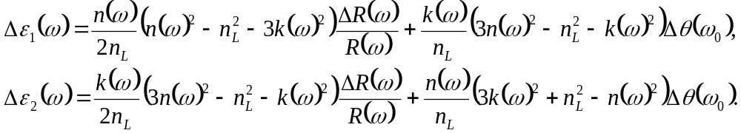 | (4a),  (4b)
These calculations require the knowledge of n and k these can be obtained, in general, from KK analysis of conventional reflection data or ellipsometric measurements, or Brusters technique.

Numerical integration meV results in present of absolute values of complex index [Mykola O. Semenenko, Ivan S. Babichuk, Oleksandr Kyriienko, Ivan V. Bodnar, Raquel Caballero and Maximo Leon. RF Electromagnetic Field Treatment of Tetragonal Kesterite CZTSSe Light Absorbers Nanoscale Research Letters (2017) 12:408.]:
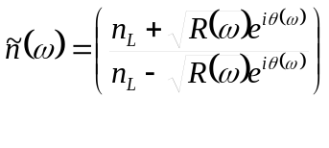,  ,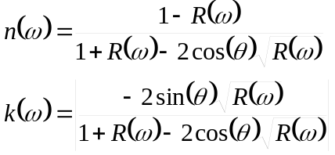. | ( )

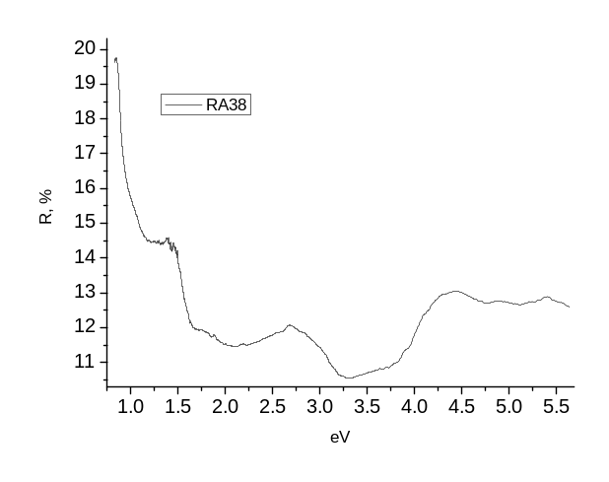
Shimadzu with integrating sphere

The normal incidence reflection spectra

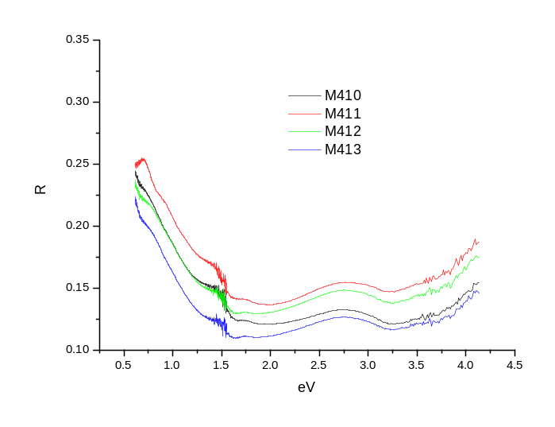
Fig. . Series of reflectance spectrum of kesterite thin film on Mo/Glass substrate

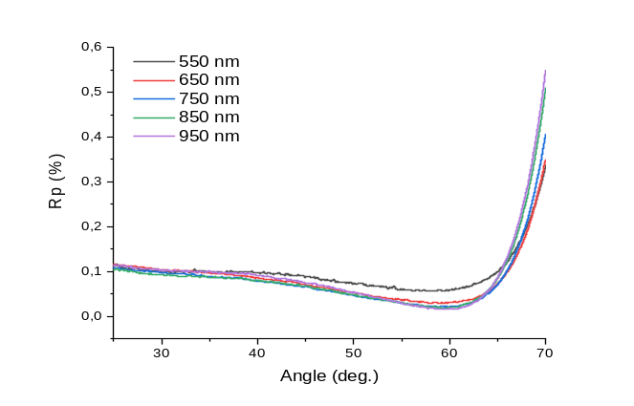
Fig. Reflectance curves of P-polarized beams depending on the angle of incidence.

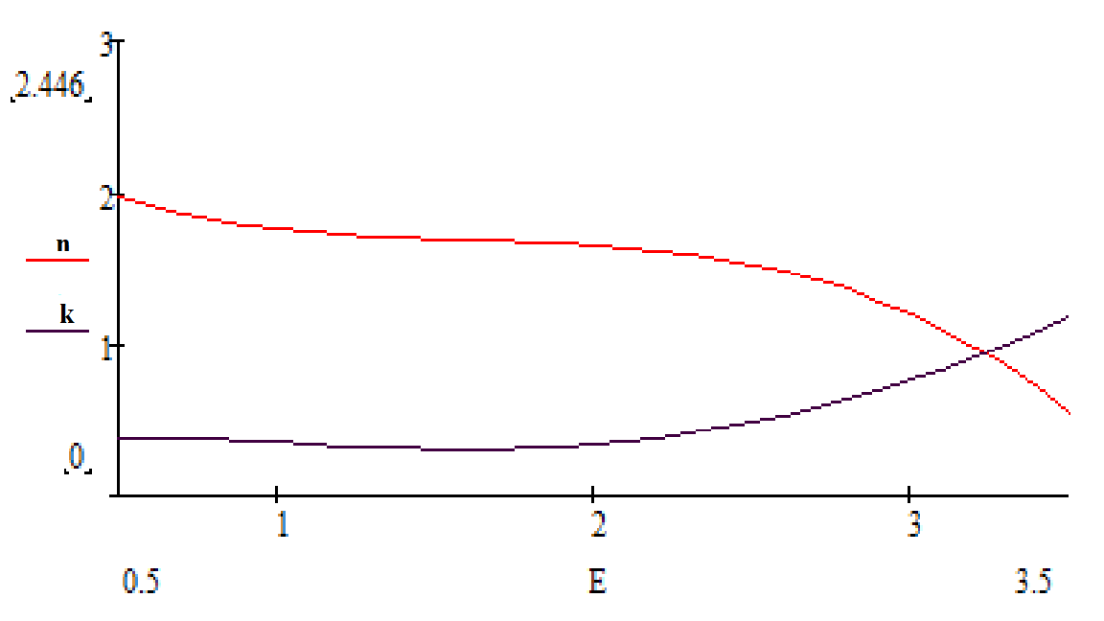
MathCad simulated dispersion curves

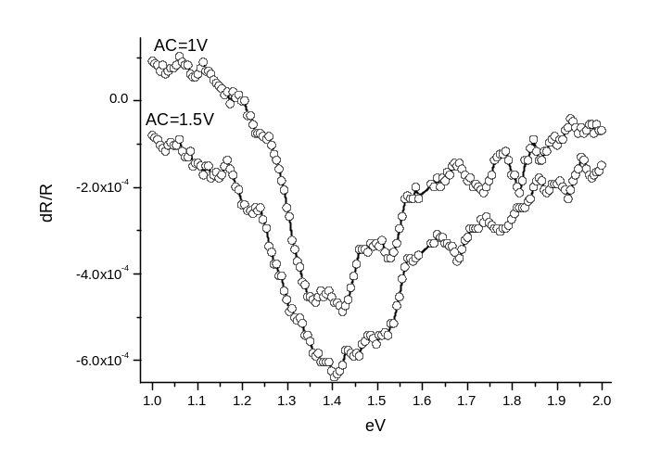 | 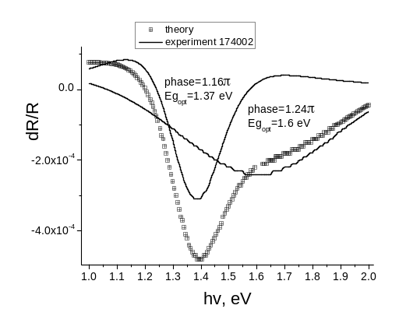
 | 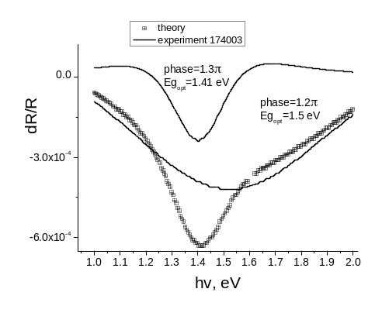
A38

4. Conclusion

It was found that the obtained films were of high quality, which is confirmed by various methods of characterization. Thus, from the Raman spectra it was found that the compound is formed in the structure of kesterite with two dominant bands of A-symmetry with frequencies of 287 and 338 cm⁻¹. It is shown that the relative intensity of the band with a frequency of 332 cm⁻¹, which refers to disordered kesterite, is quite small in relation to the literature data, which suggests a small concentration of anti-site and intrinsic structural defects in these samples. The smaller number of these structural defects has fewer effects on the bandgap of films.

5. References
[1] Abermann S. Non-vacuum processed next generation thin film photovoltaics: Towards marketable efficiency and production of CZTS based solar cells. Solar Energy 2013;94:37-70. https://doi.org/10.1016/j.solener.2013.04.017
[2] Pal K, Singh P, Bhaduri A, Thapa KB. Current challenges and future prospects for a highly efficient (>20%) kesterite CZTS solar cell: A review. Sol Energy Mater Sol Cells 2019;196:138-56. https://doi.org/10.1016/j.solmat.2019.03.001
[3] Giraldo S, Jehl Z, Placidi M, Izquierdo‐Roca V, Pérez-Rodríguez A, Saucedo E. Progress and Perspectives of Thin Film Kesterite Photovoltaic Technology: A Critical Review. Adv Mater 2019;31:1806692. https://doi.org/10.1002/adma.201806692
[4] Wang W, Winkler MT, Gunawan O, Gokmen T, Todorov TK, Zhu Y, et al. Device Characteristics of CZTSSe Thin-Film Solar Cells with 12.6% Efficiency. Adv Energy Mater 2014;4:1301465. https://doi.org/10.1002/aenm.201301465
[5] Semenenko M, Babichuk IS, Khatsevich I, Antonin S, Datsenko OI, Golovynskyi S, et al. Red-shifted photoluminescence and gamma irradiation stability of “micromorph” (nc-Si/SiO)/DLC down-converter anti-reflection coatings. Diam Relat Mater 2019;100:107578. https://doi.org/10.1016/j.diamond.2019.107578
[6] Brus VV, Ilashchuk MI, Orletskyi IG, Solovan MM, Parkhomenko GP, Babichuk IS, et al. Coupling between structural properties and charge transport in nano-crystalline and amorphous graphitic carbon films, deposited by electron-beam evaporation. Nanotechnology 2020;31:505706 (9pp). https://iopscience.iop.org/article/10.1088/1361-6528/abb5d4
[7] Brus VV, Maryanchuk PD, Ilashchuk MI, Rappich J, Babichuk IS, Kovalyuk ZD. Graphitic carbon/n-CdTe Schottky-type heterojunction solar cells prepared by electron-beam evaporation. Solar Energy 2015;112:78-84. https://doi.org/10.1016/j.solener.2014.11.023
[8] Pullano, S.A.; Rudenko, S.; Stetsenko, M.; Krishchenko, I.; Maksymenko, L.; Synyuk, V.; Fiorillo, A.S. Antireflection properties of composite zeolite gold nanoparticles film. Electron. Lett. 2018, 54, 370–372. https://doi.org/10.1049/el.2017.4647
[9] M. Semenenko, O. Kyriienko, O. Yilmazoglu, O. Steblova, and N. Klyui. Photo-assisted field emission and electro-reflectance modulation investigations of GaN nanorod arrays // Thin solid films 564, (2014) 218-221. https://doi.org/10.1016/j.tsf.2014.06.017

[8] Babichuk IS, Golovynskyi S, Caballero R, Gurieva G, Datsenko OI, Babichuk IV, et al. Thickness-dependent structural parameters of kesterite Cu2ZnSnSe4 thin films for solar cell absorbers. Mater Lett 2018;225:82-4. https://doi.org/10.1016/j.matlet.2018.04.109
[9] Kumar J, Ingole S. Optical phonons in pentanary compound (AgxCu1−x)2ZnSnS4 semiconductor: A raman study. J Alloys Compd 2021;865:158113. https://doi.org/10.1016/j.jallcom.2020.158113
[10] Valakh MY, Kolomys OF, Ponomaryov SS, Yukhymchuk VO, Babichuk IS, Izquierdo-Roca V, et al. Raman scattering and disorder effect in Cu2ZnSnS4. Phys Status Solidi RRL 2013;7:258-61. https://doi.org/10.1002/pssr.201307073
[11] Valakh MY, Dzhagan VM, Babichuk IS, Fontane X, Perez-Rodriquez A, Schorr S. Optically induced structural transformation in disordered kesterite Cu2ZnSnS4. JETP Lett 2013;98:255-8. https://doi.org/10.1134/S0021364013180136
[12] Grossberg M, Raadik T, Raudoja J, Krustok J. Photoluminescence study of defect clusters in Cu2ZnSnS4 polycrystals. Curr Appl Phys 2014;14:447-50. https://doi.org/10.1016/j.cap.2013.12.029
[13] Sheleg AU, Hurtavy VG, Mudryi AV, Valakh MY, Yukhymchuk VO, Babichuk IS, et al. Determination of the structural and optical characteristics of Cu2ZnSnS4 semiconductor thin films. Semiconductors 2014;48:1296-302. https://doi.org/10.1134/S1063782614100273
[14] Babichuk IS, Semenenko MO, Golovynskyi S, Caballero R, Datsenko OI, Babichuk IV, et al. Control of secondary phases and disorder degree in Cu2ZnSnS4 films by sulfurization at varied subatmospheric pressures. Sol Energy Mater Sol Cells 2019;200:109915. https://doi.org/10.1016/j.solmat.2019.109915
[15] Solovan MN, Mostovoi AI, Bilichuk SV, Pinna F, Kovalyuk TT, Brus VV, et al. Structural and optical properties of Cu2ZnSn(S,Se)4 films obtained by magnetron sputtering of a Cu2ZnSn alloy target. Phys Solid State 2017;59:1643-7. https://doi.org/10.1134/S1063783417080261
[16] Semenenko MO, Babichuk IS, Kyriienko O, Bodnar IV, Caballero R, Leon M. RF Electromagnetic Field Treatment of Tetragonal Kesterite CZTSSe Light Absorbers. Nanoscale Res Lett 2017;12:408-15. https://link.springer.com/article/10.1186/s11671-017-2183-9
[17] Babichuk IS, Yukhymchuk VO, Semenenko MO, Klyui NI, Caballero R, Hreshchuk OM, et al. Optical and morphological properties of tetragonal Cu2ZnSnS4 thin films grown from sulphide precursors at lower temperatures. SPQEO 2014;17:291-4. http://nbuv.gov.ua/UJRN/MSMW_2014_17_3_15
[18] Babichuk IS, Yukhymchuk VO, Dzhagan VM, Valakh MY, Leon M, Yanchuk IB, et al. Thin films of Cu2ZnSnS4 for solar cells: optical and structural properties. Funct Mater 2013;20:186-91. http://dx.doi.org/10.15407/fm20.02.186
[19] Babichuk IS, Semenenko MO, Caballero R, Datsenko OI, Golovynskyi S, Qiu R, et al. Raman mapping of MoS2 at Cu2ZnSnS4/Mo interface in thin film. Solar Energy 2020;205:154-60. https://doi.org/10.1016/j.solener.2020.05.043
[20] Fontané X, Izquierdo-Roca V, Saucedo E, Schorr S, Yukhymchuk VO, Valakh MY, et al. Vibrational properties of stannite and kesterite type compounds: Raman scattering analysis of Cu2(Fe,Zn)SnS4. J Alloys Compd 2012;539:190-4. https://doi.org/10.1016/j.jallcom.2012.06.042
[21] Caballero R, Garcia-Llamas E, Merino JM, Leon M, Babichuk I, Dzhagan V, et al. Non-stoichiometry effect and disorder in Cu2ZnSnS4 thin films obtained by flash evaporation: Raman scattering investigation. Acta Mater 2014;65:412-7. https://doi.org/10.1016/j.actamat.2013.11.010
List of tables

Table 1. Energy dispersive X-ray analysis of next layers ordering .
Sulfurization | Area | Cu  (at%) | Sn  (at%) | Zn  (at%) | S  (at%) | Mo  (at%) | Cu/Zn | Cu/Sn | Zn/Sn | Cu/(Sn+Zn)
Stoichiometric |  | 25 | 12.5 | 12.5 | 50 |  | 2 | 2 | 1 | 1
550º C, 30 min, 50 mbar Ar, 100 mg S | 1 | 21.37 | 11.54 | 14.19 | 52.90 | - | 1.51 | 1.85 | 1.23 | 0.83
 | 2 | - | - | - | - | 100

Table 3. Direct allowed optical transition within Brilluene zone.
 |  | E₀ | E₀+Δ₀ | E₁(1) | E₁(2) | E₁(1)+Δ₁ | E₁(2)+Δ₁ | E₀` | E₀`+Δ₀` | E₂ | E₂+δ | E₁`
CZTS | tabl
CZTS | meas

List of captions

Fig. 1. Surface morphology (a), elements mapping (b-e) cross-section (f), the elements spectra detected at two layers (g, h), XRD (i) and Raman spectroscopy of the representative CZTS film.

Fig. 1.

Fig. 1.

Fig. 1.

Fig. 3. ERM spectra with Lorentzian curves: a) ERM b) 0.5 mm; modulation 1V; PhEA-62; integration time τ=10 s; c) 0.5 mm; modulation 1.5V; PhEA-62; τ=10 s.

