The X-Ray Diffraction plots are shown in Figure 2. XRD measurements showed that the films crystallized in the kesterite structure. It was observed that this crystallinity improved as we moved towards higher temperatures. At 563 K, the films were found to be slightly amorphous. But at higher temperatures such as 613 K, the intensity of the peaks increased and the FWHM became narrower; evidently signifying the presence of better crystallites in the samples. At 663 K and 713 K, the samples showed a slight degradation in their crystallinity; although the peaks were discernable. It was inferred that the films were polycrystalline as there were two prominent phases; the (112) and the (220). The (112) peak was recorded at a Bragg. angle of 28.55o and the samples showed a preferred orientation along (112). The (112) peak improved at higher temperatures. The lattice parameters were found to be a = 0.54 nm and c = 1.085 nm. These are in good agreement with the single crystal data reported in literature [10]. The grain size in the layers was calculated using the Scherrer’s equation.



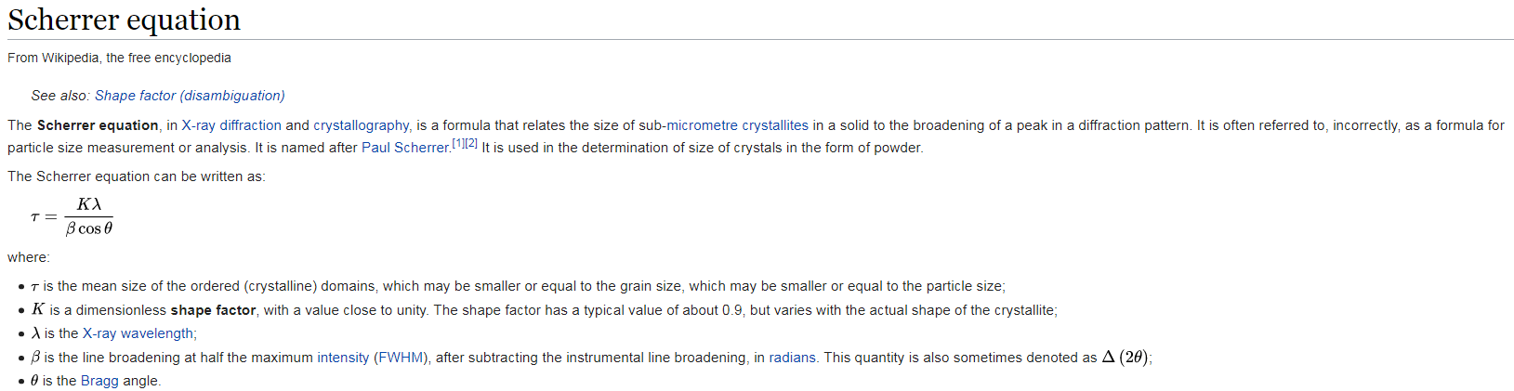

Where λ is the wavelength (1.5406 A) of the X-Ray used, β is the full width at half maximum of the peak and θ is the Bragg diffraction angle.