

4-WEEK-REPORT

Development of a Query-Based Scientific Literature Dataset Generation Pipeline for Automated Literature Review on Global warming

Submitted by:
Shreya S. Bhat

Development of a Query-Based Scientific Literature Dataset Generation Pipeline for Automated Literature Review on Global warming

1. Introduction
The rapid growth of scientific literature has made it increasingly difficult for researchers, funding agencies, and policy makers to manually assess research outputs. Thousands of research articles are published every day across multiple disciplines, creating a need for automated systems that can retrieve, organize, and evaluate relevant scientific publications. Literature review aims to address this challenge by integrating literature retrieval, metadata extraction, semantic analysis, and dataset generation into reproducible computational workflows.
An automated literature review that assists researchers in identifying relevant publications, evaluating research trends, measuring scientific impact, and constructing datasets for downstream analyses. Such systems play an important role in evidence-based decision making, systematic reviews, bibliometric studies, and the development of artificial intelligence models for scientific knowledge discovery.
During this internship, a query-based scientific literature retrieval pipeline was studied and adapted using the Semantic Corpus framework. The workflow retrieves publications from Europe PMC using user-defined scientific queries, extracts metadata, assigns relevance scores, and generates structured review datasets. The pipeline can be customized for different research domains by modifying the search query while maintaining a consistent computational workflow.
The generated datasets have several important applications, including: Development of benchmark datasets for machine learning, systematic literature reviews and analysis, research trend identification, climate and environmental research assessment, knowledge graph construction.

2. Objectives
The primary objectives were:
- To understand the workflow of automated scientific literature retrieval.
- To explore the Semantic Corpus framework for research assessment.
- To generate structured datasets using query-based searches.
- To evaluate retrieved literature using automated scoring.
- To understand how generated datasets can support scientific research and AI applications.
3. Methodology
3.1 Workflow Overview
The workflow implemented in the notebook consists of multiple sequential stages that transform a scientific search query into a structured review dataset.
User Query
│
▼
Europe PMC Search
│
▼
Retrieve Metadata
│
▼
Semantic Corpus Processing
│
▼
Relevance Scoring
│
▼
Review Table Generation
│
▼
CSV / JSON Dataset Export
Figure 1. Overall workflow of the query-based literature retrieval pipeline.

3.2 Installation of Required Packages
The workflow begins by installing the required Python libraries using Google Colab (corpus_query_review_colab.ipynb - Colab)
Required packages include semantic_corpus (https://github.com/semanticClimate/semantic_corpus )
pandas, ipywidgets
These libraries provide functions for literature retrieval, metadata processing, and interactive dataset generation.

3.3 Query Construction
A scientific query is defined using Boolean operators.
Example:
("global warming"
OR "climate change"
OR "greenhouse effect"
OR "global temperature rise")
The query is accompanied by parameters including:
- Query name
- Repository (Europe PMC)
- Number of articles to retrieve
- Output format (XML)
These parameters determine how literature is collected.

3.4 Literature Retrieval
The Semantic Corpus workflow communicates with Europe PMC using the specified search query.
For every retrieved publication, metadata such as:
- Title
- PMCID
- XML availability
- Abstract
- Keywords
are collected automatically.
The retrieval process eliminates the need for manual searching through online databases.

3.5 Review Table Generation
The retrieved metadata are converted into a structured review table.
The review table enables researchers to rapidly identify highly relevant publications.

3.6 Dataset Export
Finally, the generated datasets are exported as:
- CSV
- JSON
- ZIP archive
These formats facilitate downstream analysis using statistical software or machine learning pipelines.

4. Results
The workflow successfully demonstrated an automated pipeline for literature retrieval and dataset generation.
collab notebook: corpus_query_review_colab.ipynb - Colab
GitHub : semantic_corpus/docs/colab_corpus_review_notebook.md at main · semanticClimate/semantic_corpus · GitHub

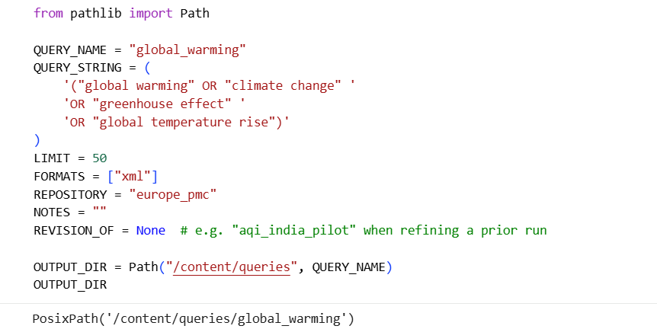
Figure 2. Overview of the pipeline with query “Global warming”

The review table was available in the following formats and saved as a zip file.
json: /content/queries/global_warming/review/review_table.json
csv: /content/queries/global_warming/review/review_table.csv
markdown: /content/queries/global_warming/review/review_table.md
The files upload: https://github.com/semanticClimate/semantic_corpus/blob/shreya/shreya_project/global_warming.zip

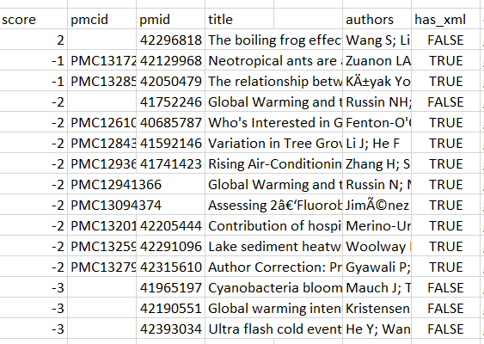
Figure 3. List of papers with pmcid, title, authors and score

Csv file upload: https://github.com/semanticClimate/semantic_corpus/blob/shreya/shreya_project/review_table.csv
However, from figure 3., it is true that the review score is below 5 for the files and thus will be excluded from the review status.
The automated workflow substantially reduces the time required for literature collection and minimizes inconsistencies associated with manual dataset preparation.

5. Objectives for the upcoming weeks:
- Execute the workflow using different scientific queries (e.g., Global Warming, Air Pollution, Biodiversity, Renewable Energy).
- Retrieve publications from Europe PMC.
- Generate structured review tables.
- Export datasets in CSV and JSON formats.
- Compare the number and relevance of retrieved publications for different queries.
- Assess whether the retrieved datasets match the intended research topic.

6. Conclusion
The Semantic Corpus workflow provides a reproducible approach to research assessment. Unlike manual literature searches, automated retrieval ensures that identical queries generate consistent datasets.
The inclusion of relevance scoring further assists researchers in prioritizing important publications during systematic reviews.
This internship provided practical exposure to automated research assessment and scientific dataset generation using the Semantic Corpus framework.
The developed workflow demonstrates how computational methods can efficiently retrieve, organize, and evaluate scientific literature from Europe PMC. By integrating literature retrieval, metadata processing, relevance scoring, and dataset generation into a single reproducible pipeline, the workflow significantly reduces manual effort while improving consistency.
The experience also highlighted the growing importance of automated research assessment tools in supporting systematic reviews, bibliometric analyses, evidence synthesis, and AI-driven scientific research. The generated datasets provide a valuable foundation for future applications in machine learning, climate research, and knowledge discovery.

7. References
- Semantic Climate. Semantic Corpus Repository. https://github.com/semanticClimate/semantic_corpus
- Europe PMC. https://europepmc.org/
- Google Colaboratory. https://colab.research.google.com/
- Python Software Foundation. https://www.python.org/
- Pandas Documentation. https://pandas.pydata.org/
- Jupyter Notebook Documentation. https://jupyter.org/
- Europe PMC REST API Documentation. https://europepmc.org/RestfulWebService
- Wilkinson MD et al. The FAIR Guiding Principles for scientific data management and stewardship. Scientific Data. 2016.
- Page MJ et al. The PRISMA 2020 Statement. BMJ. 2021.

