-Objetivo: Implementación de una regresión lineal

-Recomendado: Mirar los vidio y lecturas a modo de revisión (hay lecturas pendientes)

-Files included in this exercise:
ex1.m - Octave/MATLAB script that steps you through the exercise
ex1 multi.m - Octave/MATLAB script for the later parts of the exercise
ex1data1.txt - Dataset for linear regression with one variable
ex1data2.txt - Dataset for linear regression with multiple variables
submit.m - Submission script that sends your solutions to our servers
[?] warmUpExercise.m - Simple example function in Octave/MATLAB
[?] plotData.m - Function to display the dataset
[?] computeCost.m - Function to compute the cost of linear regression
[?] gradientDescent.m - Function to run gradient descent
[†] computeCostMulti.m - Cost function for multiple variables
[†] gradientDescentMulti.m - Gradient descent for multiple variables
[†] featureNormalize.m - Function to normalize features
[†] normalEqn.m - Function to compute the normal equations
? indicates files you will need to complete
† indicates optional exercises

-Work:
-Obligatori: Implement linear regression with one variable
-Optional: Implement linear regression with mutiple variable

-Matlab Documentation:
+http://es.mathworks.com/help/matlab/?refresh=true
+help function

2.Linear regression with one variable
OBJECTIVE: predict profits for a food truck
DATA: ex1data1 --> 1 population of a city // 2 --> profit of a food truck

WORK: You will need to complete the following functions in this exericse:

* warmUpExercise.m
* plotData.m
% gradientDescent.m
% computeCost.m
% gradientDescentMulti.m
% computeCostMulti.m
% featureNormalize.m
% normalEqn.m

2.1-Plotting the Data

plotData:
plot(x, y, 'rx', 'MarkerSize', 10); % Plot the data
ylabel('Profit in $10,000s'); % Set the y−axis label
xlabel('Population of City in 10,000s'); % Set the x−axis label

2.2-Gradient Descent

Objecyive: fit (ajustar) the linear regression parameters θ

Minimize de cost funtio:
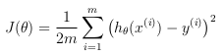

Hypothesis

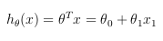

Useing radient descent algorithm to minimize de function:
*Recodatorio: No modificar valores hasta haver calculo todos los valore nuevos

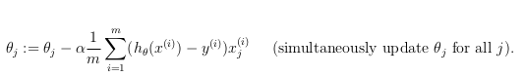
Implementar el vector X como un vector de todo 1 → Así se respeta la característica theta0.

El código de implementación del gradiente de descenso es el siguiente:

function [theta, J_history] = gradientDescent(X, y, theta, alpha, num_iters)
%GRADIENTDESCENT Performs gradient descent to learn theta
% theta = GRADIENTDESCENT(X, y, theta, alpha, num_iters) updates theta by
% taking num_iters gradient steps with learning rate alpha

% Initialize some useful values
m = length(y); % number of training examples
J_history = zeros(num_iters, 1);

for iter = 1:num_iters
% ========= YOUR CODE HERE =================
% Instructions: Perform a single gradient step on the parameter vector theta.
% Hint: While debugging, it can be useful to print out the values of the cost function (computeCost) and gradient here.

h = X*theta;
temp0 = theta(1)-alpha*(1/m)* sum(h-y);
temp1 = theta(2)-alpha*(1/m)* sum((h-y).*X(:,2));
theta(1) = temp0;
theta(2) = temp1;

% ==================================
% Save the cost J in every iteration
J_history(iter) = computeCost(X, y, theta);

end
end

2.2.3 Computing the cost J(θ)

J(θ) should never increase.

Si la implementación es correcta el resultado que obtendremos es el de la Figura2.
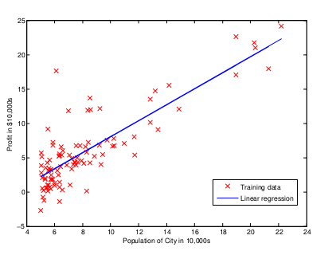

La implementación de la ‘cost function’ es la siguiente:

function J = computeCost(X, y, theta)
%COMPUTECOST Compute cost for linear regression
% J = COMPUTECOST(X, y, theta) computes the cost of using theta as the
% parameter for linear regression to fit the data points in X and y

% Initialize some useful values
m = length(y); % number of training examples

% You need to return the following variables correctly
J = 0;

% ========== YOUR CODE HERE ======================
% Instructions: Compute the cost of a particular choice of theta
% You should set J to the cost.

for iter = 1:m
h = X*theta;
J = 1/(2*m)*sum((h-y).^2);
end

% =======================================

end

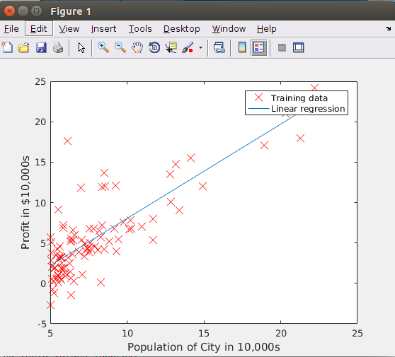

2.4 Visualizing J(θ)
To understand the cost function J(θ) better, you will now plot the cost over
a 2-dimensional grid of θ 0 and θ 1 values.

% initialize J vals to a matrix of 0's
J vals = zeros(length(theta0 vals), length(theta1 vals));
% Fill out J vals
for i = 1:length(theta0 vals)
for j = 1:length(theta1 vals)
t = [theta0 vals(i); theta1 vals(j)];
J vals(i,j) = computeCost(x, y, t);
end
end

‘J_vals’ guarda los diferentes valores de la función de costes, que siempre deberían decrecer.
Una muy buena forma de ver su correcto funcionamiento es con la representación:

