In this exercise, you will implement logistic regression and apply it to two
different datasets.

Files included in this exercise

ex2.m - Octave/MATLAB script that steps you through the exercise
ex2 reg.m - Octave/MATLAB script for the later parts of the exercise
ex2data1.txt - Training set for the first half of the exercise
ex2data2.txt - Training set for the second half of the exercise
submit.m - Submission script that sends your solutions to our servers
mapFeature.m - Function to generate polynomial features
plotDecisionBoundary.m - Function to plot classifier’s decision bound-
ary
[?] plotData.m - Function to plot 2D classification data
[?] sigmoid.m - Sigmoid Function
[?] costFunction.m - Logistic Regression Cost Function
[?] predict.m - Logistic Regression Prediction Function
[?] costFunctionReg.m - Regularized Logistic Regression Cost
? indicates files you will need to complete

1 - Logistic Regression

In this part of the exercise, you will build a logistic regression model to
predict whether a student gets admitted into a university.

Ex2.m:

% This file contains code that helps you get started on the logistic
% regression exercise. You will need to complete the following functions
% in this exericse:
%
% sigmoid.m
% costFunction.m
% predict.m
% costFunctionReg.m

1.1 - Visualizing the data

Before starting to implement any learning algorithm, it is always good to
visualize the data if possible.

In the first part of ex2.m, the code will load the data and display it on a 2-dimensional plot by calling the function plotData.

function plotData(X, y)
%PLOTDATA Plots the data points X and y into a new figure
% PLOTDATA(x,y) plots the data points with + for the positive examples
% and o for the negative examples. X is assumed to be a Mx2 matrix.

% Create New Figure
figure; hold on;

% ====================== YOUR CODE HERE ======================
% Instructions: Plot the positive and negative examples on a
% 2D plot, using the option 'k+' for the positive
% examples and 'ko' for the negative examples.
%

% Find Indices of Positive and Negative Examples
pos = find(y==1); neg = find(y == 0);
% Plot Examples
plot(X(pos, 1), X(pos, 2), 'k+','LineWidth', 2, ...
'MarkerSize', 7);
plot(X(neg, 1), X(neg, 2), 'ko', 'MarkerFaceColor', 'y', ...
'MarkerSize', 7);

%====================================================

hold off;

end

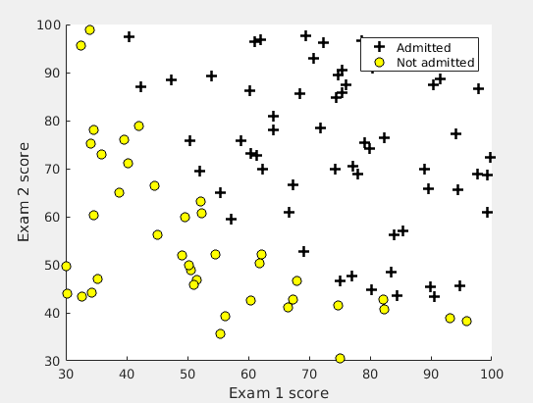
1.2 - Implementation
1.2.1 - Warmup exercise: sigmoid function

For large positive values of x, the sigmoid should be close to 1, while for large negative values, the sigmoid should be close to 0. Evaluating sigmoid(0) should give you exactly 0.5.

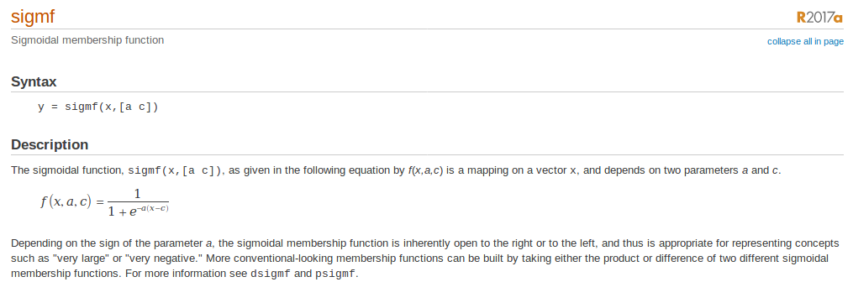

function g = sigmoid(z)
%SIGMOID Compute sigmoid function
% g = SIGMOID(z) computes the sigmoid of z.

% You need to return the following variables correctly
g = zeros(size(z));

% ====================== YOUR CODE HERE ======================
% Instructions: Compute the sigmoid of each value of z (z can be a matrix,
% vector or scalar).

g = sigmf(z,[1 0]);

%=====================================================

end

1.2.2 - Cost function and gradient

function [J, grad] = costFunction(theta, X, y)
%COSTFUNCTION Compute cost and gradient for logistic regression
% J = COSTFUNCTION(theta, X, y) computes the cost of using theta as the
% parameter for logistic regression and the gradient of the cost
% w.r.t. to the parameters.

% Initialize some useful values
m = length(y); % number of training examples

% You need to return the following variables correctly
J = 0;
grad = zeros(size(theta));

% ====================== YOUR CODE HERE ======================
% Instructions: Compute the cost of a particular choice of theta.
% You should set J to the cost.
% Compute the partial derivatives and set grad to the partial
% derivatives of the cost w.r.t. each parameter in theta
%
% Note: grad should have the same dimensions as theta

z=X*theta;
h=sigmoid(z);
logisf=(-y)'*log(h)-(1-y)'*log(1-h);
J=(1/m)*sum(logisf);

grad=1/m*((X'*h-X'*y)');

%=================================================

end

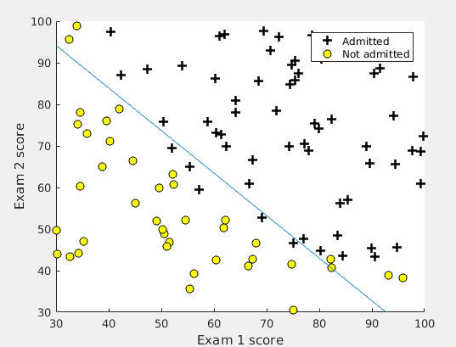

2 - Regularized logistic regression

2.1 - Visualizing the data

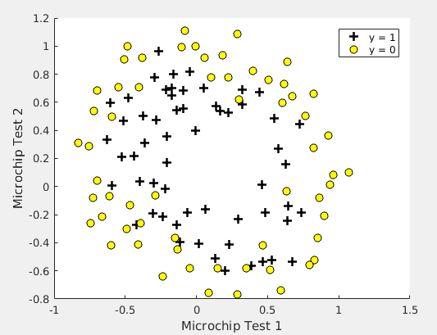

function p = predict(theta, X)
%PREDICT Predict whether the label is 0 or 1 using learned logistic
%regression parameters theta
% p = PREDICT(theta, X) computes the predictions for X using a
% threshold at 0.5 (i.e., if sigmoid(theta'*x) >= 0.5, predict 1)

m = size(X, 1); % Number of training examples

% You need to return the following variables correctly
p = zeros(m, 1);

% ====================== YOUR CODE HERE ======================
% Instructions: Complete the following code to make predictions using
% your learned logistic regression parameters.
% You should set p to a vector of 0's and 1's
%

z=X*theta;
h=sigmoid(z);
for i=1:m
if h(i)>=0.5;
p(i)=1;
else
p(i)=0;
end

%==========================================

end

2.2 - Feature mapping

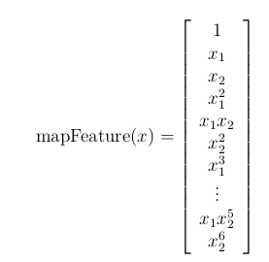

2.3 - Cost function and gradient

function [J, grad] = costFunctionReg(theta, X, y, lambda)
%COSTFUNCTIONREG Compute cost and gradient for logistic regression with regularization
% J = COSTFUNCTIONREG(theta, X, y, lambda) computes the cost of using
% theta as the parameter for regularized logistic regression and the
% gradient of the cost w.r.t. to the parameters.

% Initialize some useful values
m = length(y); % number of training examples

% You need to return the following variables correctly
J = 0;
grad = zeros(size(theta));

% ====================== YOUR CODE HERE ======================
% Instructions: Compute the cost of a particular choice of theta.
% You should set J to the cost.
% Compute the partial derivatives and set grad to the partial
% derivatives of the cost w.r.t. each parameter in theta

tempTheta = theta;
tempTheta(1) = 0;
h=sigmoid(X * theta);

J = (-1 / m) * sum(y.*log(h) + (1 - y).*log(1 - h)) + (lambda / (2 * m))*sum(tempTheta.^2);
grad = (1 / m) * (X' * (h-y)) + (lambda/m)*tempTheta;

% =============================================================

end

