In this exercise, you will implement one-vs-all logistic regression and neural
networks to recognize hand-written digits.

Files included in this exercise

ex3.m - Octave/MATLAB script that steps you through part 1
ex3 nn.m - Octave/MATLAB script that steps you through part 2
ex3data1.mat - Training set of hand-written digits
ex3weights.mat - Initial weights for the neural network exercise
submit.m - Submission script that sends your solutions to our servers
displayData.m - Function to help visualize the dataset
fmincg.m - Function minimization routine (similar to fminunc)
sigmoid.m - Sigmoid function
[?] lrCostFunction.m - Logistic regression cost function
[?] oneVsAll.m - Train a one-vs-all multi-class classifier
[?] predictOneVsAll.m - Predict using a one-vs-all multi-class classifier
[?] predict.m - Neural network prediction function

You will need to complete the following functions in this exericse:

% lrCostFunction.m (logistic regression cost function)
% oneVsAll.m
% predictOneVsAll.m
% predict.m

1 - Multi-class Classification

1.2 - Visualizing the data

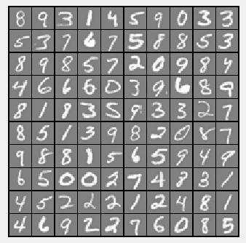
1.3 - Vectorizing Logistic Regression

1.3.1 - Vectorizing the cost function

1.3.2 - Vectorizing the gradient

1.3.3 - Vectorizing regularized logistic regression

function [J, grad] = lrCostFunction(theta, X, y, lambda)
%LRCOSTFUNCTION Compute cost and gradient for logistic regression with
%regularization
% J = LRCOSTFUNCTION(theta, X, y, lambda) computes the cost of using
% theta as the parameter for regularized logistic regression and the
% gradient of the cost w.r.t. to the parameters.

% Initialize some useful values
m = length(y); % number of training examples

% You need to return the following variables correctly
J = 0;
grad = zeros(size(theta));

% ====================== YOUR CODE HERE ======================
% Instructions: Compute the cost of a particular choice of theta.
% You should set J to the cost.
% Compute the partial derivatives and set grad to the partial
% derivatives of the cost w.r.t. each parameter in theta
%
% Hint: The computation of the cost function and gradients can be
% efficiently vectorized. For example, consider the computation
%
% sigmoid(X * theta)
%
% Each row of the resulting matrix will contain the value of the
% prediction for that example. You can make use of this to vectorize
% the cost function and gradient computations.
%
% Hint: When computing the gradient of the regularized cost function,
% there're many possible vectorized solutions, but one solution
% looks like:
% grad = (unregularized gradient for logistic regression)
% temp = theta;
% temp(1) = 0; % because we don't add anything for j = 0
% grad = grad + YOUR_CODE_HERE (using the temp variable)
%

n=length(theta);
z=X*theta;
h=sigmoid(z);
thetas=theta(2:n,1);

% J=((1/m).*sum((-y)'*log(h)-(1-y)'*log(1-h))) --> Unregularized
J=((1/m).*sum((-y)'*log(h)-(1-y)'*log(1-h)))+(lambda/(2*m)).*sum(thetas.^2);

temp=theta;
temp(1)=0;

%grad=(1/m).*(X'*(h-y) --> Unregularized
grad=(1/m).*(X'*(h-y)+lambda.*temp);

%===========================================

grad = grad(:)

end

1.4 - One-vs-all Classification

function [all_theta] = oneVsAll(X, y, num_labels, lambda)
%ONEVSALL trains multiple logistic regression classifiers and returns all
%the classifiers in a matrix all_theta, where the i-th row of all_theta
%corresponds to the classifier for label i
% [all_theta] = ONEVSALL(X, y, num_labels, lambda) trains num_labels
% logistic regression classifiers and returns each of these classifiers
% in a matrix all_theta, where the i-th row of all_theta corresponds
% to the classifier for label i

% Some useful variables
m = size(X, 1);
n = size(X, 2);

% You need to return the following variables correctly
all_theta = zeros(num_labels, n + 1);

% Add ones to the X data matrix
X = [ones(m, 1) X];

% ====================== YOUR CODE HERE ======================
% Instructions: You should complete the following code to train num_labels
% logistic regression classifiers with regularization
% parameter lambda.
%
% Hint: theta(:) will return a column vector.
%
% Hint: You can use y == c to obtain a vector of 1's and 0's that tell you
% whether the ground truth is true/false for this class.
%
% Note: For this assignment, we recommend using fmincg to optimize the cost
% function. It is okay to use a for-loop (for c = 1:num_labels) to
% loop over the different classes.
%
% fmincg works similarly to fminunc, but is more efficient when we
% are dealing with large number of parameters.
%
% Example Code for fmincg:
%
% % Set Initial theta
% initial_theta = zeros(n + 1, 1);
%
% % Set options for fminunc
% options = optimset('GradObj', 'on', 'MaxIter', 50);
%
% % Run fmincg to obtain the optimal theta
% % This function will return theta and the cost
% [theta] = ...
% fmincg (@(t)(lrCostFunction(t, X, (y == c), lambda)), ...
% initial_theta, options);
%

for i = 1:num_labels

% Set initial theta
initial_theta=zeros(n+1,1);
%initial_theta=zeros(num_labels, n + 1);

% Set options for fminunc
options = optimset('GradObj', 'on', 'MaxIter', 50);

% Run fmincg to obtain the optimal theta
% This function will return theta and the cost
[theta]=fmincg(@(t)(lrCostFunction(t,X, (y == i), lambda)), initial_theta, options);

% Updating theta to overall all_theta
if (i==1)
all_theta=theta';
else
all_theta=[all_theta; theta'];
end

end

%========================================================

end

1.4.1 - One-vs-all Prediction

function p = predictOneVsAll(all_theta, X)
%PREDICT Predict the label for a trained one-vs-all classifier. The labels
%are in the range 1..K, where K = size(all_theta, 1).
% p = PREDICTONEVSALL(all_theta, X) will return a vector of predictions
% for each example in the matrix X. Note that X contains the examples in
% rows. all_theta is a matrix where the i-th row is a trained logistic
% regression theta vector for the i-th class. You should set p to a vector
% of values from 1..K (e.g., p = [1; 3; 1; 2] predicts classes 1, 3, 1, 2
% for 4 examples)

m = size(X, 1);
num_labels = size(all_theta, 1);

% You need to return the following variables correctly
p = zeros(size(X, 1), 1);

% Add ones to the X data matrix
X = [ones(m, 1) X];

% ====================== YOUR CODE HERE ======================
% Instructions: Complete the following code to make predictions using
% your learned logistic regression parameters (one-vs-all).
% You should set p to a vector of predictions (from 1 to
% num_labels).
%
% Hint: This code can be done all vectorized using the max function.
% In particular, the max function can also return the index of the
% max element, for more information see 'help max'. If your examples
% are in rows, then, you can use max(A, [], 2) to obtain the max
% for each row.
%

z=sigmoid(all_theta * X');
[probability, indices] = max(z);
p = indices';

%=======================================================

end

2 - Neural Networks

2.1 - Model representation

% Load saved matrices from file
load('ex3weights.mat');

%The matrices Theta1 and Theta2 will now be in your Octave
%environment
%Theta1 has size 25 x 401
%Theta2 has size 10 x 26

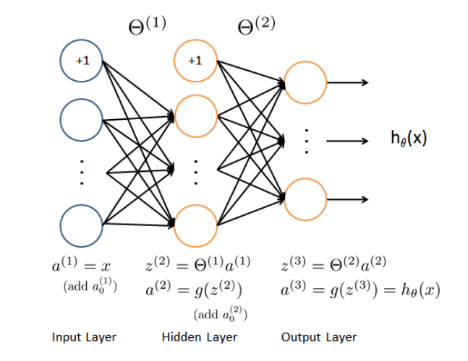

function p = predict(Theta1, Theta2, X)
%PREDICT Predict the label of an input given a trained neural network
% p = PREDICT(Theta1, Theta2, X) outputs the predicted label of X given the
% trained weights of a neural network (Theta1, Theta2)

% Useful values
m = size(X, 1);
num_labels = size(Theta2, 1);

% You need to return the following variables correctly
p = zeros(size(X, 1), 1);

% ====================== YOUR CODE HERE ======================
% Instructions: Complete the following code to make predictions using
% your learned neural network. You should set p to a
% vector containing labels between 1 to num_labels.
%
% Hint: The max function might come in useful. In particular, the max
% function can also return the index of the max element, for more
% information see 'help max'. If your examples are in rows, then, you
% can use max(A, [], 2) to obtain the max for each row.
%

data = [ones(m, 1) X];

% Map from Layer 1 to Layer 2
z1 = data * Theta1';
h1 = sigmoid(z1);

% Map from Layer 2 to Layer 3
h1 = [ones(m, 1) h1];
z2 = h1 * Theta2';
h2 = sigmoid(z2);
[probability indices] = max(h2');

%Final results
[pval, p]=max(h2,[],2); %ExpresiÃ³ donanda

%=========================================

end

