Programming Exercise 4: Neural Networks Learning

Files included in this exercise
ex4.m - Octave/MATLAB script that steps you through the exercise
ex4data1.mat - Training set of hand-written digits
ex4weights.mat - Neural network parameters for exercise 4
submit.m - Submission script that sends your solutions to our servers
displayData.m - Function to help visualize the dataset
fmincg.m - Function minimization routine (similar to fminunc)
sigmoid.m - Sigmoid function
computeNumericalGradient.m - Numerically compute gradients
checkNNGradients.m - Function to help check your gradients
debugInitializeWeights.m - Function for initializing weights
predict.m - Neural network prediction function
[?] sigmoidGradient.m - Compute the gradient of the sigmoid function
[?] randInitializeWeights.m - Randomly initialize weights
[?] nnCostFunction.m - Neural network cost function

1 - Neural Networks

1.1 - Visualizing the data

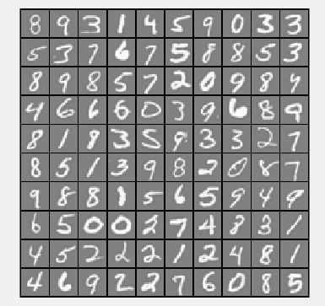

1.2 - Model representation

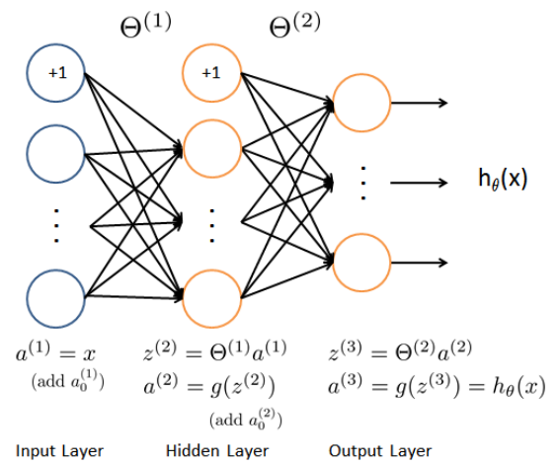

1.3 - Feedforward and cost function

function [J grad] = nnCostFunction(nn_params, ...
input_layer_size, ...
hidden_layer_size, ...
num_labels, ...
X, y, lambda)
%NNCOSTFUNCTION Implements the neural network cost function for a two layer
%neural network which performs classification
% [J grad] = NNCOSTFUNCTON(nn_params, hidden_layer_size, num_labels, ...
% X, y, lambda) computes the cost and gradient of the neural network. The
% parameters for the neural network are "unrolled" into the vector
% nn_params and need to be converted back into the weight matrices.
%
% The returned parameter grad should be a "unrolled" vector of the
% partial derivatives of the neural network.
%

% Reshape nn_params back into the parameters Theta1 and Theta2, the weight matrices
% for our 2 layer neural network
Theta1 = reshape(nn_params(1:hidden_layer_size * (input_layer_size + 1)), ...
hidden_layer_size, (input_layer_size + 1));

Theta2 = reshape(nn_params((1 + (hidden_layer_size * (input_layer_size + 1))):end), ...
num_labels, (hidden_layer_size + 1));

% Setup some useful variables
m = size(X, 1);

% You need to return the following variables correctly
J = 0;
Theta1_grad = zeros(size(Theta1));
Theta2_grad = zeros(size(Theta2));

% ====================== YOUR CODE HERE ======================
% Instructions: You should complete the code by working through the
% following parts.
%
% Part 1: Feedforward the neural network and return the cost in the
% variable J. After implementing Part 1, you can verify that your
% cost function computation is correct by verifying the cost
% computed in ex4.m

a1 = [ones(m,1) X];
a2 = sigmoid(a1*Theta1');
a2 = [ones(m,1) a2];
a3 = sigmoid(a2*Theta2');
y = repmat( [1:num_labels], m, 1) == repmat(y, 1, num_labels);
J = (-1 / m) * sum(sum(y.*log(a3) + (1 - y).*log(1 - a3)));

1.4 - Regularized cost function

%Regulaized Cost Funtion

regTheta1 = Theta1(:,2:end);
regTheta2 = Theta2(:,2:end);

error = (lambda/(2*m)) * (sum(sum(regTheta1.^2)) + sum(sum(regTheta2.^2)));

J = J + error;

2 - Backpropagation

2 - Backpropagation

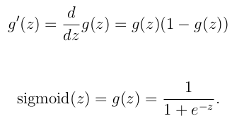
function g = sigmoidGradient(z)
%SIGMOIDGRADIENT returns the gradient of the sigmoid function
%evaluated at z
% g = SIGMOIDGRADIENT(z) computes the gradient of the sigmoid function
% evaluated at z. This should work regardless if z is a matrix or a
% vector. In particular, if z is a vector or matrix, you should return
% the gradient for each element.

g = zeros(size(z));

% ====================== YOUR CODE HERE ======================
% Instructions: Compute the gradient of the sigmoid function evaluated at
% each value of z (z can be a matrix, vector or scalar).

g=sigmoid(z).*(1-sigmoid(z));

% =============================================================

end

2.2 - Random initialization

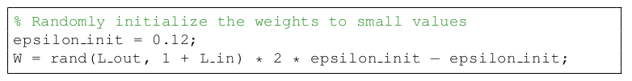
function W = randInitializeWeights(L_in, L_out)
%RANDINITIALIZEWEIGHTS Randomly initialize the weights of a layer with L_in
%incoming connections and L_out outgoing connections
% W = RANDINITIALIZEWEIGHTS(L_in, L_out) randomly initializes the weights
% of a layer with L_in incoming connections and L_out outgoing
% connections.
%
% Note that W should be set to a matrix of size(L_out, 1 + L_in) as
% the first column of W handles the "bias" terms
%

% You need to return the following variables correctly
W = zeros(L_out, 1 + L_in);

% ====================== YOUR CODE HERE ======================
% Instructions: Initialize W randomly so that we break the symmetry while
% training the neural network.
%
% Note: The first column of W corresponds to the parameters for the bias unit
%

epsilon_init = 0.12;
W = rand(L_out, 1+L_in)*2*epsilon_init - epsilon_init;

% =========================================================================

end

2.3 - Backpropagation
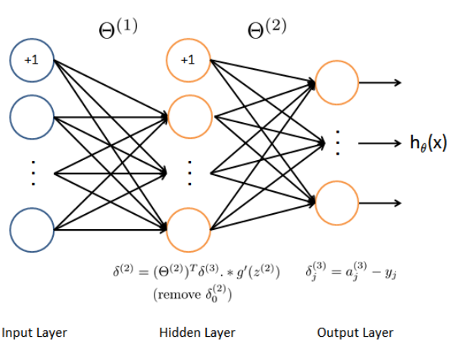
2.4 - Gradient checking

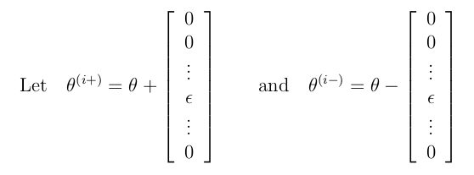

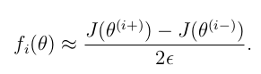

2.5 - Regularized Neural Networks

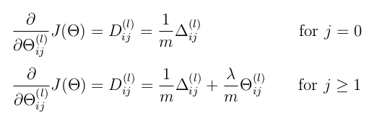

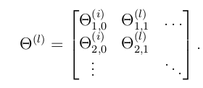
function [J grad] = nnCostFunction(nn_params, ...
input_layer_size, ...
hidden_layer_size, ...
num_labels, ...
X, y, lambda)
%NNCOSTFUNCTION Implements the neural network cost function for a two layer
%neural network which performs classification
% [J grad] = NNCOSTFUNCTON(nn_params, hidden_layer_size, num_labels, ...
% X, y, lambda) computes the cost and gradient of the neural network. The
% parameters for the neural network are "unrolled" into the vector
% nn_params and need to be converted back into the weight matrices.
%
% The returned parameter grad should be a "unrolled" vector of the
% partial derivatives of the neural network.
%

% Reshape nn_params back into the parameters Theta1 and Theta2, the weight matrices
% for our 2 layer neural network
Theta1 = reshape(nn_params(1:hidden_layer_size * (input_layer_size + 1)), ...
hidden_layer_size, (input_layer_size + 1));

Theta2 = reshape(nn_params((1 + (hidden_layer_size * (input_layer_size + 1))):end), ...
num_labels, (hidden_layer_size + 1));

% Setup some useful variables
m = size(X, 1);

% You need to return the following variables correctly
J = 0;
Theta1_grad = zeros(size(Theta1));
Theta2_grad = zeros(size(Theta2));

% ====================== YOUR CODE HERE ======================
% Instructions: You should complete the code by working through the
% following parts.
%
% Part 1: Feedforward the neural network and return the cost in the
% variable J. After implementing Part 1, you can verify that your
% cost function computation is correct by verifying the cost
% computed in ex4.m
%
% Part 2: Implement the backpropagation algorithm to compute the gradients
% Theta1_grad and Theta2_grad. You should return the partial derivatives of
% the cost function with respect to Theta1 and Theta2 in Theta1_grad and
% Theta2_grad, respectively. After implementing Part 2, you can check
% that your implementation is correct by running checkNNGradients
%
% Note: The vector y passed into the function is a vector of labels
% containing values from 1..K. You need to map this vector into a
% binary vector of 1's and 0's to be used with the neural network
% cost function.
%
% Hint: We recommend implementing backpropagation using a for-loop
% over the training examples if you are implementing it for the
% first time.
%
% Part 3: Implement regularization with the cost function and gradients.
%
% Hint: You can implement this around the code for
% backpropagation. That is, you can compute the gradients for
% the regularization separately and then add them to Theta1_grad
% and Theta2_grad from Part 2.
%

a1 = [ones(m,1) X];
a2 = sigmoid(a1*Theta1');
a2 = [ones(m,1) a2];
a3 = sigmoid(a2*Theta2');
y = repmat([1:num_labels], m, 1) == repmat(y, 1, num_labels);
J = (-1 / m) * sum(sum(y.*log(a3) + (1 - y).*log(1 - a3)));

regTheta1 = Theta1(:,2:end);
regTheta2 = Theta2(:,2:end);

error = (lambda/(2*m)) * (sum(sum(regTheta1.^2)) + sum(sum(regTheta2.^2)));

J = J + error;
del1 = zeros(size(Theta1));
del2 = zeros(size(Theta2));
for t = 1:m,
a1t = a1(t,:);
a2t = a2(t,:);
a3t = a3(t,:);
yt = y(t,:);
d3 = a3t - yt;
d2 = Theta2'*d3' .* sigmoidGradient([1;Theta1 * a1t']);
del1 = del1 + d2(2:end)*a1t;
del2 = del2 + d3' * a2t;
end;

Theta1_grad = 1/m * del1 + (lambda/m)*[zeros(size(Theta1, 1), 1) regTheta1];
Theta2_grad = 1/m * del2 + (lambda/m)*[zeros(size(Theta2, 1), 1) regTheta2];
% -------------------------------------------------------------

% =========================================================================

% Unroll gradients
grad = [Theta1_grad(:) ; Theta2_grad(:)];

end

2.6 - Learning parameters using fmincg

After you have successfully implemented the neural network cost function
and gradient computation, the next step of the ex4.m script will use fmincg
to learn a good set parameters.

If your implementation is correct, you should see a reported
training accuracy of about 95.3%

***Training Set Accuracy: 95.420000 → PERFECT

3 - Visualizing the hidden layer

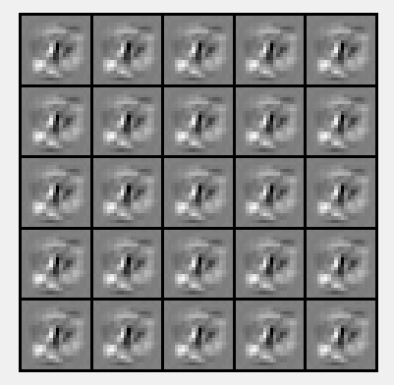

3.1 - Optional (ungraded) exercise

