Files included in this exercise
ex5.m - Octave/MATLAB script that steps you through the exercise
ex5data1.mat - Dataset
submit.m - Submission script that sends your solutions to our servers
featureNormalize.m - Feature normalization function
fmincg.m - Function minimization routine (similar to fminunc)
plotFit.m - Plot a polynomial fit
trainLinearReg.m - Trains linear regression using your cost function
[?] linearRegCostFunction.m - Regularized linear regression cost func-
tion
[?] learningCurve.m - Generates a learning curve
[?] polyFeatures.m - Maps data into polynomial feature space
[?] validationCurve.m - Generates a cross validation curve

1 - Regularized Linear Regression

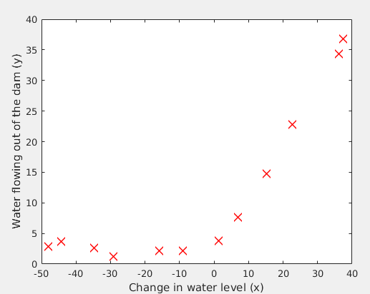

1.2 - Regularized linear regression cost function

% Calculate cost function
h=X*theta;
thetas=theta(2:end,1);
J=1/(2*m).*sum((h-y).^2)+(lambda/(2.*m)).*sum(thetas.^2);

1.3 - Regularized linear regression gradient

function [J, grad] = linearRegCostFunction(X, y, theta, lambda)
%LINEARREGCOSTFUNCTION Compute cost and gradient for regularized linear
%regression with multiple variables
% [J, grad] = LINEARREGCOSTFUNCTION(X, y, theta, lambda) computes the
% cost of using theta as the parameter for linear regression to fit the
% data points in X and y. Returns the cost in J and the gradient in grad

% Initialize some useful values
m = length(y); % number of training examples

% You need to return the following variables correctly
J = 0;
grad = zeros(size(theta));

% ====================== YOUR CODE HERE ======================
% Instructions: Compute the cost and gradient of regularized linear
% regression for a particular choice of theta.
%
% You should set J to the cost and grad to the gradient.
%

% Calculate cost function
h=X*theta;
thetas=theta(2:end,1);
J=1/(2*m).*sum((h-y).^2)+(lambda/(2.*m)).*sum(thetas.^2);

% Calculate gradient descent
temp=theta;
temp(1)=0;
grad=(1/m).*(X'*(h-y)+lambda.*temp);

%====================================================

grad = grad(:);

end

1.4 - Fitting linear regression

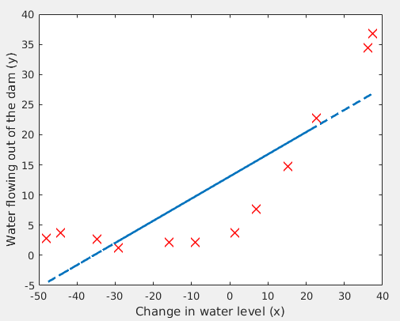

2 - Bias-variance

2.1 - Learning curves

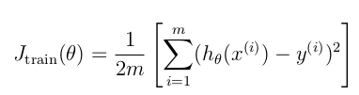

function [error_train, error_val] = ...
learningCurve(X, y, Xval, yval, lambda)
%LEARNINGCURVE Generates the train and cross validation set errors needed
%to plot a learning curve
% [error_train, error_val] = ...
% LEARNINGCURVE(X, y, Xval, yval, lambda) returns the train and
% cross validation set errors for a learning curve. In particular,
% it returns two vectors of the same length - error_train and
% error_val. Then, error_train(i) contains the training error for
% i examples (and similarly for error_val(i)).
%
% In this function, you will compute the train and test errors for
% dataset sizes from 1 up to m. In practice, when working with larger
% datasets, you might want to do this in larger intervals.
%

% Number of training examples
m = size(X, 1);

% You need to return these values correctly
error_train = zeros(m, 1);
error_val = zeros(m, 1);

% ====================== YOUR CODE HERE ======================
% Instructions: Fill in this function to return training errors in
% error_train and the cross validation errors in error_val.
% i.e., error_train(i) and
% error_val(i) should give you the errors
% obtained after training on i examples.
%
% Note: You should evaluate the training error on the first i training
% examples (i.e., X(1:i, :) and y(1:i)).
%
% For the cross-validation error, you should instead evaluate on
% the _entire_ cross validation set (Xval and yval).
%
% Note: If you are using your cost function (linearRegCostFunction)
% to compute the training and cross validation error, you should
% call the function with the lambda argument set to 0.
% Do note that you will still need to use lambda when running
% the training to obtain the theta parameters.
%
% Hint: You can loop over the examples with the following:
%
% for i = 1:m
% % Compute train/cross validation errors using training examples
% % X(1:i, :) and y(1:i), storing the result in
% % error_train(i) and error_val(i)
% ....
%
% end
%

% ---------------------- Sample Solution ----------------------

for i = 1:m
Xtrain = X(1:i, :);
Ytrain = y(1:i);
theta = trainLinearReg(Xtrain,Ytrain,lambda);
error_train(i) = linearRegCostFunction(Xtrain,Ytrain,theta,0);
error_val(i) = linearRegCostFunction(Xval,yval,theta,0);
end

% -------------------------------------------------------------

%=======================================================

end

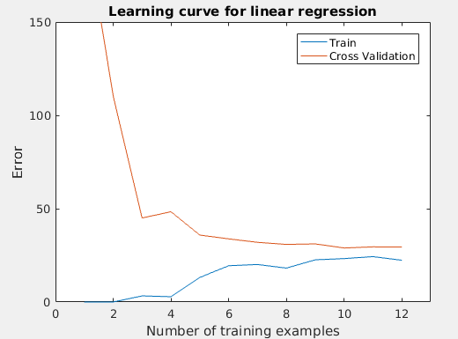

3 - Polynomial regression

function [X_poly] = polyFeatures(X, p)
%POLYFEATURES Maps X (1D vector) into the p-th power
% [X_poly] = POLYFEATURES(X, p) takes a data matrix X (size m x 1) and
% maps each example into its polynomial features where
% X_poly(i, :) = [X(i) X(i).^2 X(i).^3 ... X(i).^p];
%

% You need to return the following variables correctly.
X_poly = zeros(numel(X), p);

% ====================== YOUR CODE HERE ======================
% Instructions: Given a vector X, return a matrix X_poly where the p-th
% column of X contains the values of X to the p-th power.
%
%

for i = 1:p
X_poly(:,i) = X.^i;

end

%=======================================================

end

3.1 - Learning Polynomial Regression

function [X_poly] = polyFeatures(X, p)
%POLYFEATURES Maps X (1D vector) into the p-th power
% [X_poly] = POLYFEATURES(X, p) takes a data matrix X (size m x 1) and
% maps each example into its polynomial features where
% X_poly(i, :) = [X(i) X(i).^2 X(i).^3 ... X(i).^p];
%

% You need to return the following variables correctly.
X_poly = zeros(numel(X), p);

% ====================== YOUR CODE HERE ======================
% Instructions: Given a vector X, return a matrix X_poly where the p-th
% column of X contains the values of X to the p-th power.
%
%

for i = 1:p
X_poly(:,i) = X.^i;

end

% =========================================================================

end

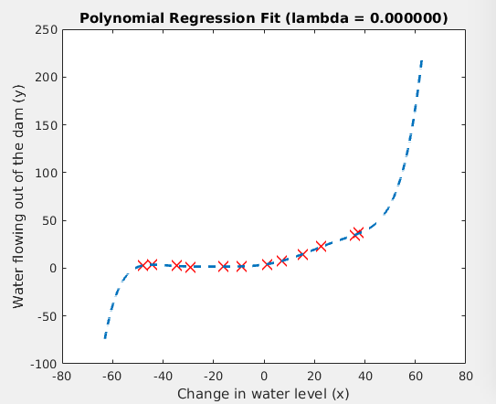

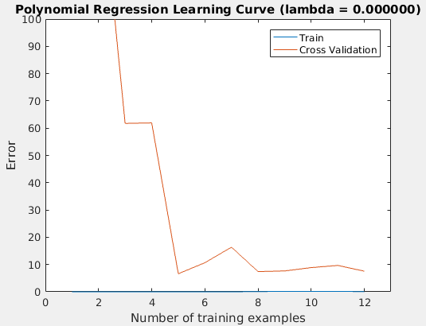
El ajuste polinomial es capaz de seguir los puntos de datos muy bien. Por lo tanto, estamos obteniendo un bajo ‘training error’.
El sjuste polinomial es muy complejo e incluso cae en los extremos. Esto es un indicador de que el modelo de regresión polinomial está ‘overfitting (superponiendo) el entrenamiento
***Tenemos un problema en la regularización de los parámetros.
La curva de aprendizaje (Figura ) muestra el mismo efecto donde el ‘training error’ (error de entrenamiento) es bajo, pero el error de validación cruzada es alto.
Ahí una brecha entre el entrenamiento y los errores de validación cruzada, lo que nos indica que hay un problema de variación (variance).

****Una manera de combatir el problema de sobrevaloración (alta varianza) es agregar regularización al modelo.
En la siguiente sección, podrás probar diferentes Λ para ver cómo la regularización puede conducir a un mejor modelo.

3.2 Optional (ungraded) exercise: Adjusting the reg-ularization parameter

labda = 1

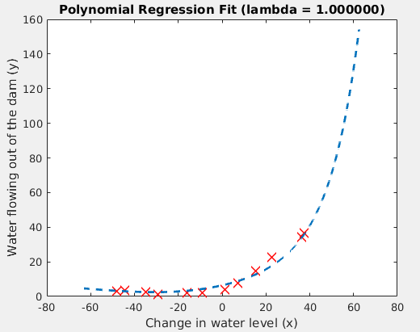
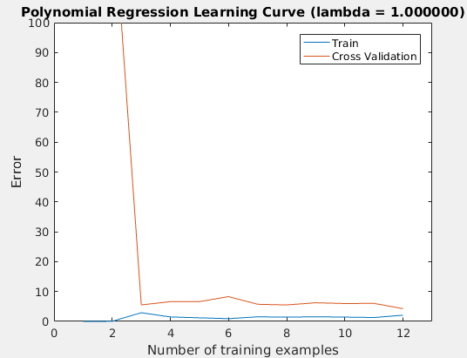
That is a really good regularization

labda = 100

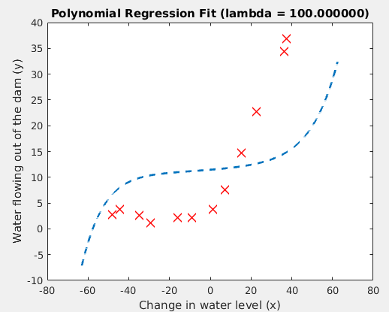

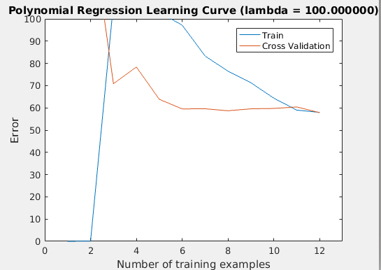

Too much regularization. The model is unable to fit the trainning data.

3.3 - Selecting λ using a cross validation set

function [lambda_vec, error_train, error_val] = ...
validationCurve(X, y, Xval, yval)
%VALIDATIONCURVE Generate the train and validation errors needed to
%plot a validation curve that we can use to select lambda
% [lambda_vec, error_train, error_val] = ...
% VALIDATIONCURVE(X, y, Xval, yval) returns the train
% and validation errors (in error_train, error_val)
% for different values of lambda. You are given the training set (X,
% y) and validation set (Xval, yval).
%

% Selected values of lambda (you should not change this)
lambda_vec = [0 0.001 0.003 0.01 0.03 0.1 0.3 1 3 10]';

% You need to return these variables correctly.
error_train = zeros(length(lambda_vec), 1);
error_val = zeros(length(lambda_vec), 1);

% ====================== YOUR CODE HERE ======================
% Instructions: Fill in this function to return training errors in
% error_train and the validation errors in error_val. The
% vector lambda_vec contains the different lambda parameters
% to use for each calculation of the errors, i.e,
% error_train(i), and error_val(i) should give
% you the errors obtained after training with
% lambda = lambda_vec(i)
%
% Note: You can loop over lambda_vec with the following:
%
% for i = 1:length(lambda_vec)
% lambda = lambda_vec(i);
% % Compute train / val errors when training linear
% % regression with regularization parameter lambda
% % You should store the result in error_train(i)
% % and error_val(i)
% ....
%
% end
%
%

for i = 1:length(lambda_vec)
lambda = lambda_vec(i);
theta = trainLinearReg(X, y, lambda);
error_train(i) = linearRegCostFunction(X, y, theta, 0);
error_val(i) = linearRegCostFunction(Xval,yval,theta,0);
end

%=======================================================

end

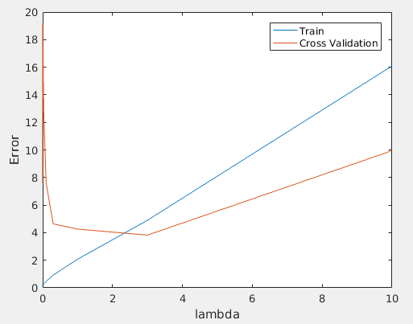
***We can see that the best value of λ is around 3.

