Introduction

In this exercise, you will be using support vector machines (SVMs) to build
a spam classifier.

Files included in this exercise

ex6.m - Octave/MATLAB script for the first half of the exercise
ex6data1.mat - Example Dataset 1
ex6data2.mat - Example Dataset 2
ex6data3.mat - Example Dataset 3
svmTrain.m - SVM training function
svmPredict.m - SVM prediction function
plotData.m - Plot 2D data
visualizeBoundaryLinear.m - Plot linear boundary
visualizeBoundary.m - Plot non-linear boundary
linearKernel.m - Linear kernel for SVM
[?] gaussianKernel.m - Gaussian kernel for SVM
[?] dataset3Params.m - Parameters to use for Dataset 3
ex6 spam.m - Octave/MATLAB script for the second half of the exercise
spamTrain.mat - Spam training set
spamTest.mat - Spam test set
emailSample1.txt - Sample email 1
emailSample2.txt - Sample email 2
spamSample1.txt - Sample spam 1
spamSample2.txt - Sample spam 2
vocab.txt - Vocabulary list
getVocabList.m - Load vocabulary list
porterStemmer.m - Stemming function
readFile.m - Reads a file into a character string
submit.m - Submission script that sends your solutions to our servers
[?] processEmail.m - Email preprocessing
[?] emailFeatures.m - Feature extraction from emails

1 - Support Vector Machines

In the first half of this exercise, you will be using support vector machines (SVMs) with various example 2D datasets.

In the next half of the exercise, you will be using support vector machines to build a spam classifier.

1.1 - Example Dataset 1

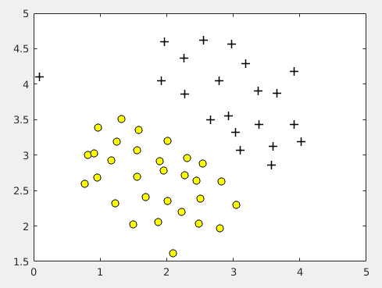

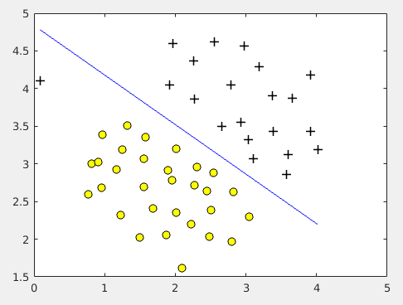
C=1

C=100
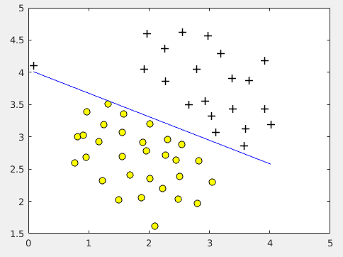

If you put C=0, then the desicion boundary disapear.

1.2 - SVM with Gaussian Kernels

1.2.1 - Gaussian Kernel

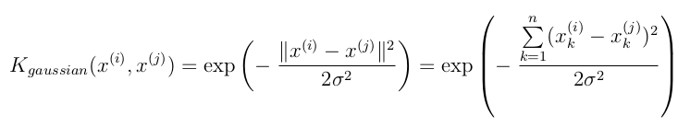
function sim = gaussianKernel(x1, x2, sigma)
%RBFKERNEL returns a radial basis function kernel between x1 and x2
% sim = gaussianKernel(x1, x2) returns a gaussian kernel between x1 and x2
% and returns the value in sim

% Ensure that x1 and x2 are column vectors
x1 = x1(:); x2 = x2(:);

% You need to return the following variables correctly.
sim = 0;

% ====================== YOUR CODE HERE ======================
% Instructions: Fill in this function to return the similarity between x1
% and x2 computed using a Gaussian kernel with bandwidth
% sigma
%
%

sim = exp(-(sum((x1-x2).^2))/(2*sigma.^2));

%====================================================

end

1.2.2 - Example Dataset 2

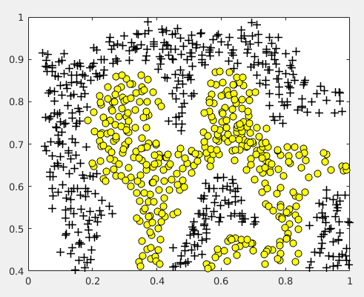

C=100
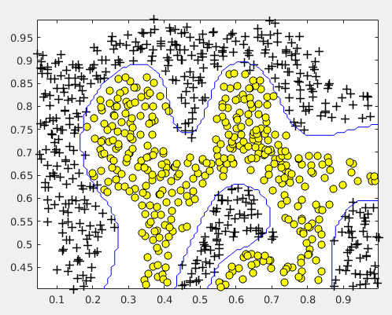

C=1
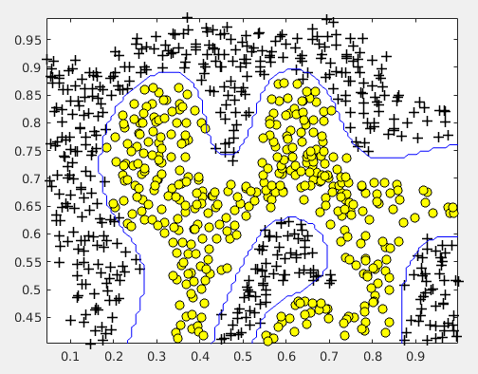

In this case the value of C don’t afect to de decision boundery. (WHY??)
1.2.3 - Example Dataset 3

function [C, sigma] = dataset3Params(X, y, Xval, yval)
%DATASET3PARAMS returns your choice of C and sigma for Part 3 of the exercise
%where you select the optimal (C, sigma) learning parameters to use for SVM
%with RBF kernel
% [C, sigma] = DATASET3PARAMS(X, y, Xval, yval) returns your choice of C and
% sigma. You should complete this function to return the optimal C and
% sigma based on a cross-validation set.
%

% You need to return the following variables correctly.
C = 1;
sigma = 0.3;

% ====================== YOUR CODE HERE ======================
% Instructions: Fill in this function to return the optimal C and sigma
% learning parameters found using the cross validation set.
% You can use svmPredict to predict the labels on the cross
% validation set. For example,
% predictions = svmPredict(model, Xval);
% will return the predictions on the cross validation set.
%
% Note: You can compute the prediction error using
% mean(double(predictions ~= yval))
%

choice = [0.01 0.03 0.1 0.3 1 3 10 30]';
minError = Inf;
curC = Inf;
cur_sigma = Inf;

for i = 1:8
for j = 1:8
model = svmTrain(X, y, choice(i), @(x1, x2) gaussianKernel(x1, x2, choice(j)));
predictions = svmPredict(model,Xval);
error = mean(double(predictions ~= yval));
if error < minError
minError = error;
curC = choice(i);
cur_sigma = choice(j);
end
end
end

C = curC;
sigma = cur_sigma;

steps = [ 0.01 0.03 0.1 0.3 1 3 10 30 ];
minError = Inf;
minC = Inf;

%======================================================

end

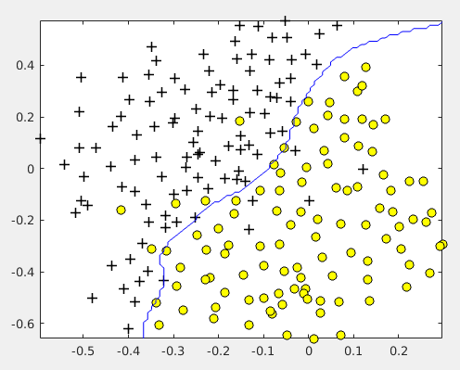
The next image is the result to try to choise the best value of the parameters C and sigma.

2 - Spam Classification

2.1 - Preprocessing Emails

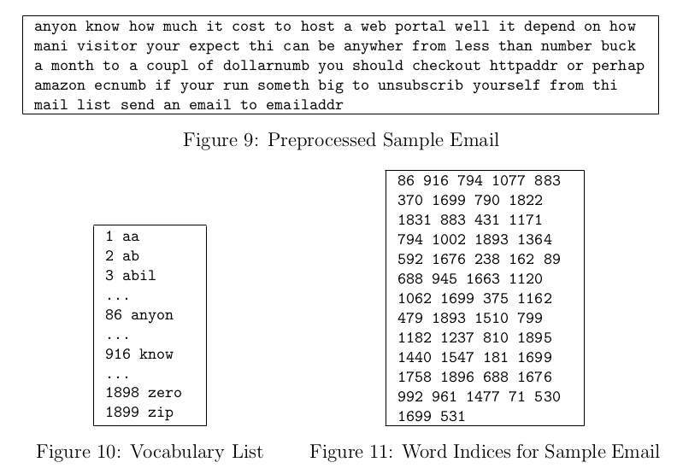

2.1.1 - Vocabulary List

function word_indices = processEmail(email_contents)
%PROCESSEMAIL preprocesses a the body of an email and
%returns a list of word_indices
% word_indices = PROCESSEMAIL(email_contents) preprocesses
% the body of an email and returns a list of indices of the
% words contained in the email.
%

% Load Vocabulary
vocabList = getVocabList();

% Init return value
word_indices = [];

% ========================== Preprocess Email ===========================

% Find the Headers ( \n\n and remove )
% Uncomment the following lines if you are working with raw emails with the
% full headers

% hdrstart = strfind(email_contents, ([char(10) char(10)]));
% email_contents = email_contents(hdrstart(1):end);

% Lower case
email_contents = lower(email_contents);

% Strip all HTML
% Looks for any expression that starts with < and ends with > and replace
% and does not have any < or > in the tag it with a space
email_contents = regexprep(email_contents, '<[^<>]+>', ' ');

% Handle Numbers
% Look for one or more characters between 0-9
email_contents = regexprep(email_contents, '[0-9]+', 'number');

% Handle URLS
% Look for strings starting with http:// or https://
email_contents = regexprep(email_contents, ...
'(http|https)://[^\s]*', 'httpaddr');

% Handle Email Addresses
% Look for strings with @ in the middle
email_contents = regexprep(email_contents, '[^\s]+@[^\s]+', 'emailaddr');

% Handle $ sign
email_contents = regexprep(email_contents, '[$]+', 'dollar');

% ========================== Tokenize Email ===========================

% Output the email to screen as well
fprintf('\n==== Processed Email ====\n\n');

% Process file
l = 0;

while ~isempty(email_contents)

% Tokenize and also get rid of any punctuation
[str, email_contents] = ...
strtok(email_contents, ...
[' @$/#.-:&*+=[]?!(){},''">_<;%' char(10) char(13)]);

% Remove any non alphanumeric characters
str = regexprep(str, '[^a-zA-Z0-9]', '');

% Stem the word
% (the porterStemmer sometimes has issues, so we use a try catch block)
try str = porterStemmer(strtrim(str));
catch str = ''; continue;
end;

% Skip the word if it is too short
if length(str) < 1
continue;
end

% Look up the word in the dictionary and add to word_indices if
% found
% ================= YOUR CODE HERE ======================
% Instructions: Fill in this function to add the index of str to
% word_indices if it is in the vocabulary. At this point
% of the code, you have a stemmed word from the email in
% the variable str. You should look up str in the
% vocabulary list (vocabList). If a match exists, you
% should add the index of the word to the word_indices
% vector. Concretely, if str = 'action', then you should
% look up the vocabulary list to find where in vocabList
% 'action' appears. For example, if vocabList{18} =
% 'action', then, you should add 18 to the word_indices
% vector (e.g., word_indices = [word_indices ; 18]; ).
%
% Note: vocabList{idx} returns a the word with index idx in the
% vocabulary list.
%
% Note: You can use strcmp(str1, str2) to compare two strings (str1 and
% str2). It will return 1 only if the two strings are equivalent.
%

for i = 1:length(vocabList)
if strcmp(str,vocabList{i})
word_indices = [word_indices; i];
break;
end
end

%==============================================

% Print to screen, ensuring that the output lines are not too long
if (l + length(str) + 1) > 78
fprintf('\n');
l = 0;
end
fprintf('%s ', str);
l = l + length(str) + 1;

end

% Print footer
fprintf('\n\n=========================\n');

end

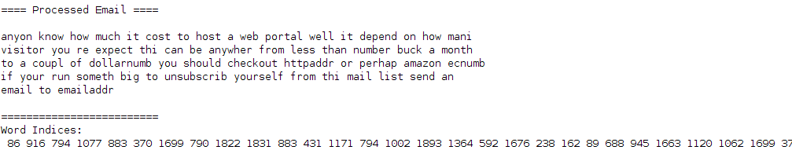

2.2 - Extracting Features from Emails

function x = emailFeatures(word_indices)
%EMAILFEATURES takes in a word_indices vector and produces a feature vector
%from the word indices
% x = EMAILFEATURES(word_indices) takes in a word_indices vector and
% produces a feature vector from the word indices.

% Total number of words in the dictionary
n = 1899;

% You need to return the following variables correctly.
x = zeros(n, 1);

% ====================== YOUR CODE HERE ======================
% Instructions: Fill in this function to return a feature vector for the
% given email (word_indices). To help make it easier to
% process the emails, we have have already pre-processed each
% email and converted each word in the email into an index in
% a fixed dictionary (of 1899 words). The variable
% word_indices contains the list of indices of the words
% which occur in one email.
%
% Concretely, if an email has the text:
%
% The quick brown fox jumped over the lazy dog.
%
% Then, the word_indices vector for this text might look
% like:
%
% 60 100 33 44 10 53 60 58 5
%
% where, we have mapped each word onto a number, for example:
%
% the -- 60
% quick -- 100
% ...
%
% (note: the above numbers are just an example and are not the
% actual mappings).
%
% Your task is take one such word_indices vector and construct
% a binary feature vector that indicates whether a particular
% word occurs in the email. That is, x(i) = 1 when word i
% is present in the email. Concretely, if the word 'the' (say,
% index 60) appears in the email, then x(60) = 1. The feature
% vector should look like:
%
% x = [ 0 0 0 0 1 0 0 0 ... 0 0 0 0 1 ... 0 0 0 1 0 ..];
%
%

for i = 1:length(word_indices)
x(word_indices(i)) = 1;
end

%======================================================

end

2.3 - Training SVM for Spam Classification

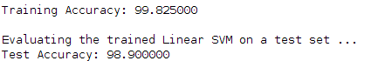

2.4 - Top Predictors for Spam

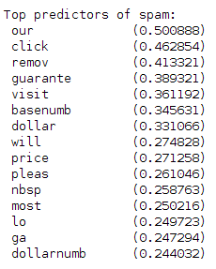
2.5 - Optional (ungraded) exercise: Try your own emails

The last part of ex6 spam.m runs the spam classifier over the first spam example and classifies it using the learned SVM.

