Introduction

In this exercise, you will implement the K-means clustering algorithm → apply it to compress an image.

In the second part, you will use principal component analysis → to find a low-dimensional representation of face images.

Files included in this exercise

ex7.m - Octave/MATLAB script for the first exercise on K-means
ex7 pca.m - Octave/MATLAB script for the second exercise on PCA
ex7data1.mat - Example Dataset for PCA
ex7data2.mat - Example Dataset for K-means
ex7faces.mat - Faces Dataset
bird small.png - Example Image
displayData.m - Displays 2D data stored in a matrix
drawLine.m - Draws a line over an exsiting figure
plotDataPoints.m - Initialization for K-means centroids
plotProgresskMeans.m - Plots each step of K-means as it proceeds
1runkMeans.m - Runs the K-means algorithm
submit.m - Submission script that sends your solutions to our servers
[?] pca.m - Perform principal component analysis
[?] projectData.m - Projects a data set into a lower dimensional space
[?] recoverData.m - Recovers the original data from the projection
[?] findClosestCentroids.m - Find closest centroids (used in K-means)
[?] computeCentroids.m - Compute centroid means (used in K-means)
[?] kMeansInitCentroids.m - Initialization for K-means centroids7

1 - K-means Clustering

You wil use the K-means algorithm for image compression by reducing the number of colors that occur in an image to only those that are most common in that image.

1.1 - Implementing K-means

The K-means algorithm is as follows:
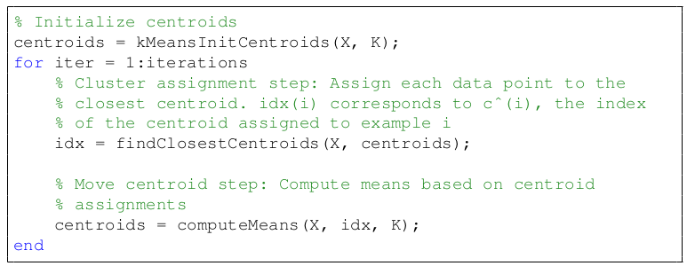
Note that the converged solution may not always be ideal and depends on the initial setting of the centroids.

1.1.1 - Finding closest centroids

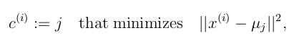
where c (i) is the index of the centroid that is closest to x (i) , and μ j is the position (value) of the j’th centroid. Note that c (i) corresponds to idx(i) in the starter code.

Your task is to complete the code in findClosestCentroids.m. This function takes the data matrix X and the locations of all centroids inside centroids and should output a one-dimensional array idx that holds the index (a value in {1, ..., K}, where K is total number of centroids) of the closest centroid to every training example.

function idx = findClosestCentroids(X, centroids)
%FINDCLOSESTCENTROIDS computes the centroid memberships for every example
% idx = FINDCLOSESTCENTROIDS (X, centroids) returns the closest centroids
% in idx for a dataset X where each row is a single example. idx = m x 1
% vector of centroid assignments (i.e. each entry in range [1..K])
%

% Set K
K = size(centroids, 1);

% You need to return the following variables correctly.
idx = zeros(size(X,1), 1);

% ====================== YOUR CODE HERE ======================
% Instructions: Go over every example, find its closest centroid, and store
% the index inside idx at the appropriate location.
% Concretely, idx(i) should contain the index of the centroid
% closest to example i. Hence, it should be a value in the
% range 1..K
%
% Note: You can use a for-loop over the examples to compute this.
%

N = size(X,2);

for i=1:length(X)
for k=1:K
for n=1:N
a(n)=(X(i,n)-centroids(k,n)).^2; % Calc distance from X to centroids (sum to N, not just 2)
end
dist(k)=sum(a); % Distance from point X to centroids
end
[r,c] = min(dist); % Find the index of the min distance btw X and centroids
idx(i) = c; % Assign for each X which centroid it belongs to
end

%===========================================

end

1.1.2 - Computing centroid means

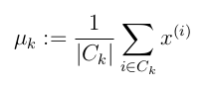
where C k is the set of examples that are assigned to centroid k.

function centroids = computeCentroids(X, idx, K)
%COMPUTECENTROIDS returns the new centroids by computing the means of the
%data points assigned to each centroid.
% centroids = COMPUTECENTROIDS(X, idx, K) returns the new centroids by
% computing the means of the data points assigned to each centroid. It is
% given a dataset X where each row is a single data point, a vector
% idx of centroid assignments (i.e. each entry in range [1..K]) for each
% example, and K, the number of centroids. You should return a matrix
% centroids, where each row of centroids is the mean of the data points
% assigned to it.
%

% Useful variables
[m n] = size(X);

% You need to return the following variables correctly.
centroids = zeros(K, n);

% ====================== YOUR CODE HERE ======================
% Instructions: Go over every centroid and compute mean of all points that
% belong to it. Concretely, the row vector centroids(i, :)
% should contain the mean of the data points assigned to
% centroid i.
%
% Note: You can use a for-loop over the centroids to compute this.
%

for i = 1:K
c_i = idx==i;
n_i = sum(c_i);
c_i_matrix = repmat(c_i,1,n);
X_c_i = X .* c_i_matrix;
centroids(i,:) = sum(X_c_i) ./ n_i;
end

%=================================================

end

1.2 - K-means on example dataset

Runs ex7-m that use the functions implemented and try to undertand how works.

>> ex7.m

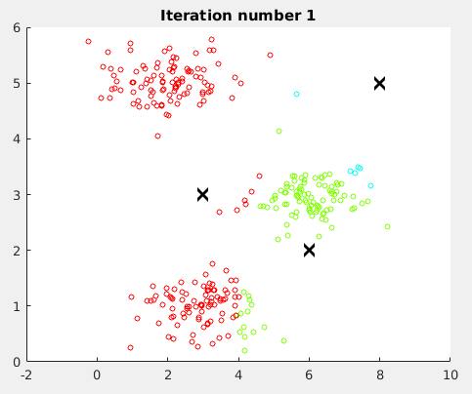

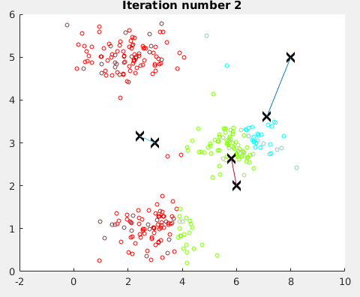

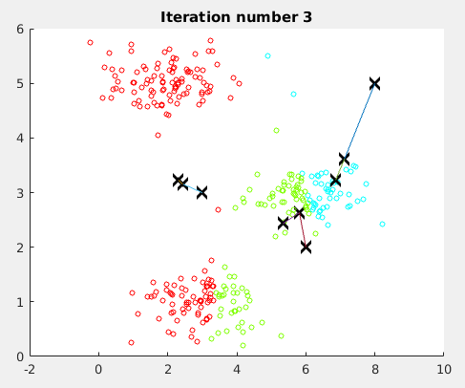

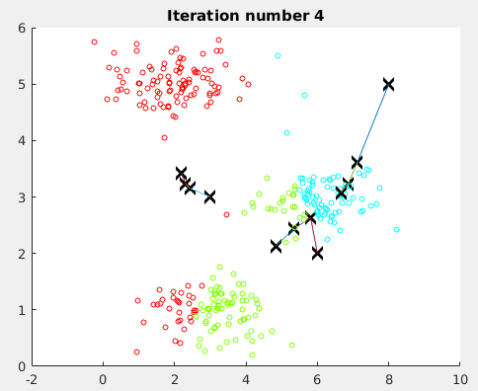

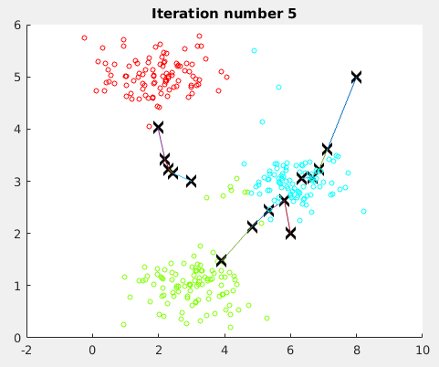
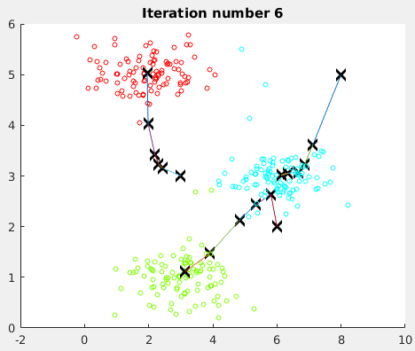

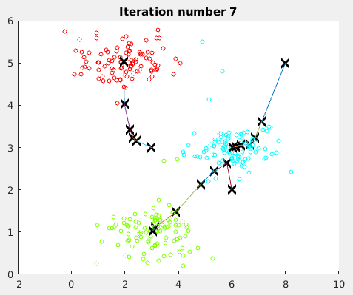
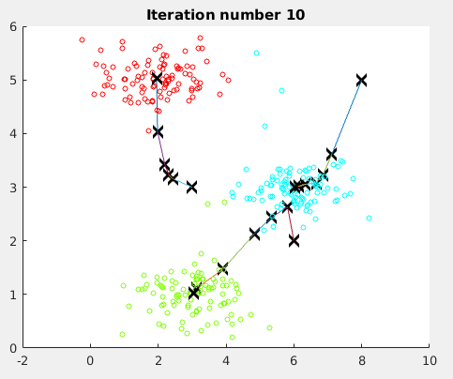

1.3 - Random initialization

A good strategy for initializing the centroids is to select random examples from the training set.
In this part of the exercise, you should complete the function kMeansInitCentroids.m
with the following code:

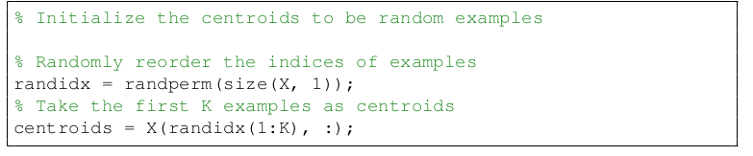

1.4 - Image compression with K-means

n this exercise, you will apply K-means to image compression. In a 6straightforward 24-bit color representation of an image, 2 each pixel is represented as three 8-bit unsigned integers (ranging from 0 to 255) that specify the red, green and blue intensity values.

In this exercise, you will use the K-means algorithm to select the 16 colors that will be used to represent the compressed image.

1.4.1 - K-means on pixels

In Octave/MATLAB, images can be read in as follows
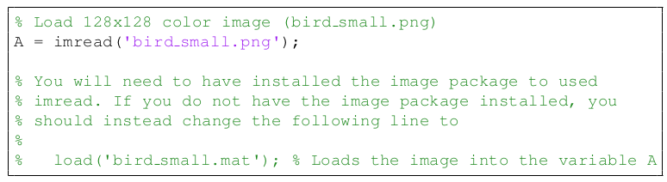
This creates a three-dimensional matrix A whose first two indices identify a pixel position and whose last index represents red, green, or blue.
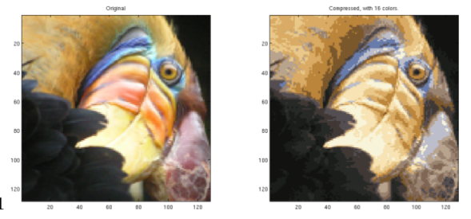
***The code doesn’t works well****
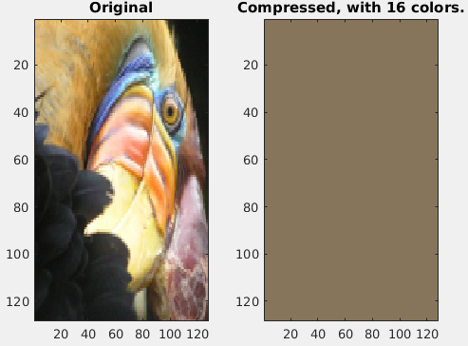
2 - Principal Component Analysis
In this exercise, you will use principal component analysis (PCA) to perform dimensionality reduction.

You will first experiment with an example 2D dataset to get intuition on how PCA works, and then use it on a bigger dataset of 5000 face image dataset.

2.1 - Example Dataset

To help you understand how PCA works, you will first start with a 2D dataset which has one direction of large variation and one of smaller variation.

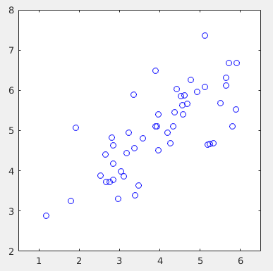

2.2 - Implementing PCA

1) Compute covariance matrix → sigma = 1/m x’*x
2) svd (sigma)

function [U, S] = pca(X)
%PCA Run principal component analysis on the dataset X
% [U, S, X] = pca(X) computes eigenvectors of the covariance matrix of X
% Returns the eigenvectors U, the eigenvalues (on diagonal) in S
%

% Useful values
[m, n] = size(X);

% You need to return the following variables correctly.
U = zeros(n);
S = zeros(n);

% ====================== YOUR CODE HERE ======================
% Instructions: You should first compute the covariance matrix. Then, you
% should use the "svd" function to compute the eigenvectors
% and eigenvalues of the covariance matrix.
%
% Note: When computing the covariance matrix, remember to divide by m (the
% number of examples).
%

Sigma=(1./m).*X'*X;
[U, S, V]=svd(Sigma);

%===================================================

end

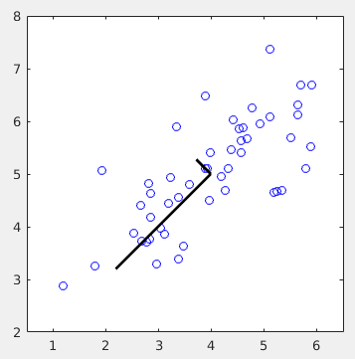

2.3 - Dimensionality Reduction with PCA

2.3.1 - Projecting the data onto the principal components

You should now complete the code in projectData.m. Specifically, you are given a dataset X, the principal components U, and the desired number of dimensions to reduce to K. You should project each example in X onto the top K components in U.

function Z = projectData(X, U, K)
%PROJECTDATA Computes the reduced data representation when projecting only
%on to the top k eigenvectors
% Z = projectData(X, U, K) computes the projection of
% the normalized inputs X into the reduced dimensional space spanned by
% the first K columns of U. It returns the projected examples in Z.
%

% You need to return the following variables correctly.
Z = zeros(size(X, 1), K);

% ====================== YOUR CODE HERE ======================
% Instructions: Compute the projection of the data using only the top K
% eigenvectors in U (first K columns).
% For the i-th example X(i,:), the projection on to the k-th
% eigenvector is given as follows:
% x = X(i, :)';
% projection_k = x' * U(:, k);
%

Z=X*U(:,1:K);

%================================================

end

2.3.2 - Reconstructing an approximation of the data

Project each example in Z back onto the original space and return the recovered approxi-
mation in X rec.

function X_rec = recoverData(Z, U, K)
%RECOVERDATA Recovers an approximation of the original data when using the
%projected data
% X_rec = RECOVERDATA(Z, U, K) recovers an approximation the
% original data that has been reduced to K dimensions. It returns the
% approximate reconstruction in X_rec.
%

% You need to return the following variables correctly.
X_rec = zeros(size(Z, 1), size(U, 1));

% ====================== YOUR CODE HERE ======================
% Instructions: Compute the approximation of the data by projecting back
% onto the original space using the top K eigenvectors in U.
%
% For the i-th example Z(i,:), the (approximate)
% recovered data for dimension j is given as follows:
% v = Z(i, :)';
% recovered_j = v' * U(j, 1:K)';
%
% Notice that U(j, 1:K) is a row vector.
%

X_rec=Z*U(:,1:K)';

%======================================================

end
2.3.3 - Visualizing the projections

>>ex7_pca

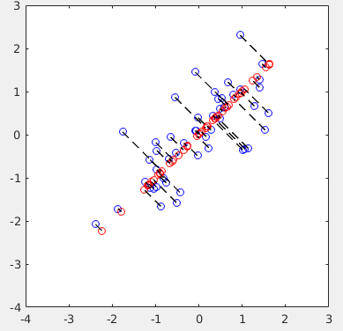
2.4 - Face Image Dataset

In this part of the exercise, you will run PCA on face images to see how it can be used in practice for dimension reduction.

This dataset was based on a cropped version of the labeled faces in the wild dataset.

Will load and visualize the first 100 of these face images

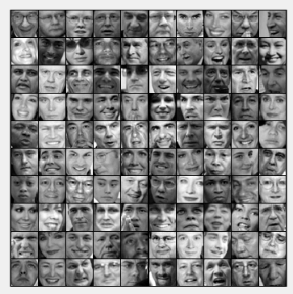
2.4.1 - PCA on Faces

First normalize the dataset by subtracting the mean of each feature from the data matrix X.

After running PCA, you will obtain the principal components of the dataset.

2.4.2 - Dimensionality Reduction

Now that you have computed the principal components for the face dataset, you can use it to reduce the dimension of the face dataset.

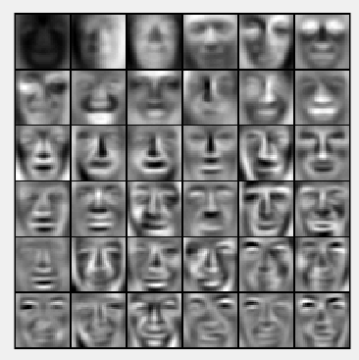
The projected data Z has a size of: 5000 100

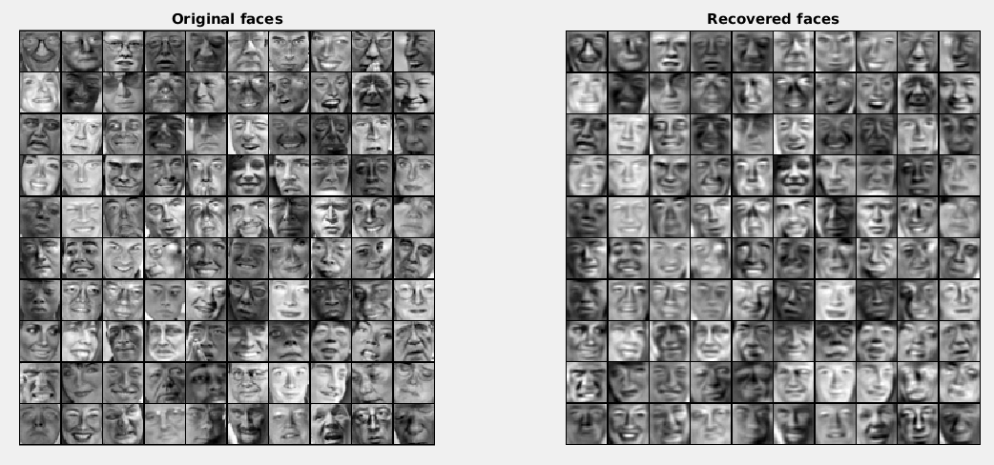

2.5 - Optional (ungraded) exercise: PCA for visualization

