Programming Exercise 8: Anomaly Detection and Recommender Systems

Introduction

In this exercise, you will implement the anomaly detection algorithm and
apply it to detect failing servers on a network. In the second part, you will
use collaborative filtering to build a recommender system for movies.

Files included in this exercise

ex8.m - Octave/MATLAB script for first part of exercise
ex8 cofi.m - Octave/MATLAB script for second part of exercise
ex8data1.mat - First example Dataset for anomaly detection
ex8data2.mat - Second example Dataset for anomaly detection
ex8 movies.mat - Movie Review Dataset
ex8 movieParams.mat - Parameters provided for debugging
multivariateGaussian.m - Computes the probability density function
for a Gaussian distribution
visualizeFit.m - 2D plot of a Gaussian distribution and a dataset
checkCostFunction.m - Gradient checking for collaborative filtering
computeNumericalGradient.m - Numerically compute gradients
1fmincg.m - Function minimization routine (similar to fminunc)
loadMovieList.m - Loads the list of movies into a cell-array
movie ids.txt - List of movies
normalizeRatings.m - Mean normalization for collaborative filtering
submit.m - Submission script that sends your solutions to our servers
[?] estimateGaussian.m - Estimate the parameters of a Gaussian dis-
tribution with a diagonal covariance matrix
[?] selectThreshold.m - Find a threshold for anomaly detection
[?] cofiCostFunc.m - Implement the cost function for collaborative fil-
tering

1 - Anomaly detection

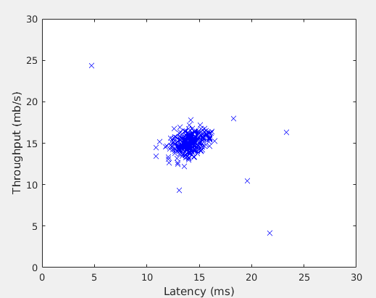

1.1 - Gaussian distribution

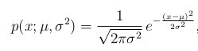

1.2 - Estimating parameters for a Gaussian

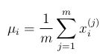
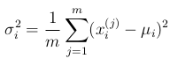

function [mu sigma2] = estimateGaussian(X)
%ESTIMATEGAUSSIAN This function estimates the parameters of a
%Gaussian distribution using the data in X
% [mu sigma2] = estimateGaussian(X),
% The input X is the dataset with each n-dimensional data point in one row
% The output is an n-dimensional vector mu, the mean of the data set
% and the variances sigma^2, an n x 1 vector
%

% Useful variables
[m, n] = size(X);

% You should return these values correctly
mu = zeros(n, 1);
sigma2 = zeros(n, 1);

% ====================== YOUR CODE HERE ======================
% Instructions: Compute the mean of the data and the variances
% In particular, mu(i) should contain the mean of
% the data for the i-th feature and sigma2(i)
% should contain variance of the i-th feature.
%

mu=1./m.*sum(X)

%for i=1:n
% sigma2(i)=1./m.*sum((X-mu(i)).^2);
%end
sigma2=var(X).*(m-1)./m;

%====================================================

end

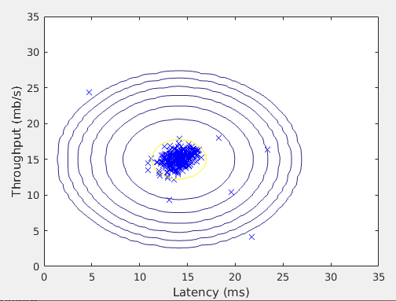
1.3 - Selecting the threshold, ε

The F 1 score is computed using precision (prec) and recall (rec):

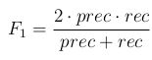

You compute precision and recall by:

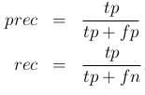
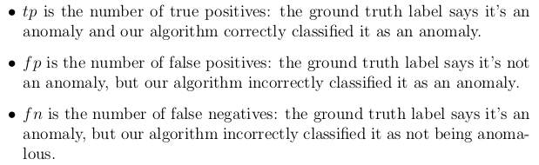

function [bestEpsilon bestF1] = selectThreshold(yval, pval)
%SELECTTHRESHOLD Find the best threshold (epsilon) to use for selecting
%outliers
% [bestEpsilon bestF1] = SELECTTHRESHOLD(yval, pval) finds the best
% threshold to use for selecting outliers based on the results from a
% validation set (pval) and the ground truth (yval).
%

bestEpsilon = 0;
bestF1 = 0;
F1 = 0;

stepsize = (max(pval) - min(pval)) / 1000;
for epsilon = min(pval):stepsize:max(pval)

% ============== YOUR CODE HERE ======================
% Instructions: Compute the F1 score of choosing epsilon as the
% threshold and place the value in F1. The code at the
% end of the loop will compare the F1 score for this
% choice of epsilon and set it to be the best epsilon if
% it is better than the current choice of epsilon.
%
% Note: You can use predictions = (pval < epsilon) to get a binary vector
% of 0's and 1's of the outlier predictions

predictions = (pval < epsilon);
tp = sum((yval==1) & (predictions==1));
fp = sum((yval==0) & (predictions==1));
fn = sum((yval==1) & (predictions==0));

prec = tp./(tp+fp);
rec = tp./(tp+fn);

F1 = 2.*prec.*rec/(prec+rec);

%=====================================================

if F1 > bestF1
bestF1 = F1;
bestEpsilon = epsilon;
end
end

end

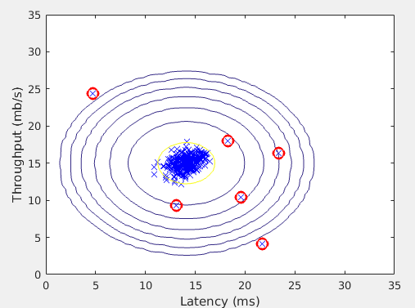

1.4 - High dimensional dataset
The last part of the script ex8.m will run the anomaly detection algorithm
you implemented on a more realistic and much harder dataset. In this
dataset, each example is described by 11 features, capturing many more
properties of your compute servers.
2 - Recommender Systems

In this part of the exercise, you will implement the collaborative filtering
learning algorithm and apply it to a dataset of movie ratings.

This dataset consists of ratings on a scale of 1 to 5. The dataset has n_u = 943 users, and
n_m = 1682 movies.

2.1 - Movie ratings dataset

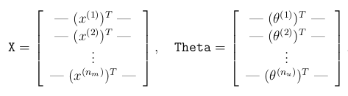

The i-th row of X corresponds to the feature vector x (i) for the i-th movie, and the j-th row of Theta corresponds to one parameter vector θ (j) , for the j-th user. Both x (i) and θ (j) are n-dimensional vectors. For the purposes of this exercise, you will use n = 100, and therefore, x (i) ∈ R 100 and θ (j) ∈ R 100 . Correspondingly, X is a n m × 100 matrix and Theta is a n u × 100 matrix.

2.2 - Collaborative filtering learning algorithm

The collaborative filtering algorithm in the setting of movie recommendations considers a set of n-dimensional parameter vectors x (1) , ..., x (n m ) and θ (1) , ..., θ (n u ) , where the model predicts the rating for movie i by user j as y (i,j) = (θ (j) ) T x (i) . Given a dataset that consists of a set of ratings produced by some users on some movies, you wish to learn the parameter vectors x (1) , ..., x (n m ) , θ (1) , ..., θ (n u ) that produce the best fit (minimizes the squared error).

2.2.1 - Collaborative filtering cost function

The collaborative filtering cost function (without regularization):

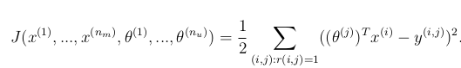
2.2.2 - Collaborative filtering gradient

Now, you should implement the gradient (without regularization):

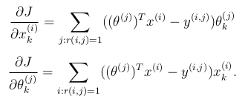
Note that the function returns the gradient for both sets of variables by unrolling them into a single vector.

2.2.3 - Regularized cost function

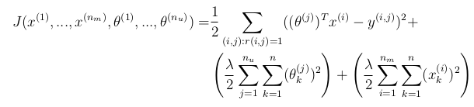
2.2.4 - Regularized gradient

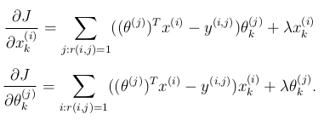

function [J, grad] = cofiCostFunc(params, Y, R, num_users, num_movies, ...
num_features, lambda)
%COFICOSTFUNC Collaborative filtering cost function
% [J, grad] = COFICOSTFUNC(params, Y, R, num_users, num_movies, ...
% num_features, lambda) returns the cost and gradient for the
% collaborative filtering problem.
%

% Unfold the U and W matrices from params
X = reshape(params(1:num_movies*num_features), num_movies, num_features);
Theta = reshape(params(num_movies*num_features+1:end), ...
num_users, num_features);

% You need to return the following values correctly
J = 0;
X_grad = zeros(size(X));
Theta_grad = zeros(size(Theta));

% ====================== YOUR CODE HERE ======================
% Instructions: Compute the cost function and gradient for collaborative
% filtering. Concretely, you should first implement the cost
% function (without regularization) and make sure it is
% matches our costs. After that, you should implement the
% gradient and use the checkCostFunction routine to check
% that the gradient is correct. Finally, you should implement
% regularization.
%
% Notes: X - num_movies x num_features matrix of movie features
% Theta - num_users x num_features matrix of user features
% Y - num_movies x num_users matrix of user ratings of movies
% R - num_movies x num_users matrix, where R(i, j) = 1 if the
% i-th movie was rated by the j-th user
%
% You should set the following variables correctly:
%
% X_grad - num_movies x num_features matrix, containing the
% partial derivatives w.r.t. to each element of X
% Theta_grad - num_users x num_features matrix, containing the
% partial derivatives w.r.t. to each element of Theta
%

J = (1/2).*sum(sum(((X*Theta').*R-Y.*R).^2))+(lambda./2.*sum(sum(Theta.^2)))+(lambda./2.*sum(sum(X.^2)));
% Only predict rating X*Theta' if user has rated (i.e. R=1)

X_grad = (((X*Theta').*R*Theta-Y.*R*Theta)+lambda.*X);
Theta_grad = ((X'*((X*Theta').*R)-X'*(Y.*R)))'+lambda.*Theta;

% Alternative according to exercise handout
%[r,c]=size(R);
%for i=1:r
% idx = find(R(i,:)==1);
% Theta_temp = Theta(idx,:);
% Y_temp = Y(i,idx);
% X_grad(i,:) = (X(i,:)*Theta_temp'-Y_temp)*Theta_temp;
%end

% For Theta_grad, similar approach to X_grad

%==============================================

grad = [X_grad(:); Theta_grad(:)];

end

2.3 - Learning movie recommendations

After you have finished implementing the collaborative filtering cost function and gradient, you can now start training your algorithm to make movie recommendations for yourself.

2.3.1 – Recommendations

Executing the code:

Top recommendations for you:
Predicting rating 5.0 for movie Great Day in Harlem, A (1994)
Predicting rating 5.0 for movie Saint of Fort Washington, The (1993)
Predicting rating 5.0 for movie Someone Else's America (1995)
Predicting rating 5.0 for movie Santa with Muscles (1996)
Predicting rating 5.0 for movie Entertaining Angels: The Dorothy Day Story (1996)
Predicting rating 5.0 for movie Aiqing wansui (1994)
Predicting rating 5.0 for movie Prefontaine (1997)
Predicting rating 5.0 for movie They Made Me a Criminal (1939)
Predicting rating 5.0 for movie Marlene Dietrich: Shadow and Light (1996)
Predicting rating 5.0 for movie Star Kid (1997)

Original ratings provided:
Rated 4 for Toy Story (1995)
Rated 3 for Twelve Monkeys (1995)
Rated 5 for Usual Suspects, The (1995)
Rated 4 for Outbreak (1995)
Rated 5 for Shawshank Redemption, The (1994)
Rated 3 for While You Were Sleeping (1995)
Rated 5 for Forrest Gump (1994)
Rated 2 for Silence of the Lambs, The (1991)
Rated 4 for Alien (1979)
Rated 5 for Die Hard 2 (1990)
Rated 5 for Sphere (1998)

