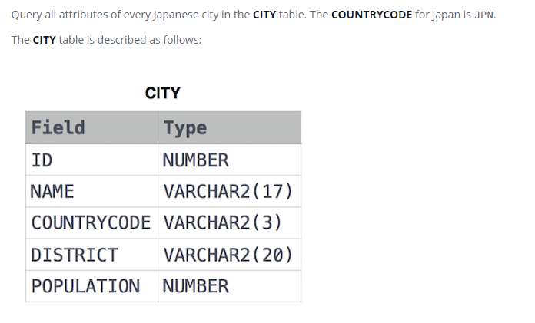

SELECT \*

FROM CITY

WHERE (COUNTRYCODE='JPN');