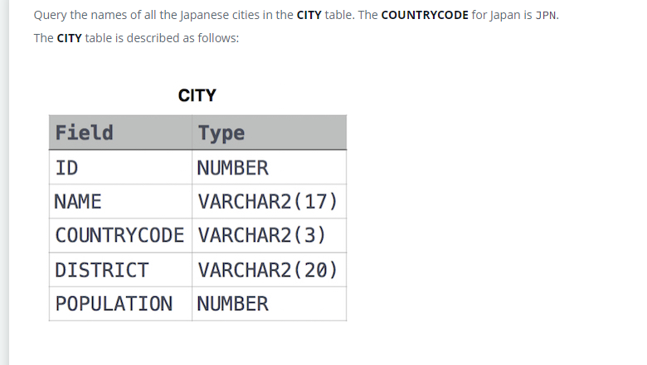

SELECT NAME

FROM CITY

WHERE (COUNTRYCODE = 'JPN');