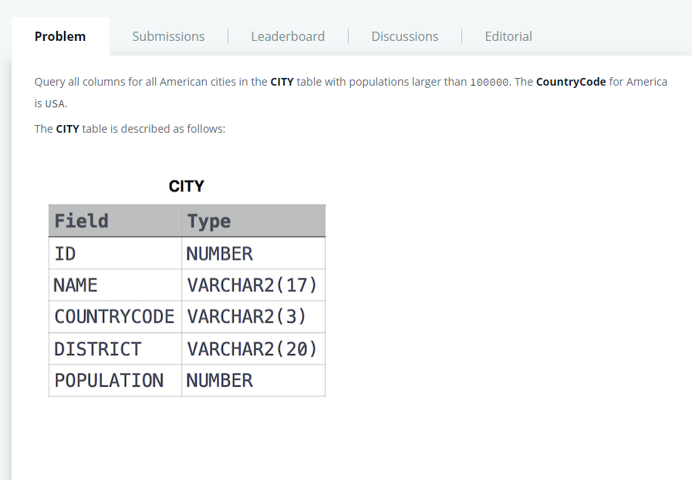

SELECT \*

FROM CITY

WHERE (COUNTRYCODE = 'USA') AND POPULATION >100000