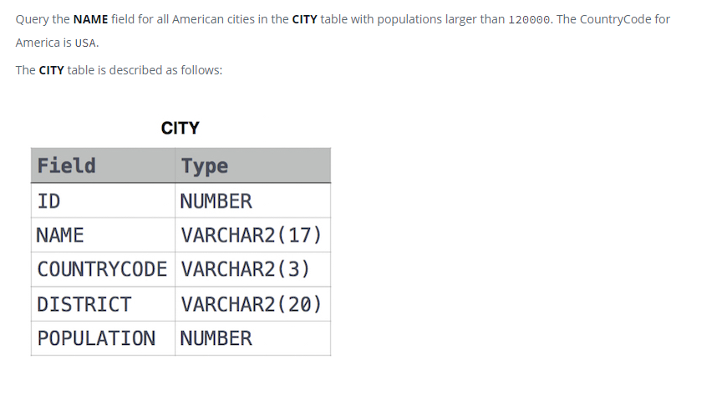

SELECT NAME

FROM CITY

WHERE (COUNTRYCODE="USA") AND POPULATION> 120000