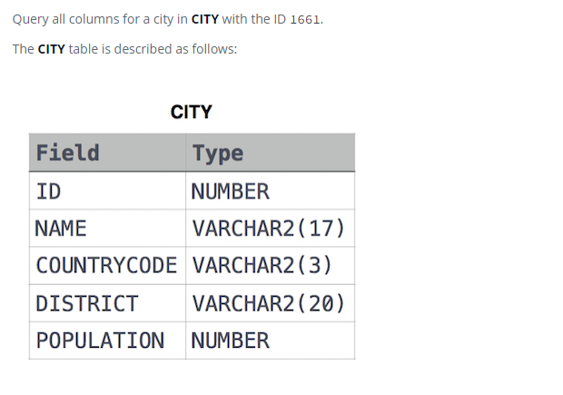

SELECT \*

FROM CITY

WHERE ID = 1661