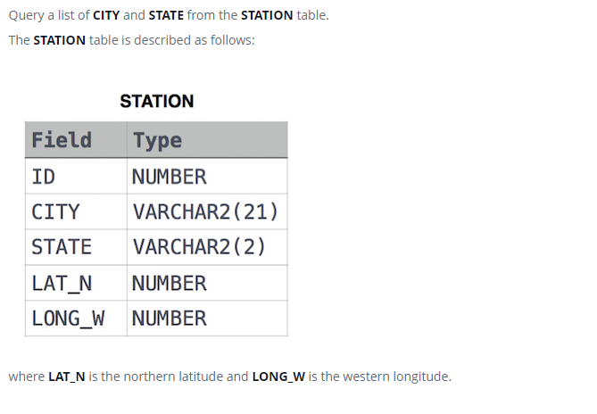

SELECT CITY, STATE FROM STATION;