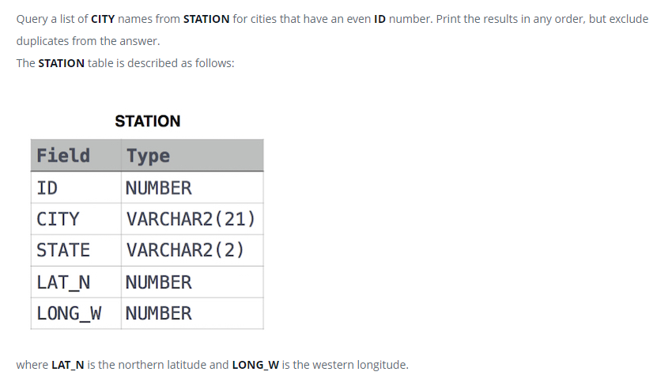

SELECT DISTINCT CITY

FROM STATION

WHERE ID % 2 =0;