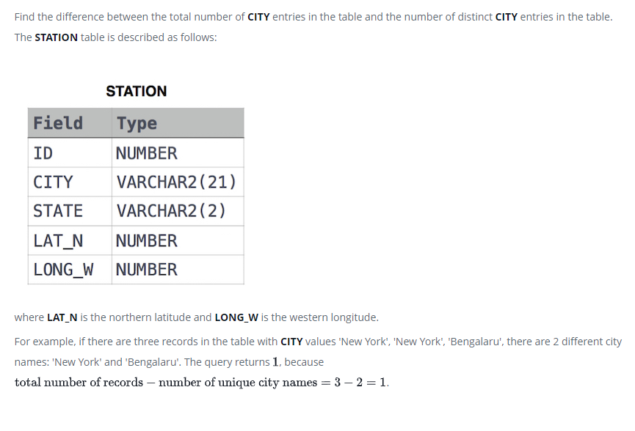

SELECT COUNT(CITY) - COUNT(DISTINCT CITY)

FROM STATION;