Line DDA algorithm, time – 67 ms:

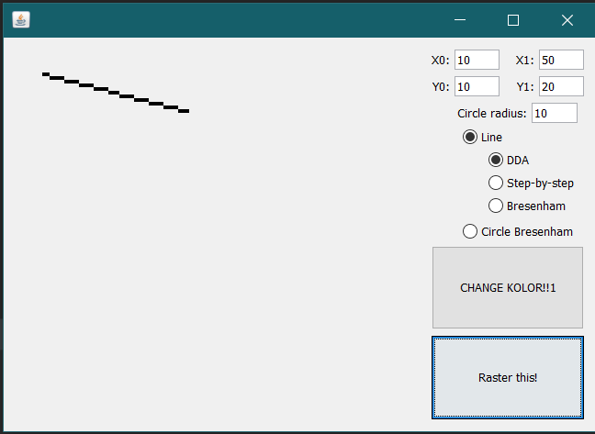

Line step-by-step algorithm, time – 128 ms:

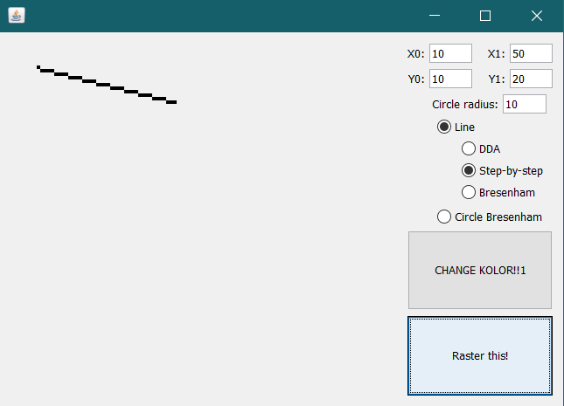

Line Bresenham algorithm, time – 85 ms:

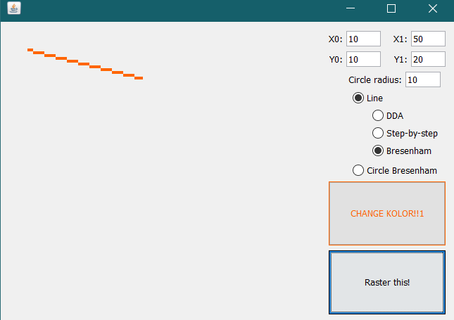

Circle Bresenham algorithm, time – 27 ms:

