0.vagrant up

After all VMs are up :

1.vagrant ssh docker

2. cd /vagrant/terraform-all

3. terraform init

4. terraform plan

5. terraform apply

6. After all containers are up check if rabbit-discoverer and observer are up using docker container ls

If they are exited execute terraform apply again .   
If they are up execute

docker container restart rabbit-discoverer and docker container restart rabbit-observer

After all that the following should be visible after executing the docker logs command for rabbit-discoverer and observer and docker container ls :

7.Enter http://192.168.99.100:3000/dashboard/import in order to import RabbitMQ monitoring dashboard

8. Paste the following in the box below Import via grafana.com :

https://grafana.com/grafana/dashboards/10991-rabbitmq-overview/?fbclid=IwAR3XiHn_-GVl0EfGz11IOehRepes6QDP1r8GUTulReGhetfAUT8TDRq_q1o

9.Above the Import button you must choose Prometheus .

10. The following should be visible now :

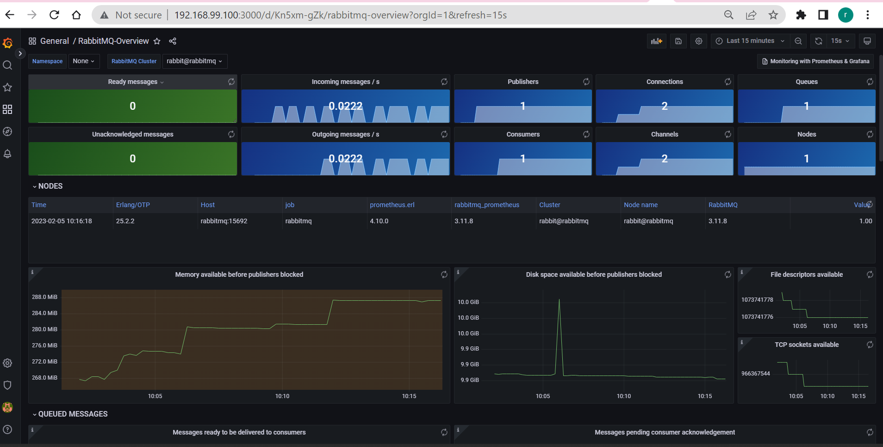

11. In order to get metrics from the discoverer, go to <http://192.168.99.100:3000/dashboards> --> New Dashboard 🡪 Add new Panel 🡪 Add the below query   
discovered_facts_created{instance="rabbit-discoverer:8000"}

Or this one

discovered_facts_total{job="rabbitmq-discoverer"}  
  
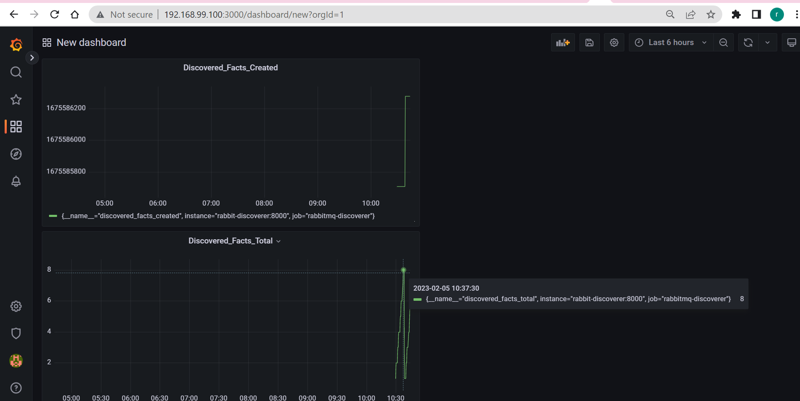

Enter : http://192.168.99.101:8081/

Enter http://192.168.99.101:8082/

Prometheus : http://192.168.99.100:9090/targets?search=

Observer <http://192.168.99.100:5000/> :  
  
