## Lab - Deep Learning in the cloud

# Lab - Search for Extra-Terrestrial Intelligence (SETI)¶

In this lab, we will use the famous SETI Dataset to build a Convolutional Neural Networks capable to perform signals classification. CNN will say, with some associated error, what type of signal is the presented input. You will use a cloud-based environment powered by GPU accelerators to run this lab.

Lab overview:

Each night, using the Allen Telescope Array (ATA) in northern California, the SETI Institute scans the sky at various radio frequencies, observing star systems with known exoplanets, searching for faint but persistent signals. The current signal detection system is programmed to search only for particular kinds of signals: narrow-band carrier waves. However, the detection system sometimes triggers on signals that are not narrow-band signals (with unknown efficiency) and are also not explicitly-known radio frequency interference (RFI). There seem to be various categories of these kinds of events that have been observed in the past. Our goal is to classify these accurately in real-time. This may allow the signal detection system to make better observational decisions, increase the efficiency of the nightly scans, and allow for the explicit detection of these other signal types.

Our goal:

Convolutional Neural Network involves a lot of matrix and vector multiplications that can be parallelized, so GPUs can overperform because GPUs were designed to handle these kinds of matrix operations in parallel!

If you don’t have a system with GPU on-premise, you still can accelerate your deep learning model in the cloud. To this end, you need to have access to a GPU-accelerated, high-performance computing platform in the cloud, such as IBM Power Systems S822LC (Minsky).  One of IBM partners, Nimbx, is hosting IBM Power Systems S822LC powered by the 128-thread POWER8 CPU, which are uniquely suited to GPU-accelerated, high-performance computing applications such as deep learning models.  You can get a trial account, for 24-hours of free processing time on the PowerAI platform, to run your model. Follow the instruction below:

## **Get 24-hours of free access to the PowerAI platform**

IBM has partnered with Nimbix to provide cognitive developers a trial account that provides 24-hours of free processing time on the PowerAI platform. Follow these steps to register for access to Nimbix to try the PowerAI Cognitive Code Patterns and explore the platform.

1) Go to the [Deep Learning and PowerAI Development](https://cocl.us/ML0122EN-PowerAI-Trial)

2) Click **Create a new account** to create an IBMid. If you already have an IBMid, enter your credentials and click **Continue**.  
3) On the **IBM PowerAI Trial registration** page, enter the required information and click **Continue**to complete the registration and launch the **IBM Marketplace Products and Services** page  
4) Your **IBM Marketplace Products and Services** page displays all offerings that are available to you; the PowerAI Trial should now be one of them. From the PowerAI Trial section, click **Launch**, as shown below, to launch the **IBM PowerAI trial** page. Note: Your trial container has a default four-hour timer built in.   
  
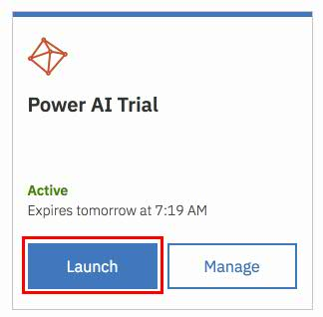

5) The **Welcome to IBM PowerAI Trial** page provides instructions for accessing the trial, as shown below. Alternatively, you will receive an email confirming your registration with similar instructions that you can follow to start the trial.   
  
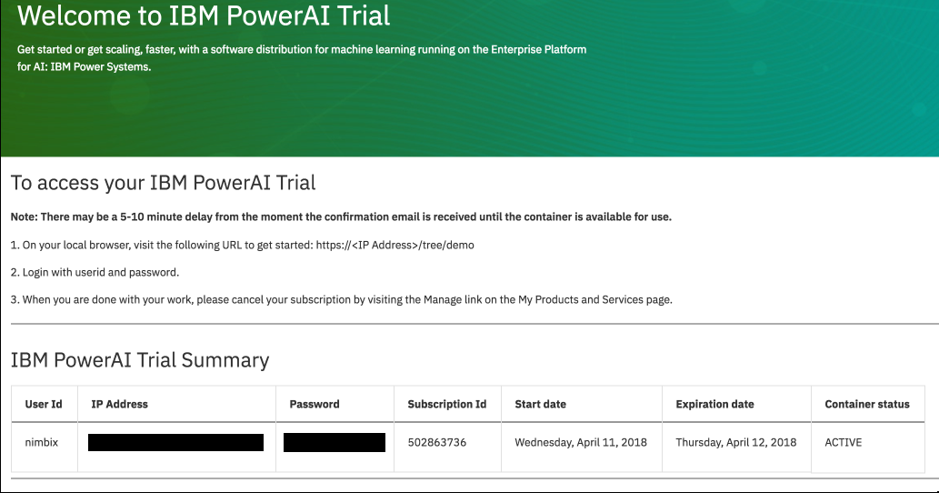

6) Start the trial:

* From your local browser, visit the following URL, https://<IP Address>/tree/demo  where IP Address is the IP Address shown on the Welcome page (or in the confirmation email)
* Login with the userid and password shown on the Welcome page (or in the confirmation email)

7) Click on SETI_CNN_Tf_SingleGpu.ipynb notebook and run it. In this notebook, we will use the famous [SETI Dataset](https://github.com/setiQuest/ML4SETI/) to build a Convolutional Neural Networks capable to perform signals classification. CNN will say, with some associated error, what type of signal is the presented input.