## Make your own Image Classification model

## Make your own object recognition model

PowerAI Vision is a powerful tool for image classification.   
In this lab, we will be using PowerAI Vision to train a model that given an image of fast food, it will correctly classify the image as Burger, Chicken, Coke, Fries, Hotdog, Pizza or Taco. However, if you have other topics in mind, you can also train your model to classify different images. Please take the following steps to complete the lab:

1. Getting in the PowerAI Vision.
2. Prepare and upload your dataset.
3. Train and deploy your model.
4. Test your model.
5. Use the API of your model for web applications.
6. **Optional:** Make a video of this lab and share it on social media. Feel free to make your video 'unlisted', to share with others.

## **Step 1)** Getting in your PowerAI Vision

* Please register a 3-days trail of PowerAI Vision by pressing on the link below.   
  Notice: It is a 3-days trial version of PowerAI Vision and you should finish your project in 3 days.
* After registration and launched PowerAI Vision, you should be on the webpage on the picture below. Copy the following URL into your browser address bar:   
  http://<IP Address>:9080/powerai-vision/index.html#!/datasets  
    
  And replace **<IP Address>** with the IP Address of your container indicated by the red rectangular border in the picture below.  
  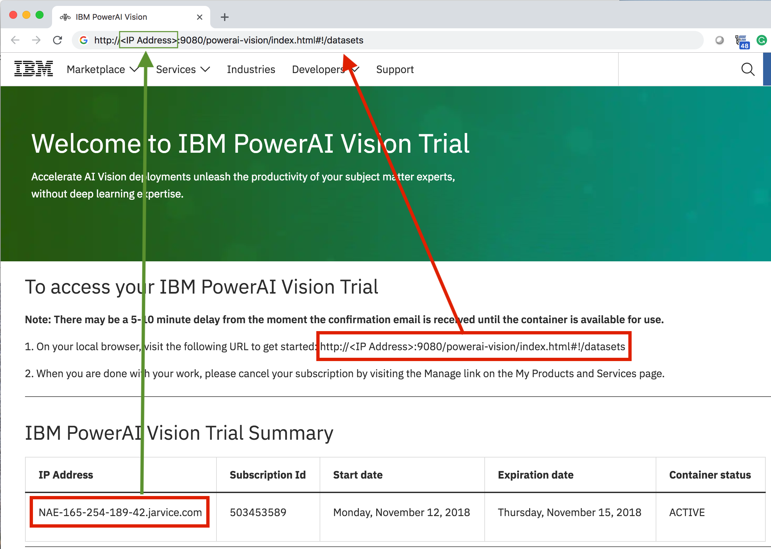

## **Step 2)** Prepare and upload your dataset

Once you are in **My Data Sets** workspace on PowerAI Vision, there are two ways you can upload a dataset for training your classification model. i) Upload from a zip file (which we already prepared for you), ii) Upload from images on your local drive.

### i) Upload from a zip file

Please press on the "Dataset" button below to download the zip file for the training dataset.

After you downloaded the zip file, go back to **My Data Sets** workspace on PowerAI Vision, on the top right corner click on **Add Dataset** button, then select the **Import From Zip File** option from the dropdown menu.  
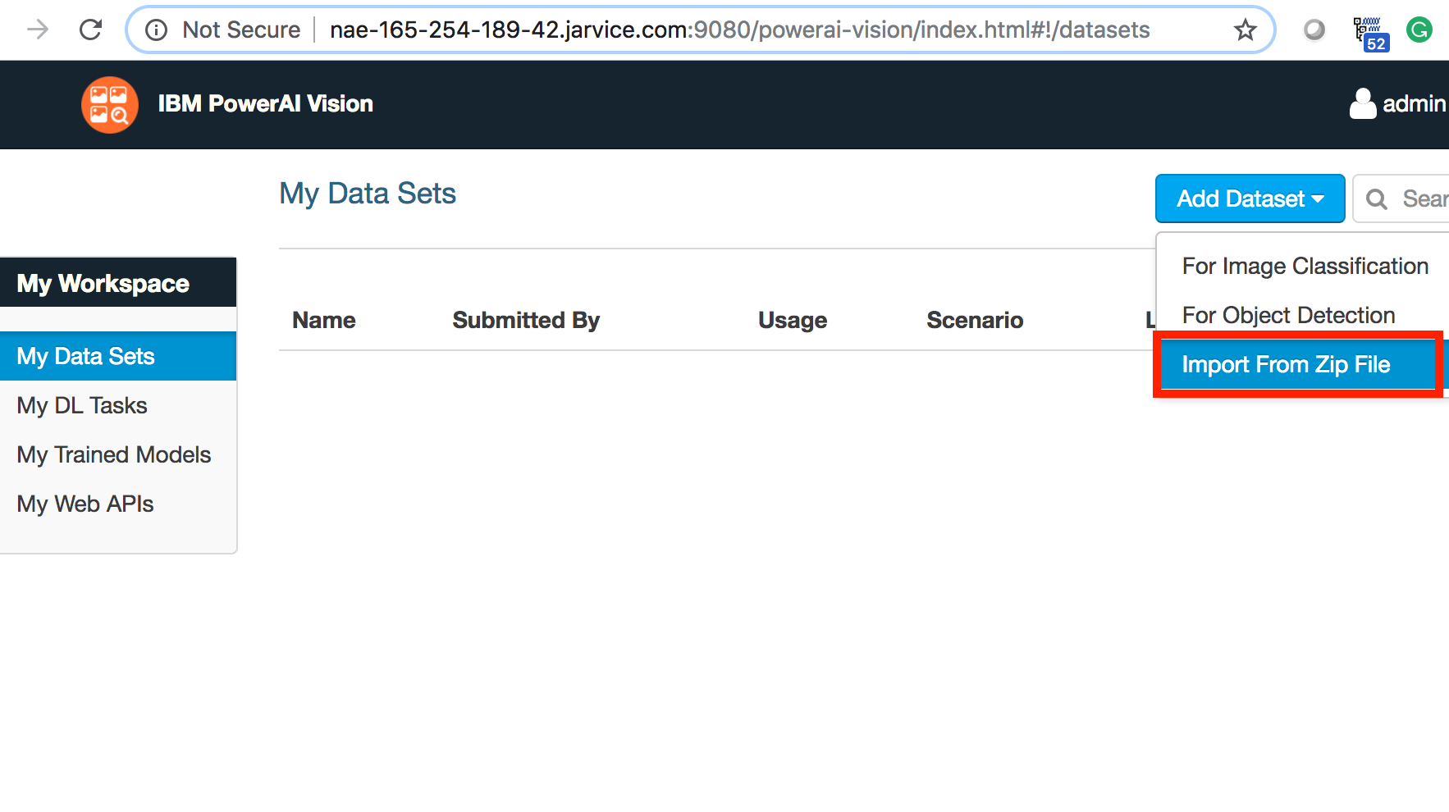

### ii) Upload from images on your local drive.

If you already have a dataset of "jpg/png" files on your local drive, you can upload your own dataset for training. On the top right corner click on **Add Dataset** button, then select the **For Image Classification** option from the dropdown menu.  
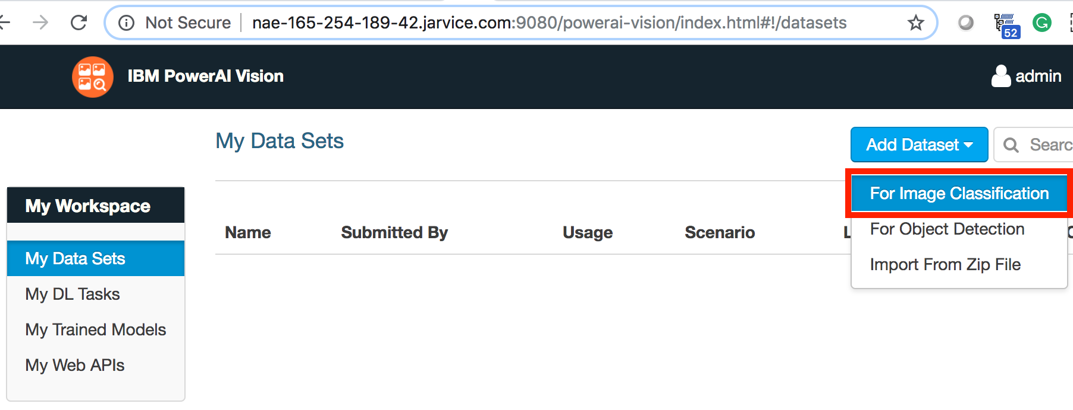  
  
Give your dataset a name, for example "FastFoodClassifier", then select **Other ( other scenarios )** option.  
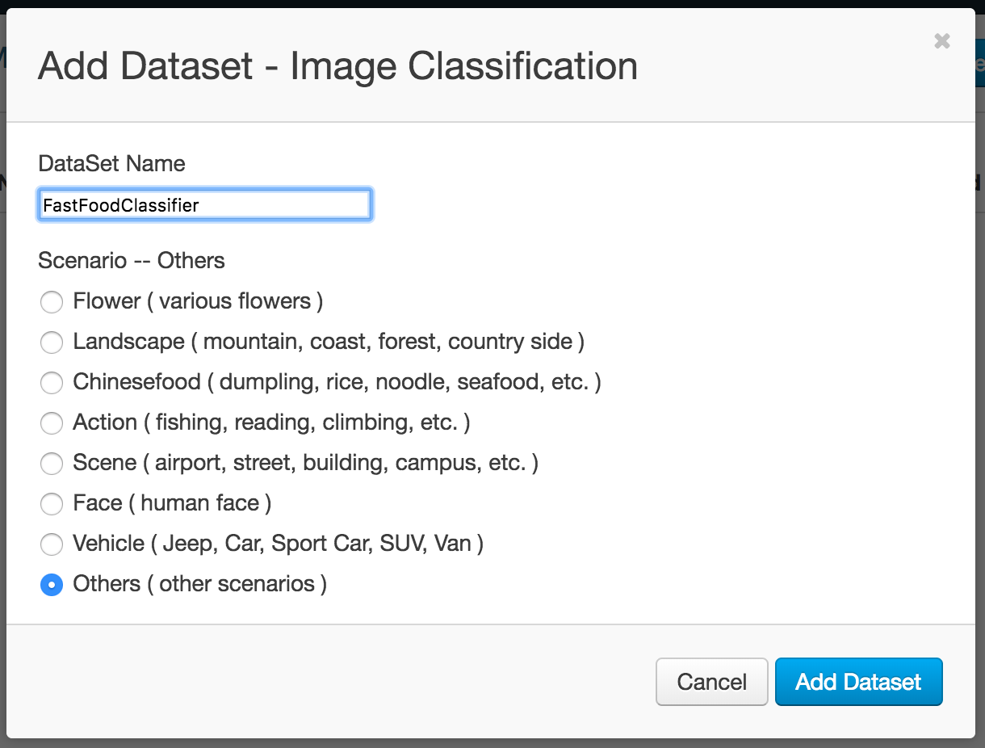  
  
Once you name your dataset, you need to add the categories that you want to classify. Click the **Add Category** button then give your category a name, for example "Burger".  
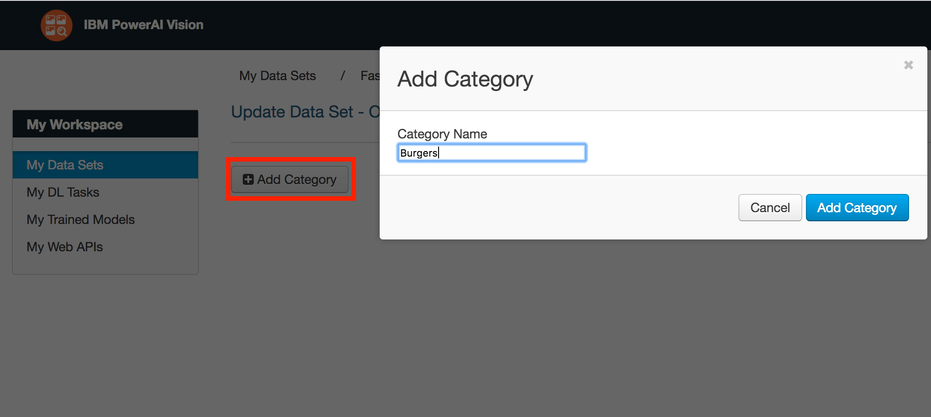  
  
Once you created your "Burger" category, click on **Select Some** then upload all your training images for burgers.  
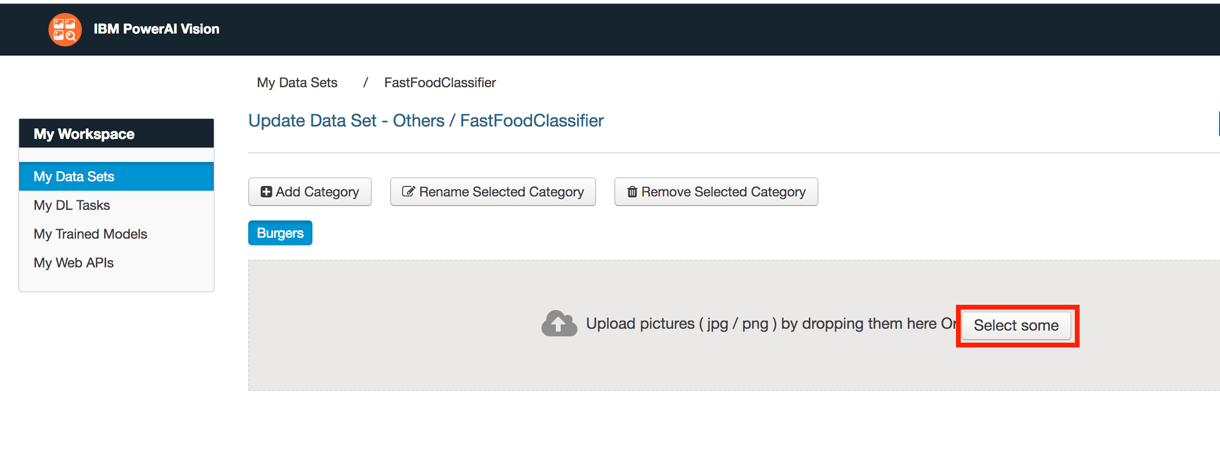  
Repeat this step for all the other categories you want to classify.

## **Step 3)** Train and deploy your model

After you created your training dataset, you need to train your model.  
Go to **My DL Tasks** workspace, click on **Create New Task** button on the top right corner. Then select **Classification**.  
  
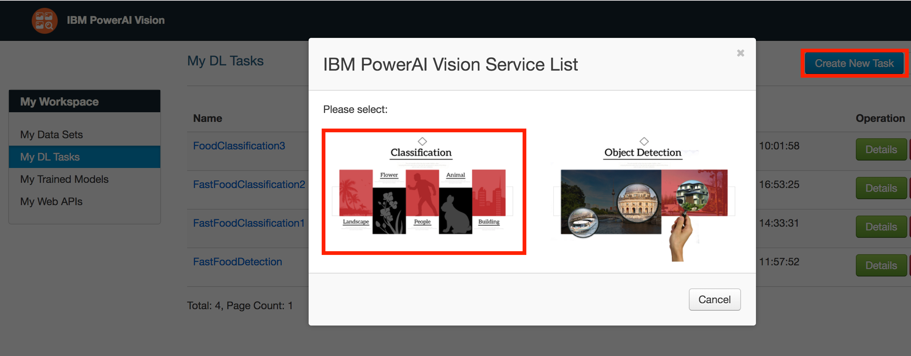  
  
  
Now you need to give your model a name such as "FastFoodClassification". You need to select a dataset, in our case it is "FastFoodClassifier". For the training Strategy, the default is "Fast First", but you can customize it, in our case we set the Max Iteration to 1800. Then press the **Build Model** button.  
  
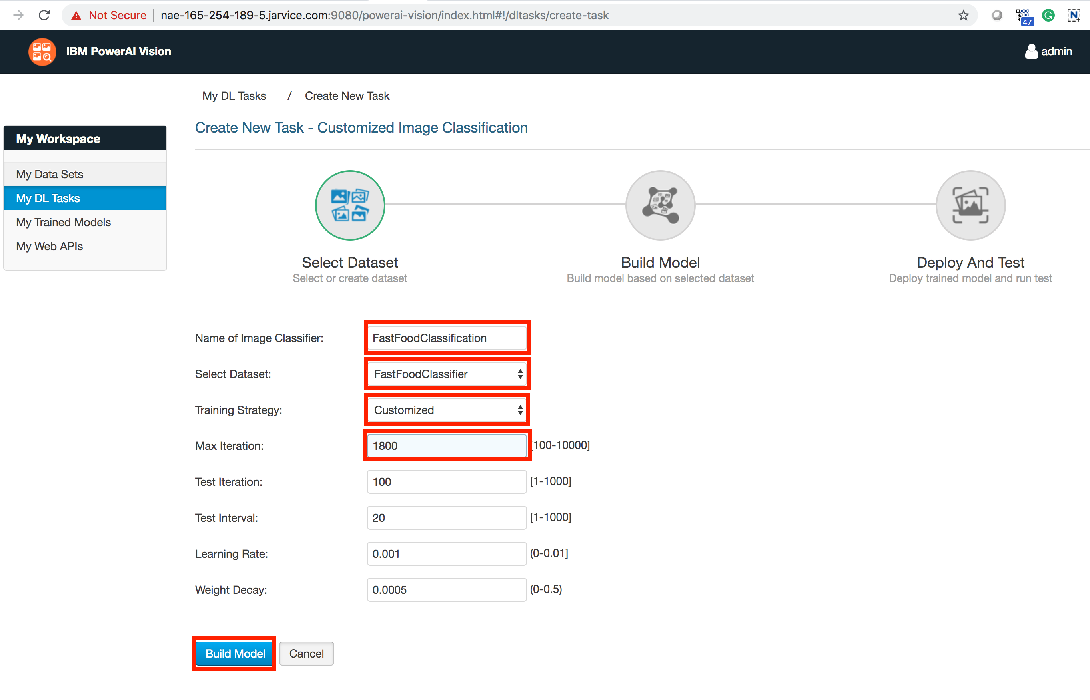  
  
Now you are ready to deploy and test your model.

## **Step 4)** Test your model and use the API of your model for web applications

Once you built your model, you can test your model on some images you found on the internet, or you can test your model on the test dataset that we provided for you below, you can click the button below to download the test dataset:

Once you prepared your test dataset, go to **My Web APIs** workspace, and press the button **Select some**, and upload the image you want to test.  
  
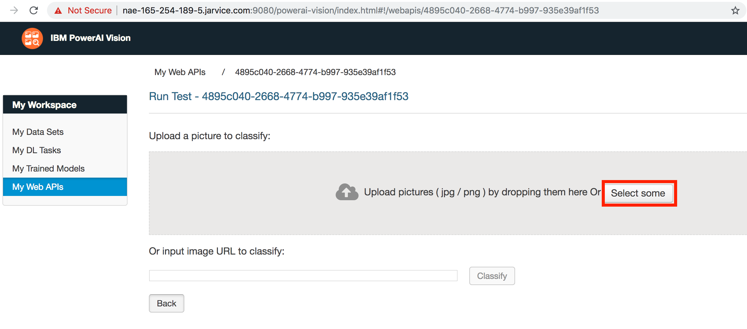  
  
  
As you can see that the model classified the image as a "Burger", the number beside "Burger" is the level of confidence, so our model classified the image as a "Burger" with 66% confidence. The image enclosed by the red rectangular border is the heat map of which part of the image that the neural network used for classification. Since the parts in red correspond to the top and bottom bun of the burger, the neural network may use these features to classify the image as a "Burger".  
  
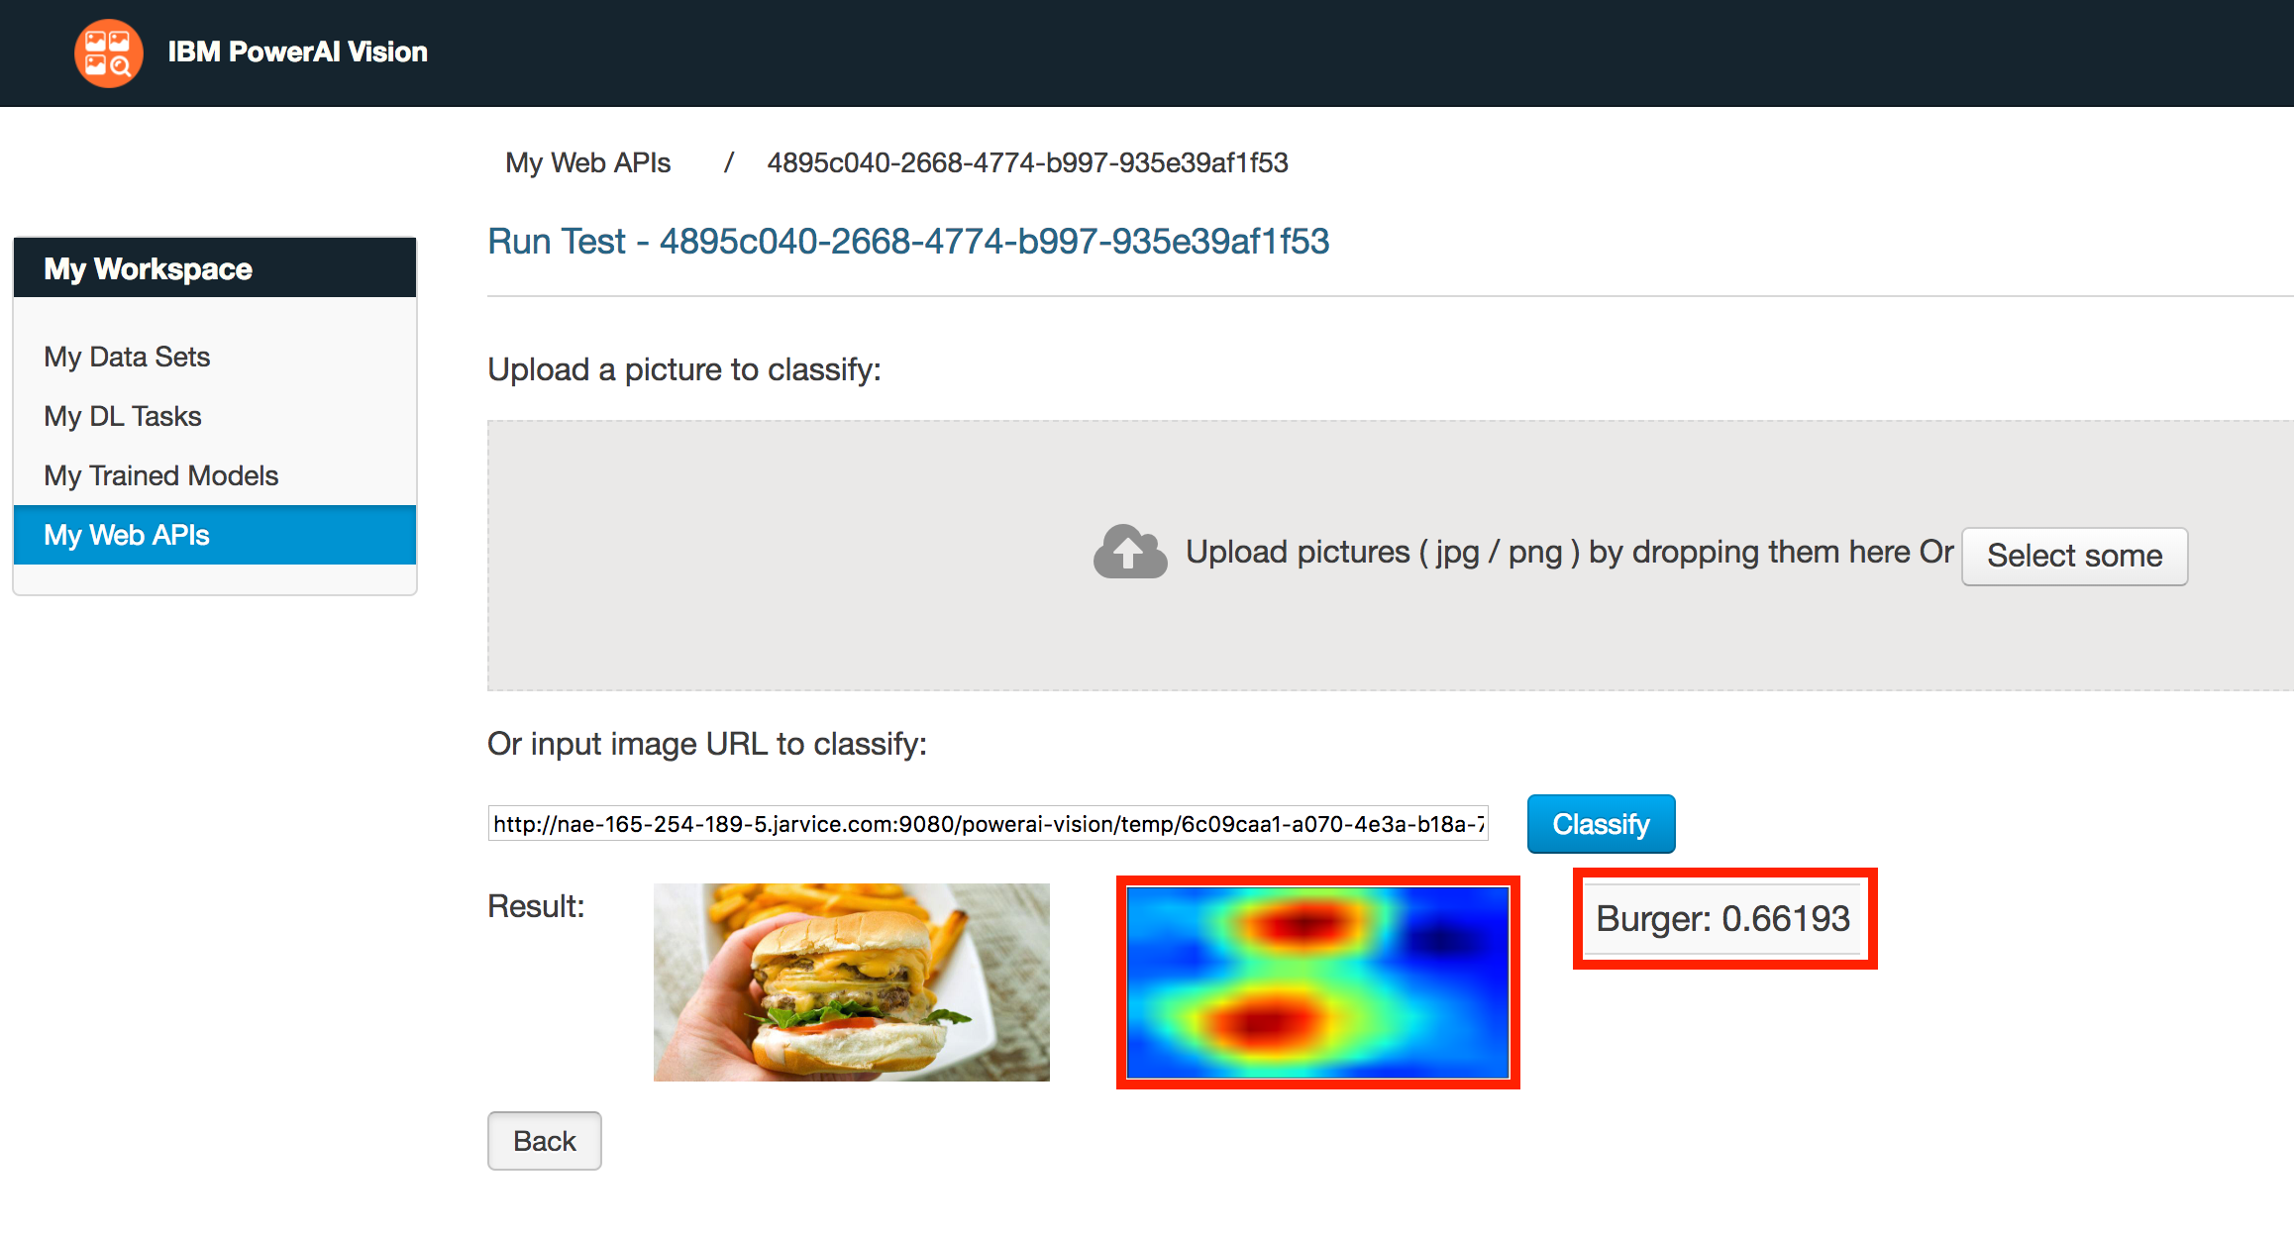

## **Step 5)** Use the API of your model for web application

After you trained your model, you can use the API of your model for web applications.  
We create a HTML template as an example of how you can use the API of your model, please download the zip file by clicking the buttion below.

Enclose in the zip file is the HTML template.  
Now open the HTML file in an editor and go to the **My Web APIs** workspace. On the html file, replace {IP:PORT} with the IP and PORT of your browser address bar. Then replace {web_api} with the URL of your API.  
  
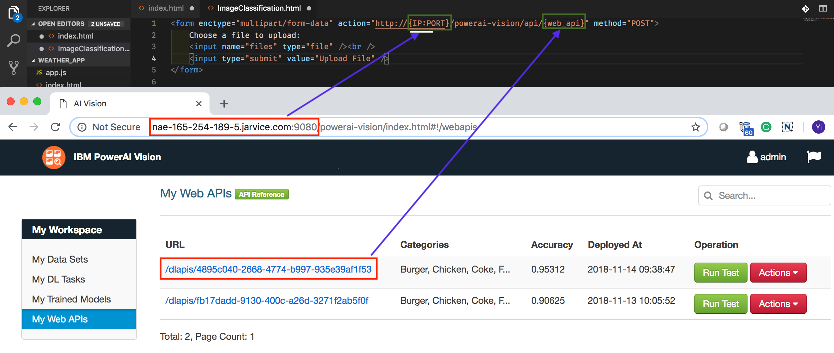  
  
  
You should end up with a configuration similar to the image below.  
  
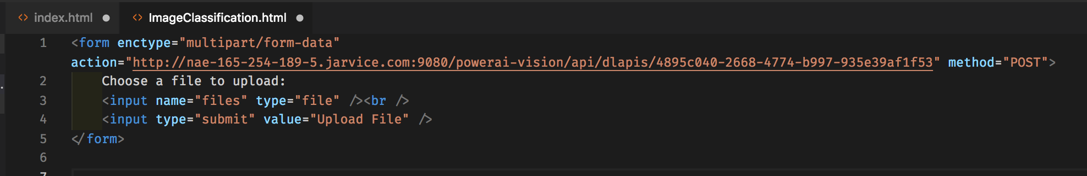  
  
  
Open the HTML file on a web browser, Choose a File and Upload, you will end up with the following JSON object that stores the result of the classification.  
  
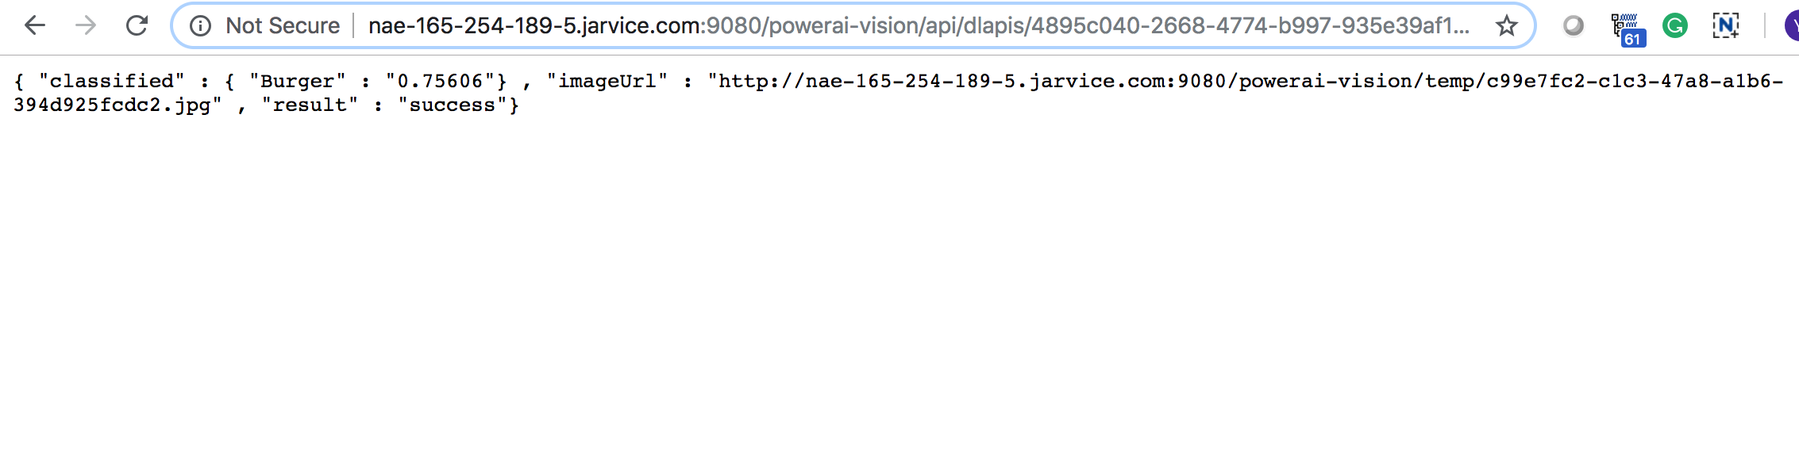  
  
  
**Notice**: Visit your dashboard, and make sure your container status is active. If it is paused, resume it again. Please notice that your IP address might be changed every time that you resume it, but your data set and trained models will be persistent.

## **step 6) Optional** Upload the video of this lab into youtube, and share it on linkedin, facebook, twitter or any social media platform

After completing this lab, you can teach other people how to create their own image classification model.  
You can make a video of this lab, upload the video into youtube, and share it on linkedin, facebook, twitter or any social media platform.  
  
You can put the video of this lab in the Projects section of your resume or linkedin profile. It is a good opportunity to show potential employers that you have experience creating machine learning models.  
  
Advice: If you do have a Screen Video Recorder, you can use Nimbus Screenshot and Screen Video Recorder, which is a free Chrome extension that allows you to record videos of your screen. You can add Nimbus Screenshot and Screen Video RecorderNimbus Screenshot and Screen Video Recorder extension [here](https://chrome.google.com/webstore/detail/nimbus-screenshot-screen/bpconcjcammlapcogcnnelfmaeghhagj?hl=en).

Step 7) Share your result with us on Twitter!

Follow me on Twitter and send me the video that you have built using IBM PowerAI Vision.

[Follow Saeed Aghabozorgi](https://twitter.com/SaeedAghabozorg)

Tweet about what you just learned:

