## Lab: Training Model - PyTorch

# Assignment Instructions

In order to receive a grade for this assignment, you need to submit your assignment for peer evaluation, and you also need to evaluate your peer's assignment.  
  
To submit your assignment for peer evaluation, you must:

1. Open the assignment file
2. Complete the assignment
3. Save the assignment on your local computer
4. Submit your assignment for Peer Review

## 1. Open the Assignment file (External resource)

To open the project please click the **View resource in a new window** button below.  
  
In this assignment, you will train two pre-trained models **resnet18** and **Densenet121** to classify the seven different denominations of European banknotes.

# 2. Complete the assignment

After you opened the notebook **DL0320EN-3-1-BuildingModel_PyTorch.ipynb** on **Cognitive Class Labs** there are 4 questions that you must answer. They are labeled:

* Question 3.1: Preparation
* Question 3.2: Train the model
* Question 3.3: Plot 5 Random Images with their predictions
* Question 3.4: Use the second model Densenet121 to do the prediction

You must fill in the missing code for these questions in the notebook, save your notebook and submit it.

### Grading Rubric

* (5 marks) Question 3.1: Preparation  
    
  After filling in the missing codes, you should be able to load the pretrained model **resnet18**. Setting the parameter **pretrained** to be true **resnet18** returns a model that was pre-trained on the ImageNet database. Since ImageNet contains 1000 classes the last layer of **resnet18** "fc" has 1000 outputs. But for this assignment you are classifying the Denomination of the Euro. And there are seven different denomination of the European banknotes so you need to modify the last layer of the model that you loaded to have 7 outputs.  
    
  In order to get full marks: You should be able to load the pretrained model **resnet18** and modify its last layer to have 7 outputs. For example you should generate the following output.

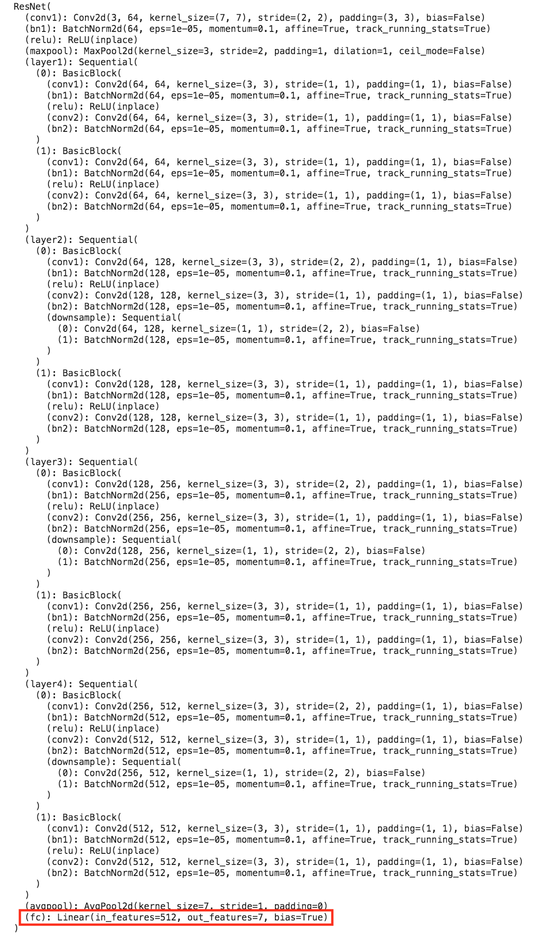

* (5 marks) Question 3.2: Train the model  
    
  After setting up your model, you have to train your model on the training dataset of images of European Denomination.  
    
  In order to get full marks: You should be able to reach a validation accuracy of greater than 0.95 on your model and print out the validation accuracy. And plot a graph of **Average Loss per Epoch vs Epoch** and a graph of **Accuracy vs Epoch** as shown in the pictures below.

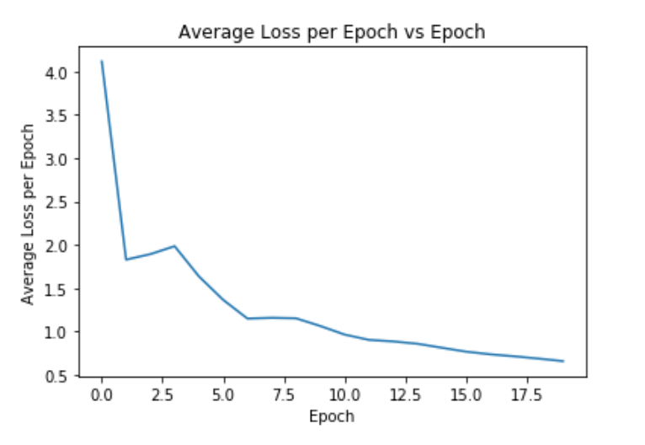 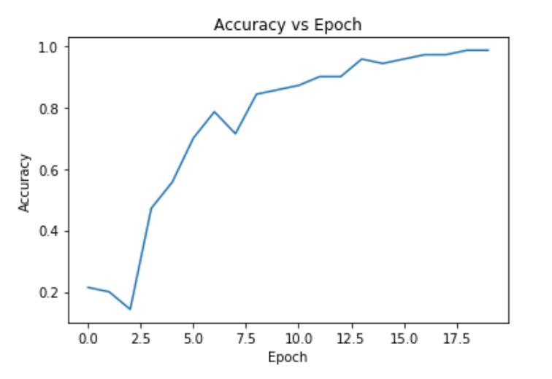

* (5 marks) Question 3.3: Plot 5 Random Images with their Predictions  
    
  After training your model you want to see how your well your model works on the test dataset. In order to do that, you should randomly pick 5 images from your test dataset, predict the value of the European banknote in your test images that were randomly chosen.  
    
  In order to get full marks: For the 5 banknotes, you should print the image of each of the banknote, the predicted value of the banknote. If the predicted value of the banknote matches the actual value on the image of the banknote you should print "Correctly Classified". If the predicted value of the banknote does not match the actual value on the image of the banknote you should print "Mis-classified". As shown in the picture below. 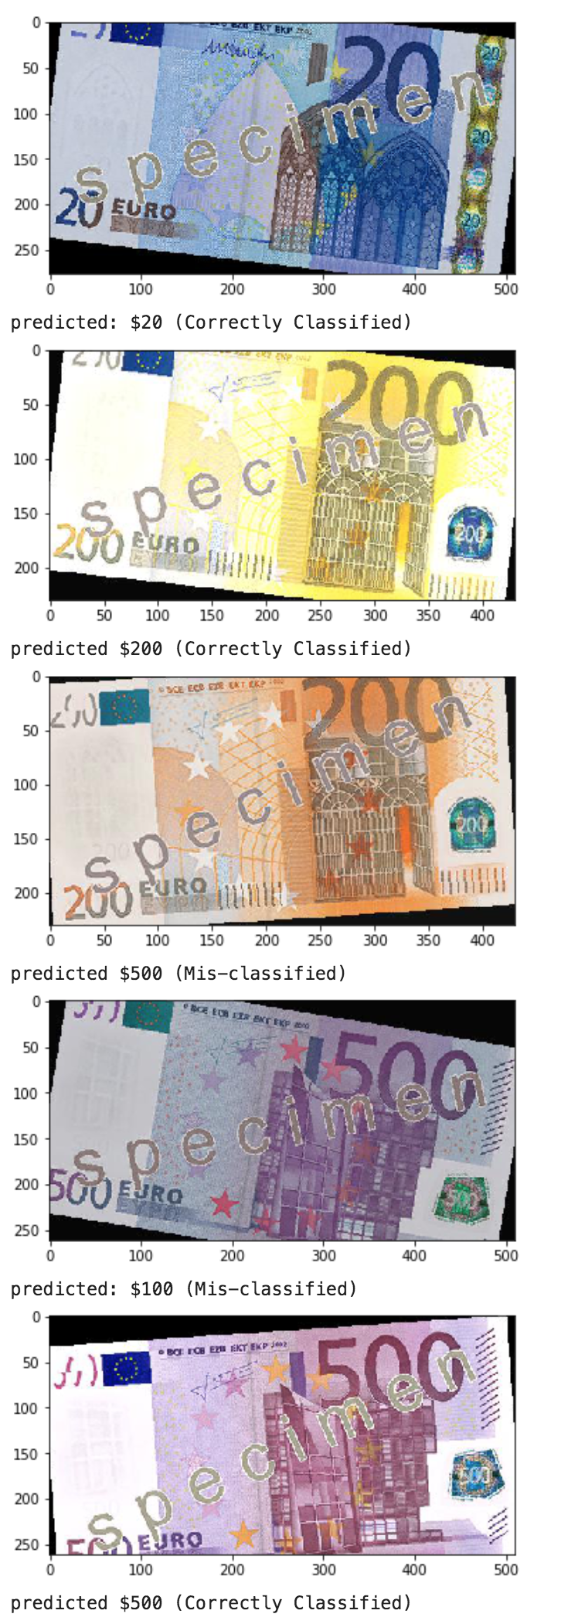
* (3 marks) Question 3.4: Use the second model Densenet121 to do the prediction  
    
  **Densenet121** is another pre-trained model for image classification. In this question you will repeat Question 3.1 and Question 3.2 using **Densenet121** instead of **resnet18**.  
    
  In order to get full marks: You should load the pretrained model, modify the last layer of the model have 7 outputs and then train the model to achieve a validation accuracy of greater than 0.95.

# 3. Saving the Project File on your local computer

* After you completed the notebook for this project on **Cognitive Class - Labs** you need to save your lab file, please click the **save** icon on the top left corner of your file, as indicated by the red rectangular border in the picture below, **please do not clean your output, you will be marked based on your output**.   
    
  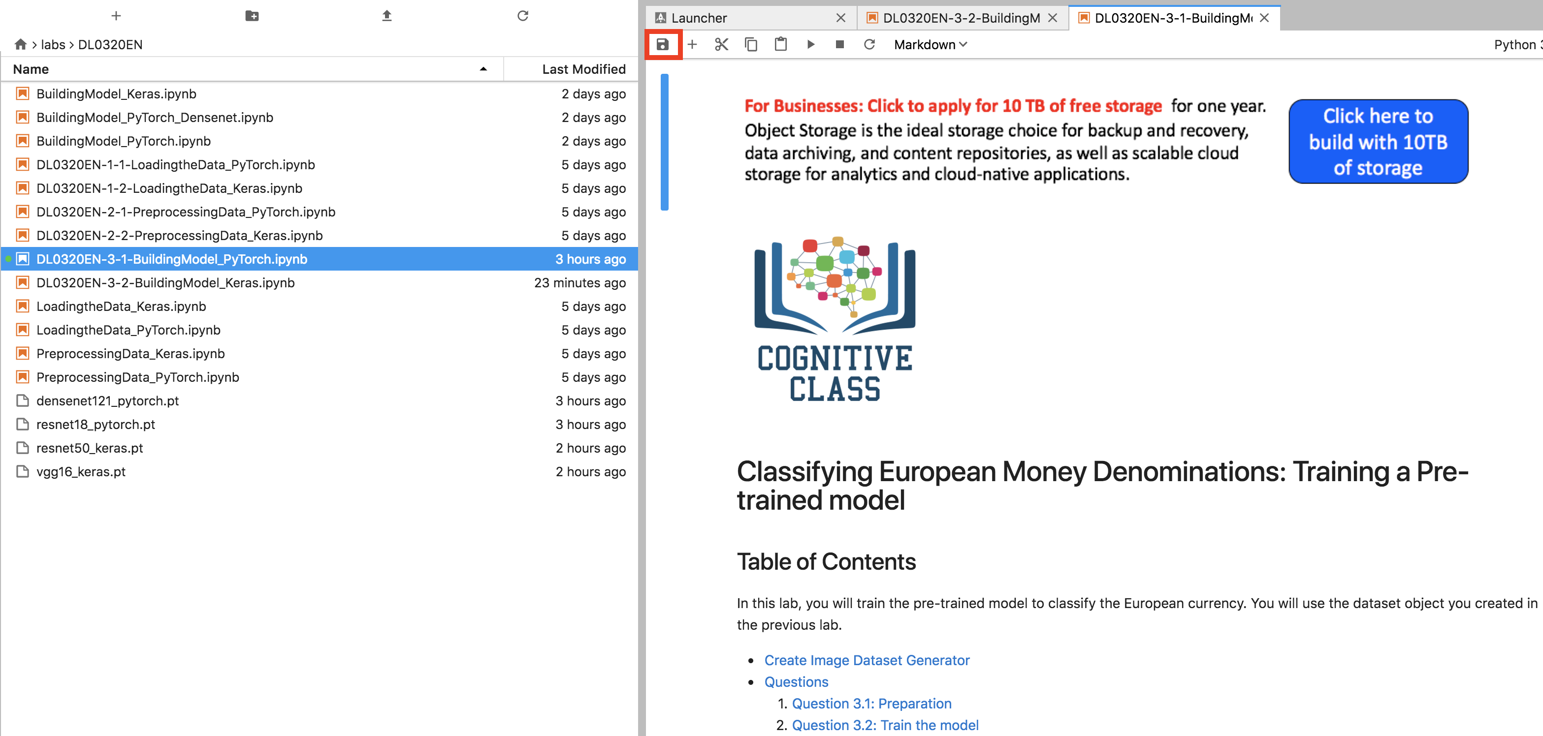
* After that you should save your project file on your local computer, please right-click on the file for this project **DL0320EN-3-1-BuildingModel_PyTorch.ipynb**, then press the **download option** as indicated by the red rectangular border in the picture below.   
    
  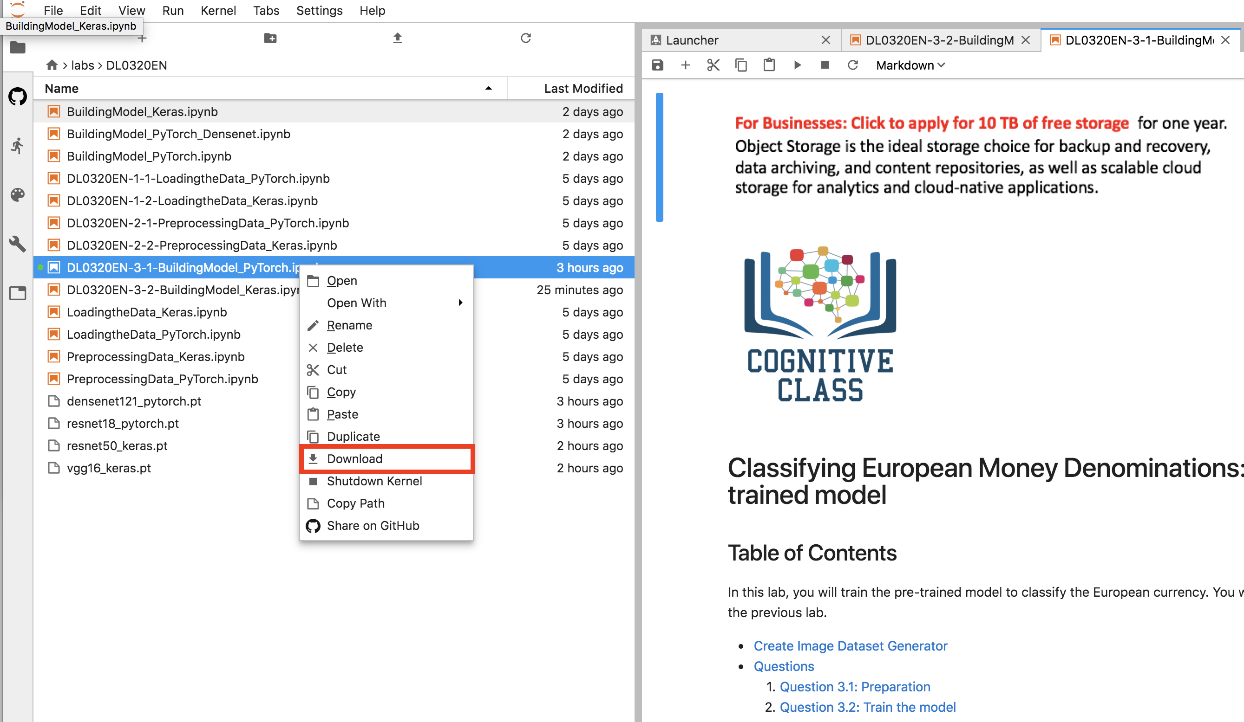

After completing the above step, you are ready to submit your project for peer review.  
To submit your project please go to **Module 5 - Deep Learning Project** of this course, then go to the **Project Submission** subsection or click on the button below.