**INTRODUCTION TO MACHINE LEARNING**

**What is Machine Learning**

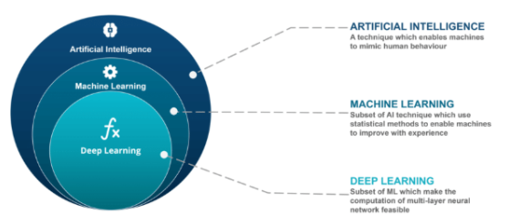

**Brief History**

Machine learning was defined in 1959 by Arthur Samuel. By definition, machine learning is the workspace that gives computers the ability to learn without being programmed openly. Professor Samuel was an employee of artificial intelligence at IBM, and he developed a program that could play chess better than a person.

The artificial intelligence, which became popular especially in the 1980s, continued to be developed to make reliable predictions in more specific areas after it was seen to be successful in certain areas. Thus, machine learning was developed in the 2000s. This system, which can interact naturally with people as part of cognitive science, has gained the ability to find solutions to complex problems thanks to its predictions.

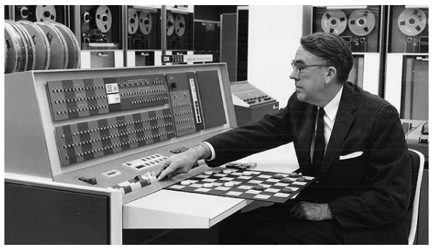

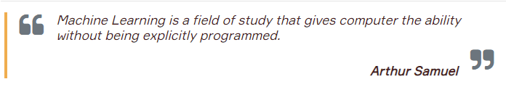

**What is Machine Learning?**

**Machine learning** is a data analytics technique, getting computers to learn and also act like a human. **Machine learning** algorithms use computational methods to “learn” by feeding data and information. And it is also known as a field of data analytics to make predictions depends on trends and insights of the data.

Machine learning algorithms use statistical tools to find meaningful connections in large amounts of data. The data here are; covers many things like numbers, words, images, clicks. If this data can be stored digitally, it can be fed into a machine learning algorithm.

Briefly, the main basis of machine learning is to create algorithms that can process its data and to predict the result using statistical analysis. The new data obtained during this process continues to be learned and used to update and improve the results.

**More About Machine Learning**

**1. What is it used for?**

In the video below you can find a very simple explanation of machine learning.

# **Machine Learning Explained in 5 Minutes**

<https://www.youtube.com/watch?v=3bJ7RChxMWQ>

Machine learning, which can analyze data without human intervention and offers the best estimates, is also used in many corporate applications. Likewise, it also helps many professions with the opportunities it provides.

Machine learning is becoming an increasingly needed application in today's world with its functions such as ease of **data analysis** and giving the **best estimates**, **defining abnormalities**, and **solving problems**.

Machine learning algorithms are used in a wide variety of applications, such as:

* Recommendation engines
* Customer churn
* New pricing models
* Email spam filtering
* Material and stock estimates
* Pattern and image recognition
* Predictive inventory planning
* Purchasing trends
* Credit scoring, etc.

##### 2. Machine Learning Types

##### 

During the Machine Learning course we'll focus on:

* **Supervised Learning**
* **Unsupervised Learning**

Before diving into machine learning topics, let's look at a short Terminology of Machine Learning.

### Machine Learning Terminology

**Observations:**Each piece of data used to learn for the model.**Each row** in a dataset represents an observation. Ex: each email is an observation.

**Features:**Represents a measurable piece of data that can be used for the analysis. Ex: name, age, gender, size, fare, date, etc. Features are also sometimes referred to as “variables” or “attributes.” **Each column** except the label column in a dataset is called a feature.

**Labels:**The label (often called the target column) is the thing we're predicting. Briefly, the features are the input and the **label (target) is the output**. Ex: spam or not spam email, price of the house.

##### 

The picture above demonstrates a very simple dataset. In this dataset;

* Each row is an observation,
* Feature1 and Feature2 columns are the features of the data,
* The Target column contains the labels of the data.
* And what about the training and test data? Find below detailed information about test and training data.

**Training Data:**A subset of the full dataset to **train** a model.

##### Test Data: A subset of the full dataset to test a model.

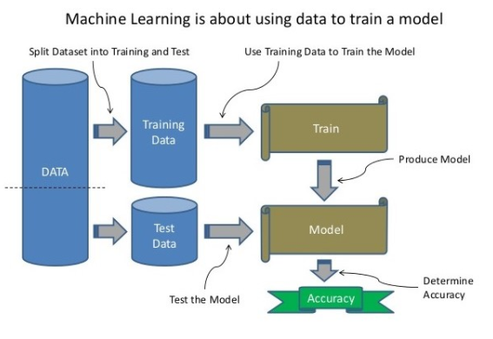

UDEMY 2021 Python for Machine Learning & Data Science Masterclass 🡪

Part-76. Introduction to Machine Learning Overview Section

Part-77. Why Machine Learning?

Part-78. Types of Machine Learning Algorithms" lectures from your Udemy course.

### Supervised Learning Overview

After the "Introduction" topic of our course, we will continue with the "Supervised Learning Algorithms" and then "Unsupervised Learning Algorithms". The video of this lesson will cover the issues related to supervised learning. In order to better understand the subject, we will first make short definitions of supervised learning.

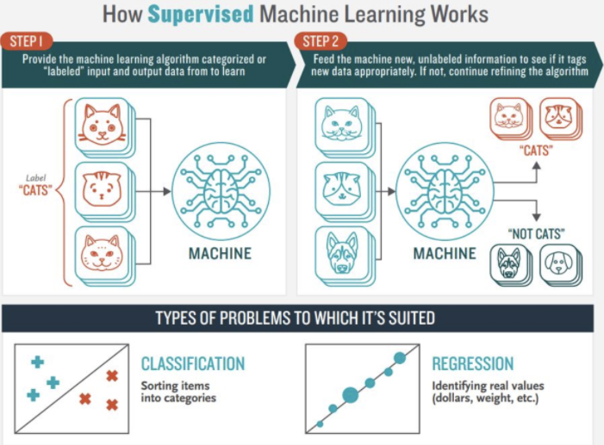

**Supervised Learning**  
It is the process of learning from labeled observations. Labels teach the algorithm how to label the observations. Data consists of both inputs and outputs. In the data we have, there are both the features and the result (labels).

**For example,**let's imagine that we are dealing with the real estate business. Our goal is to create a model that predicts house prices. We have many properties/features (size of the house, number of bedrooms, neighborhood, number of floors, etc.) and sales price (label). In supervised learning, we **feed the model with features and the price** to learn (training data). The model creates a formula/function by using and comparing the features and prices.

Supervised Learn uses classification or regression algorithms.

**Classification:**Each observation throws a category / class assignment: Ex: spam / not spam. Classes are discrete (not numbers) and there is no such thing as being close / far apart.

**Regression:**It estimates a real value based on what it has learned for each observation. For example: "The price of a house which has the 4 bedrooms and 3 baths should be 245.000 $".

**💡Tips:**

Keep in mind that the majority of practical machine learning models use supervised learning.

UDEMY 2021 Python for Machine Learning & Data Science Masterclass 🡪

Part- 79. Supervised Learning Overview

Part- 80. Companion Book

Part-78. Types of Machine Learning Algorithms" lectures from your Udemy course.