Note: This document will be updated as you are given more parts. So don’t panic if you don’t have some of the things that are on this document. They will come later.

# General Drivetrain Construciton

You will need;

* 2x Motor blocks
* 4x Load blocks
* 2x Tensioner blocks

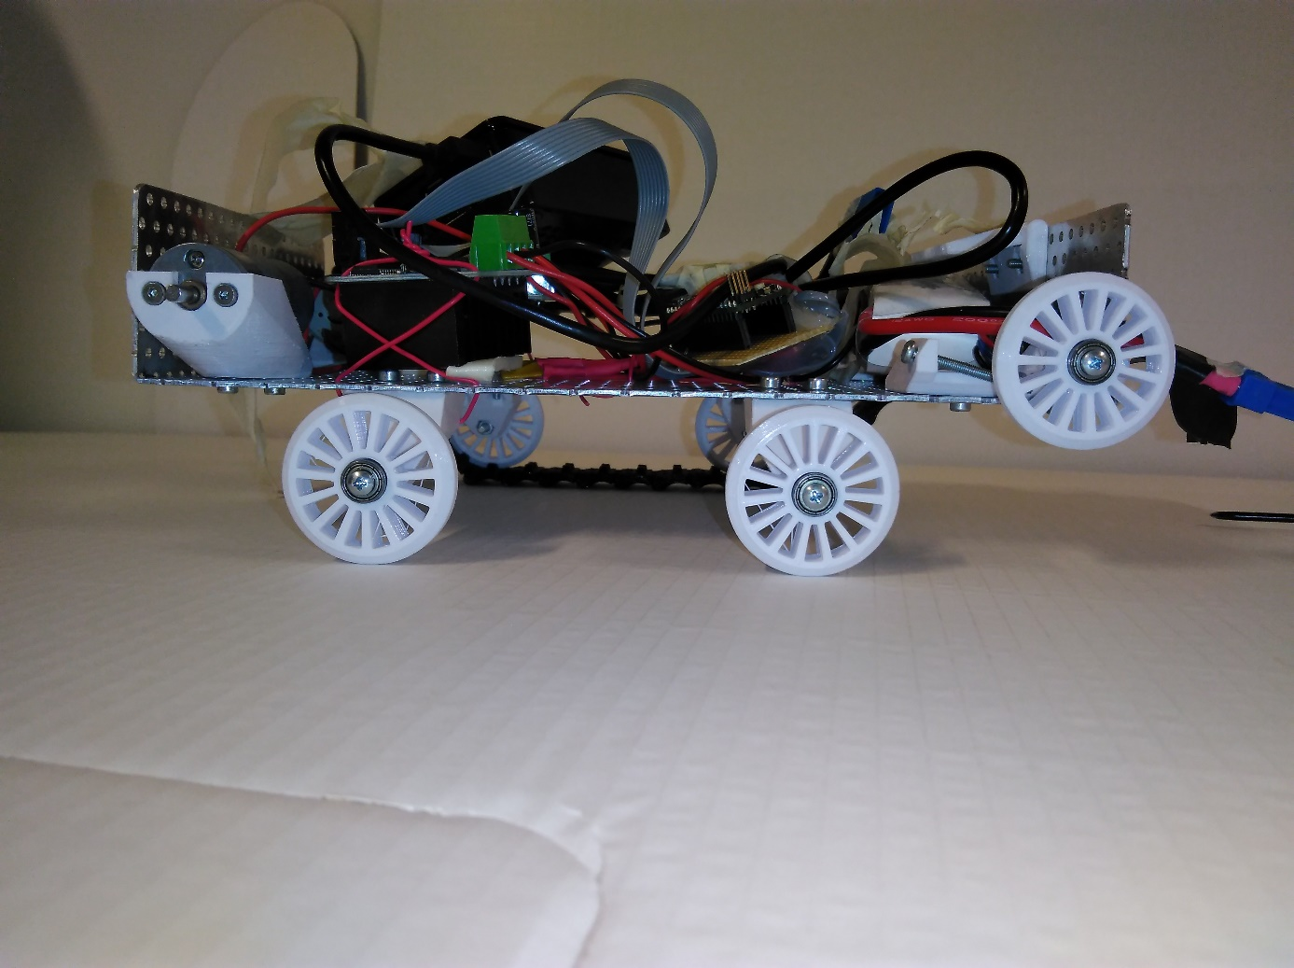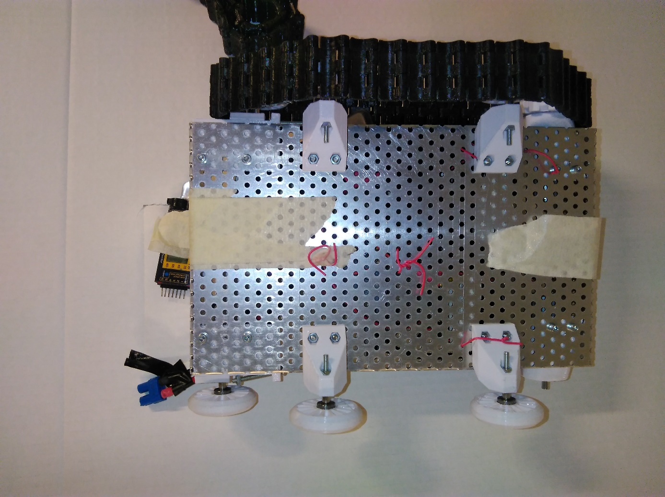

Load blocks

Tensioner block

Tensioner block

Tensioner block

Load blocks

Motor block

Motor block

Motor block

# Freewheel assembly

You will need;

* 1x Freewheel
* 2x Bearings
* 2x Spacers
* 1x M3 long screw

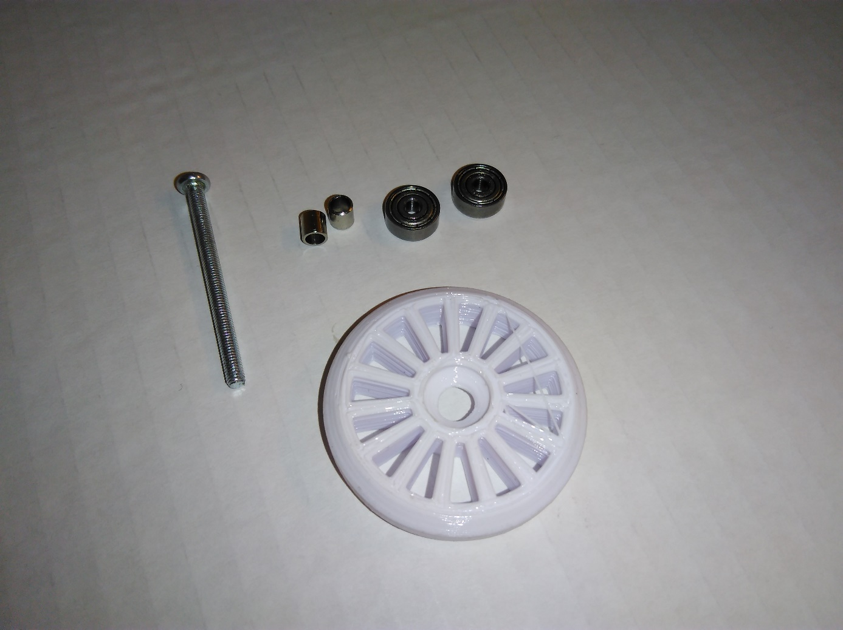

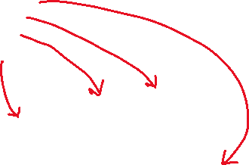

Arrange the items on the screw in the following order, so it looks like the next image.

* Bearing -> spacer -> freewheel -> bearing -> spacer

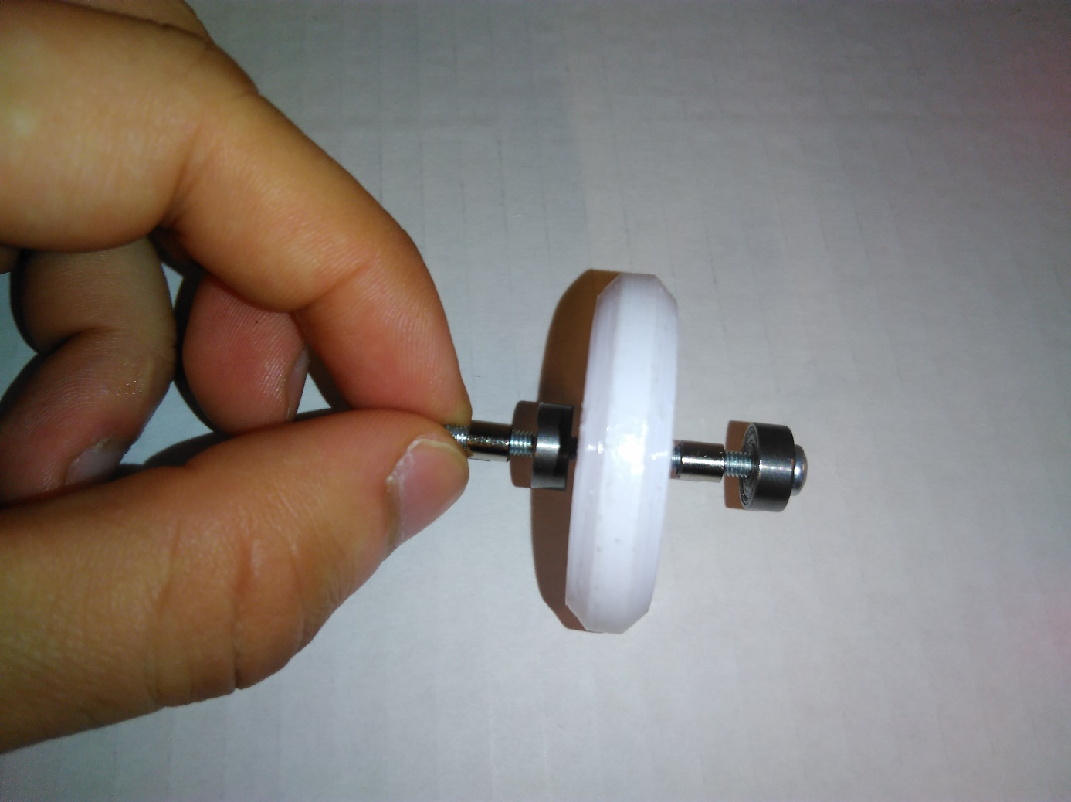

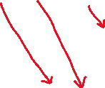

Now the part is ready. All you need to do is, to push them together. Like so;

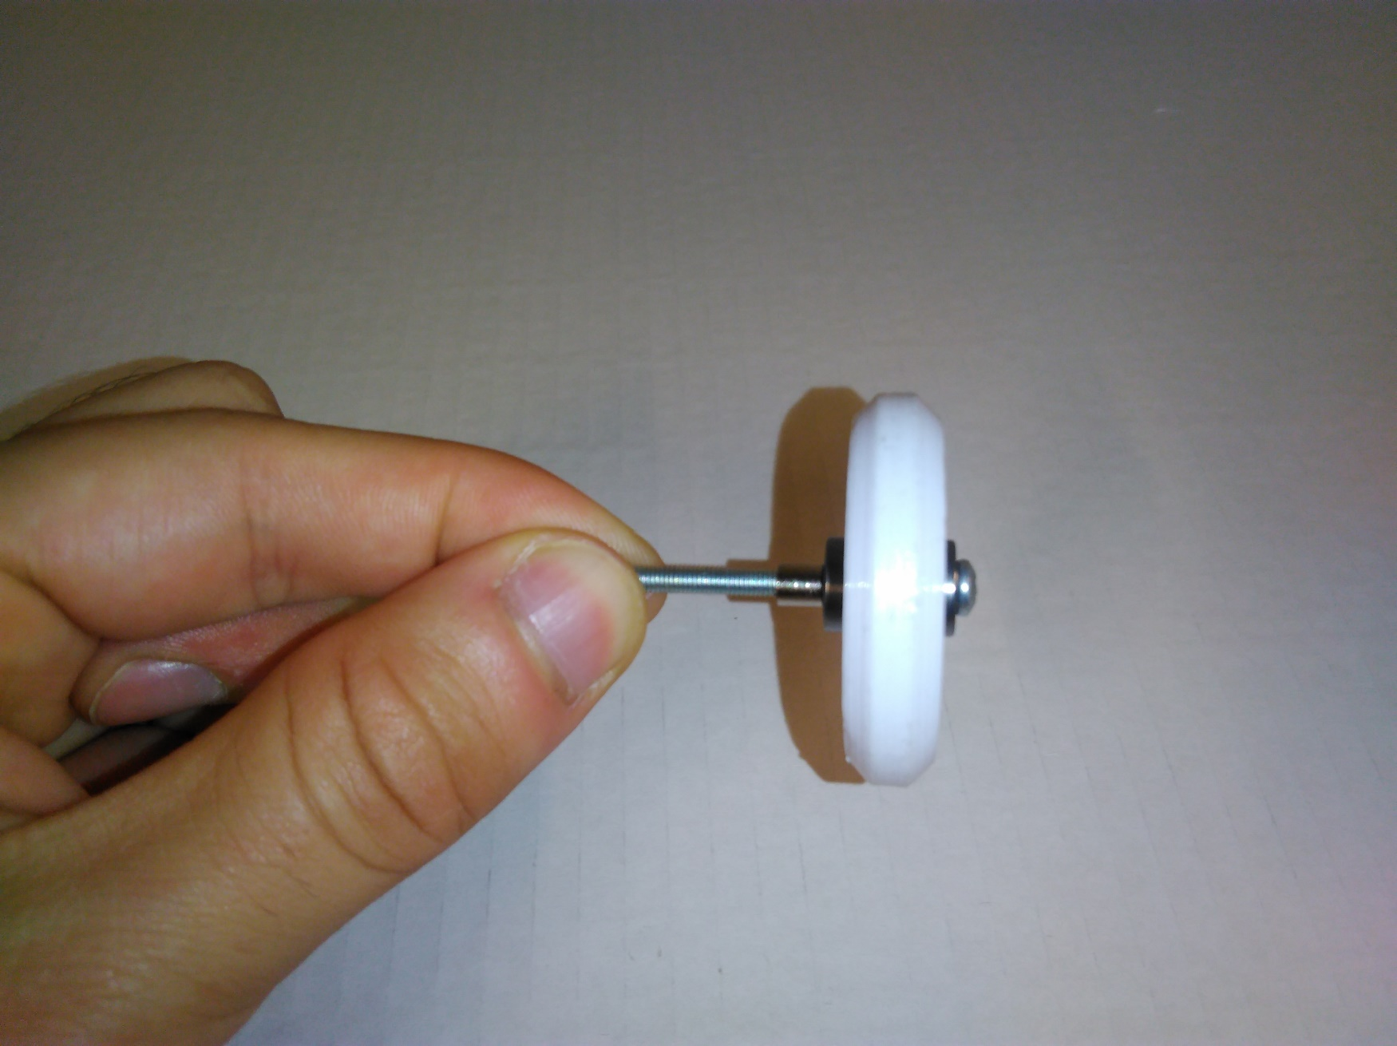

# Load Block Assembly

You will need;

* 1x Freewheel assembly
* 3x M3 nuts
* 2x M3 short screws
* 1x Load block
* Allen key

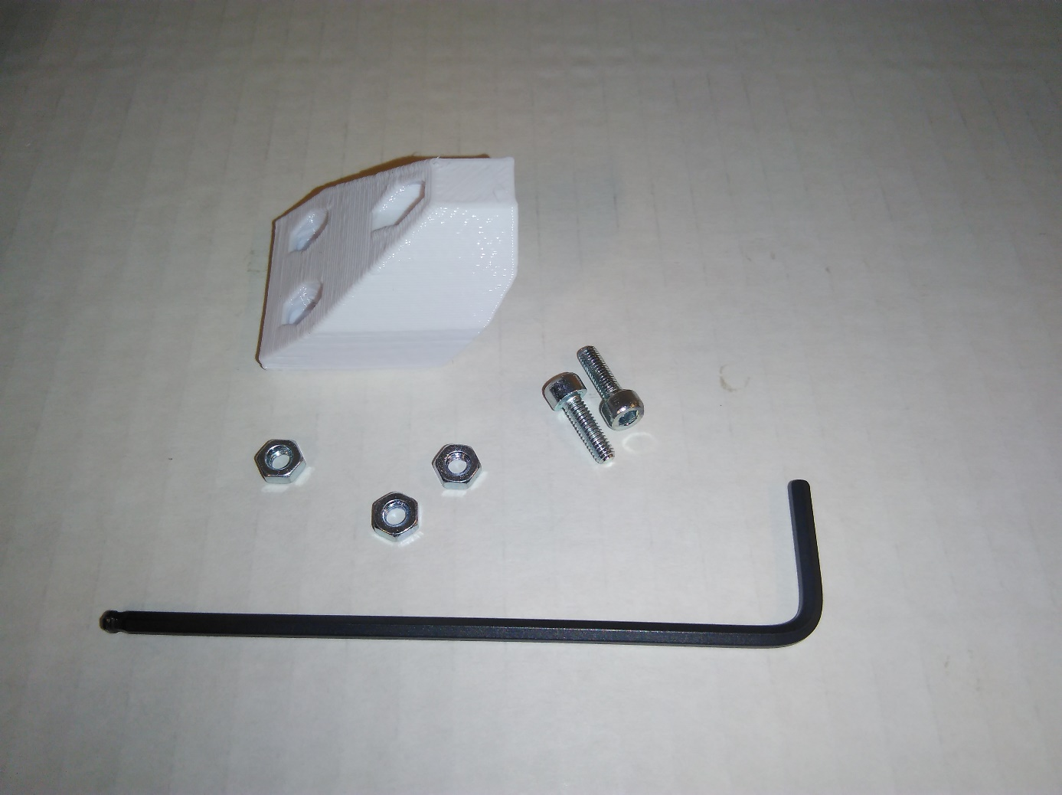

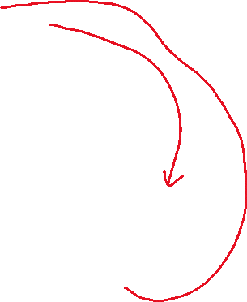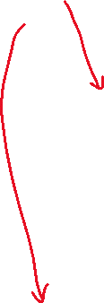

Insert the freewheel into the designated hole (see the photo below) and start screwing the nut by hand. Then you can tighten it using the allen key.

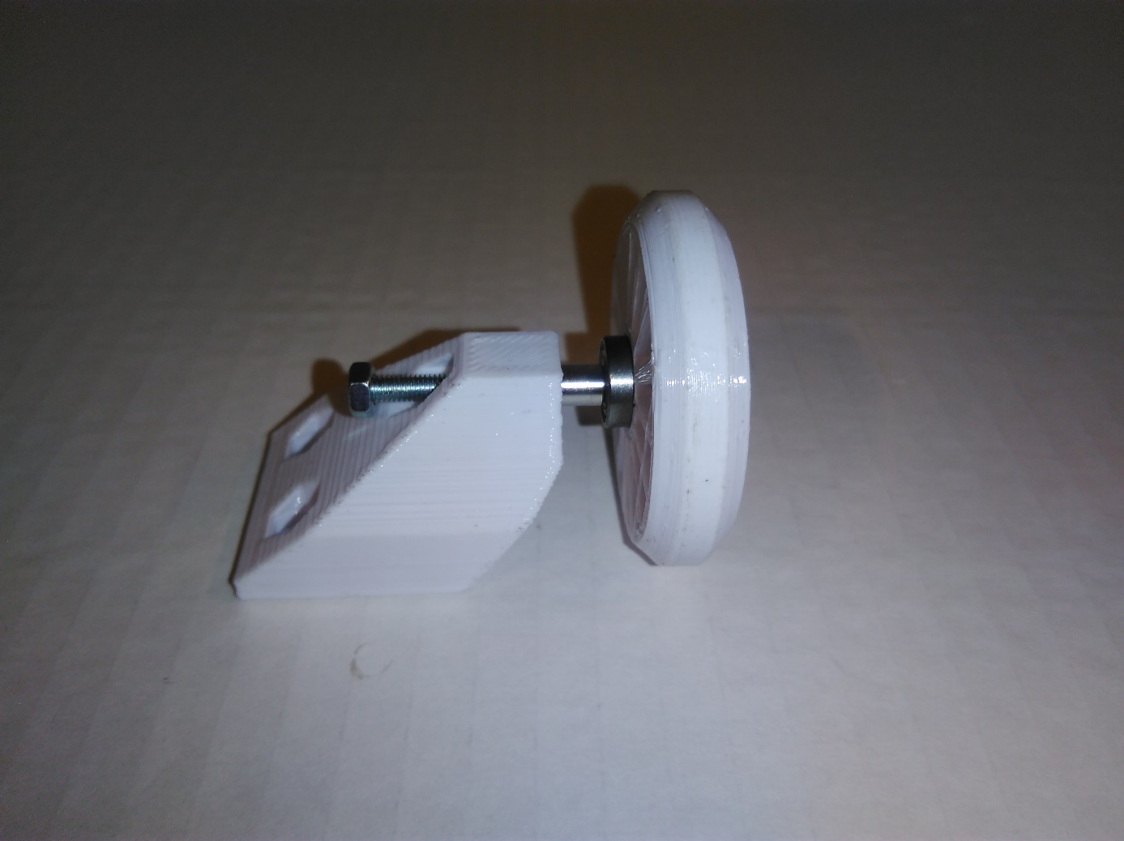

Insert two remaining M3 nuts into the designated locations as shown below.

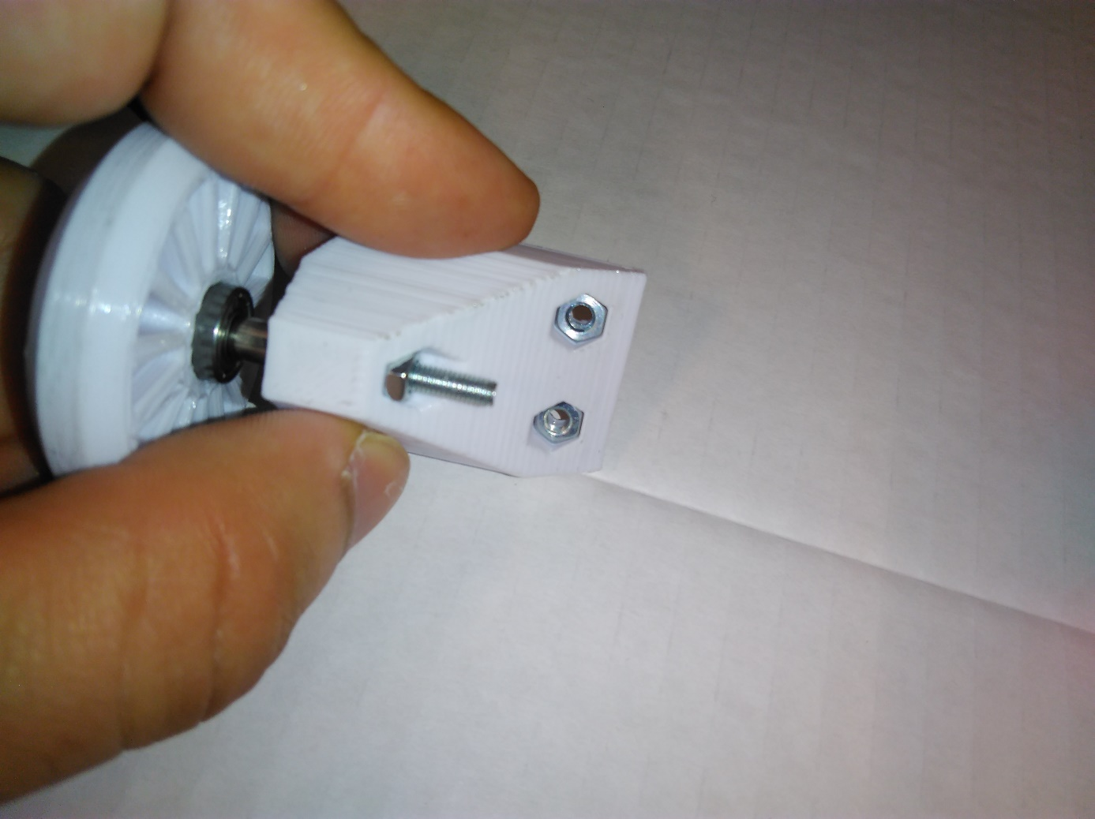

Retain the nuts by hand and start screwing two short screws to mount the piece on the robot chasis.

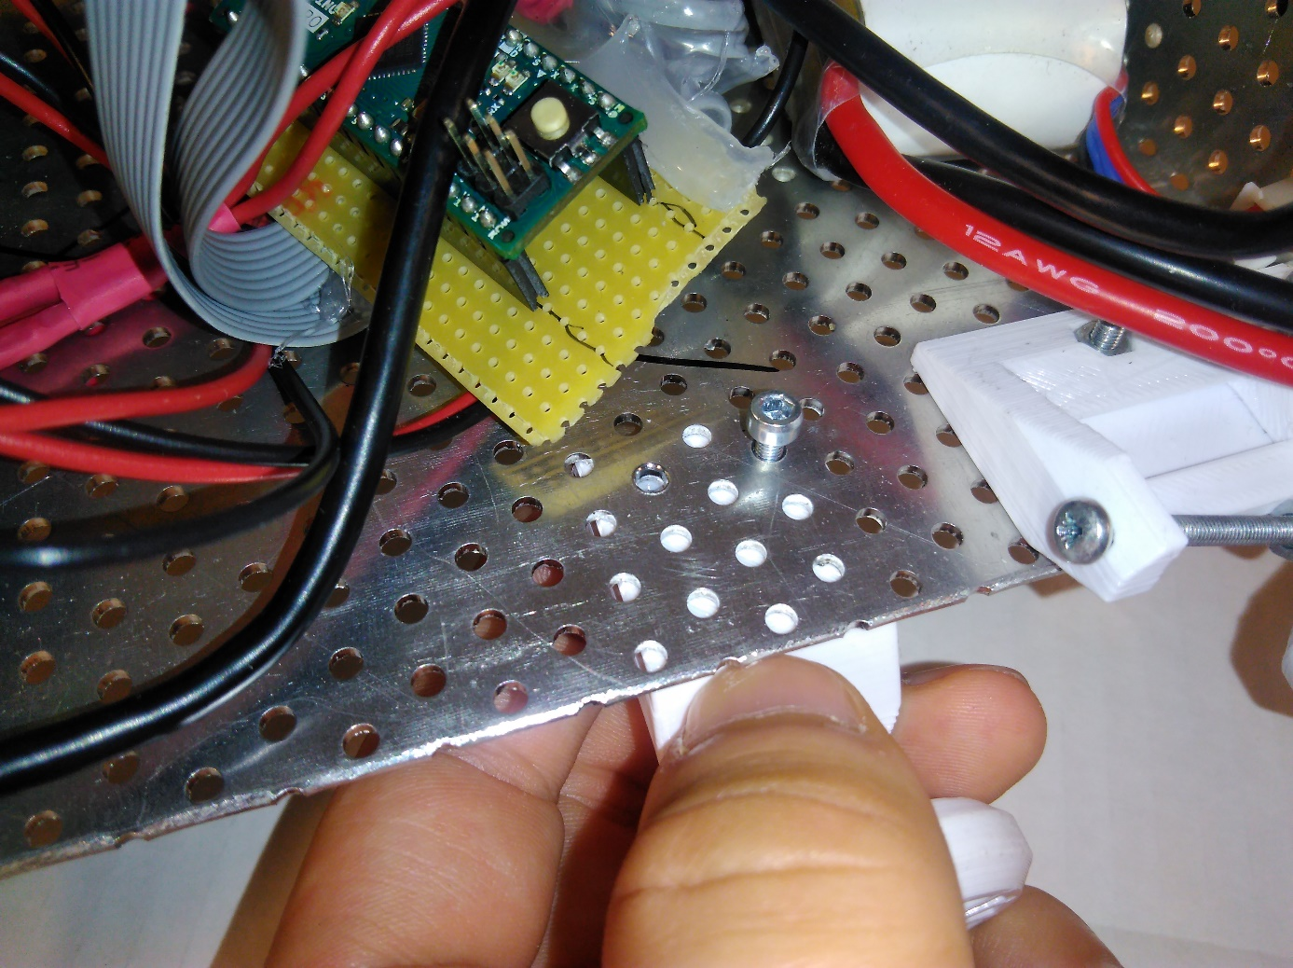

Tighten the screws using the allen key

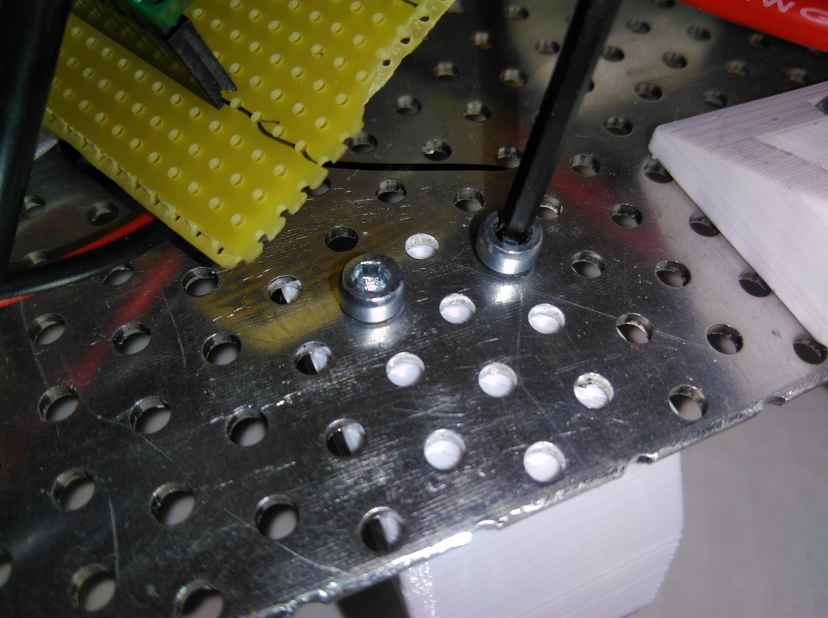

# Motor Block Assembly

You will need;

* 1x Motor block
* 2x M3 nuts
* 2x M3 short screws
* …more items will follow

[image will come here]

The next step is similar to load block. You will need to insert the nuts into their slots and retain them by hand. Then, install the block as shown below;

