# Warnings

**DISCONNECT ALL BATTERY CONNECTIONS BEFORE DOING ANY ELECTRICAL WORK!**

This is a bit of common sense. Always cut the power before doing anything electrical.

**DO NOT CHANGE THE TRIMMER ADJUSTMENT!**

The trimmer (shown below) adjusts the output voltage of the USB port. Do not modify it or you will kill motor drivers and also whatever is connected to the USB port. If you changed it accidentally, follow the steps below;

* Cut the power and disconnect the battery
* Remove the connected USB device
* Remove the Arduino
* Remove motor driver control cables
* Re-connect the battery and use a multimeter to re-adjust the trimmer. You want to see 4.95-5.05V at the output.

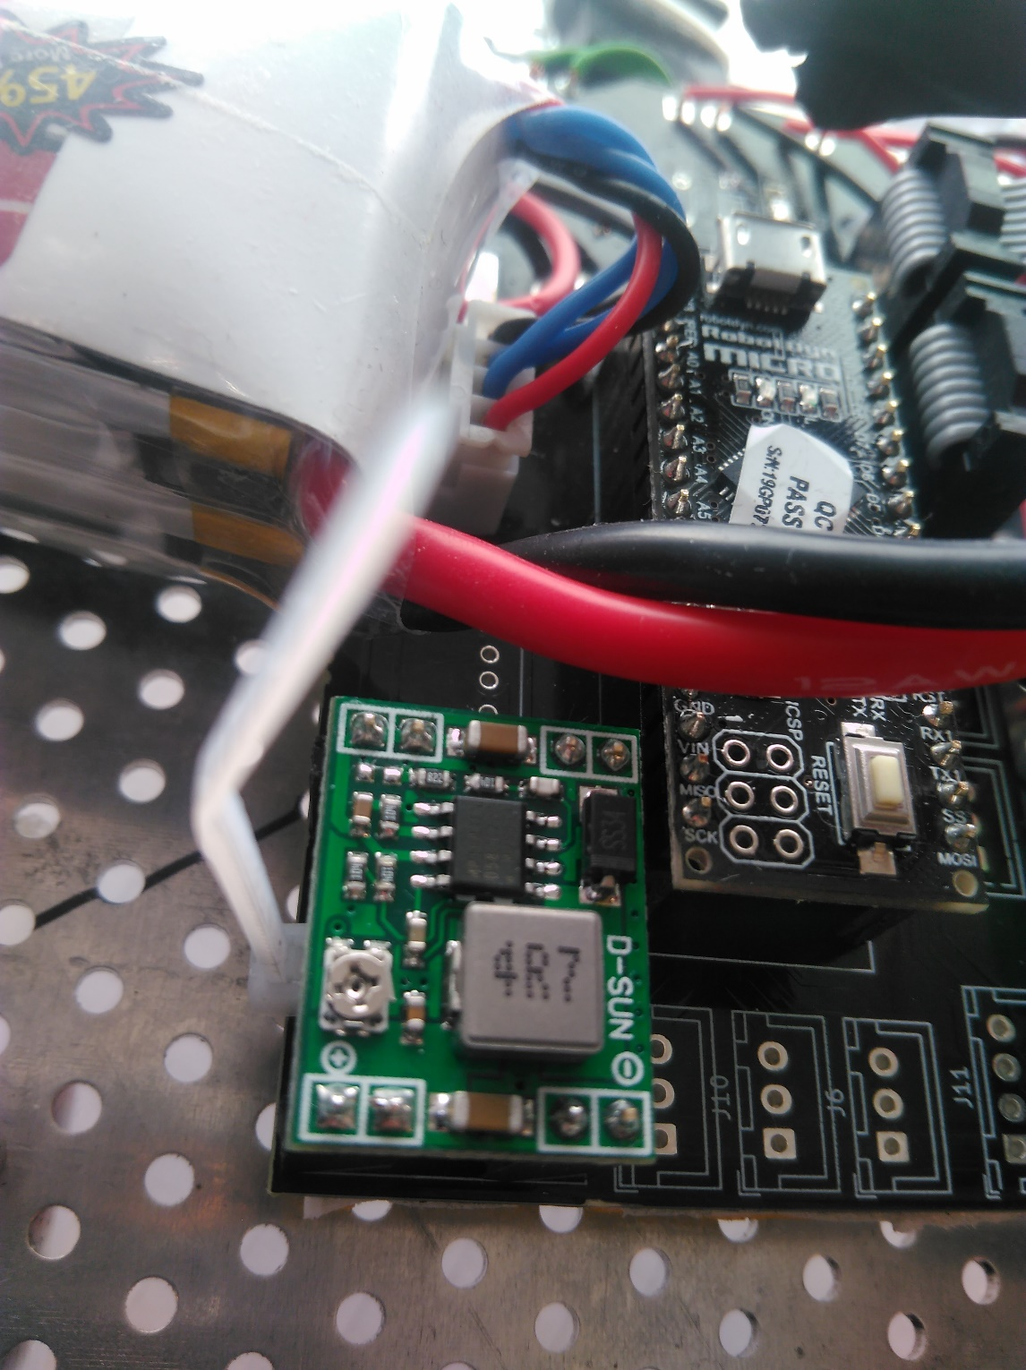

trimmer

# Power Connections

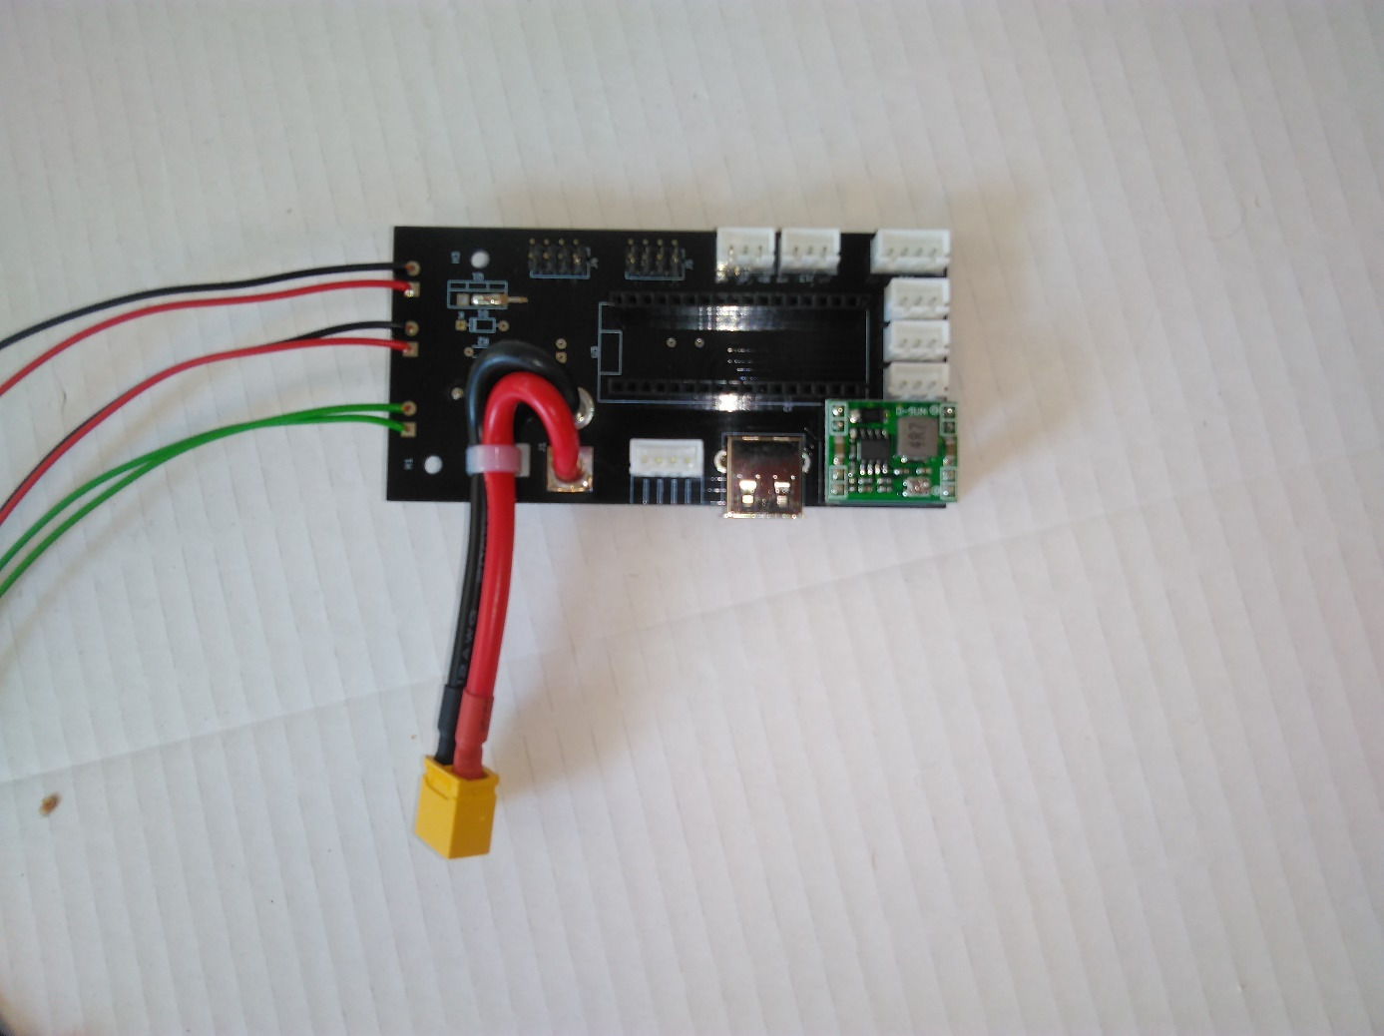



Power outputs for motor drivers

Main battery connector

Battery balance connector



Connect motor drivers’ power cables. Note that the cables are color coded:

* Black means “ground” (i.e. 0V reference. AKA negative [-] terminal)
* Red means “hot” (12V or 5V or [+] terminal).

Never mix the polarities or you will fry some (or all) of the components.

**Do not connect battery balance connector other than indicated place!** [Cat logic](https://knowyourmeme.com/memes/if-it-fits-i-sits) doesn’t work in electronics.

# 

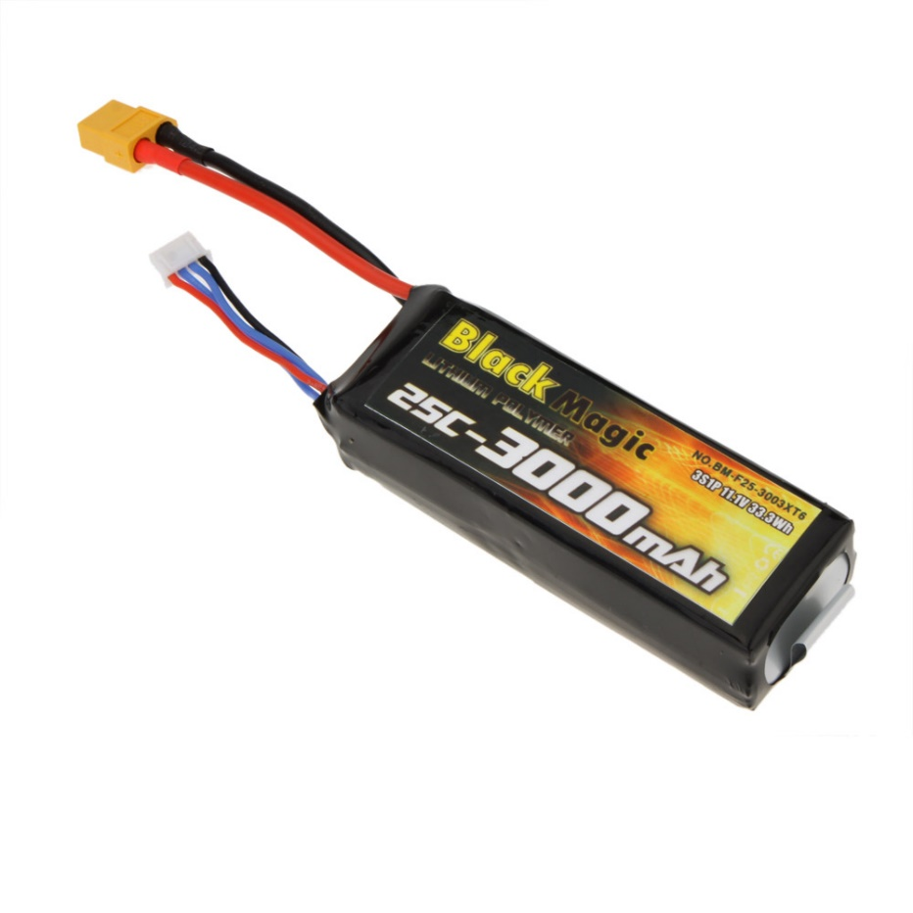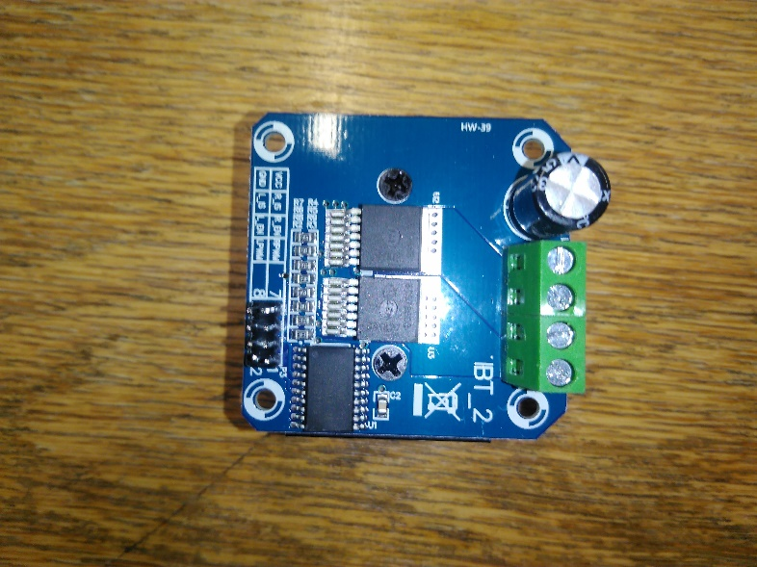

# Motor Connections

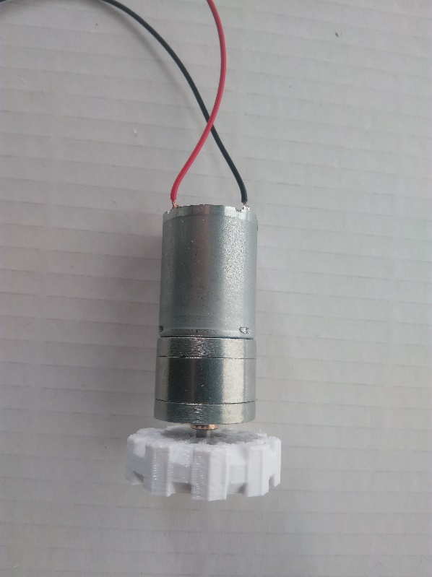Motor cables are also color coded. However, these motors do not require a certain polarity. It only changes the turning direction.





# Motor Driver Control Cable

This cable has polarity and it needs to be installed properly. Here are the steps;

* Find the 1st pin of the cable. This is marked with a tiny arrow. You can also see that the cable is marked as can be seen below.

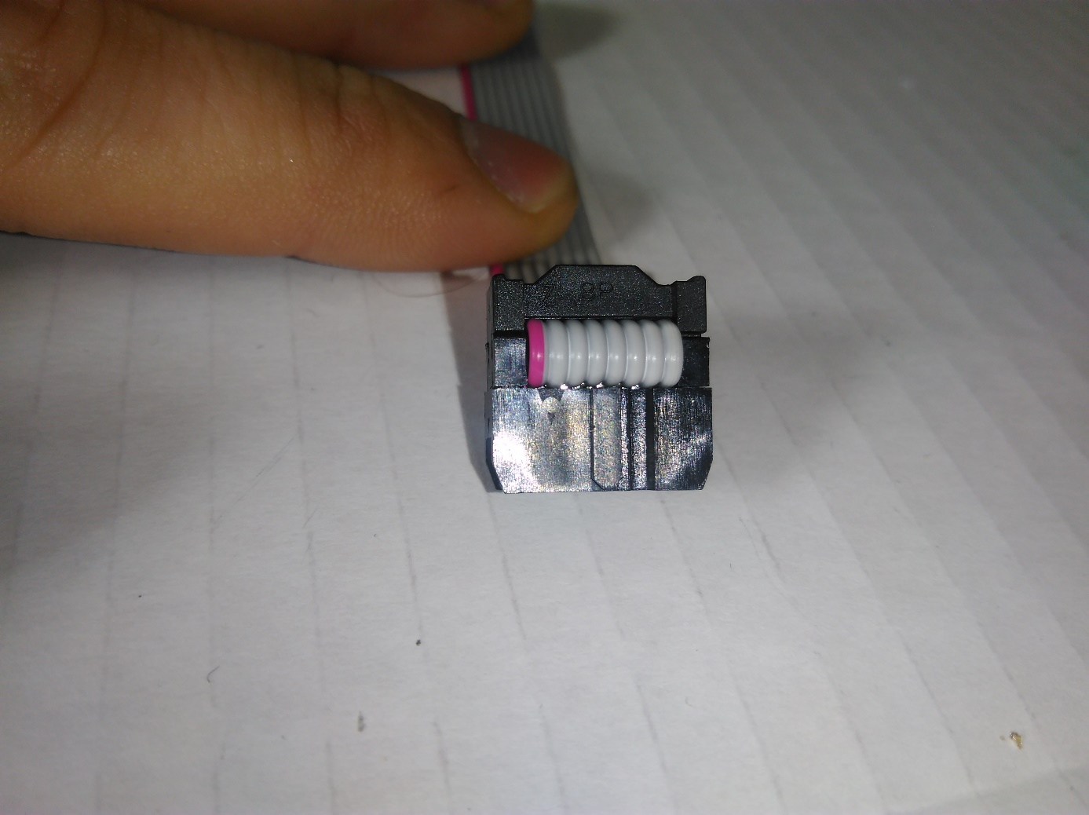

The arrow

* Align the 1st pin of the cable and 1st pin of the motor driver. Note that it is marked on the circuit board very clearly.
* Align the 1st pin on the main circuit board. The 1st pin is marked as shown below;

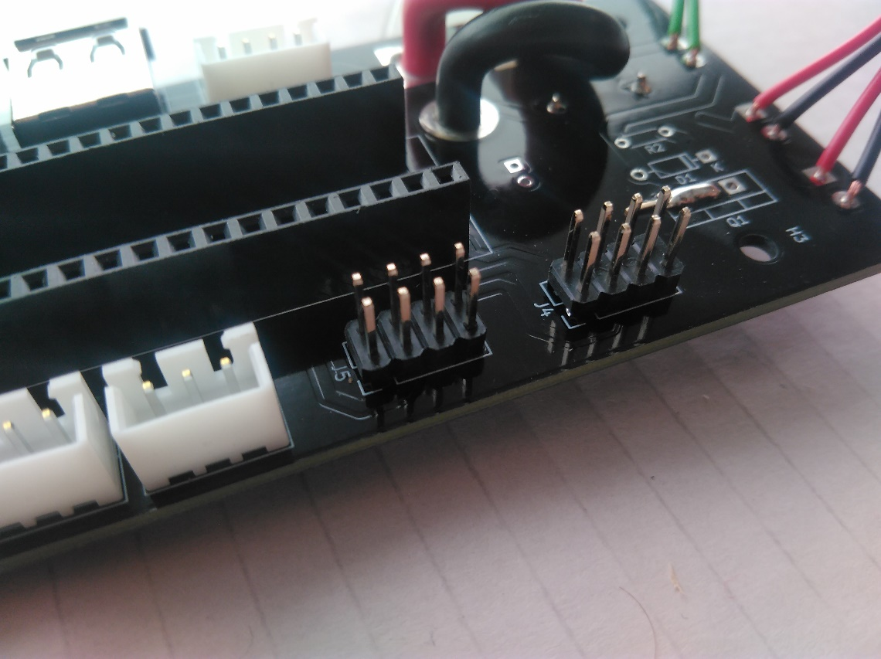

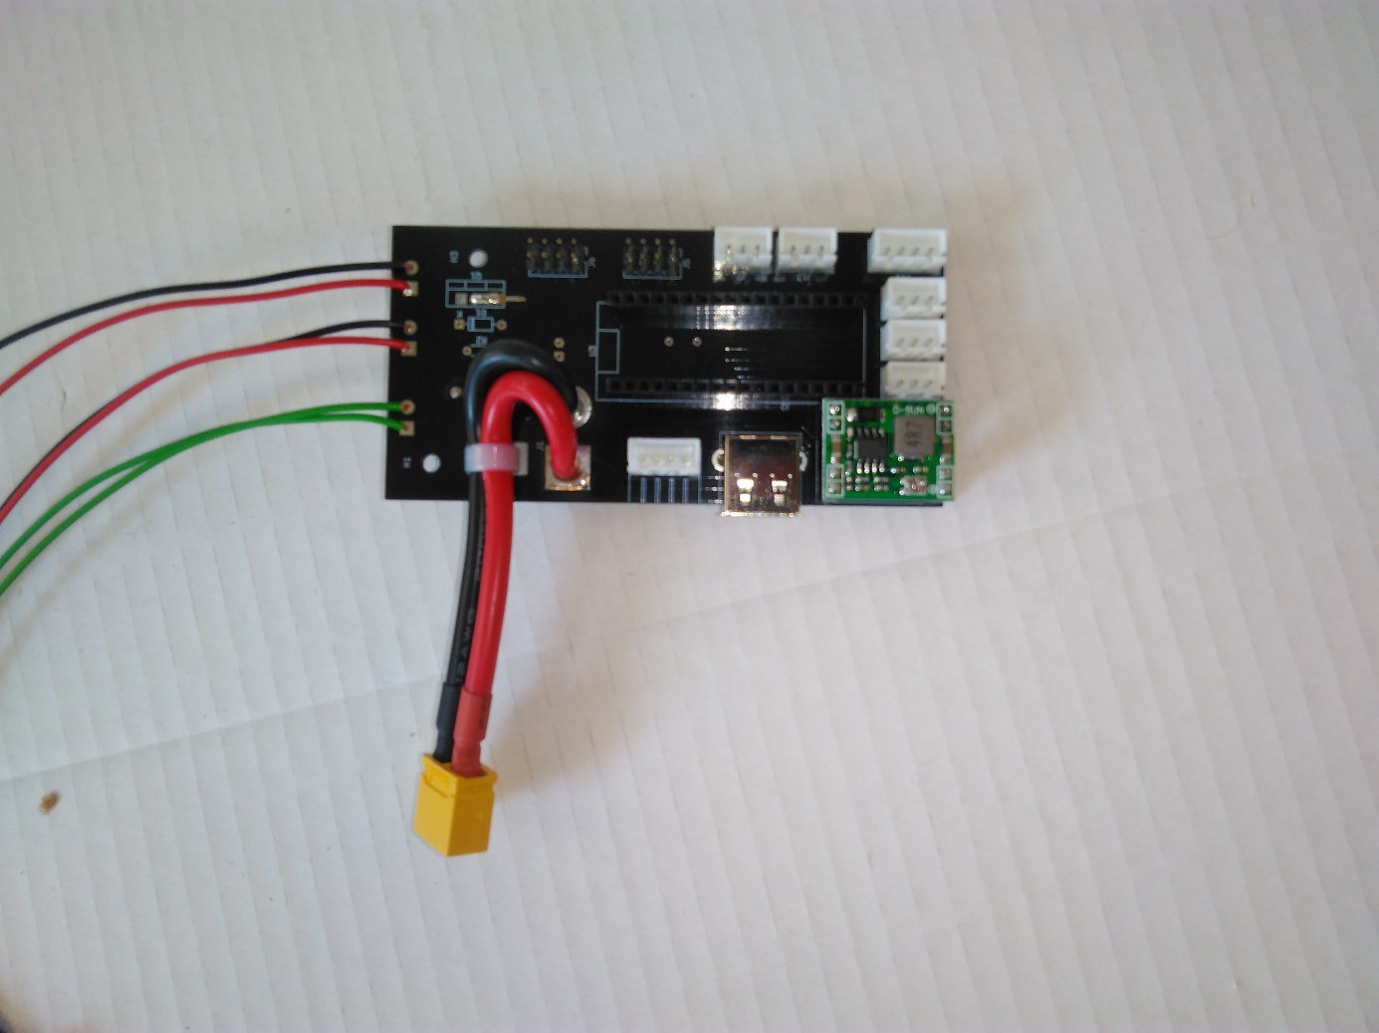

# Components on The Board

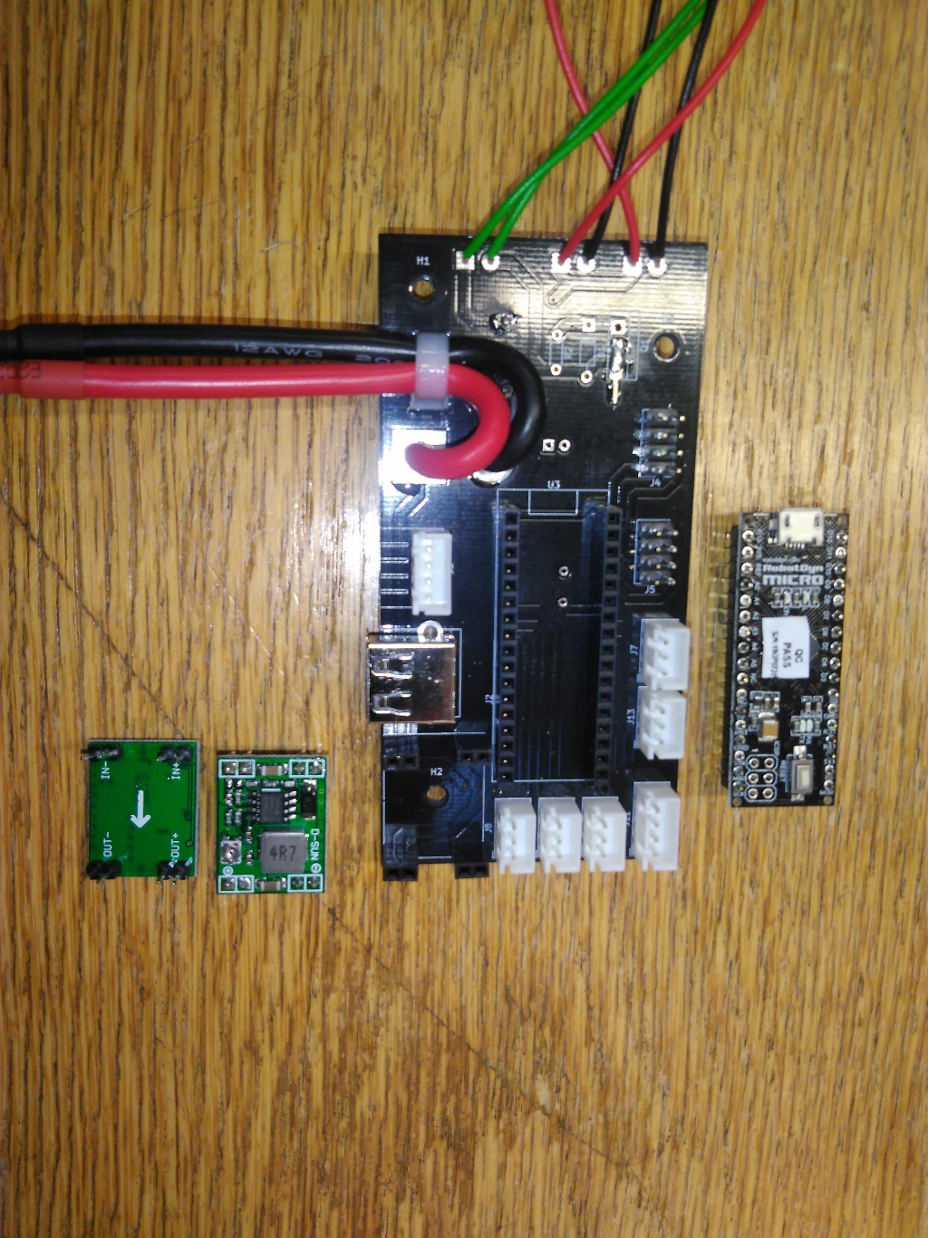

Arrow underneath shows this direction

Correct placement

…with this shape

Align this connector…

# Mounting on the Robot

You can use whatever you want: Double sided tape, cable tie, screws…

**Make sure that there is no electrical connection between the circuitry and the robot base!**

## Use of Spacers

See the photo below as an example on how you can use spacers to elevate your circuit boards

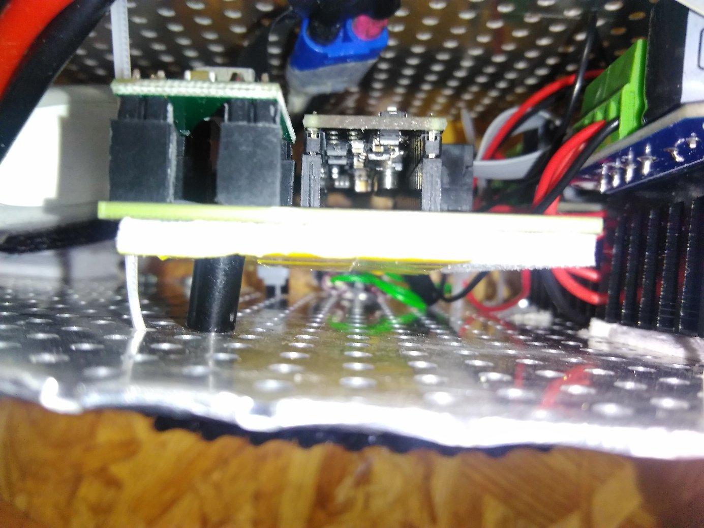

spacer

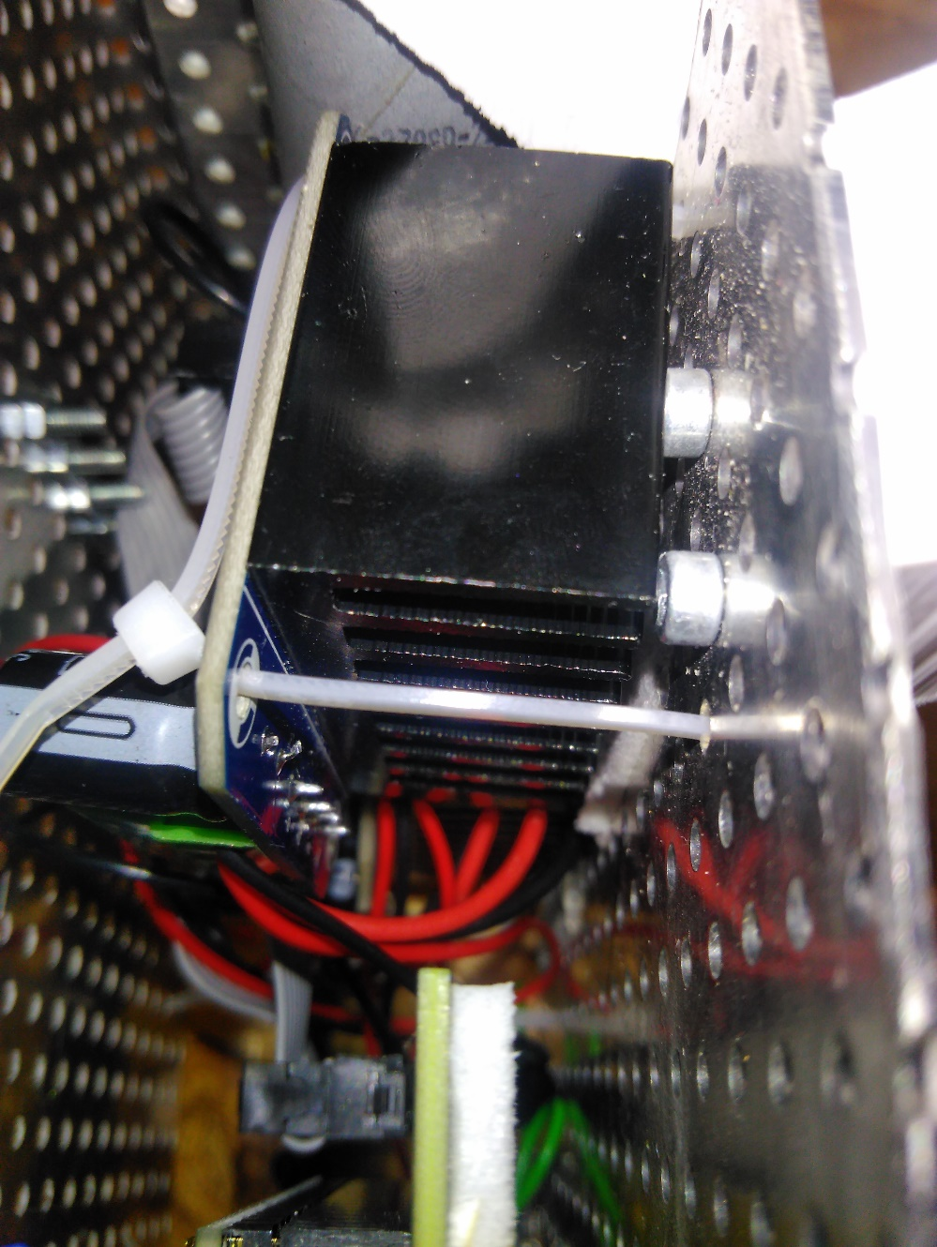

This is not an electrical part, so it can touch the metal