# DLC: driveWheel3

This is the latest iteration of the driveWheel. Thanks to the the improved motor shaft connection design, you can now deliver more torque to the tracks when needed.

## Assembly Instructions

You will need…

* 1x driveWheel3 hub
* 1x M3x10 screw
* 1x driveWheel3

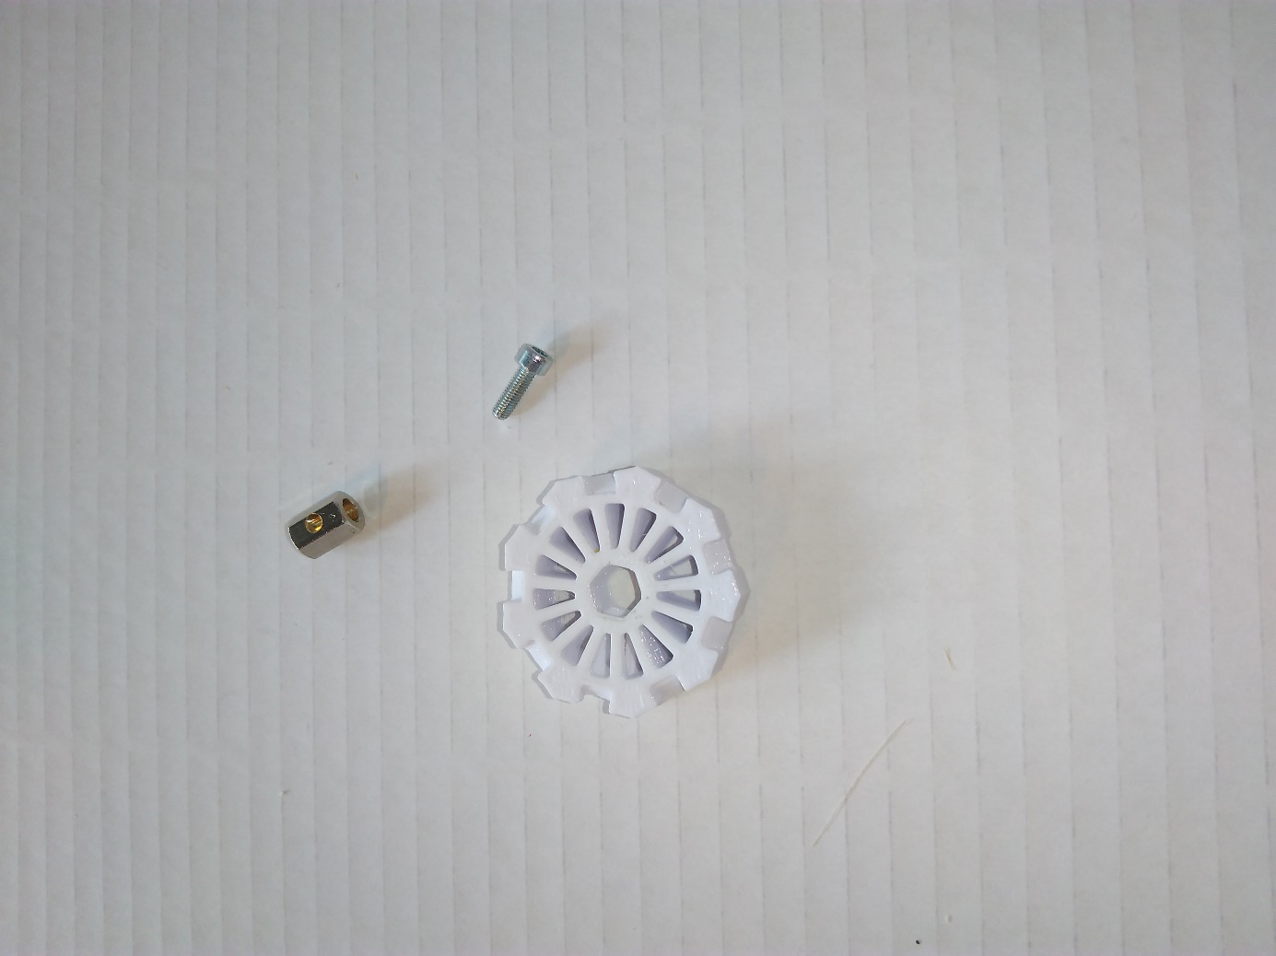

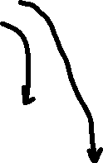

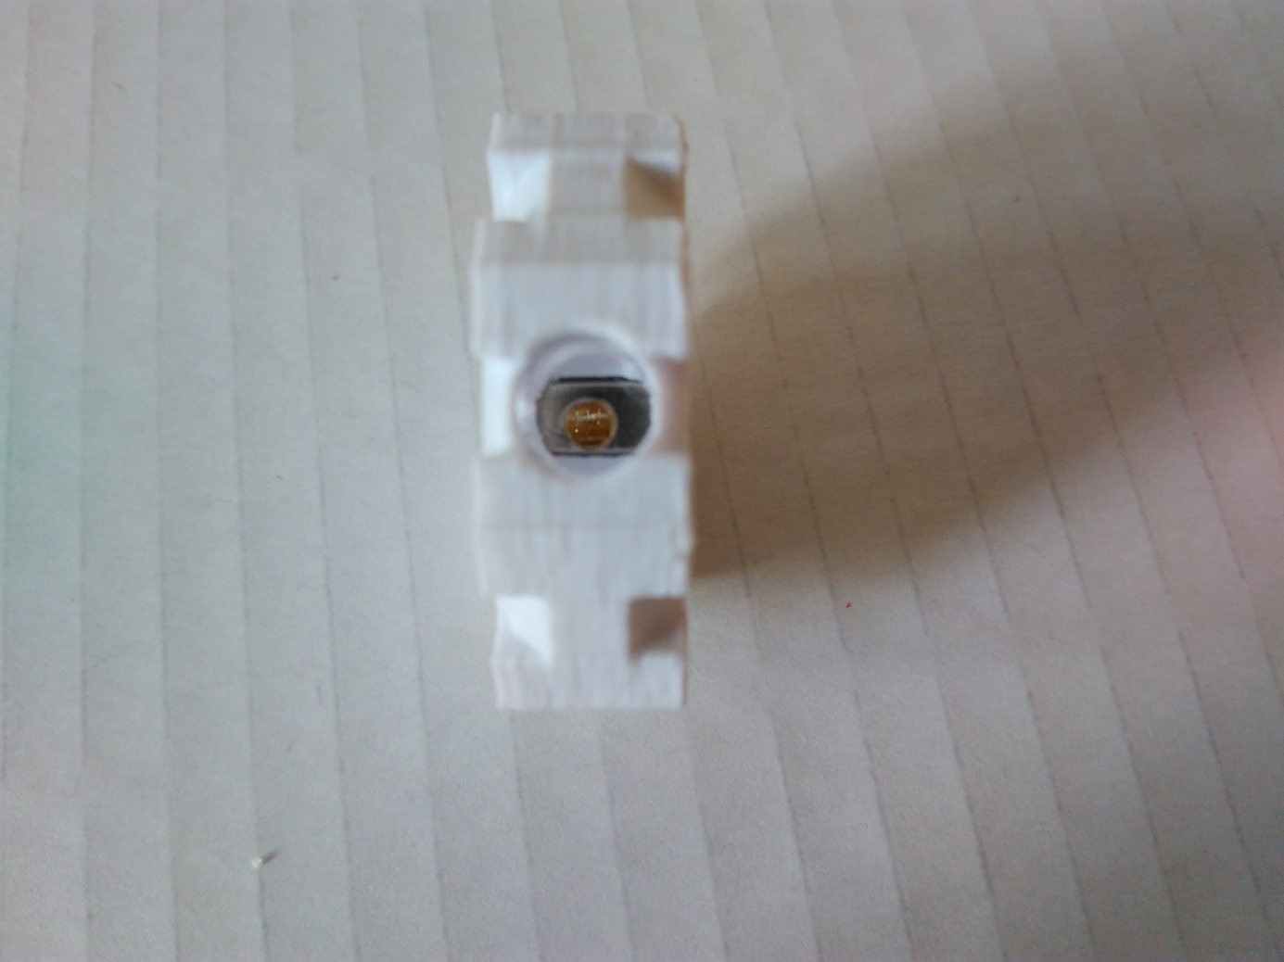

Align and insert the hub so that you

see the hole through the hole

my finger

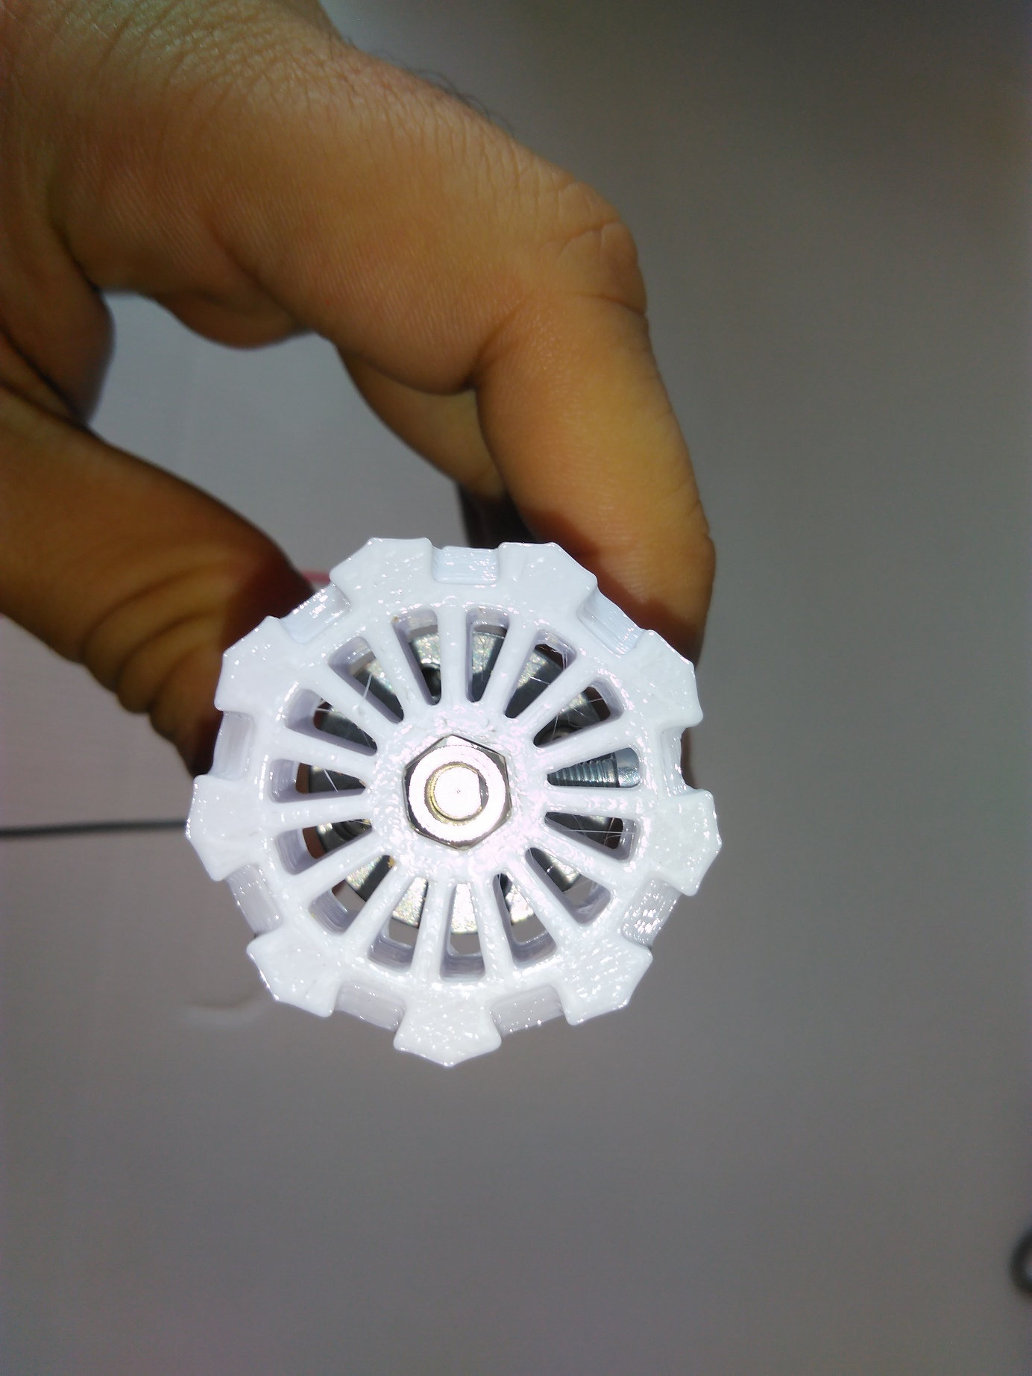

the flat side of shaft must be

perpendicular to the screw