The Semantic Web
ECS 735P

Mini Project

Student Name: Semil Halani

Student Number: 210147012

- Introduction

The main purpose of this mini project for the module The Semantic Web is to define an ontology which is to be used to fill the data from an external source and apply a few queries for the ontology to illustrate the correct workflow and the combined information offered by it.

Basic Task

Initially, I looked for the best kind of fit for the domain and the source of data which would be used for building the ontology for this project. After a lot of efforts of doing research online, I decided to select the data related to Motorsport Cars, from the online data resource, DBpedia. I referred a lot of different entries of the domain, which possesses few useful information in order to construct the ontology for my project. Furthermore, I used the software application named Protégé, version 5.5.0, for defining the ontology structure for my project, which resulted in the file named car_basic.owl.

Class Hierarchy

According to the data from the dataset on the website, DBpedia, I discovered the structure of the information given and then arranged them in a proper way. Moreover, I created 10 classes for the same, as shown below:

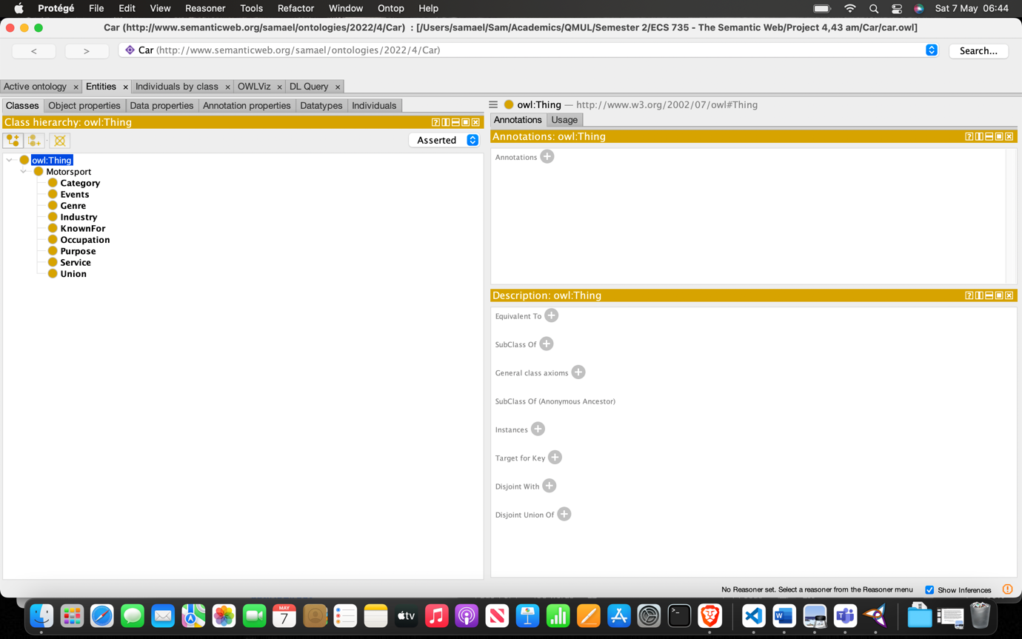

As shown in the image, there are a few classes such as Category, Events, Industry, Service etc. Motorsport is the top most class and then the other classes are beneath it. All the other classes are the subclasses of the class Motorsport. The Service class just includes 2 records and the Union class has just 1 record, whereas the Genre, Industry and other classes have a lot of other varied data for those respective classes.

Class | Asserted information
Motorsport | N/A
Category | N/A
Events | N/A
Genre | N/A
Industry | N/A
KnownFor | N/A
Occupation | N/A
Purpose | N/A
Service | N/A
Union | N/A

Table 1. Asserted information for each class in the Motorsport Cars ontology.

- Concepts and Properties

Object Properties:

To illustrate the relationship between the classes, I created a few object properties which would relate the classes as shown below:

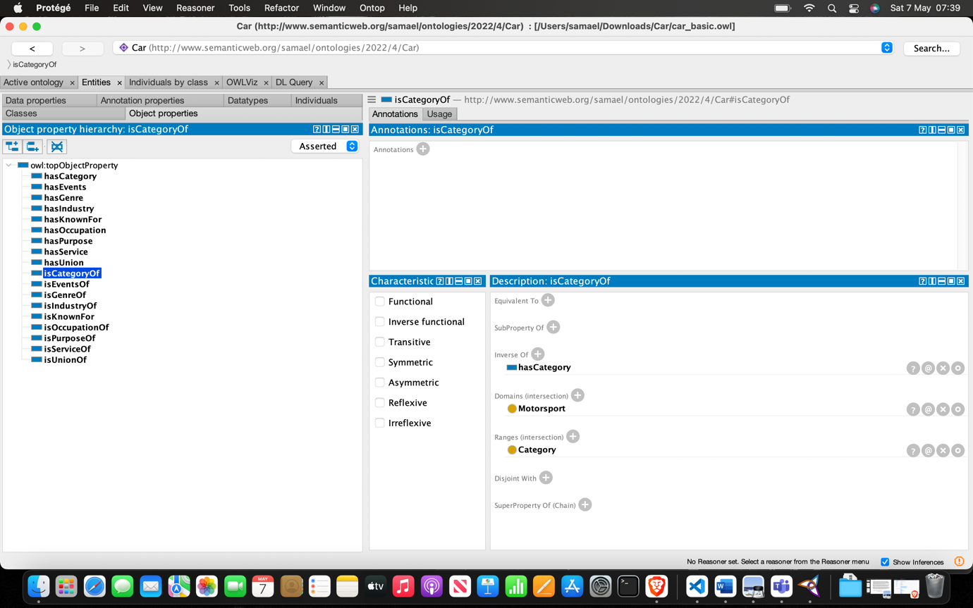

With respect to the object properties discussed above, I went through the process of determining whether the object properties are functional, inversely functional, symmetric etc. For instance, consider the object property isGenreOf; it is Asymmetric because every Motorsport car is a genre of the respective genre whereas vice versa doesn’t hold true.

Also, isGenreOf is an inverse property for the object property hasGenre. It works in similar way for most of the object properties.

We asserted the following object properties:

- hasUnion: Motorsport cars has different unions
- isCategoryOf: Motorsport cars is a different category
- isEventsOf: Motorsport cars is related to different events
- isGenreOf: Motorsport cars is a genre of different instances
- isIndustryOf: Motorsport cars is industry of different instances
- isKnownFor: Motorsport cars is known for various stuff
- isOccupationOf: Motorsport cars is an Occupation of a lot of people
- isPurposeOf: Motorsport cars is a purpose for a lot of instances
- isServiceOf: Motorsport cars is a service for a few different instances
Data Properties:

For the mentioned dataset, I created 5 data properties as shown below:

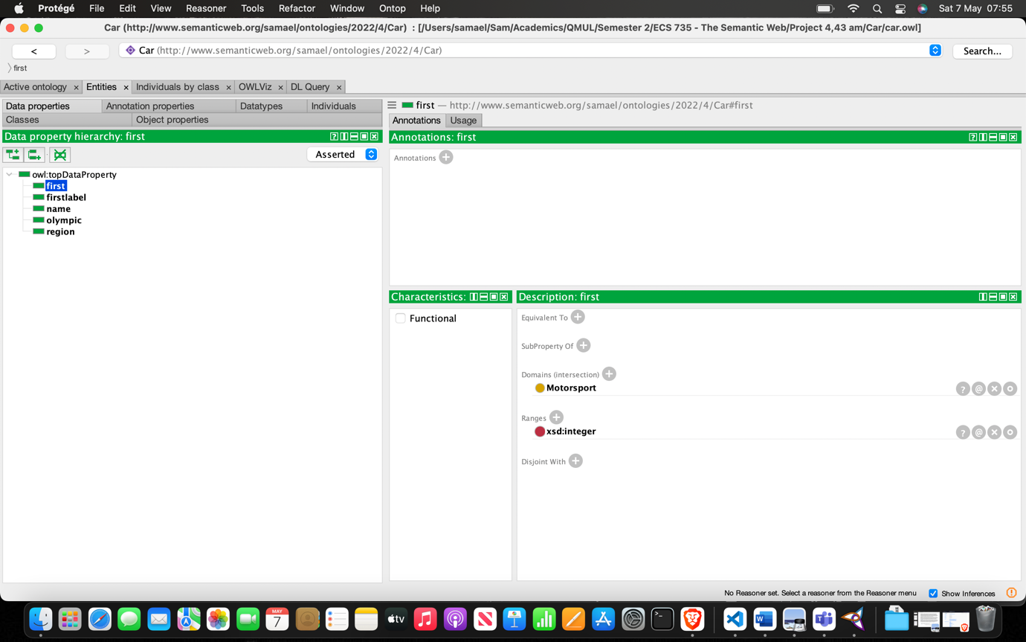

For the above 5 data properties,

- first: Motorsport car has a year when it was first released. The first is an integer.
- name: Motorsport car has a name. The name is a string.
- region: Motorsport car has a region. The region is a string.
- olympic: Motorsport car has a year when it appeared in the Olympic for the first time. The olympic is an integer.
- firstlabel: Motorsport car has a firstlabel. The firstlabel is a string.

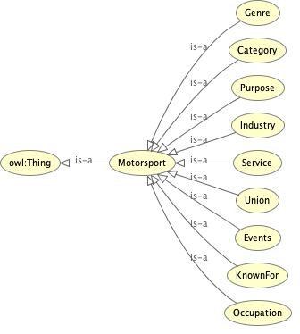

- Asserted Individuals

Class | Individuals
Service | MotorSport_Vision, Racelogic
Genre | Supercars_Life, Sniff_Petrol, …
Category | Auto_Action, Avto_Plus, Auto_Motor_und_Sport, …
Industry | Alpinestars, AMR_GP, AGV_Sports_Group, Abt_Sportsline, …
KnownFor | Antonio_Maeso, Charlie_Christina_Martin, Lee_McKenzie, …
Events | Alexandra_Park_Street_Circuit
Occupation | Alfieri_Maserati, Ralph_Bellamy_(racing_car_designer), Bill_Boddy, …
Purpose | FIA_World_Motor_Sport_Council, ASN_Canada_FIA, Fédération_Internationale_de_l’Automobile, …
Union | Alexandra_Park_Street_Circuit

For a full list of Individuals, kindly refer to the Ontology file.

Query Data

The query is shown below in the query_basic.py file, which queries all the motorsports cars according to their genre:

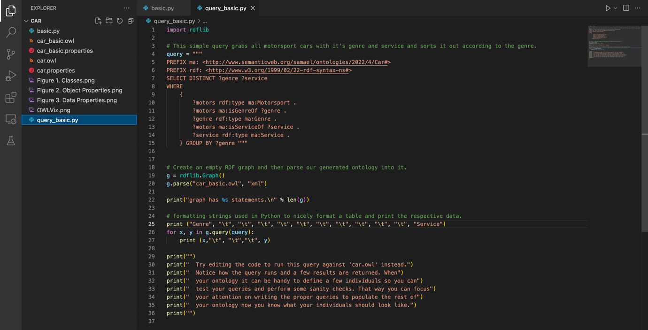
Result:

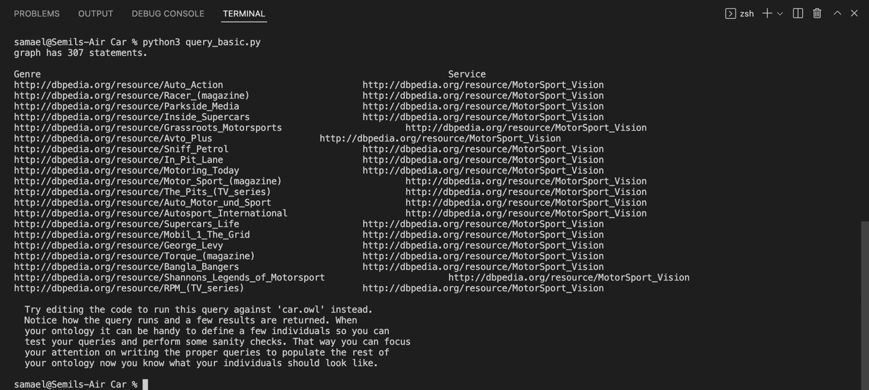

- Issues

There was a lot of issues that were faced while looking for the information and creating the ontology. For example, as there was observed a lot of inconsistency of the data obtained through the data resource, some had enough data while some did not, I had to manually select which classes should be created. Furthermore, a few individuals have an incorrect data type which is why I had to format the ontology in a more structured and correct manner. Furthermore, the reasoner takes a lot of time which results in a slow and delayed process.

- Conclusion

We can get a lot more information from the initial statements asserted into the ontology if we use inference. Furthermore, it can be noted that the efficiency of the reasoning process needs to be worked upon too, as the reasoners are often too time consuming, which restricts us from a lot of other rule definitions and thus limits our information gain overall.

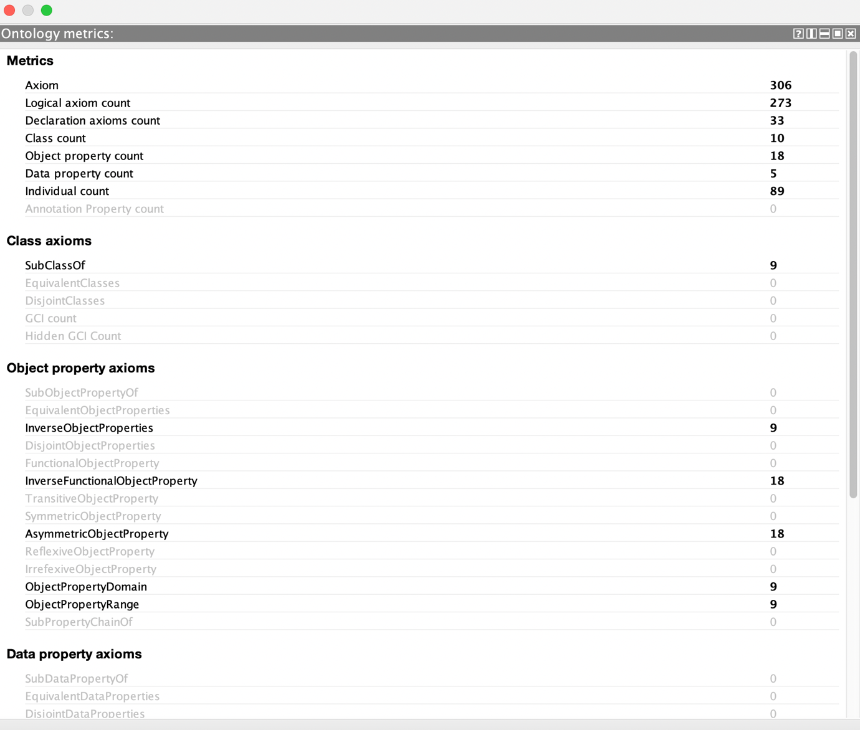

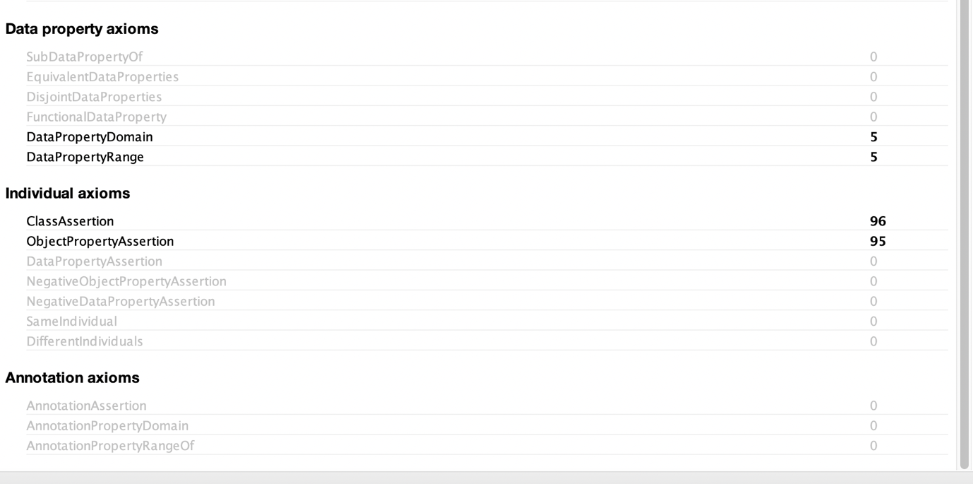

- References

- https://dbpedia.org/page/Motorsport
- https://dbpedia.org/page/Auto_Motor_und_Sport
- https://dbpedia.org/page/Car

