1，设置工具连接，进行下面操作前，前先安装驱动。
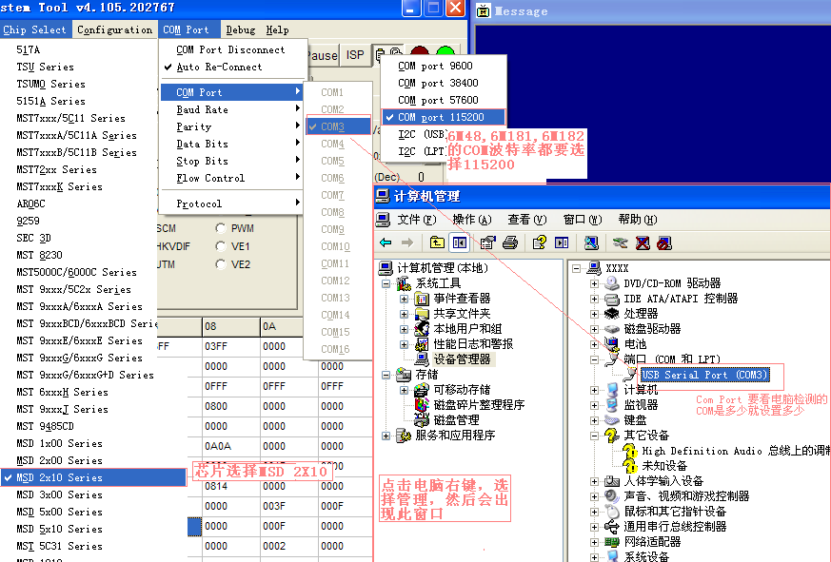

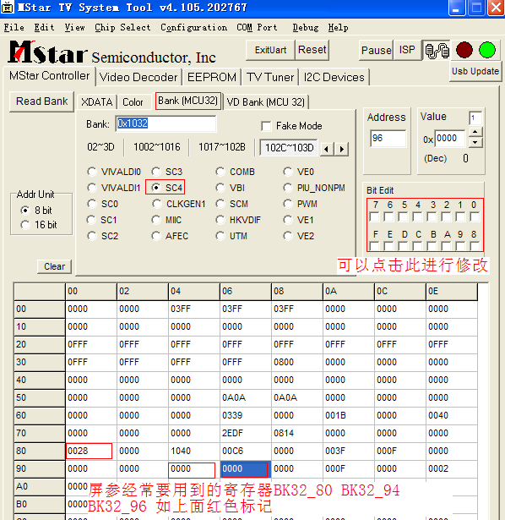
2.
enPanelbitMode BK32_96[0 1]
enPanelDualPort BK32_94[1]
enPanelSwapPort BK32_94[0]
enPanelSwapOdd_ML BK32_92[12]
enPanelSwapEven_ML BK32_92[14]
enPanelSwapOdd_RB BK32_92[11]
enPanelSwapEven_RB BK32_92[13]
enPanelSwapLVDS_POL BK32_80[5]
enPanelSwapLVDS_CH BK32_80[6]
enPanelLVDS_TI_MODE BK32_80[2]
enPanelDoubleClk BK31_06[7]

Display H start REG_SC_BK10_08_L (BK10_10 BK10_11)
Display H end REG_SC_BK10_09_L (BK10_12 BK10_13)
Display V start REG_SC_BK10_0A_L (BK10_14 BK10_15)
Display V end REG_SC_BK10_0B_L (BK10_16 BK10_17)

3.YPBPR VGA通道下干扰问题。
