Content:
- Overview
- Terms
- Architecture Design
- Interface Design
- User Cases
- Test Design

1 Overview
This document describes the design consideration of HDMI CEC Feature which will be shipped in common consumer electronic devices (such as BDP, Google TV compliant devices), also the prototype and usage of the interfaces which can be invoked in Java language of the CEC feature is enumerated and illustrated.

2 Terms
2.1 HDMI CEC ----- HDMI Consumer Electronics Control, which is a protocol that provides high-level control, functions between all of the various audiovisual products in a user’s environment.

2.2 Android Architecture ----- Android has the following layers:
application (written in java, executing in Dalvik)
framework services and libraries (written mostly in java)
applications and most framework code executes in a virtual machine
native libraries, daemons and services (written in C or C++)
the Linux kernel, which includes
drivers for hardware, networking, file system access and inter-process-communication

2.3 JNI ----- The JavaTM Native Interface (JNI) is a powerful feature of the Java platform. Applications that use the JNI can incorporate native code written in programming languages such as C and C++, as well as code written in the Java programming language.

2.4 AIDL ----- Android Interface Definition Language that allow you to define the programming interface that both the client and service agree upon in order to communicate with each other using interprocess communication (IPC). This technique is necessary only if you allow clients from different applications to access your service for IPC and want to handle multithreading in your service.

2.5 A3CE TV Framework ----- A framework which is developed by Marvell co. provided to App developer to develop TV feature related Application, it contains some media devices and appropriate controllers , a TvService which hook up all the content provider and controller and MrvlTvView which is similar to the VideoView provided in original android sdk. For more detail, refer to A3CE_TvFramework.doc.
2.6 TV_CEC_API ----- CEC under-layer API for TV compliant hardware which is dependent on Linux CEC driver and called through java JNI technique.

2.7 BDP_CEC_API ----- CEC under-layer API for BDP compliant hardware which is dependent on Linux CEC driver and called through java JNI technique.

2.8 CecSerivce ----- A application service inherited from Service class to accept client request through Context.bindService() to get a Bp Service object which implements ICecServiceHub, client can get one of two other Bp Service objects(one implements the IDmpCecService interface, the other implements ITvCecService, but one concrete implementation corresponding to device type at runtime) through this ICecServiceHub to access the actual HDMI CEC functions. The term “CecService” in generalized concept also refers the object/function set made up of CecService, CecServiceHub, TvCecService, DmpCecService in “Figure 1 design of HDMI CEC Feature Implement”. This is explained in the section 3.1. You can tell the difference from the context.

2.9 CecManager ----- A helper manager object which wrapper some common and easy functions of TvCecService or DmpCecService which is only needed in application level.

2.10 OTP ----- One touch play which is a HDMI CEC feature allows a device to be played and become the active source with a single button press.

3 Architecture Design
The Figure 1 illustrates the relationship between objects in UML view.

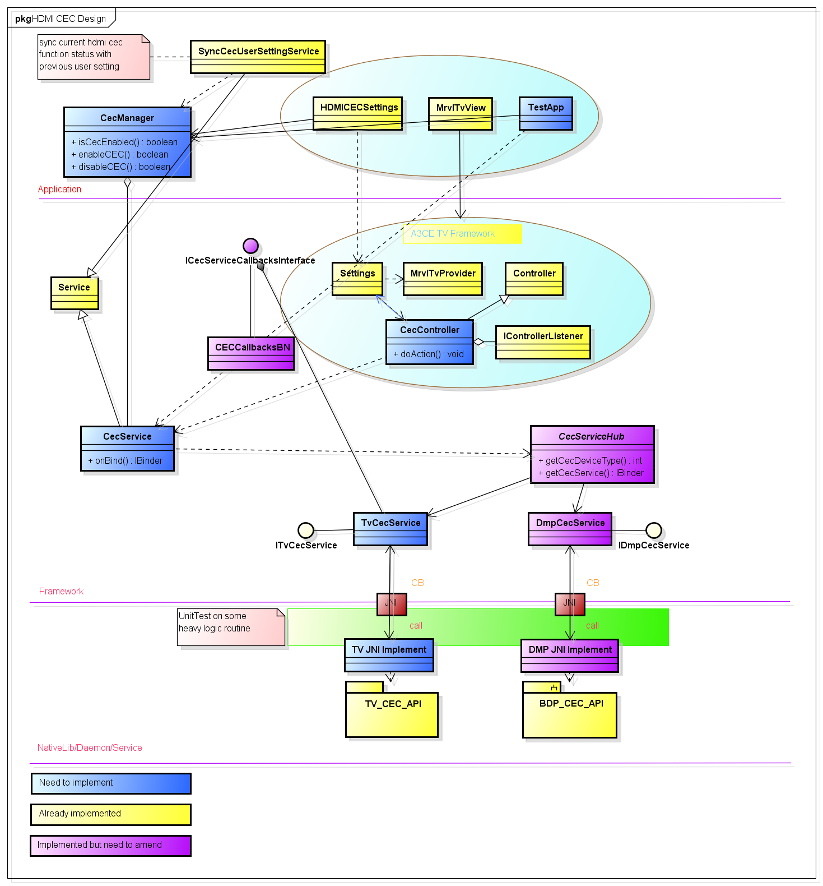
Figure 1 design of HDMI CEC Feature Implement
Some more detailed explanation about the components in the Figure 1 is listed in the next section:
3.1 CecService
A function set made up of CecService, CecServiceHub, TvCecService, DmpCecService which provides common HDMI CEC utilities(e.g. enable/disable cec feature, registerCECCallback/unregisterCECCallback, system audio control, deck control, remote control pass through). The actual CecService implementation is represented by TvCecService object or DmpCecService ojbect which implement the CEC functionality corresponding to the actual CEC device/hardware with the help of JNI technique and different under layer CEC API.

3.2 CecController
A controller used to control all the connected HDMI CEC compliant devices which is similar to IR Blaster controller & ATVController in the A3CE TV framework which involves the Deck Control & Remote Control Pass Through feature of HDMI CEC most.

3.3 ICecServiceCallbacksInterface
A AIDL interface which is used by notifier side to inform listener side that some event is happened, such as HDMI device scan is started, HDMI device scan is stopped, HDMI device scan is completed, HDMI CEC feature is enabled/disabled(available or unavailable for other components to use).

3.4 CecCallbacksBN
A class which realizes the ICECServiceCallbacksInterface interface to play a BN side role in IPC. All the listener side of CECService should derive from this class.

3.5 TestApp
An android application which used to test the functionality of HDMI CEC feature implement based on Junit test framework.

3.6 Design consideration
The design goal of HDMI CEC Service is:
- easy
which means the implementation is easy for code-review, easy to understand.
- stable
There are some must APIs is exported to application layer of Android, so keep API stable and downward compatibility is ultra-important
- easy to maintain
Have an ability that adapt to hardware/Android/solution version migration with least modification

The core part of the HDMI CEC functionality is the TvCecService object and DmpCecService ojbect which relies on the CEC API in native code through JNI. The CecManager, CecController in A3CE TV framework and TestApp are dependent on it. The interface of TvCecService is stable and comprehensive. Besides cec functions invoked from request side, the TvCecService object is also responsible for forwarding some under-layer events(mostly sent by other cec-compliant devices) to request other android component’s collaboration(sending broadcast, start some activity, or invoking audio system to mute or unmute specified channel, save some cec related state and etc.).

CecController keeps a ServiceConnection to CecService, based upon which CecController forwards the user control request from A3CE TV framework(in application view only MrvlTvView and some input event is explicitly involved). These requests include UC commands, Deck Control, standby, OTP and etc., also receiving callbacks from CecService to get to know that some fatal thing has happened. Besides the above, whenever the channel between cec-compliant device is switched on and the android driven host(TV or DMP), the CecService is always prepared for serving and forwarding some reported events/requests.

5 Interface Design
The following is the interfaces of ICecServiceHub:
/**
* Return the cec device type(currently only DMP & TV available)
*/
int getCecDeviceType();

/**
* Return a IBinder CecService object, client side should cast it to a appropriate
* interface respecting to the result of getCecDeviceType()
*/
IBinder getCecService();

The following is the interfaces of CecManager:
/**
* give the status of current cec function
* @return true if currently enabled, otherwise false
*/
boolean isCecEnabled();

/**
* enable the cec function
* It is important to note that the real stuff will be completed async,
* depending on the status of remote CecService
*
* @return true on success, otherwise false
*/
boolean enableCEC();

/**
* disable the cec function
*
* @return true on success, otherwise false
*/
boolean disableCEC();

/**
* unbind the CecService in application layer and release the ServiceConnection
* Note: When the Context object which is used to create this CecManager object
* becoming inactive(such as in onDestroy() of a activity), do remember to call this function
*/
public void recycle();

The next section lists the interfaces of IDmpCecService:
/**
* whether this CecService object is of specified type
* @param[in] devTypeId the type ID of the target cec device to be judged
*
* @see com.marvell.hdmicec.CecServiceHub.CEC_DEVICE_TYPE_TV
* @see com.marvell.hdmicec.CecServiceHub.CEC_DEVICE_TYPE_DMP
* @return true if actually being specified type, otherwise false
*/
boolean isOfType(int devTypeId);

/**
* enable the cec function
*
* @param[in] isOnBoot whether enable cec function when system booting
* @return true on success, otherwise false
*/
boolean enableCEC(boolean isOnBoot);

/**
* disale the cec function
*
* @return true on success, otherwise false
*/
boolean disableCEC();

/**
* give the status of current cec function
* @return true if currently enabled, otherwise false
*/
boolean isCECEnabled();

/**
* set the power status of device (POWER_ON or POWER_STANDBY)
*
* @param[in] power_mode request power mode
* @return void
*/
boolean setPowerStatus(int power_mode);

/**
* inform all other devices on the network that the active route
* is changed
*
* @return true on success, otherwise false
*/
boolean sendRoutingChange();

/**
* issue that this device becoming the active source device
*
* @return true on success, otherwise false
*/
boolean setActiveSource();

/**
* get currently supported cec feature list
*
* @return cec feature list
*/
List<String> getSupportedCECFeatureSet();

The following section lists the interfaces of ITvCecService:
/**
* whether this CecService object is of specified type
* @param[in] devTypeId the type ID of the target cec device to be judged
*
* @see com.marvell.hdmicec.CecServiceHub.CEC_DEVICE_TYPE_TV
* @see com.marvell.hdmicec.CecServiceHub.CEC_DEVICE_TYPE_DMP
* @return true if actually being specified type, otherwise false
*/
boolean isOfType(int devTypeId);

/**
* whether the system audio control feature is enabled
*
* @return the current system audio control status
*/
boolean isSACEnabled();

/**
* store the status whether some cec device has bootup(been activated)
*
* @param[in] token the tag indicating whether activated
* @return void
*/
void setBootUpToken(boolean token);

/**
* retrieve the status whether some cec device has bootup(been activated)
*
* @return the bootup token
*/
boolean getBootUpToken();

/**
* whether the menu of a cec device is on/activited
*
* @return the status of device menu
*/
boolean isDevMenuOn();

/**
* setting the mute status of TV
*
* @param[in] status the status requested
* @return void
*/
void setTvMuteStatus(boolean status);

/**
* request a steaming path from the specified address
*
* @param[in] devPhyAddress the physical address of the new streaming source device
* @return void
*/
void setStreamPath(char devPhyAddress);

/**
* Get the address of the active input device that normally sending the ACTIVE_INPUT,TEXT_VIEW_ON,IMAGE_VIEW_ON
* events
*
* @return the address of the active source device
*/
int getActiveInputDeviceAddress();

/**
* same with disableSAC, but no broadcasting the SAC state switch
*
* @return the address of the active source device
*/
void disableSacWithoutStateUpdate();

/**
* set the logic address of the active input device
*
* @param[in] devLogicAddress logic address of the active input device
* @return void
*/
void setActiveInputDeviceLogicAddress(int devLogicAddress);

/**
* set the physical address of the active input device
*
* @param[in] devPhysicalAddress physical address of the active input device
* @return void
*/
void setActiveInputDevicePhysicalAddress(int devPhysicalAddress);

/**
* enable the cec function
*
* @param[in] isOnBoot whether enable cec function when system booting
* @return true on success, otherwise false
*/
boolean enableCEC(boolean isOnBoot);

/**
* disale the cec function
*
* @return true on success, otherwise false
*/
boolean disableCEC();

/**
* give the status of current cec function
* @return true if currently enabled, otherwise false
*/
boolean isCECEnabled();

/**
* get the mute status of the TV speaker
*
* @return the the mute status of the TV speaker
*/
boolean isTvSpeakerMute();

/**
* issue that this device becoming the active source device
*
* @return true on success, otherwise false
*/
boolean setActiveSource();

/**
* retrieve the list of connected CEC devices
*
* @note this method may be heavy
* @see CECDevInfo
* @return the device list in which the elements are of CECDevInfo type
*/
List<CECDevInfo> getListOfConnectedCECDevices();

/**
* launch the discovery routine of connected CEC devices
*
* @return 1 on success, otherwise 0
*/
int startCECDeviceDiscovery();

/**
* stop the discovery routine of connected CEC devices
*
* @return 1 on success, otherwise 0
*/
int stopCECDeviceDiscovery();

/**
* inform all other devices on the network that the active route
* is changed from oldDevAddr to newDevAddr
*
* @param[in] newDevAddr the new address to be switched to
* @param[in] oldDevAddr the old address previously switched to
* @return true on success, otherwise false
*/
boolean sendRoutingChange(int newDevAddr, int oldDevAddr);

/**
* register callbacks to be informed some cec related events
*
* @param[in] cb the callback object to be registerred
* @return void
*/
void registerCECCallBack(ICecServiceCallbacksInterface cb);

/**
* unregister callbacks that don't want to be informed some cec related events any longer
*
* @param[in] cb the callback object wanted to be unregisterred
* @return void
*/
void unregisterCECCallBack(ICecServiceCallbacksInterface cb);

/**
* Activates the specified CEC device in the cec bus network
*
* @param[in] devAddress the logic address of the target device
* @param[in] portNumber the port number of the target device
* @param[in] physicalAddress the physical address of the target device
* @return - int return 0 for success, error number otherwise
*/
int activateCECDevice(int devAddress, int portNumber, int physicalAddress);

/**
* unregister callbacks that don't want to be informed some cec related events any longer
*
* @param[in] cb the callback object wanted to be unregisterred
* @return void
*/

/**
* get the active cec port number in the network
*
* @return the current active CEC port
*/
int getActiveInputPort();

/**
* Gets the OSD display string of the CEC device
*
* @param[in] target device address
* @return OSD display string
*/
String getOsdNameOfDevice(int devAddress);

/**
* get the deck status of the CEC device
*
* @param devAddress target deck device address
*
* @return DeckStatus
*/
int getDeckStatus(int devAddress);

/**
* set the current input port number for the current CEC device
*
* @param inputPort port number
* @return 0 for success, error number otherwise
*/
int setCurrentInput(int inputPort);

/**
* sets the OSD name of the current CEC device
*
* @param osdName OSD name for the current CEC device
* @return 0 on success, error number otherwise
*/
int setDeviceOsdName(String osdName);

/**
* Get the number of HDMI CEC Devices
*
* @return number of CEC Devices
*/
int getNumberOfHDMICECDevices();

/**
* get current active device address
*
* @return The current active device address in the CEC network
*/
int getCurrentActiveCECDeviceAddress();

/**
* Send Standby message to the all devices in HDMI Bus.
*
* @return void
*/
void sendStandyMessageToSystem();

/**
* send the abort reason for the CEC device
*
* @param[in] opCode the operation code
* @param[in] type Abort type
* @return 0 for success, error number otherwise
*/
int sendAbort(int opCode, int type);

/**
* send the Play Mode
*
* @param int - device address
* @param int - com.google.cec.types.DeckControl enumerated value
* @return 0 for success, error number otherwise
*/
void sendPlayMode(int devAddress, int playMode);

/**
* send the vendor specific commands
*
* @param[in] device address
* @param[in] com.google.cec.CecVendorCmd - value configuration for vendor command
* @return 0 for success, error number otherwise
*/
int sendVendorCommand(int devAddress, in CECVendorCmd vendorCmd);

/**
* query all the audio descriptors
*
* @return list of audio descriptors
*/
List<String> getSupportedAudioDescriptors();

/**
* set the tuner status
*
* @param[in] tunerChannel value configuration for tuner parameters
* @return 0 on success, error number otherwise
*/
int setTunerStatus(in CECTunerChannelInfo tunerChannel);

/**
* set the ARC status
*
* @param[in] bEnable true to enable, false to disable
* @param[in] audioDevAddress logic address of the audio device
* @param[in] audioDevPhyAddress physical address of the audio device
* @return 0 on success, error number otherwise
*/
int setARCStatus(boolean bEnable, int audioDevAddress, int audioDevPhyAddress);

/**
* turn ON the ARC feature
*
* @return 0 on success error code in case of failure
*
*/
int enableARC();

/**
* turn OFF the ARC feature
*
* @return 0 on success error code in case of failure
*
*/
int disableARC();

/**
* send the deck control command to the specified device
*
* @param[in] devAddress target device address
* @param[in] deckCtrl the control command
* @return 0 on success, error number otherwise
*/
void sendDeckControl(int devAddress, int deckCtrl);

/**
* send the user specific key to the specified device
*
* @param[in] devAddress target device address
* @param[in] userKeyMode - com.google.cec.types.KeyPressMode enumerated value
* @param[in] userKeyCode- com.google.cec.types.userKeyCode enumerated value
* @return 0 on success, error number otherwise
*/
int sendUserControl(int devAddress, int userKeyMode, int userKeyCode);

/**
* send the menu command for the specified device
*
* @param[in] devAddress target device address
* @param[in] bActivate true to activate, false to deactivate
* @return 0 on success, error number otherwise
*/
int sendMenuCommand(int devAddress, boolean bActivate);

/**
* Handle the about the TV standby mode event
*
* @param[in] bIsInStandByMode whether TV is in standby mode
* @return void
*/
void setCECShutdownStatus(boolean bIsInStandByMode);

/**
* set the TV power status (POWER_ON or POWER_STANDBY)
*
* @param[in] powerStatus power mode
* @return void
*/
void setTvPowerStatus(int powerStatus);

/**
* get the power status of a particular device
*
* @param[in] devAddr the address of the target device
* @return the power status
*/
int getPowerStatus(int devAddr);

/**
* get the adress of the current active source
*
* @param[in] devAddr the address of the target device
* @return 0 on success, error number otherwise
*/
int requestActiveSource();

/**
* set the target device's system audio mode on
*
* @param[in] devLogicAddress the logic address of the target device
* @param[in] devPhyAddress the logic address of the target device
* @return 0 on success, error number otherwise
*/
int setSystemAudioModeOn(int devLogicAddress, int devPhyAddress);

/**
* set the target device's system audio mode off
*
* @param[in] devLogicAddress the logic address of the target device
* @param[in] devPhyAddress the logic address of the target device
* @return 0 on success, error number otherwise
*/
int setSystemAudioModeOff(int devLogicAddress, int devPhyAddress);

/**
* get the current device's OSD display name
*
* @param[in] devLogicAddress the logic address of the target device
* @param[in] devPhyAddress the logic address of the target device
* @return 0 on success, error number otherwise
*/
String getOSDDisplayString();

/**
* get address of the device that wakeuped this device
*
* @return the device address
*/
int getWakeUpSource();

/**
* send HDMI CEC Language code in ISO-639-1 format
*
* @param[in] ISO639_1_lngcode Language code in ISO-639-1 format
* @return void
*/
void broadcastNewMenuLanguage(String ISO639_1_lngcode);

/**
* get currently supported cec feature list
*
* @return cec feature list
*/
List<String> getSupportedCECFeatureSet();

5 User Cases
4.1 OTP
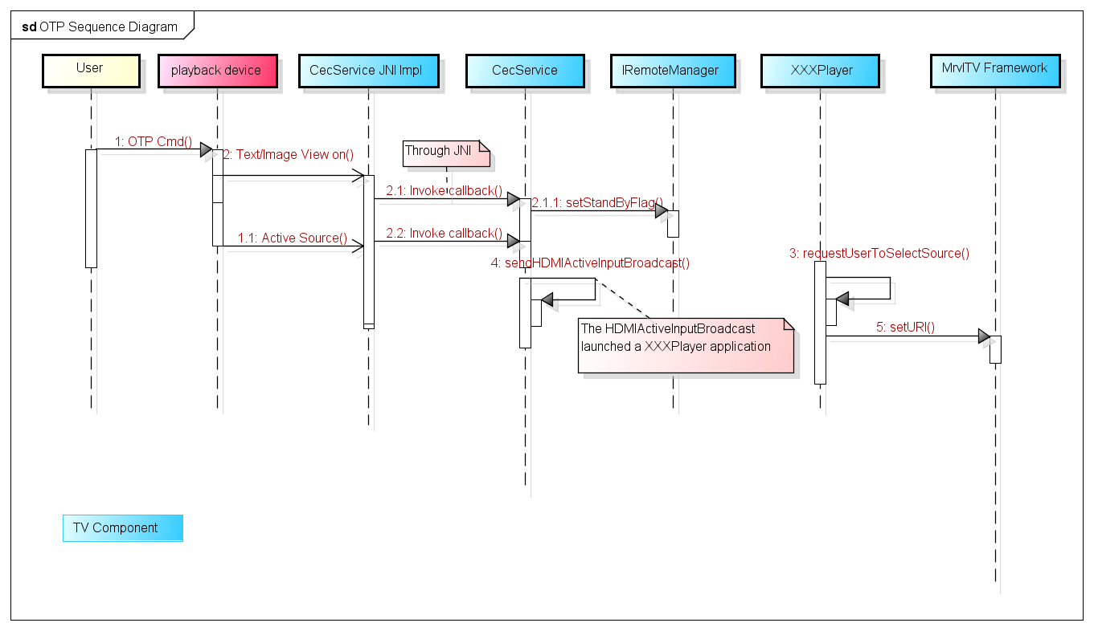
Figure 2 OTP user case

4.2 System Standby
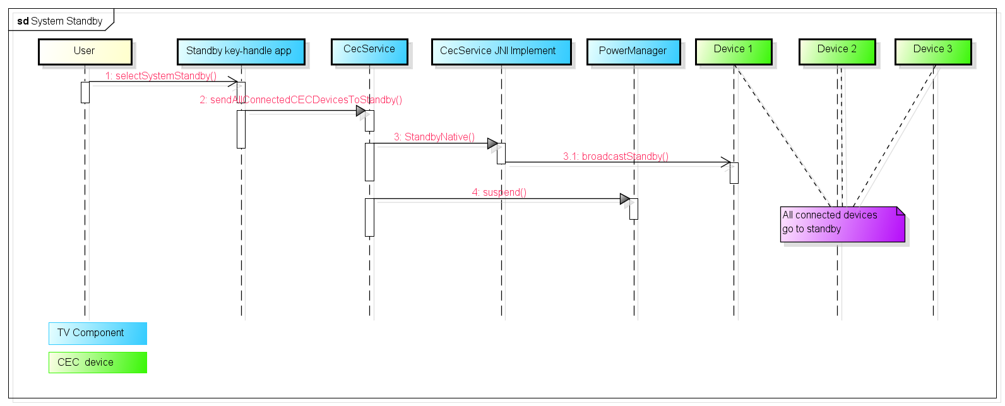
Figure 3 System Standby user case

4.3 Remote Control Pass Through
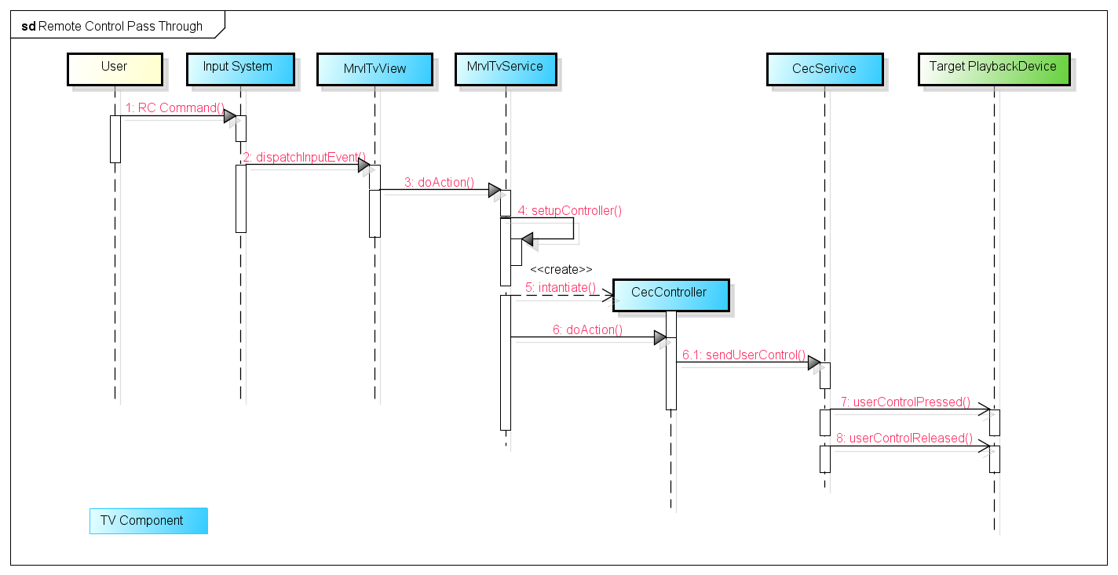
Figure 4 Remote Control Pass Through user case

6 Test Design
See DmpCecFeatureTest.java

