USB OSD AND MEDIA FILE PROCEDURE

- USB DETECTION:
1:MULTITASK FUNCTION:
  - msAPI_Timer_ResetWDT();
  - MApp_ProcessUserInput();
  - _MApp_Video_Handler(g_bRealTimeMonitorOnly);
  - MApp_MPlayer_Task()；
  - MApp_DigitalMedia_Task();
  - MIPS_MBOX_DBGOUT();
  - SUCH MONITOR( pw, countdown,sleep,pvr, etc)
  - …………
- USB DETECTION:

MApp_MPlayer_Task();
↓
void MApp_MPlayer_CheckUSBStatus(void)
↓ if changed ?
_MApp_MPlayer_DisconnectDrive();
MApp_MPlayer_InitializeAllDevices();
NOTIFY(E_MPLAYER_NOTIFY_USB_ACTIVE_DEVICE_STATUS_CHANGE, &m_u32DriveStatus);
_MApp_ACTdmp_HandleUsbStatusChanged();
MAPP_MPLAYTASK PERIOD.
………….
- USB STATUS:
  - EN_DMP_FLAG
  - EN_DMP_UI_STATE
  - EN_DMP_STATE
↓
DMP Main() function process these status when there are any keys pressed by user.
MApp_DMP_NotifyUiState();

- USB OSD HANDLE PROCEDURE:
Key
Action
Winpro
MSG HANDLE( msg-> timer : info, status)

- USB MEDIA FILE PROCEDURE:
Mapp_mplaytask();
Photo play;
Music play;
Video play;
MApp_UiMediaPlayer_Notify() –Media play > ~~~ < usb ui action

DMP 下通常需要处理的问题集结：
添加功能项：
- 播放下一个音视频文件：
PLAYBACK INFO 按键 ->
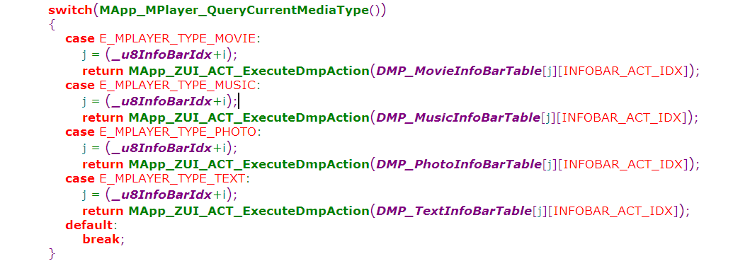
case EN_EXE_DMP_PLAYBACK_MOVIEINFO_NEXT:
MApp_MPlayer_PlayNextFile();
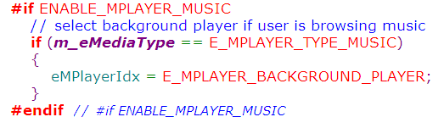
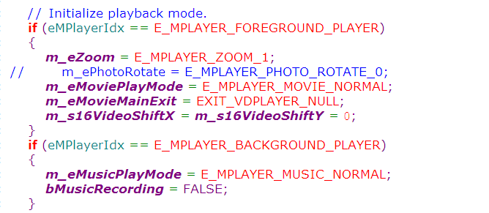

PHOTO NEXT :
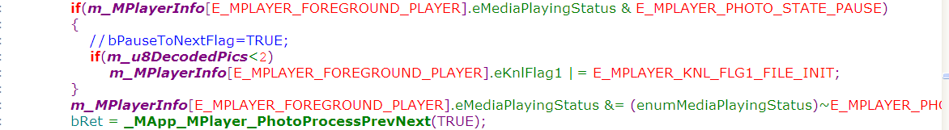
MUSIC NEXT:
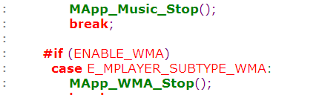
MOVIE NEXT:
TEXT NEXT:


// play flag init:
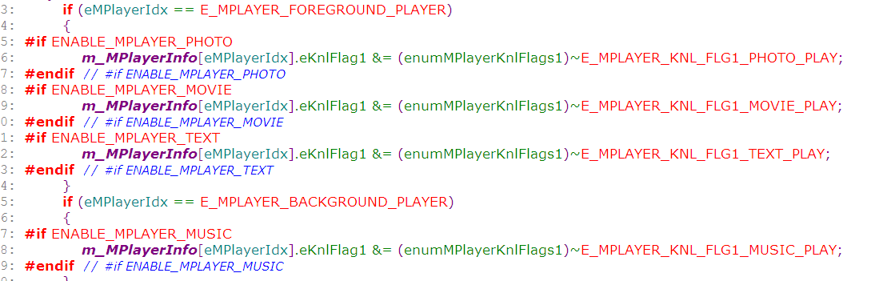
Then play next file:
bRet = _MApp_MPlayer_PlayNext(eMPlayerIdx);
↓
if(m_MPlayerInfo[eMPlayerIdx].eRepeatMode != E_MPLAYER_REPEAT_1)
m_MPlayerInfo[eMPlayerIdx].u16PlayingIdx++;
cal playing index:
a、repeat all:
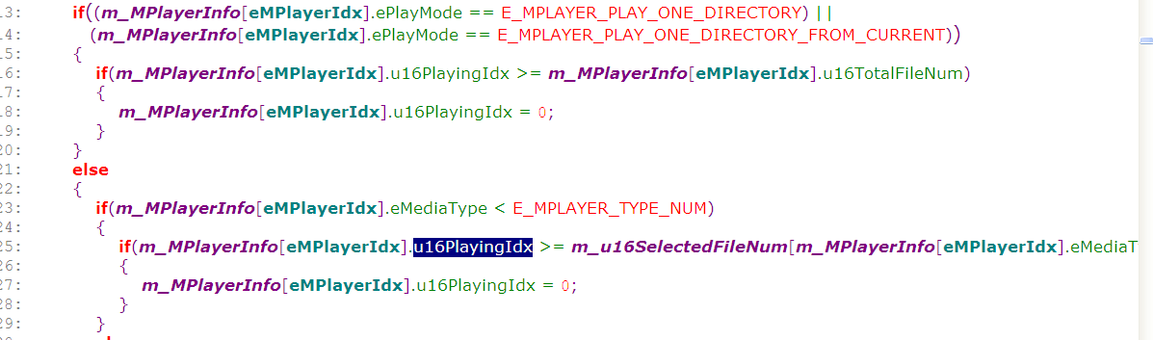
b、repeat none：
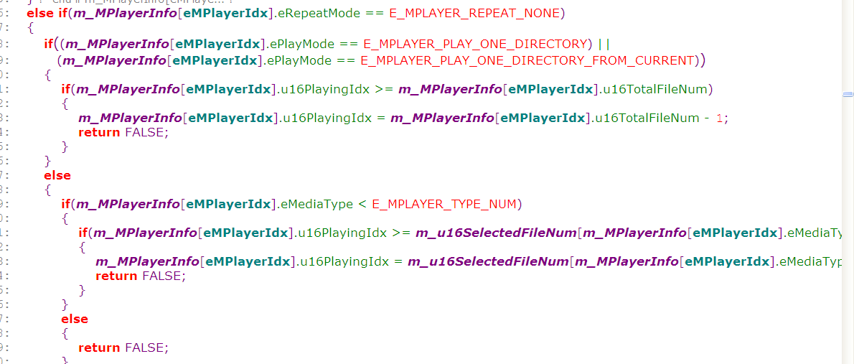

_MApp_MPlayer_PlayDirectory(eMPlayerIdx);
else
_MApp_MPlayer_PlayList(eMPlayerIdx);

_MApp_MPlayer_PlayDirectory(eMPlayerIdx)
{
….
memset(&fileInfo, 0, sizeof(fileInfo));//remove klocwork warning message
//find the media file
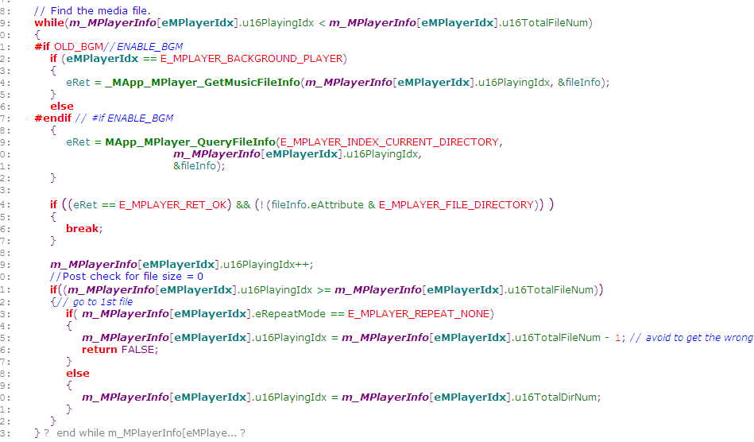

Look and find the current playing index file info,prepare init for next playing
If your file index not true, then it could not find the file info and other informations.
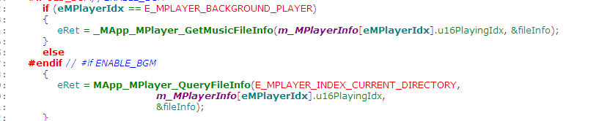
↓
Init for mplay task to play current file:
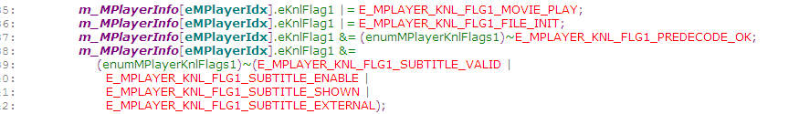
….
}

通常在MPLAY TASK函数中基本上就开始了音视频的解码及输出。
Init:
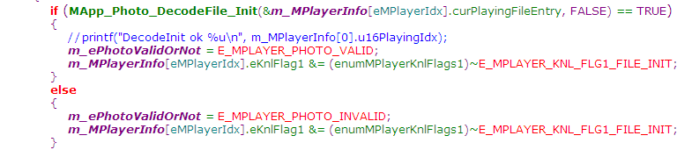
………………

…..
MApp_VDPlayer_Play();
↓


