Artivity
Table of Contents
1 Executive summary 2
2 Stakeholders, goals and objectives 2
2.1 Stakeholders 2
2.2 Goals and objectives 3
2.3 Use cases 3
3 Deliverables 4
3.1 Deliverables for Phase 1 4
3.1.1 Data specification 4
Creative-research data 4
Data about technique (visual art and design) 4
3.1.2 Software 5
3.1.3 Testing 7
3.2 Deliverables for Phase 2 7
3.2.1 Sharing Artivity data 7
Report 7
Why share Artivity data? 7
Artivity data model 7
The value of ontology based models 8
Review of candidate ontologies 8
Conclusions 10
Bibliography 10
Specification 11
3.2.2 Software 11
Why Zeitgeist was abandoned 11
3.3 Deliverables for Phase 3 11
4 Schedule and Milestones 11
4.1 Schedule for Phase 1 11
4.2 Schedule for Phase 2 13
5 Resources 14
5.1 Financial 14
5.1.1 Phase 1 14
5.1.2 Phase 2 14
5.2 Human 14
5.3 Communications 14
6 Sustainability 15
6.1 Community engagement 15
6.2 Related projects 15
7 Additional elements to consider 15
7.1 Strategy and methodology of the overall approach 16
7.2 Critical local, national, global initiatives and standards used 16
7.3 Constraints to the project 16
7.4 Intellectual Property Rights (all Jisc funded projects must share outcomes with the community) and what will happen to the project outputs/outcomes at the end of the project 16
8 References 16

Executive summary
Artivity is a project funded by JISC which aims to produce a toolkit for capturing contextual data produced during the creative process of artists and designers while working on a computer. This data may include browsing history, email exchange and file editing statistics. Such information is already provided by GNOME's Activity Journal (zeitgeist framework). This project will extend Activity Journal to capture data about the way designers and artists use popular software applications such as Inkscape, GIMP and Krita.
The captured data will then be used as part of evidence for design historians and art historians who wish to support their interpretations about art history on real data. It will also be used as a way to document digital techniques during creative production. Finally, the captured data will be the basis of a self-archiving tool for artists who wish to document their practice.

Stakeholders, goals and objectives

Stakeholders
This project was initiated following discussions on the mechanisms of creativity in an art and design context. We have identified a number of stakeholders:
- Academics in the fields of art and design history and art conservation will be offered a new tool to help study creativity in the arts and design. This will allow academics to support interpretations on quantitative data as well as analyse digital technique for artwork created on a computer.
- Professional bodies, such as the Association of Art Historians (AAH) and the Institute for Conservation (ICON), can inform their members on the value of Artivity's tools and therefore encourage and improve the documentation techniques used in these fields.
- Cultural institutions, such as national museums and galleries, have a core mission to document artistic production and capture information about creators especially in the context of archiving practice within galleries. The wide use of Artivity's tools would ensure that the records held about artwork are more complete and give an insight on the so-called tacit dimension of artwork.
- Interested public will benefit from Artivity's tools as the captured data can be used to give an insight in artwork creation which is typically perceived as a moment of enlightenment by a creative genious rather than a lengthy process of research and iterative working.
The engagement of these stakeholders and the adoption of Artivity's tools will indicate whether there is scope in including policy makers in the list of stakeholders (such as the Arts and Design Councils and the Arts and Humanities Research Board).
We recognise the variety of formats of creative output but for the limited capacity of this project we focus only on visual arts as far data about technique is concerned.
Although the identified stakeholders are primarily from the creative sector, creativity fuels work in all sectors. There is scope in examining how Artivity's tools could be used to capture creativity in other sectors such as the Maths and Sciences at a later stage in the project.

Goals and objectives
The goal of the project is to produce a set of tools which will allow capturing contextual data about the process of artistic creation and making these available for further use.
To achieve this goal we have set a number of objectives:
- Engage in dialogue with art historians, conservators, artists and designers to identify the nature of contextual data in their practices and how best these can be used.
- Identify the right technologies which we can extend to capture contextual data and implement these extensions based on an iterative development process.
- Capture data from volunteer artists and designers and analyse it to extract a well-supported narrative about their practice.
- Engage with stakeholders to undertake longer tests and promote the tool.

Use cases
Following consultation with stakeholders, we have chosen to provide tools and data for three user cases as explained next.
Art historical research: Research methods in art history and criticism tend to look at the whole output of an artist over his active lifetime. Artivity will provide mechanisms of delivering data about artists' work produced over long periods of time, by allowing solutions to be scalable.
Research on techniques (primarily for artwork in digital formats): In both art history and art conservation, investigation of the techniques used by artists is a critical part of any analysis of the artwork. Investigating production/creation techniques allows art historians to analyse the process of learning during making and allows conservators to identify the values of the artwork inherent in the making process that need to be preserved.
Self-archiving: Artists regularly consider the value of documentation when producing artwork. Unless documentation is part of the artist's practice (i.e. the artists uses documentation as an important part of art production, e.g. Marsha Bradfield) then the methods used to document practice are limited to notes and photographs. Many artists consider this process of self-archiving as external to their practice and the methods they use not adequate. Artivity will be an automated tool which can record relevant information, package it and export it for preservation.

Deliverables

Deliverables for Phase 1

Data specification
This project will make use of open source software based on the GNOME desktop. More specifically:
- GNOME Activity Journal (zeitgeist framework), which provides a way of logging user activity on the GNOME desktop.
- Inkscape, which is a popular vector drawing application.
- a raster image editing application (possibly Krita or GIMP, to be decided in phase 2).
GNOME Activity Journal already logs user events in relation to web browsing, email messaging and file editing. This project will extend this functionality to cover specific tool use in the aforementioned applications.

Creative-research data
Web-browsing history: The starting point of researching at the begining of art production is online search engines and resources. Therefore the web-browsing history on the creator's desktop is an important source of information which may help art historical research about an artwork or a body of work.
File editing statistics: Although in some cases digital outputs are produced from an empty digital canvas, in other cases existing artwork is used and modified or combined to produce new art. To track that interaction we need to capture file editing statistics (sequence and frequency of editing files) on the creator's desktop. A file that has been created and never edited again may be less important than a file that has been edited hundreds of times for lengthy period of times each. Other creative-research data may include email exchange and chat history but given the sensitive nature of such communication we will consider further how this can be filtered and captured.

Data about technique (visual art and design)
Apart from consulting with stakeholders, a number of academic publications have been used to identify these types of data (see References) which are listed here in no particular order.
Layers and layering: data to describe the order of objects on a canvas which is a typical way of building up an image especially in painting.
Confidence: data to describe the confidence with which tools are being used. We will record the number of undos, the length of lines and brushstrokes and the number of segments on curves (in relation to the complexity of the curve as calculated based on curvature).
Zoom level: data to indicate the level of magnification (and therefore desired detail) in which the artwork is being worked.
Speed: data to indicate when an artwork progresses fast or slow. We will record the number of objects generated and modified during a given period of time.
Number of modifications: data to indicate how many times the properties of an object have changed.
Number of objects: a count of the number of objects on a canvas to indicate how busy (or how minimalist) the result is.
Subtlety of gradients: the colour difference between nodes of a gradient will indicate the contrast of the image.
Masking: data to describe the frequency of use of masks in image processing to indicate the focus on detailed work.
Copying/tracing: data to describe the frequency of copied objects and the extend of the use of selections.
Colour quality: data to indicate the overall quality of colour used in the artwork and the dominant pallete in terms of hue and saturation.
Brush type: data to describe the width and type of brushes used.
Composition: data, such as the average position of large objects in relation to the canvas, which will indicate the overall positioning of the subject.
The above records will be retrieved on a per-artwork basis and therefore comparisons between data from different artworks will be possible. This will allow investigating whether there is a pattern of work (e.g. the starting settings of tools, or colours chosen).

Software
Artivity delivers a repository which includes software to offer these features.
- Data about actions taken by the user in Inkscape to be sent to the zeitgeist framework (see patched version of Inkscape in the Artivity repository).
- Inkscape data stored in zeitgeist is accessible to the user by a GUI which is called Artivity Explorer (see relevant bitbucket directory). Figure 1 shows the Artivity Explorer icon rendered under the Ubuntu desktop. Figure 2 shows the Artivity Explorer window. This displays a panel on the left with the list of calculations of the metrics described in section 3.1.1 (zoom, speed, brush data and compositions are yet to be implemented). It displays a graph with clusters of activity over a period of time which contains actions while editing Inkscape files and also browsing activity. The window also allows access to the individual action records as a list related to the graph. Figure 3 shows the statistics summary as extracted from the data saved in the zeitgeist framework and the resulting svg file from Inkscape.
- Artivity data to be exported in a suitable format (data exporting options have yet to be considered in the project, but a mapping to the CIDOC-CRM is likely). Conclusions from discussions with the CREAM project will also contribute to this decision.


Figure 1: Artivity Explorer icon rendered under the Ubuntu desktop.
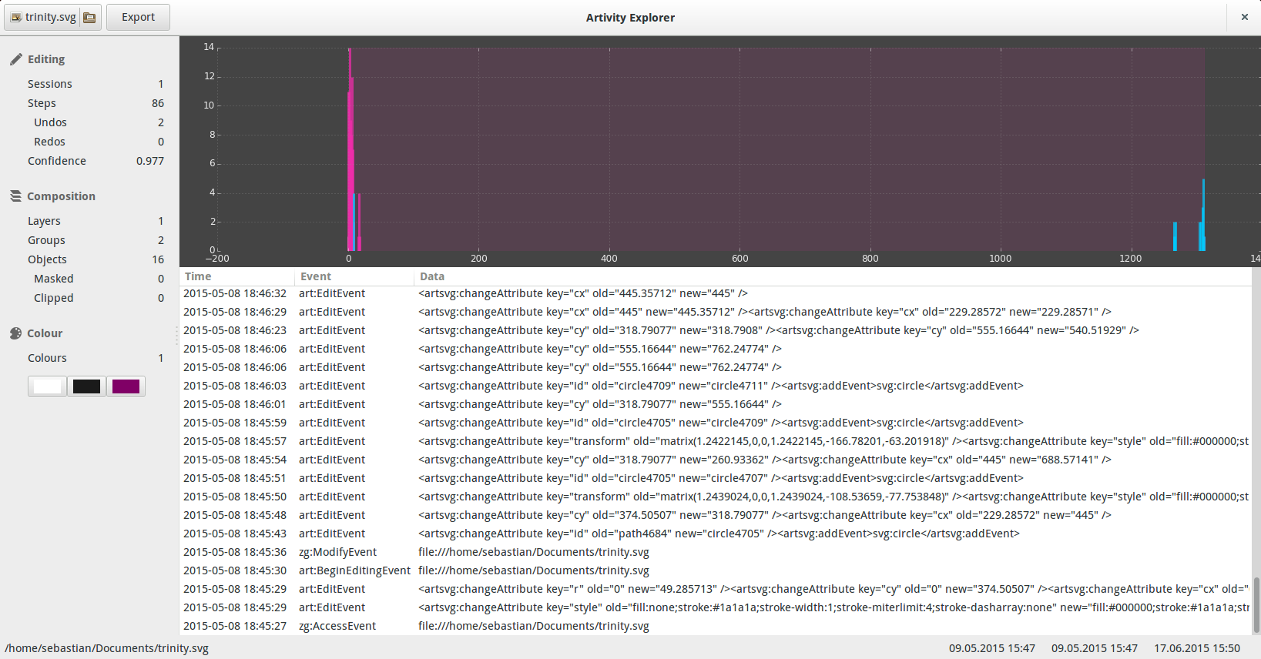
Figure 2: Artivity Explorer window in GNOME.
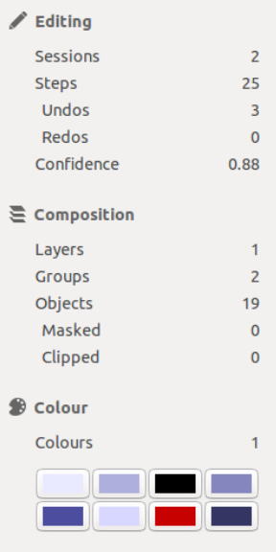
Figure 3: Artivity Explorer statistics panel.

Testing
During Phase 1 the Artivity software was tested at UAL to check that the basic functionality is there. Volunteers from two UAL courses were invited to use Artivity software for a period of time and report any crashes or problems which would affect the usability of Inkscape. The produced Inkscape svg files of these test sessions were also examined using Artivity Explorer to test that the calculation of the metrics is as expected. The data collected during these initial tests helped identify a number of issues which have now been solved. For example some of the problems resolved during this initial testing are:
- capturing Artivity data prior to a file having been given a file name.
- tranferring Artivity data when files have been renamed.
- maintaining robust links between web browser software, the versions of which typically ascend quickly.
Further testing on a larger scale will take place during Phase 2 and 3. The extensive tests will indicate possible narratives that can be extracted from the collected data about the creative process.

Deliverables for Phase 2

Sharing Artivity data
Preliminary work on exporting data as simple CSV files took place during Phase 1. Here we explain how we extend this functionality to allow exporting data from multiple files created over a long period of time and map these to an ontology for compatibility with semantic technologies.
Decisions on the development of the Artivity data model and the choice of export format have been influenced by discussions with the CREAM project. Further improvements may be proposed after consultation with the SaS project (see JISC Research Data Spring).

Report
In this report we present the Artivity data model (as it stands in Phase 2) and undertake a short review of the different formats that we can use to export Artivity data for long-term repository storage or for use in other applications.

Why share Artivity data?
One of the main purposes of Artivity is to allow contextual research data from art practice to be used by other researchers as part of their future analysis on the development of that practice. This may be data about a particular artwork, data about a particular artist or combined data from a group of artists. An important consideration in relation to the model is that contextual research data collected on the desktop can come from a variety of source applications, each sharing different types of data. An underlying issue when it comes to sharing is that of long-term preservation of Artivity data especially when researchers look into long periods of time (e.g. the development of an artist over a decade). The following text has been produced with the above considerations in mind.

Artivity data model
An important characteristic of the development of visual artworks, which is also evident in other types of artistic creation (e.g. [3]), is that it happens over time. Research and artistic creation on the computer desktop consists of a collection of actions (computer interactions) which result in outputs. On a computer desktop these outputs are often computer files. Artivity can track actions on supported software applications (Inkscape and Krita are currently supported with plans for other software in the future). These actions are normally undertaken by the artist or designer. Actions are considered as events and they carry relevant data depending on the type of software they have occured. Typical data that is associated to events is the time the event occured, the artist or designer who undertook the event, the file that changed because of the event and any associated data of that change (for example a colour value being changed from black #000 to white #fff). When capturing web-browsing events, the viewing of a webpage does produce a new file which can be recorded but the important information there is the URL visited. A schematic representation of the type of data collected by Artivity is shown in Figure 4. As Artivity expands to include events from other software, other types of data may need to be captured. Maintaining a flexible data model is therefore critical for Artivity.
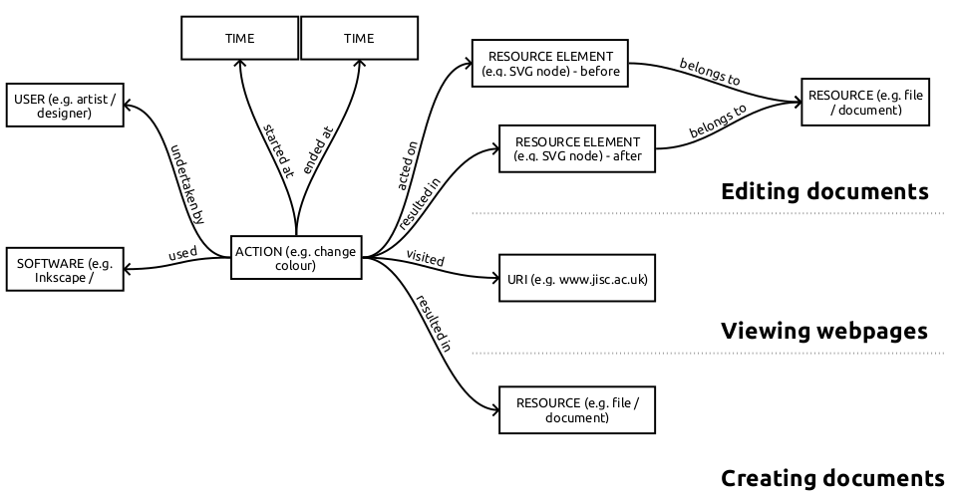Figure 4: Examples of data collected by Artivity.

The value of ontology based models
Early influencial surveys of methods for modeling context in computing (e.g. [Error: Reference source not found]) identify ontology-based models as good candidates. Similar views have been expressed more recently in research on knowledge management (e.g. [7]). The main benefits of ontology-based models being their good performance in the following fields:
- distributed data (especially for groups of artists)
- incompleteness and ambiguity (especially for art practice partially undertaken on the computer desktop)
- applicability to existing environments, i.e. ease of implementation
- reusability, i.e. data can be referenced directly and without involving a schema
- extensibility, i.e. ease of adding other sources of contextual data in the future
- scalability of relationships, i.e. typically ontologies allow linking of data in different levels
It is therefore reasonable to opt for an ontology-based solution for Artivity data than for an application-specific schema.

Review of candidate ontologies
Given that the core of the Artivity data model revolves around the concept of the event, an ontology which is based on actions and their relationships with products would be a reasonable choice.
A number of projects have followed an ontology-based solution to user tracking on the desktop especially for applications of ubiquitous computing. Some of them (e.g. UICO/KnowSelf [5, 4]) have remained closed systems with little documentation on the details of their ontological models.
Others, like Haystack, Personal Radar (from RadarNetworks) and OpenIRIS [1] were projects which developed around 2005 but appear to have been less busy over the past few years or they have completely disappeared. The documentation project for OpenIRIS seems to be pointing to the “Component Library ontology” but the lack of activity around these projects poses a risk in the adoption of their recommendations.
Topic Maps [8] is frequently referenced in the bibliography alongside ontologies. It is a rare example of a project which has sustained active development over the years leading to an ISO standard. However, the Topic Maps standard is not strictly speaking an ontology. It is a way to express ontologies [9] and the separation between ontological concepts (topics) and their manifestation as resources. Using Topic Maps provides benefits for developers, but it is not expressive enough without an underlying ontology. Therefore, although its use may be considered for development reasons, it does not compete as an option to model Artivity data.
An important EU project called NEPOMUK led the way in the development of ontologies to model user interaction on a computer desktop. Early implementations by the Gnowsis project and the KDE software community produced software which made use of these ontologies. Later implementations like the GNOME Zeitgeist framework followed. A recent announcement by the KDE developers indicated that NEPOMUK on KDE will be replaced by a new project called Baloo. With Zeitgeist's development having stalled (the last major release was in 2011) this meant that two of the most crucial implementations of NEPOMUK ontologies are essentailly no longer active (see also Why Zeitgeist was abandoned). However, the NEPOMUK ontologies themselves are still maintained and could be used to describe entities on the desktop, but we think that using these ontologies exclusively may be a risk to Artivity since the flagship NEPOMUK projects seem to have completed their life-cycle.
Other efforts have led to recommendations and standards with support from solid communities and organisations and their outcomes can be considered sustainable. Activity Streams (AS) is a draft recommendation of the W3C and it is backed by a number of leading companies such as Google, Facebook and Microsoft. AS is developed for online sharing of content by users, particularly in the form of timelines. With the core concepts being the Actor undertaking an action and the Activity taking place at a specific time, AS can be easily modified to store data about activity on the desktop through extensions to the core classes. Although this looks like a promising candidate for Artivity, we are concerned about the specificity of Activity Streams and their focus on social media. We are also concerned about possible confusions between the AS Object (class) and the AS object (property) given that the object (property) of an activity is meant as a static entity whereas the AS specification allows it to be an event. Despite these reservations it may be possible to express Artivity data using AS.
CIDOC-CRM is another popular ISO standard [10] under active development which is based on the notions of Actors, Events and Objects. Developed to describe historical events and cultural heritage objects the CIDOC-CRM is a generic ontology which requires additional expert vocabularies to produce records in a domain. CIDOC-CRM is a good candidate to describe activity and its relationships to objects on a desktop. Recent work [2] on an extension of the CRM called CRM_{dig}, explains how it is possible to model interactions and processes on the computer using the CRM to track file modifications and other activities. The CRM is another candidate which could be used to express Artivity data through the CRM_{dig} extension which, however, is not part of the ISO standard.
A mapping of Artivity data to the CRM_{dig} is shown in Figure 5.
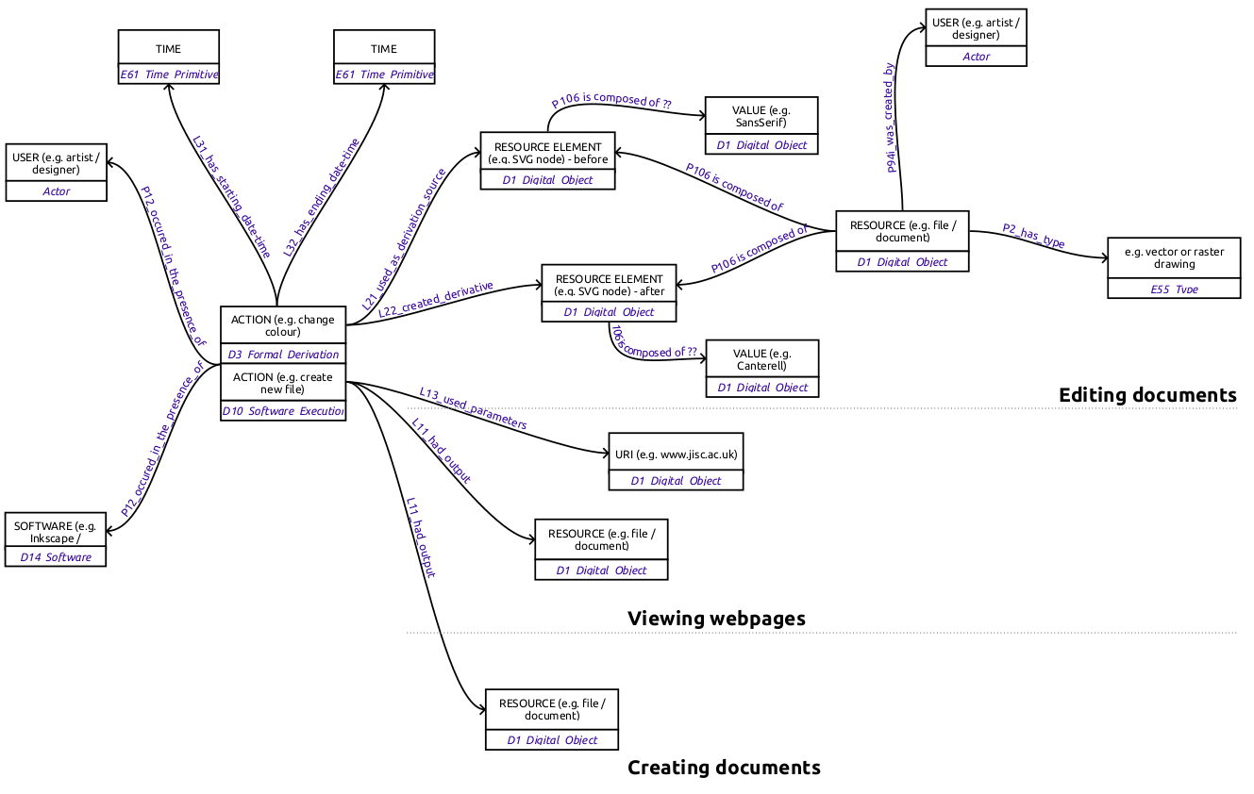Figure 5: Mapping of Artivity data to CRM_{dig}.
PROV is a recent W3C recommendation with an active working group for modeling provenance metadata of objects in relation to Agents and Activities. PROV uses the core concept of Derivation to model modifications on computer files and has been developed with both physical and digital resources in mind. It is recognised as the most prominent solution for semantically expressing provenance on the computer desktop and as such it is a strong candidate for Artivity.
A mapping of Artivity data to PROV is shown in Figure 6.
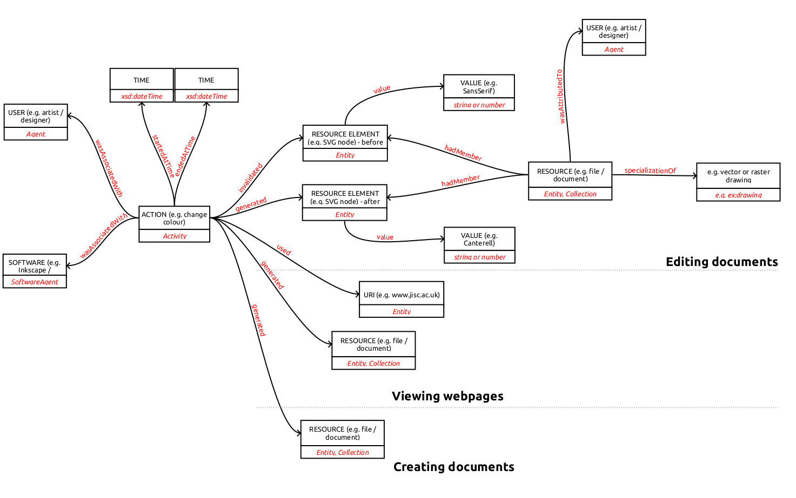Figure 6: Mapping of Artivity data to PROV.

Conclusions
The NEPOMUK ontologies, AS, CRM_{dig} and PROV are reasonable candidates for expressing Artivity data. We were able to produce mappings for PROV and CRM_{dig} and we think it would be possible to produce a mapping for AS. Entities defined in the NEPOMUK ontologies can be used in these mappings. Of these candidates we have decided to base Artivity's internal model on PROV for the following reasons:
- PROV is designed specifically to express provenance data which is essentially what Artivity produces,
- PROV is backed by the W3C which guarantees long term support and alignment with current technologies,
- PROV is a generic model which can be used to express different types of data and this is important to ensure that applications supported by Artivity in the future can still fit within the adopted data model.
Therefore, Artivity data will be stored as PROV RDF statements in Artivity's local triple store. They can be serialised and exported easily as XML-RDF. As soon as the Artivity data model is mapped to as CRM_{dig} and AS further serialisations can be produced.

Bibliography
- Cheyer, A., Park, J. and Giuli, R. (2005) ‘IRIS: Integrate. Relate. Infer. Share.’, in. 1st Workshop on The Semantic Desktop. 4th International Semantic Web Conference, p. 15. Available at: http://citeseerx.ist.psu.edu/viewdoc/download?doi=10.1.1.84.3070&rep=rep1&type=pdf (Accessed: 1 September 2015).
- Doerr, M. and Theodoridou, M. (2011) ‘CRMdig: A Generic Digital Provenance Model for Scientific Observation.’, in TaPP. Available at: http://static.usenix.org/events/tapp11/tech/final_files/Doerr.pdf (Accessed: 28 September 2015).
- Garrelfs, I. (2015) From inputs to outputs: an investigation of process in sound art practice. PhD Thesis. University of the Arts London.
- Pammer, V. and Bratic, M. (2013) ‘Surprise, Surprise: Activity Log Based Time Analytics for Time Management’, in CHI ’13 Extended Abstracts on Human Factors in Computing Systems. New York, NY, USA: ACM (CHI EA ’13), pp. 211–216. doi: 10.1145/2468356.2468395.
- Rath, A. S., Devaurs, D. and Lindstaedt, S. N. (2009) ‘UICO: an ontology-based user interaction context model for automatic task detection on the computer desktop’, in Proceedings of the 1st Workshop on Context, Information and Ontologies. ACM, p. 8. Available at: http://dl.acm.org/citation.cfm?id=1552270 (Accessed: 28 August 2015).
- Strang, T. and Linnhoff-Popien, C. (2004) ‘A Context Modeling Survey’, in Workshop Proceedings. First International Workshop on Advanced Context Modelling, Reasoning And Management at UbiComp 2004, Nottingham, England, September 7, 2004, Nottingham, UK. Available at: http://citeseer.ist.psu.edu/strang04context.html (Accessed: 28 August 2015).
- Thalmann, S., Seeber, I., Maier, R., Peinl, R., Pawlowski, J. M., Hetmank, L., Kruse, P. and Bick, M. (2012) ‘Ontology-based standardization on knowledge exchange in social knowledge management environments’, in Proceedings of the 12th International Conference on Knowledge Management and Knowledge Technologies. ACM, p. 12. Available at: http://dl.acm.org/citation.cfm?id=2362472 (Accessed: 28 August 2015).
- ‘ISO/IEC 13250:2003 - Information technology -- SGML applications -- Topic maps’ (2006). ISO. Available at: http://www.iso.org/iso/iso&5Fcatalogue/catalogue%5Ftc/catalogue%5Fdetail.htm?csnumber=38068 (Accessed: 1 September 2015).
- An Introduction to Topic Maps (no date). Available at: https://msdn.microsoft.com/en-us/library/aa480048.aspx (Accessed: 1 September 2015).
- ‘ISO 21127:2014 Information and documentation -- A reference ontology for the interchange of cultural heritage information’ (2014). ISO.

Specification

Software
Krita: a plugin will be developed to link Krita with the zeitgeist framework and allow Artivity Explorer to collect data from Krita files. Krita has been selected instead of GIMP due to the popularity of the tool among illustrators and raster artists.

Why Zeitgeist was abandoned

Community engagement (sustainability - scalability)
- Produce systematic data from a small group of artists / designers and examine the resulting data and its capacity to indicate trends in the work of artists.
- Propose and design a workshop for the Libre Graphics Meeting in 2016 in London which will be a good opportunity to showcase the project to the community after the JISC funding is completed.
- Present the project at representatives of the conservation and art historical communities.
- Produce a strategy document for Artivity's sustainability post-funding.

Deliverables for Phase 3
Depending on the engagement of the community in Phase 2, deliverables for Phase 3 may need to be modified.
Development
- Desktop environment capture: a number of characteristics of the desktop will be linked to the captured data from the two creative applications including screenshots.
- Visualisation: Tools to visualise the development of a digital artwork / design will be developed to assist at an educational level in terms of technique.
- Self-archiving button: a hardware button will be linked to Artivity to ensure that privacy issues are addressed.
- Consider porting to other platforms.
Community engagement (sustainability - scalability)
- Deliver a full case study of a group of artists / designers working on a project.
- Involve art historians and digital media conservators and evaluate the collected data for them based on that case study.

Schedule and Milestones

Schedule for Phase 1
 | Apr |  |  |  | May |  |  |  | Jun |  |  |  | Jul
Specification
Software
Testing
Deliverable for Phase 2, 3
Specification document complete
Project meeting
Inkscape – zeitgeist bridge complete
Report on testing complete
Description of deliverables for Phase 2 and 3 complete
Second sandpit

Schedule for Phase 2
 | Jul |  | Aug |  |  |  | Sep |  |  |  | Oct |  |  |  | Nov
Krita
Export
Testing
Libre Graphics
Art history & Conserv
Identify LGM 2016 chair
Krita plugin ready
Present to Art Historical groups
Finish proposal for LGM 2016
Project meeting
Export tools ready
Present to Conservation groups
Testing report complete
Third sandpit

Resources

Financial

Phase 1
Researcher: 0.1 × 3months = £1,300
Development costs: £9,000
Travel / subsistence: 3 UK trips = £300, 1 European trip = £400
Total: £11,000

Phase 2
Researcher: 0.2 × 4months = £3,563
Development costs: £12,000
Testing (commissions/vouchers): £2,000
Travel / subsistence: £1,350
Admin: 0.1 × 4months = £1,296
Other: Estates + Indirect = £2,996
Total (FEC): £23,205 JISC to fund: £17,403.75

Human
List required skills and roles required to carry out the project. Identify by name, the individuals and organisations that are collaborating or have a leading role in the project. They must commit time and have the capacity to work on your project.
Ligatus (UAL)
Athanasios Velios will have the overall management of the project
Semiodesk

Communications
Artivity maintains a project page at http://www.ligatus.org.uk/project/artivity with an associated blog. It also maintains a software repository at https://bitbucket.org/semiodesk/artivity Project members regularly tweet about the project from personal, project and institutional accounts. We contribute to discussions with members of the communities we are engaging including subject specific workshops and meetings in UAL with relevant practicioners.

Sustainability
Artivity focuses on implementing software using established frameworks and tools within the open source community. GNOME Activity journal and the zeitgeist framework are robust technologies which work well. Inkscape is an extremely popular package in the open graphics communities with an active group of developers. The quality of these projects is indicated by their continues availability in all major repositories over the past years. Artivity Explorer requires data from Inkscape. In order to provide this data a patched version of Inkscape is required. The Artivity team is in discussion with Inkscape developers to adopt the patch as part of the main Inkscape programme to ensure that the required functionality remains in the future.
Artivity software is delivered either as source code ready for compilation or as pre-compiled binaries for the Ubuntu and Ubuntu derivative distributions through a ppa (ppa:faubulous/artivity). This makes scaling the distribution of software easy and indeed the large number of potential users has little impact on the support resources. Support for Fedora and RedHat derivatives will be considered in the future.

Community engagement
We are engaging with the various communities within UAL which is one of the largest art universities in the world.
We have approached Libre Graphics World and are in discussion about involving part of that community during testing. We already had some interest and we will pursue this during Phase 2.
We are aware that a large number of artists and designers are exclusively using Adobe (or other commercial) software. We are commited to enhancing the capacity of open source communities but Artivity software is being developed on Linux but without excluding other platforms. If the sustainability and scalability of the project is jeopardised by the lack of engagement because of the choice of creative software, then we should be able to expand to other platforms without wasting any work that has already been done.

Related projects
We are being inspired by a number of other projects with similar objectives including:
- Instrumented GIMP, a version of GIMP which tracks user activity for usability testing.
- Life-logging applications

Additional elements to consider
Depending on where you think these fit best, you may also think about the implications that the following elements would have on your project:

Strategy and methodology of the overall approach

Critical local, national, global initiatives and standards used

Constraints to the project

Intellectual Property Rights (all Jisc funded projects must share outcomes with the community) and what will happen to the project outputs/outcomes at the end of the project

References
Jarvis, M. (2007) ‘Articulating the tacit dimension in artmaking’, Journal of Visual Art Practice, 6(3), pp. 201–213. doi: 10.1386/jvap.6.3.201_1.
Thomas Hess (1953) ‘De Kooning Paints a Picture | ARTnews’, ARTnews. Available at: http://www.artnews.com/2012/11/12/de-kooning-paints-a-picture/ (Accessed: 13 April 2015).
Whiteley, N. (2007) ‘Seeing what, how and why: the ARTnews series, 1953–58’, Journal of Visual Art Practice, 6(3), pp. 215–228. doi: 10.1386/jvap.6.3.215_1.

Jarvis, M. (2007) ‘Articulating the tacit dimension in artmaking’, Journal of Visual Art Practice, 6(3), pp. 201–213. doi: 10.1386/jvap.6.3.201_1.
http://haystack.csail.mit.edu/
http://www.cs.utexas.edu/users/mfkb/RKF/tree/
http://isotopicmaps.org/sam/sam-model/
http://nepomuk.semanticdesktop.org/
http://gnowsis.opendfki.de/
https://dot.kde.org/2014/02/24/kdes-next-generation-semantic-search
https://community.kde.org/Baloo
http://www.w3.org/TR/activitystreams-vocabulary/
http://cidoc-crm.org/
http://www.w3.org/TR/prov-overview/

