**DESIGN DFA USING SIMULATION TO ACCEPT THE INPUT STRING “A”,”AC” AND “BAC”**

AIM :

TO DESIGN DFA USING SIMULATION TO ACCEPT INPUT STRING “A”,”AC”,”BAC”

**OUTPUT:**

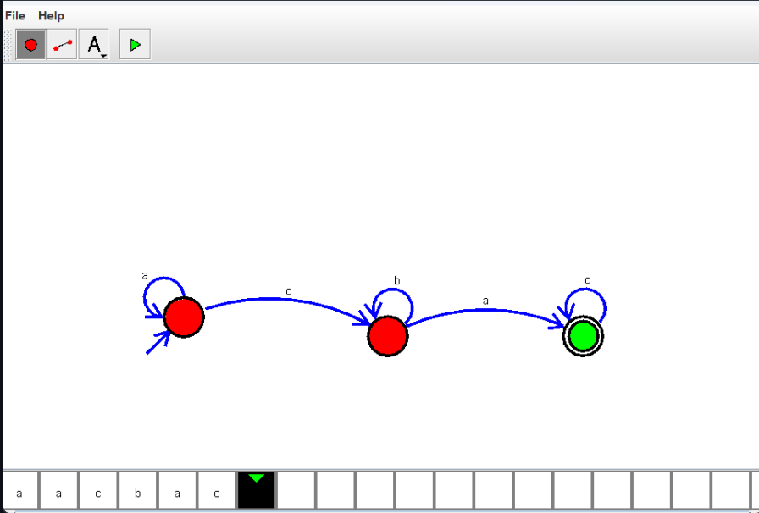

RESULT:

THUS THE DESIGNED DFA IS WORK SUCCESSFULLY