**DESIGN PDA USING SIMULATOR TO ACCEPT THE INPUT STRING AABB**

AIM:

DESIGN PDA USING SIMULATOR TO ACCEPT THE INPUT STRING AABB

OUTPUT:

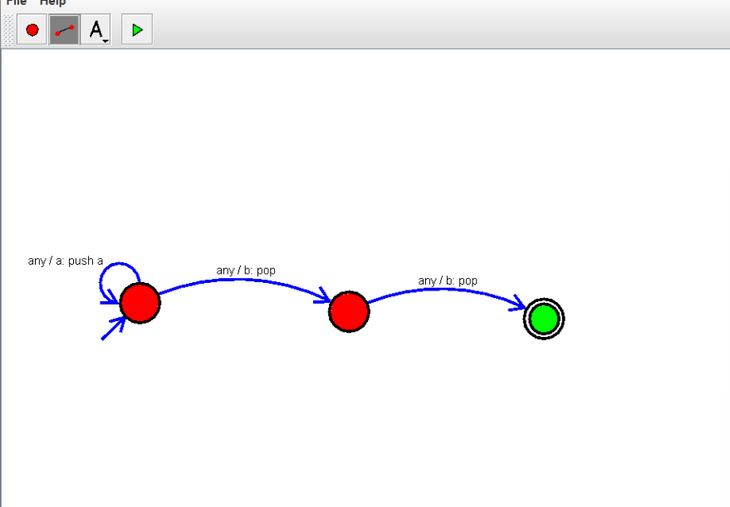

RESULT:

THUS THE DESIGNED PDA IS WORKED SUCCESSFULLY