**DESIGN PDA USING SIMULATOR TO ACCEPT THE STRING ANB2N**

AIM:

DESIGN PDA USING SIMULATOR TO ACCEPT THE STRING ANB2N

OUTPUT:

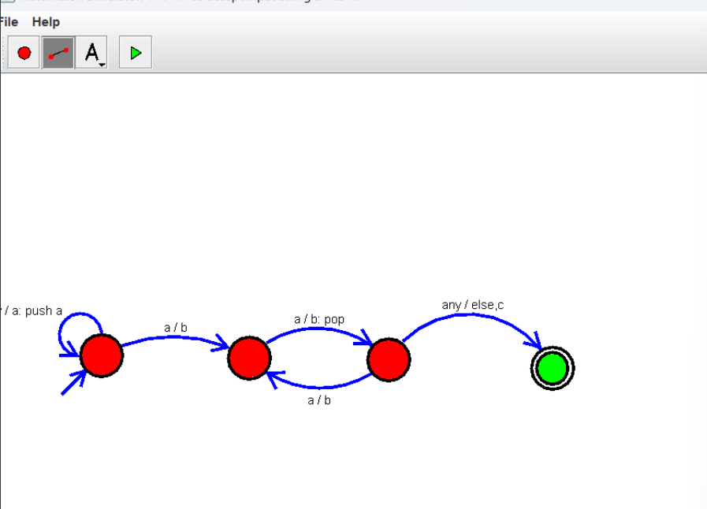

RESULT:

THUS THE DESIGNED PDA IS WORKED SUCCESSFULLY