**DESIGN TM USING SIMULATOR TO ACCEPT THE INPUT STRING AN BN**

AIM:

DESIGN TM USING SIMULATOR TO ACCEPT THE INPUT STRING AN BN

OUTPUT:

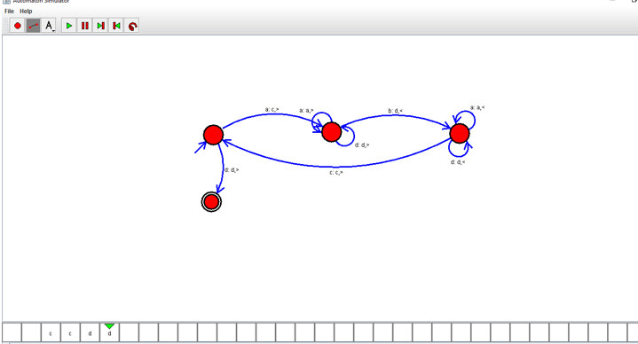

RESULT:

THUS THE DESIGNED TM IS WORKED SUCCESSFULLY