**. DESIGN TM USING SIMULATOR TO ACCEPT STRING AN B2N**

AIM:

DESIGN TM USING SIMULATOR TO ACCEPT STRING AN B2N

OUTPUT:

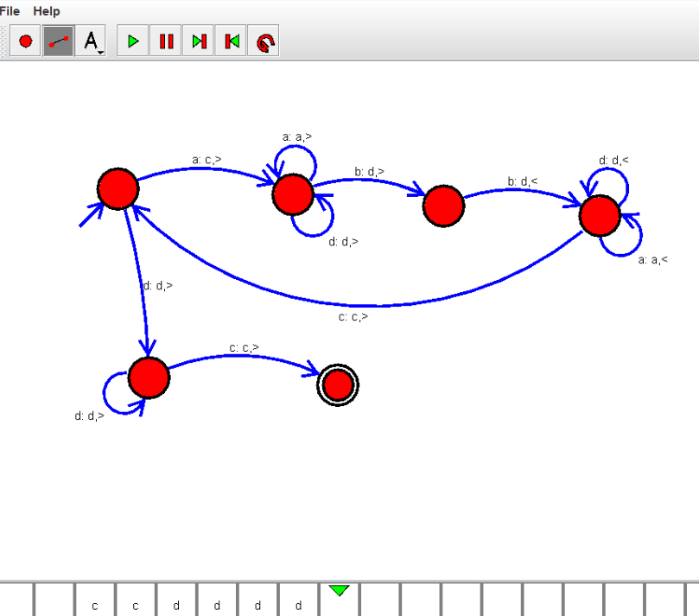

RESULT:

THUS THE DESIGNED TM IS WORKED SUCCESSFULLY