**DESIGN TM TO ACCEPT STRING PALINDROME ABABA**

AIM:  
 DESIGN TM TO ACCEPT STRING PALINDROME ABABA

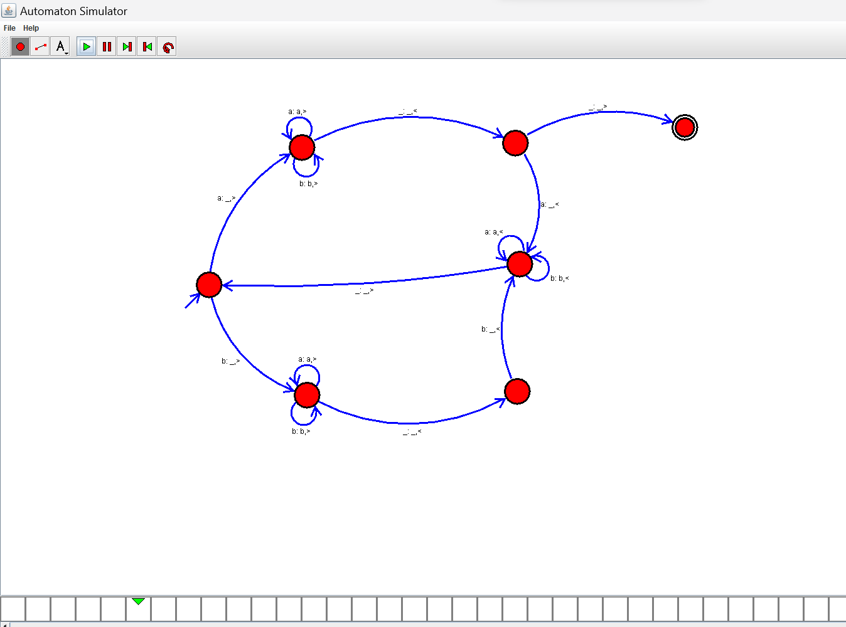

RESULT:

THUS THE DESIGNED TM IS WORKED SUCCESSFULLY