**DESIGN TM USING SIMULATOR TO ACCEPT INPUT STRING WW**

AIM:

DESIGN TM USING SIMULATOR TO ACCEPT INPUT STRING WW

OUTPUT:  
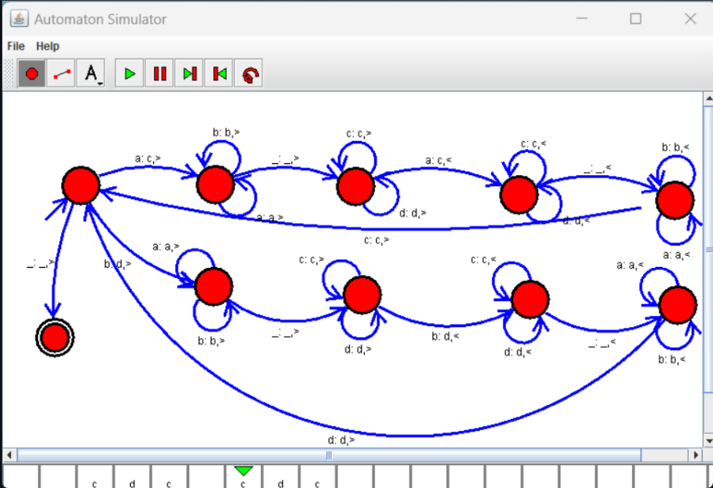

RESULT:

THUS THE DESIGNED TM IS WORKED SUCCESSFULLY