**DESIGN TM TO PERFORM ADDITION**

AIM:

DESIGN TM TO PERFORM ADDITION

OUTPUT:

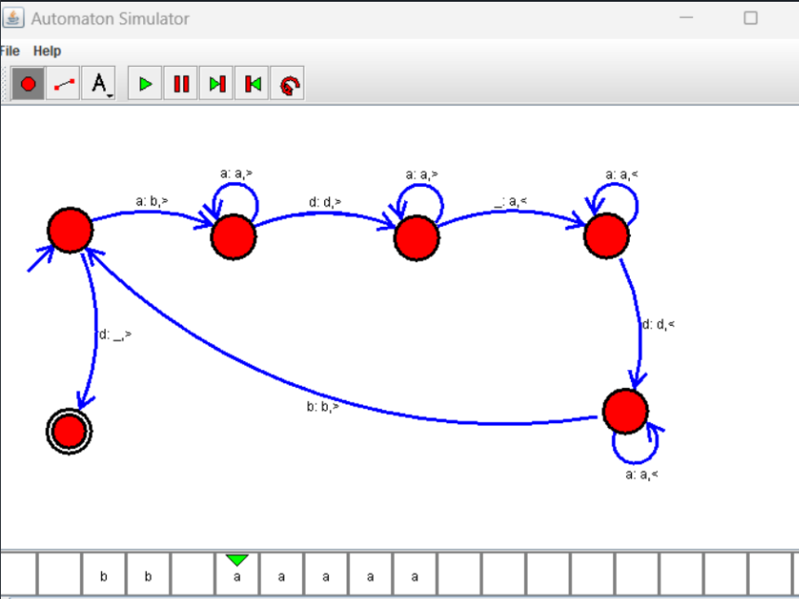

RESULT:

THUS THE DESIGNED TM IS WORKED SUCCESSFULLY