**DESIGN TM TO PERFORM SUBTRACTION**

AIM:

DESIGN TM TO PERFORM SUBTRACTION

OUTPUT

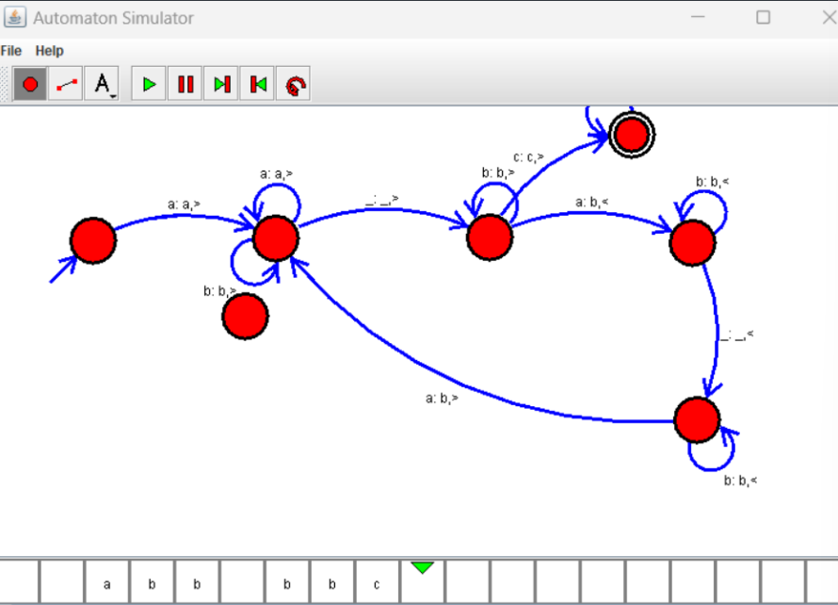

RESULT:

THUS THE DESIGNED TM IS WORKED SUCCESSFULLY