**DESIGN DFA PROGRAM TO ACCEPT EVEN NUMBER OF A**

AIM:

DESIGN DFA PROGRAM TO ACCEPT EVEN NUMBER OF A

OUTPUT:

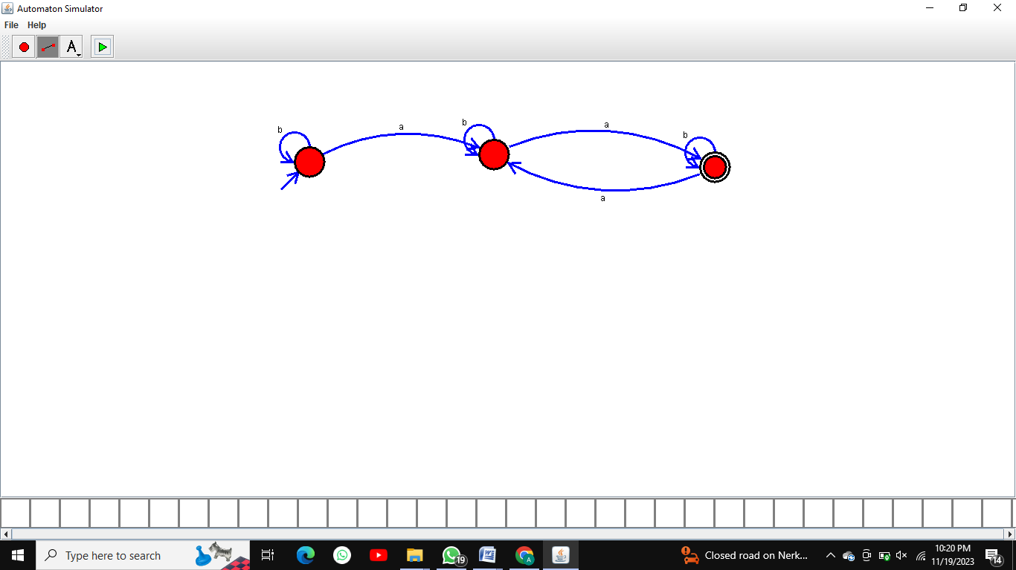

RESULT:  
 THUS THE DESIGNED DFA IS WORKED SUCCESSFULLY

,